Assignment 1

Task 1: Overview:

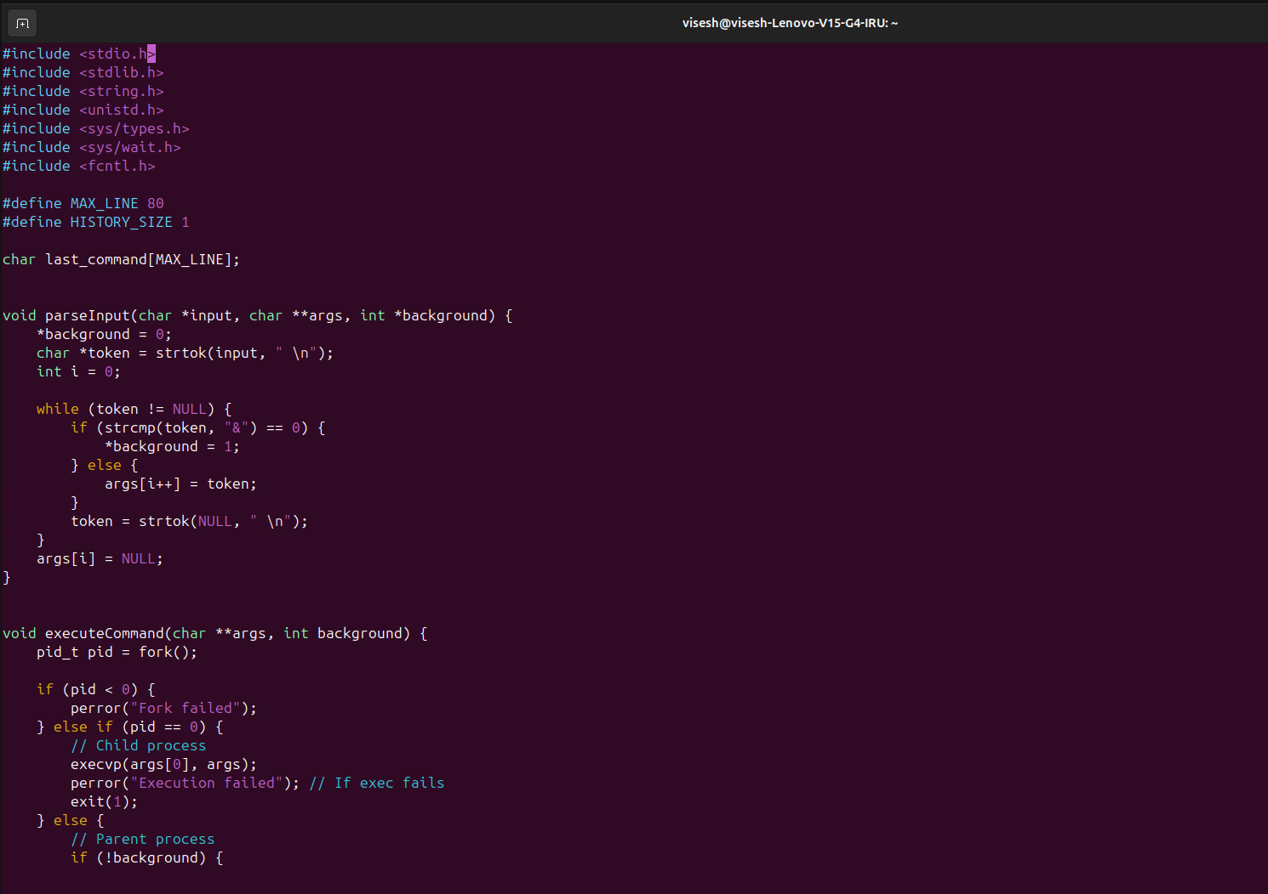
Code:

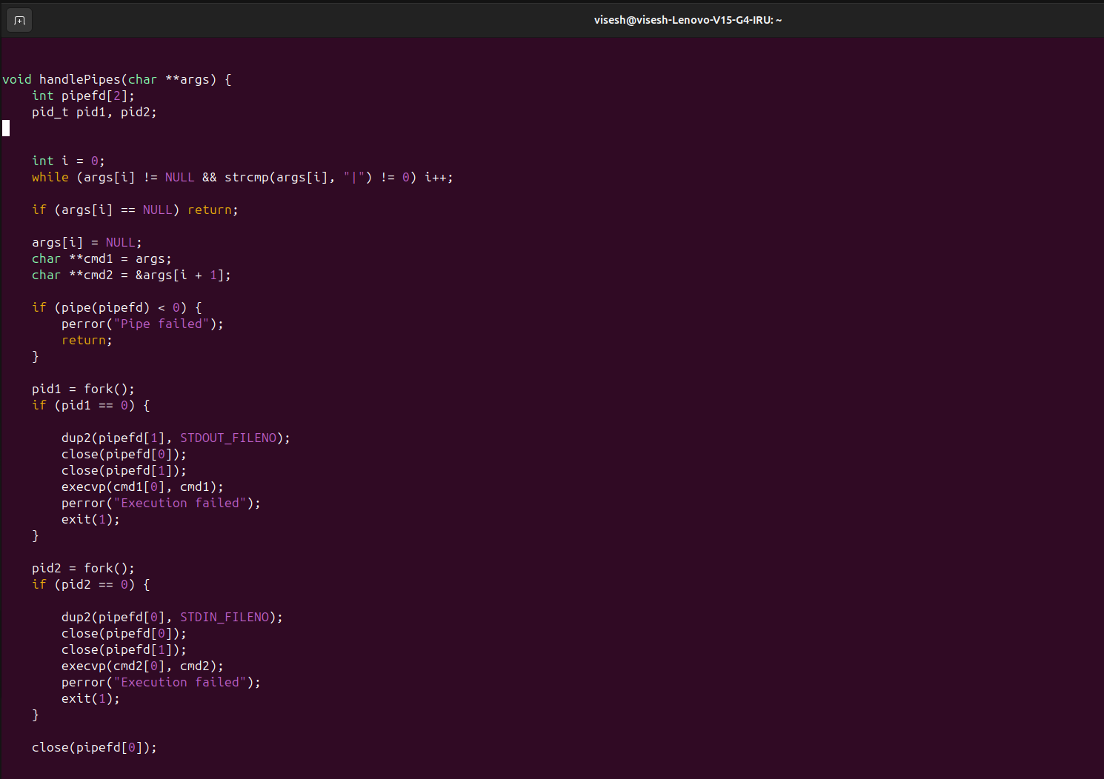

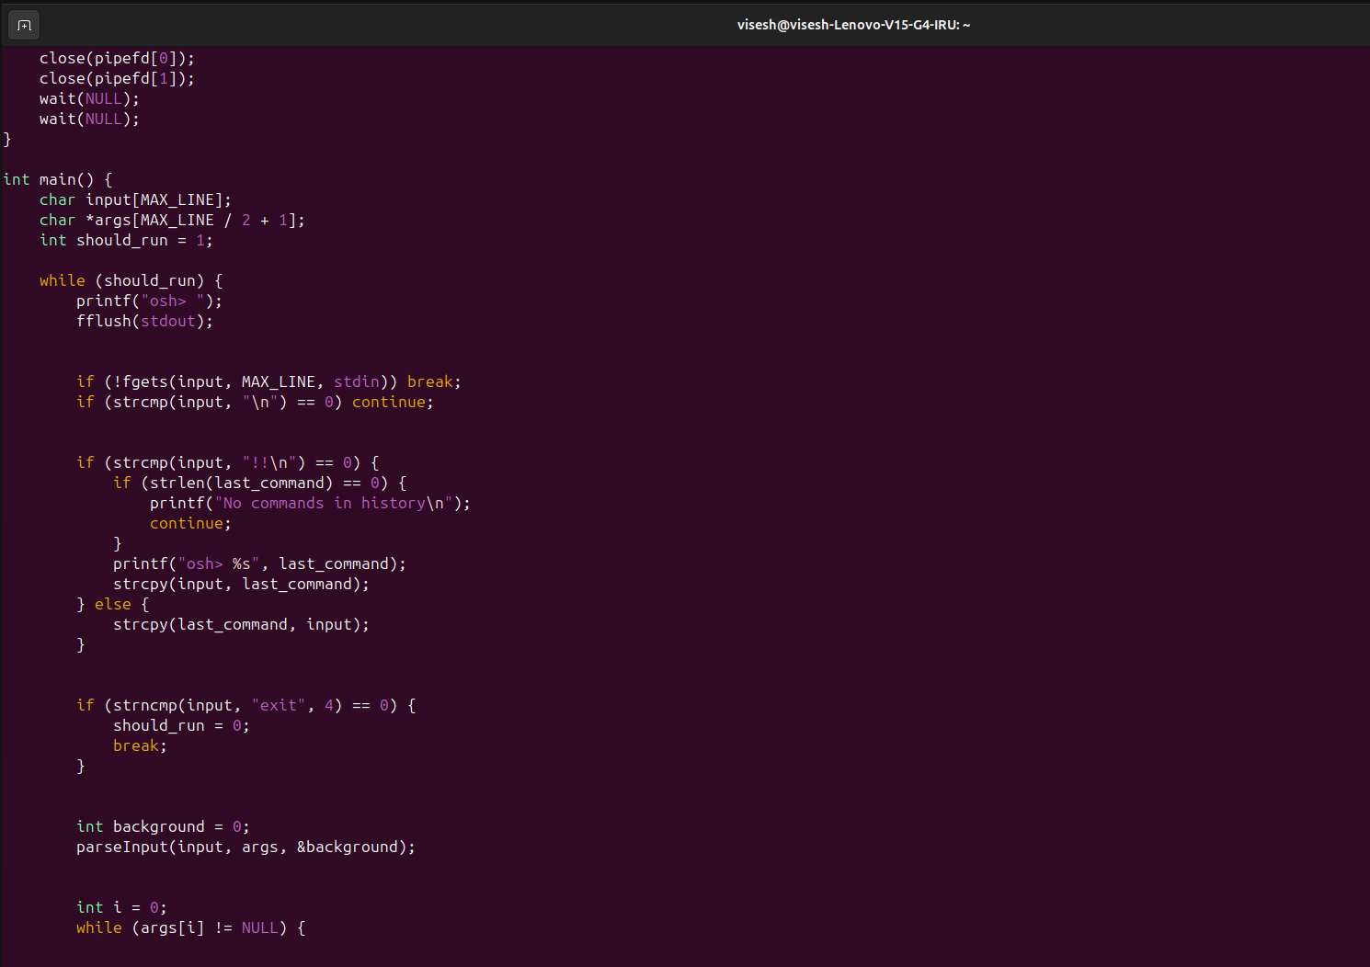

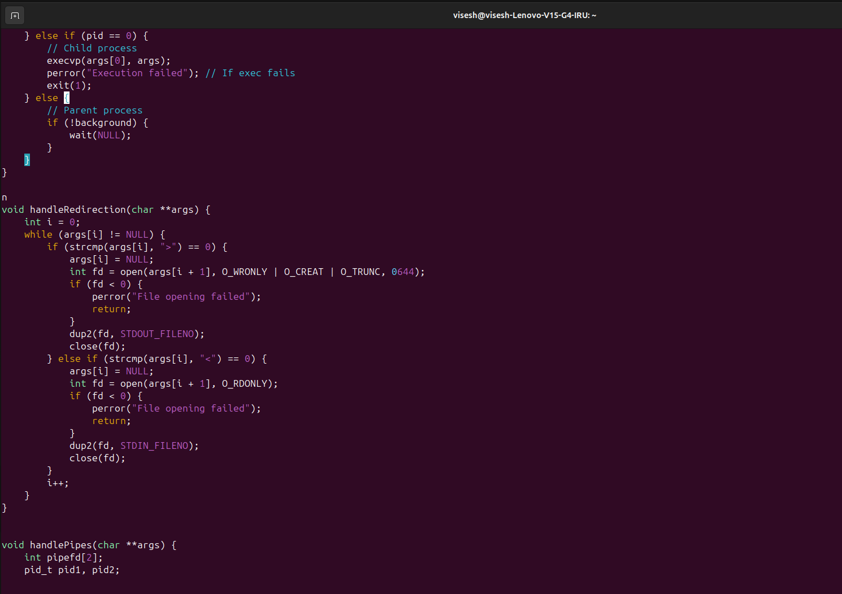

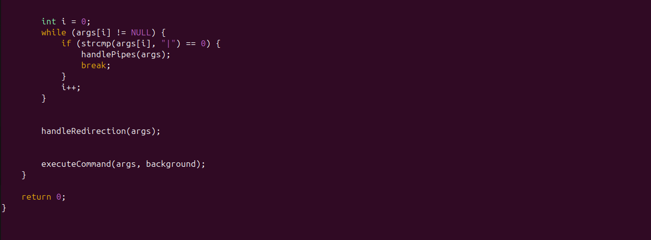

Task 2: Executing Command in a Child Process:
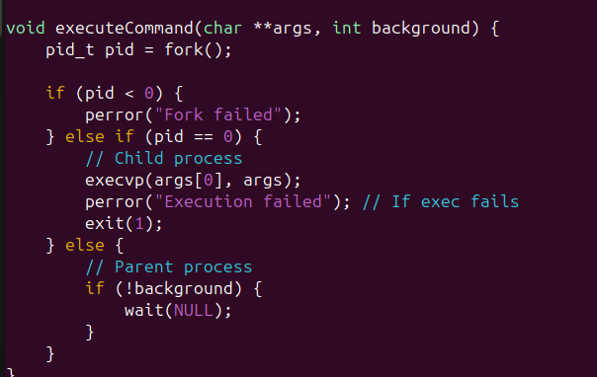

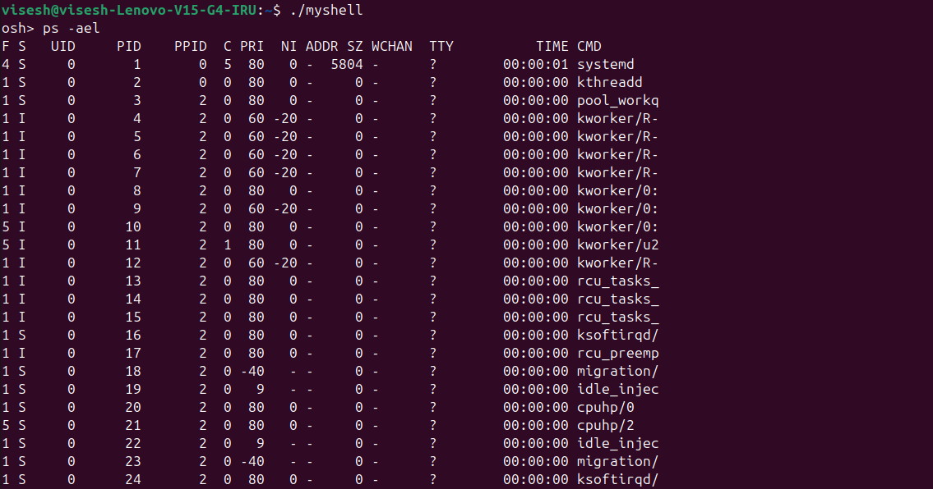

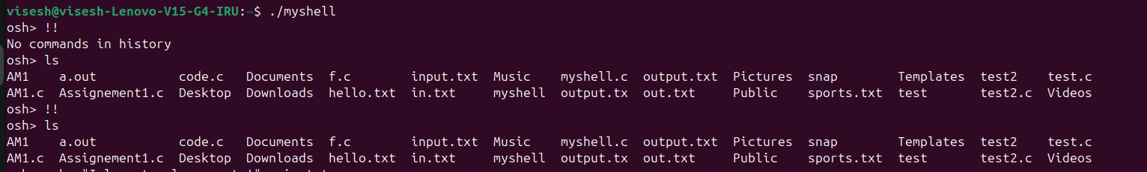
Task 3: Creating a history feature:

I have added a basic error handling feature when there is no history and if we execute the command !! then w’ll get “No commands in history”.

Task 4: Redirecting Input and Output:

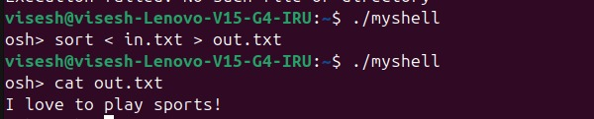

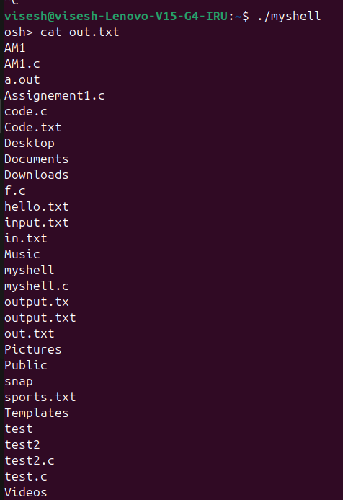

Task 5: Communication via a pipe:

The final modification I made to the shell allows the output of one command to serve as input to another using a pipe. The primary function of a pipe (|) is to facilitate communication between parent and child processes, enabling seamless data transfer between commands.
For example, I executed the command ls | grep .c. Here, the pipe (|) connects the parent and child processes by taking the output of ls and passing it as input to grep .c. As a result, grep .c filters the output, displaying only the lines containing .c. In this case, the output includes myshell.c.
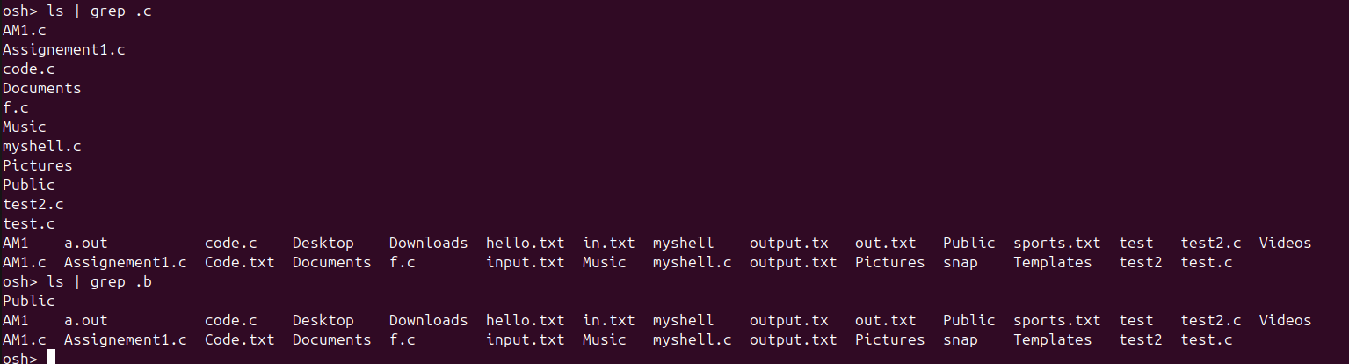
And another example, the command cat input.txt reads and displays the contents of input.txt. The pipe (|) then forwards this output as input to wc -c, which counts the number of words in the input. Finally, it displays the total word count, which in this case is 5.
This demonstrates how parent and child processes effectively communicate using pipes through the pipe() system call.
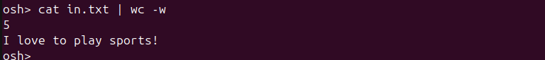
The following command sequence osh>ls -l | less has the output of the command
ls −l serve as the input to the less command. Both the ls and less commands will run as separate processes and will communicate using the UNIX pipe() function

