Source Code:

This C program lists files in a directory (default: current directory) with details similar to ls -l. It displays permissions, links, owner, group, size, modification time, and filename.

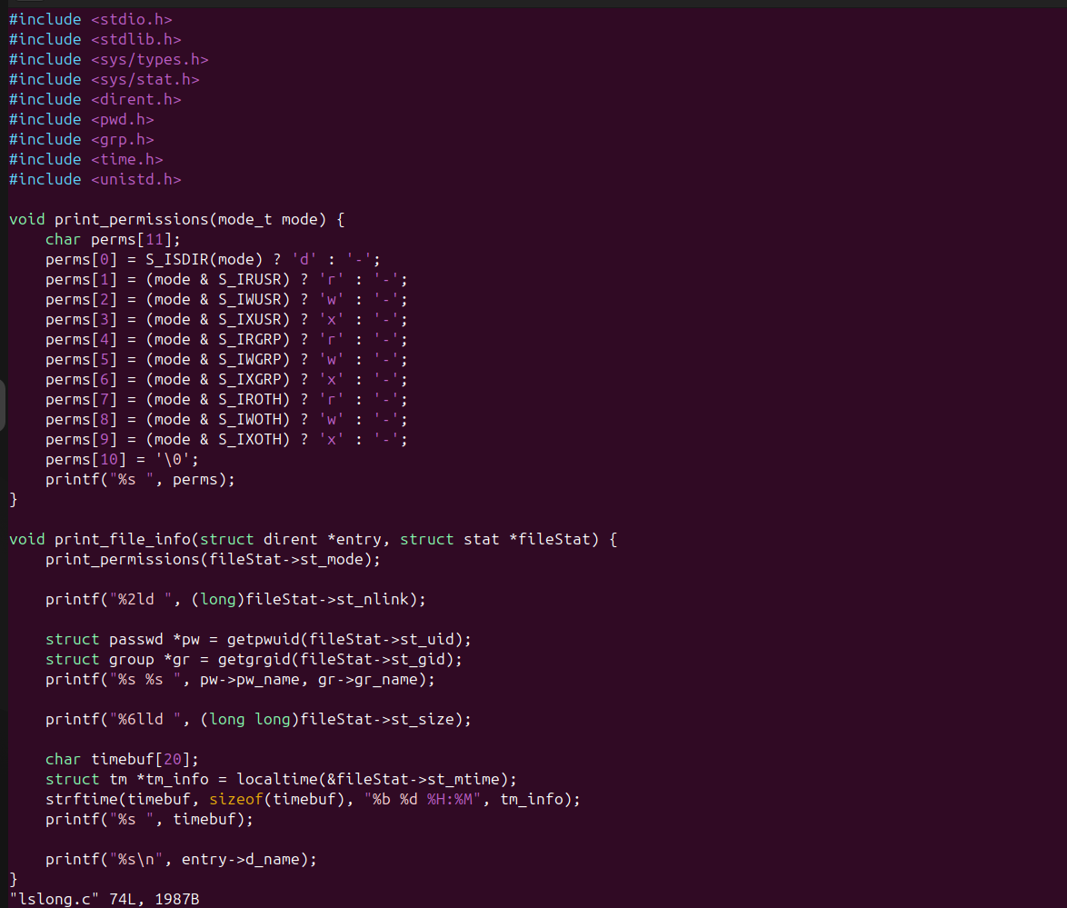

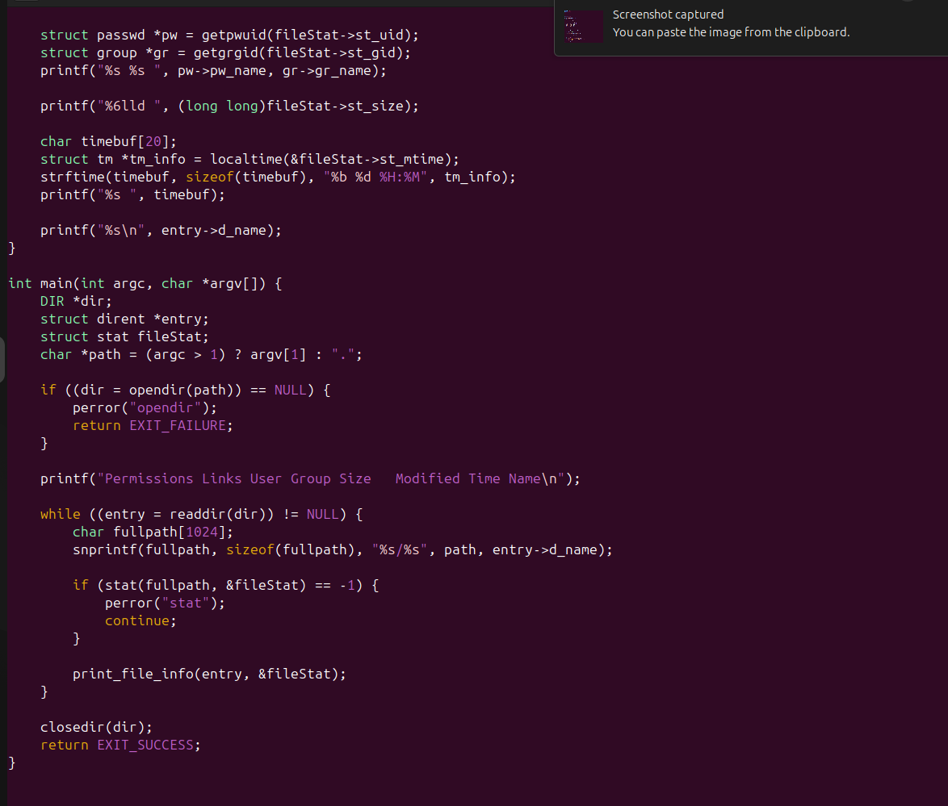

Output of lslong Execution:
The following is the output of running the lslong program in a directory that contains various files, including hidden files. The program successfully displays file details in the long listing format, similar to the ls -al command in Linux.
