ASSIGNMENT 3

Source Code: (I haven’t used the code given, I did it from scratch)
#include <stdio.h>
#include <stdlib.h>
#include <string.h>

typedef struct Task {
char name[10];
int priority;
int burstTime;
struct Task* next;
} Task;

// Function to create a new task node
Task* createTask(char* name, int priority, int burstTime) {
Task* newTask = (Task*)malloc(sizeof(Task));
strcpy(newTask->name, name);
newTask->priority = priority;
newTask->burstTime = burstTime;
newTask->next = NULL;
return newTask;
}

// Function to add a task to the list
void addTask(Task** head, char* name, int priority, int burstTime) {
Task* newTask = createTask(name, priority, burstTime);
if (*head == NULL) {
*head = newTask;
} else {
Task* temp = *head;
while (temp->next != NULL) {
temp = temp->next;
}
temp->next = newTask;
}
}

// Function to sort tasks by burst time (for Shortest Job First)
void sortByBurstTime(Task** head) {
if (*head == NULL) return;

Task* temp = *head;
Task* i, * j;
for (i = *head; i != NULL; i = i->next) {
for (j = i->next; j != NULL; j = j->next) {
if (i->burstTime > j->burstTime) {
// Swap the tasks
int tempBurst = i->burstTime;
char tempName[10];
strcpy(tempName, i->name);

i->burstTime = j->burstTime;
strcpy(i->name, j->name);

j->burstTime = tempBurst;
strcpy(j->name, tempName);
}
}
}
}

// Function to sort tasks by priority (for Priority Scheduling)
void sortByPriority(Task** head) {
if (*head == NULL) return;

Task* temp = *head;
Task* i, * j;
for (i = *head; i != NULL; i = i->next) {
for (j = i->next; j != NULL; j = j->next) {
if (i->priority < j->priority) {
// Swap the tasks
int tempPriority = i->priority;
int tempBurst = i->burstTime;
char tempName[10];
strcpy(tempName, i->name);

i->priority = j->priority;
i->burstTime = j->burstTime;
strcpy(i->name, j->name);

j->priority = tempPriority;
j->burstTime = tempBurst;
strcpy(j->name, tempName);
}
}
}
}

// Function for First-Come, First-Served (FCFS) Scheduling
void FirstComeFirstServed(Task* head) {
int currentTime = 0;
Task* temp = head;
printf("Executing First-Come, First-Served (FCFS):\n");
while (temp != NULL) {
printf("%d\n| %s\n", currentTime, temp->name);
currentTime += temp->burstTime;
temp = temp->next;
}
printf("%d\n", currentTime); // Final cumulative time
}

// Function for Priority Scheduling
void PriorityScheduling(Task* head) {
int currentTime = 0;
Task* temp = head;
// Sort tasks by priority (highest priority first)
sortByPriority(&head);

printf("Executing Priority Scheduling:\n");
while (temp != NULL) {
printf("%d\n| %s\n", currentTime, temp->name);
currentTime += temp->burstTime;
temp = temp->next;
}
printf("%d\n", currentTime);
}

// Function for Round-Robin Scheduling
void RoundRobinScheduling(Task* head, int timeQuantum) {
int currentTime = 0;
Task* temp = head;
printf("Executing Round-Robin Scheduling (Time Quantum = %d):\n", timeQuantum);

// Implement Round Robin by keeping track of remaining burst time for each task
while (temp != NULL) {
if (temp->burstTime > timeQuantum) {
printf("%d\n| %s\n", currentTime, temp->name);
currentTime += timeQuantum;
temp->burstTime -= timeQuantum;
} else {
printf("%d\n| %s\n", currentTime, temp->name);
currentTime += temp->burstTime;
temp->burstTime = 0; // Task completed
}

if (temp->burstTime > 0) {
temp = temp->next; // Move to the next task if this one isn't finished
} else {
temp = temp->next; // Skip the completed tasks
}
}
printf("%d\n", currentTime); // Final cumulative time
}

// Function for Shortest Job First (SJF) Scheduling
void ShortestJobFirst(Task* head) {
int currentTime = 0;
Task* temp = head;

// Sort the tasks by burst time in ascending order
sortByBurstTime(&head);

printf("Executing Shortest Job First (SJF):\n");
while (temp != NULL) {
printf("%d\n| %s\n", currentTime, temp->name);
currentTime += temp->burstTime;
temp = temp->next;
}
printf("%d\n", currentTime); // Final cumulative time
}

// Function for Priority Round-Robin Scheduling
void PriorityRoundRobinScheduling(Task* head, int timeQuantum) {
int currentTime = 0;

// Sort tasks by priority (highest priority first)
sortByPriority(&head);

printf("Executing Priority Round-Robin Scheduling (Time Quantum = %d):\n", timeQuantum);

// Implement Round Robin after sorting by priority
Task* temp = head;
while (temp != NULL) {
if (temp->burstTime > timeQuantum) {
printf("%d\n| %s\n", currentTime, temp->name);
currentTime += timeQuantum;
temp->burstTime -= timeQuantum;
} else {
printf("%d\n| %s\n", currentTime, temp->name);
currentTime += temp->burstTime;
temp->burstTime = 0; // Task completed
}

if (temp->burstTime > 0) {
temp = temp->next; // Move to the next task if this one isn't finished
} else {
temp = temp->next; // Skip the completed tasks
}
}
printf("%d\n", currentTime); // Final cumulative time
}

// Function to read tasks from a file
void readTasksFromFile(Task** head, const char* filename) {
FILE* file = fopen(filename, "r");
if (file == NULL) {
printf("Error opening file.\n");
exit(1);
}

char name[10];
int priority, burstTime;
while (fscanf(file, "%s %d %d", name, &priority, &burstTime) != EOF) {
addTask(head, name, priority, burstTime);
}

fclose(file);
}

int main() {
Task* head = NULL;
int choice;

// Read tasks from the file
readTasksFromFile(&head, "scheduler.txt");

// Menu for selecting scheduling algorithm
printf("Choose scheduling algorithm:\n");
printf("1. First-Come, First-Served (FCFS)\n");
printf("2. Priority Scheduling\n");
printf("3. Round-Robin Scheduling\n");
printf("4. Shortest Job First (SJF)\n");
printf("5. Priority Round-Robin Scheduling\n");
printf("Enter choice: ");
scanf("%d", &choice);

switch (choice) {
case 1:
FirstComeFirstServed(head);
break;
case 2:
PriorityScheduling(head);
break;
case 3:
RoundRobinScheduling(head, 3); // Time Quantum set to 3 for Round Robin
break;
case 4:
ShortestJobFirst(head);
break;
case 5:
PriorityRoundRobinScheduling(head, 3); // Time Quantum set to 3 for Priority Round-Robin
break;
default:
printf("Invalid choice\n");
}

return 0;
}

INPUTS:
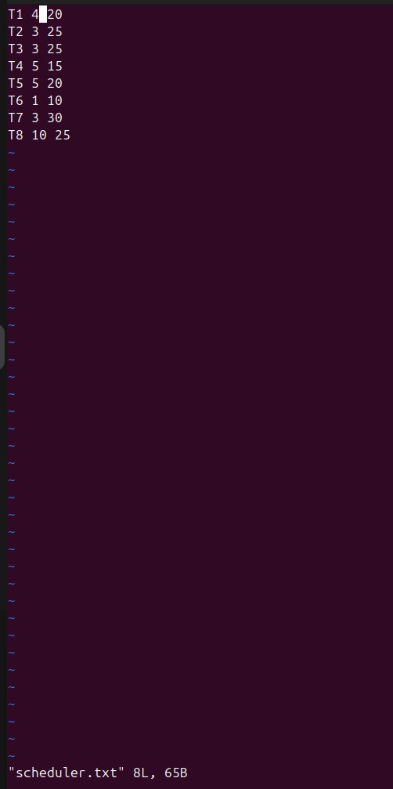

OUTPUTS:

