Producer-Consumer Assignment_4

Introduction
The Producer-Consumer problem is a classic synchronization problem that models a scenario where multiple producers generate data, and multiple consumers process that data using a shared buffer. Proper synchronization is required to prevent race conditions and ensure data consistency.
In this assignment, I implemented the Producer-Consumer problem in C using threads and semaphores. The shared buffer is managed as a circular queue, and semaphores are used for synchronization.
The solution includes:
- A fixed-size buffer (size = 7)
- Multiple producer and consumer threads
- Mutex locks and semaphores for synchronization

Implementation Details
We use three synchronization primitives:
1. Mutex (`pthread_mutex_t`) – Ensures mutual exclusion while accessing the buffer.
2. Semaphore `empty` – Tracks the number of empty slots in the buffer.
3. Semaphore `full` – Tracks the number of filled slots in the buffer.
The program consists of three files:
1. `buffer.h` – Header file containing buffer definitions.
2. `buffer.c` – Implements buffer insertion and removal functions.
3. `producer_consumer.c` – Main implementation file for thread creation and execution.

Code Implementation

1) buffer.h (Header File)
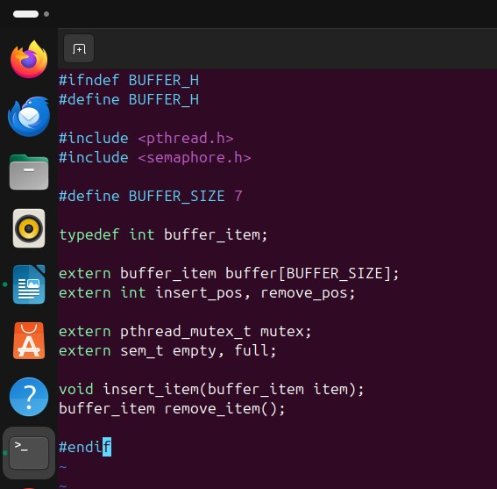

2) buffer.c (Buffer Operations Implementation)
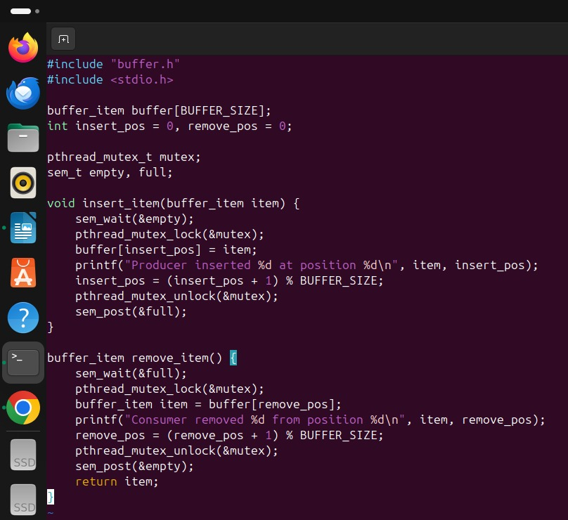

3) producer_consumer.c (Main Program)
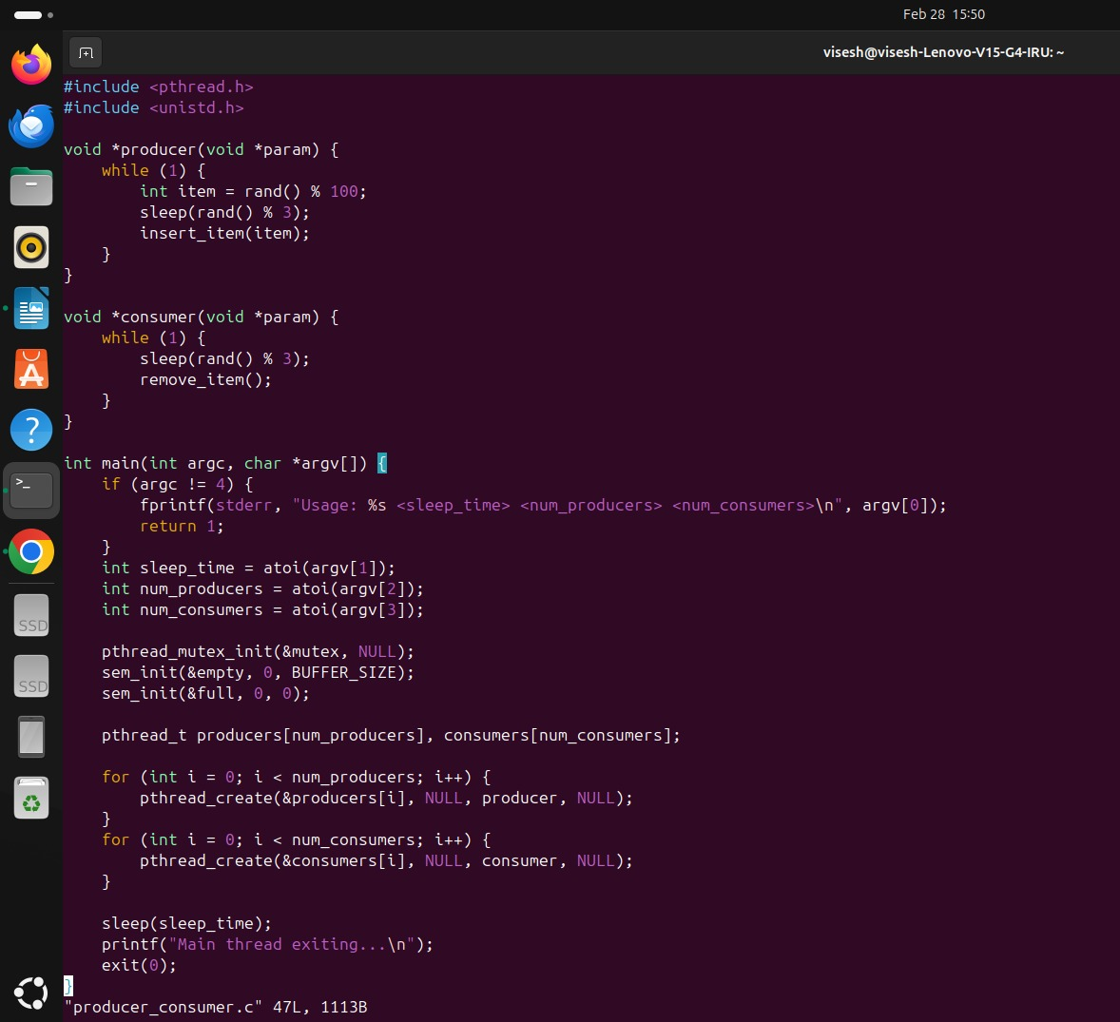

Program Output
$ gcc producer_consumer.c buffer.c -o producer_consumer -pthread
$ ./producer_consumer 3 2 2
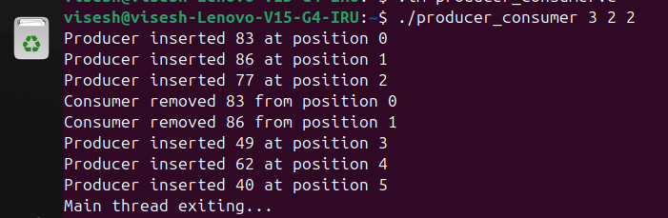

Conclusion:
This assignment successfully implements the Producer-Consumer problem using C, threads, and semaphores. The use of `pthread_mutex_t` for mutual exclusion and `sem_t` for empty/full slots ensures proper synchronization. The circular buffer correctly handles data insertion and removal. This implementation demonstrates fundamental concepts of concurrency and synchronization in operating systems.

