A6. Building a Multithreaded Web Server

Code: Main.rs

use std::{
fs,
io::{prelude::*, BufReader},
net::{TcpListener, TcpStream},
sync::{
atomic::{AtomicBool, Ordering},
mpsc, Arc, Mutex,
},
thread,
time::Duration,
};

use ctrlc; // Add ctrlc = "3.2" (or latest) to Cargo.toml

pub type Job = Box<dyn FnOnce() + Send + 'static>;

pub struct ThreadPool {
workers: Vec<Worker>,
senders: Vec<mpsc::Sender<Job>>,
next: Mutex<usize>,
}

impl ThreadPool {
pub fn new(size: usize) -> ThreadPool {
assert!(size > 0, "ThreadPool size must be greater than zero");

let mut workers = Vec::with_capacity(size);
let mut senders = Vec::with_capacity(size);

for id in 0..size {
let (sender, receiver) = mpsc::channel();
let receiver = Arc::new(Mutex::new(receiver));
workers.push(Worker::new(id, Arc::clone(&receiver)));
senders.push(sender);
}

ThreadPool {
workers,
senders,
next: Mutex::new(0),
}
}

pub fn execute<F>(&self, f: F)
where
F: FnOnce() + Send + 'static,
{
let job = Box::new(f);
let mut next = self.next.lock().unwrap();
let sender = &self.senders[*next];
*next = (*next + 1) % self.senders.len();
sender.send(job).expect("Failed to send job to worker");
}
}

impl Drop for ThreadPool {
fn drop(&mut self) {
// Signal shutdown by clearing senders.
self.senders.clear();
println!("Shutting down.");

// Join each worker.
for worker in self.workers.drain(..) {
println!("Shutting down worker {}", worker.id);
worker.thread.join().unwrap();
}
}
}

pub struct Worker {
id: usize,
thread: thread::JoinHandle<()>,
}

impl Worker {
fn new(id: usize, receiver: Arc<Mutex<mpsc::Receiver<Job>>>) -> Worker {
let thread = thread::spawn(move || loop {
let message = receiver.lock().unwrap().recv();
match message {
Ok(job) => {
println!("Worker {id} got a job; executing.");
job();
}
Err(_) => {
println!("Worker {id} disconnected; shutting down.");
break;
}
}
});
Worker { id, thread }
}
}

fn handle_connection(mut stream: TcpStream) {
let buf_reader = BufReader::new(&stream);
let http_request: Vec<String> = buf_reader
.lines()
.map(|result| result.unwrap_or_default())
.take_while(|line| !line.is_empty())
.collect();

if http_request.is_empty() {
let response = "HTTP/1.1 400 BAD REQUEST\r\nContent-Length: 0\r\n\r\n";
stream.write_all(response.as_bytes()).unwrap();
return;
}
let request_line = &http_request[0];
let base_path = env!("CARGO_MANIFEST_DIR");
let (status_line, filename) = match request_line.as_str() {
"GET / HTTP/1.1" => (
"HTTP/1.1 200 OK",
format!("{}/src/hello.html", base_path)
),
"GET /sleep HTTP/1.1" => {
thread::sleep(Duration::from_secs(5));
(
"HTTP/1.1 200 OK",
format!("{}/src/hello.html", base_path)
)
},
"GET /unknown HTTP/1.1" => (
"HTTP/1.1 404 NOT FOUND",
format!("{}/src/404.html", base_path)
),
_ => (
"HTTP/1.1 404 NOT FOUND",
format!("{}/src/404.html", base_path)
),
};

let contents = fs::read_to_string(filename)
.unwrap_or_else(|_| String::from("File not found"));
let length = contents.len();
let response = format!("{status_line}\r\nContent-Length: {length}\r\n\r\n{contents}");
stream.write_all(response.as_bytes()).expect("Failed to write response");
}

fn main() {
let listener = TcpListener::bind("127.0.0.1:8080")
.expect("Failed to bind address. Is the port already in use?");
listener.set_nonblocking(true).expect("Cannot set non-blocking");

println!("Server running on 127.0.0.1:8080");
let pool = ThreadPool::new(4);
let running = Arc::new(AtomicBool::new(true));
let running_clone = Arc::clone(&running);

ctrlc::set_handler(move || {
println!("\nCtrl+C pressed. Initiating shutdown...");
running_clone.store(false, Ordering::SeqCst);
})
.expect("Error setting Ctrl+C handler");

while running.load(Ordering::SeqCst) {
match listener.accept() {
Ok((stream, _addr)) => {

pool.execute(move || {
handle_connection(stream);
});
}
Err(ref e) if e.kind() == std::io::ErrorKind::WouldBlock => {
thread::sleep(Duration::from_millis(100));
}
Err(e) => eprintln!("Error accepting connection: {}", e),
}
}

// The pool is dropped here when main exits the loop.
println!("Server shutting down gracefully.");

}

Code: Lib.rs

use std::{
sync::{mpsc, Arc, Mutex},
thread,
};

pub type Job = Box<dyn FnOnce() + Send + 'static>;

pub struct ThreadPool {
workers: Vec<Worker>,
// Use a Vec to store senders.
senders: Vec<mpsc::Sender<Job>>,
next: Mutex<usize>,
}

impl ThreadPool {

pub fn new(size: usize) -> ThreadPool {
assert!(size > 0, "ThreadPool size must be greater than zero");

let mut workers = Vec::with_capacity(size);
let mut senders = Vec::with_capacity(size);

// Create each worker with its own channel.
for id in 0..size {
let (sender, receiver) = mpsc::channel();
// Wrap the receiver in an Arc and Mutex so it can be shared safely.
let receiver = Arc::new(Mutex::new(receiver));
workers.push(Worker::new(id, Arc::clone(&receiver)));
senders.push(sender);
}

ThreadPool {
workers,
senders,
next: Mutex::new(0),
}
}

pub fn execute<F>(&self, f: F)
where
F: FnOnce() + Send + 'static,
{
let job = Box::new(f);

// Get the next sender based on a round-robin index.
let mut next = self.next.lock().unwrap();
let sender = &self.senders[*next];
*next = (*next + 1) % self.senders.len();

sender.send(job).expect("Failed to send job to worker");
}
}

impl Drop for ThreadPool {
fn drop(&mut self) {
// Drop all senders so that each worker's receiver gets an error.
self.senders.clear();

for worker in self.workers.drain(..) {
println!("Shutting down worker {}", worker.id);
// Join each worker thread.
worker.thread.join().unwrap();
}
}
}

pub struct Worker {
// The worker id helps us identify which worker handles the job.
id: usize,
thread: thread::JoinHandle<()>,
}

impl Worker {
fn new(id: usize, receiver: Arc<Mutex<mpsc::Receiver<Job>>>) -> Worker {
let thread = thread::spawn(move || loop {
// Lock the receiver and block on recv.
let message = receiver.lock().unwrap().recv();

match message {
Ok(job) => {
println!("Worker {id} got a job; executing.");
job();
}
Err(_) => {
println!("Worker {id} disconnected; shutting down.");
break;
}
}
});

Worker { id, thread }
}
}

HTML CODE (Hello.html):
<!DOCTYPE html>
<html lang="en">
<head>
<meta charset="utf-8">
<title>Hello!</title>
</head>
<body>
<h1>Hello!</h1>
<p>Hi from Rust</p>
</body>
</html>

HTML CODE (404.html):
<!DOCTYPE html>
<html lang="en">
<head>
<meta charset="utf-8">
<title>Hello!</title>
</head>
<body>
<h1>Oops!</h1>
<p>Sorry, I don't know what you're asking for.</p>
</body>
</html>

OUTPUT:
The screenshot below is for root URL
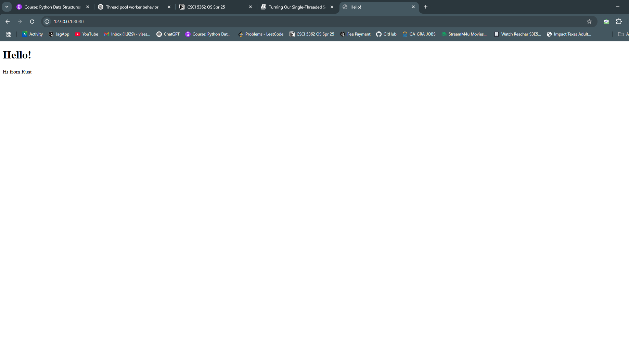

The below screenshot for /sleep URL:
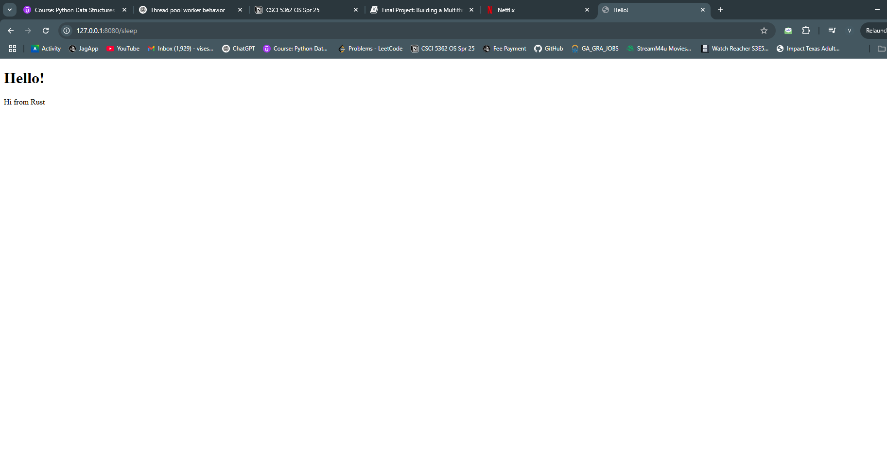

The screenshot below for /unknown URL:
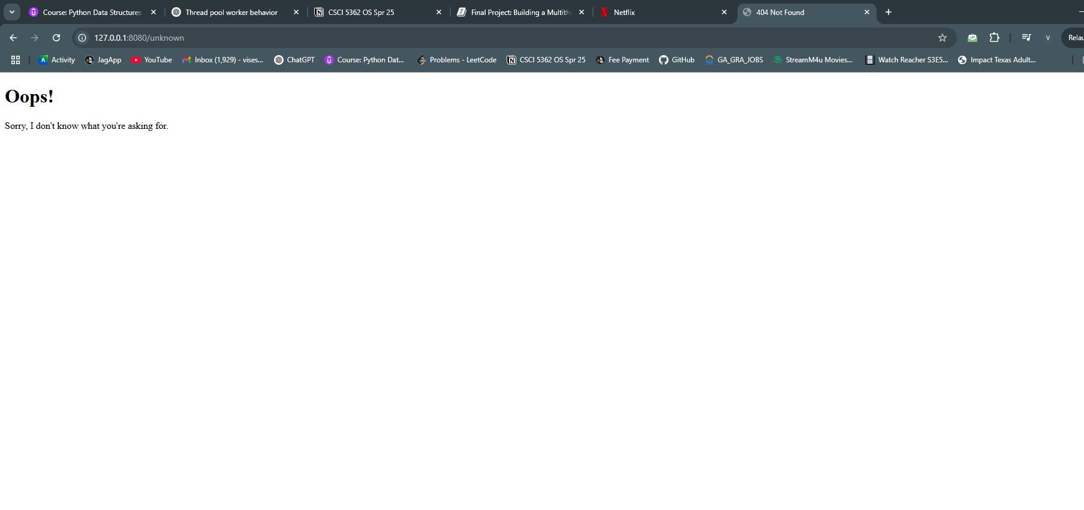

The screenshot below is for the output:

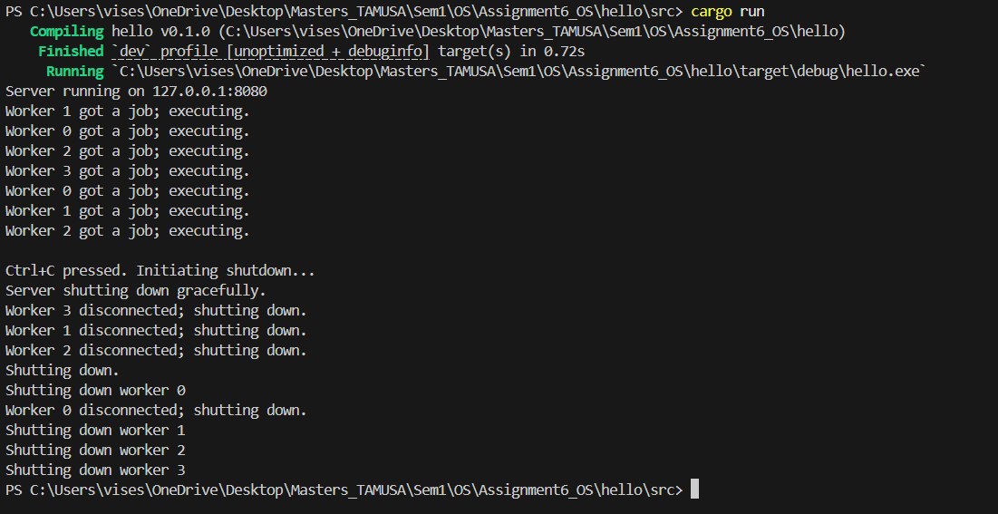

A web browser marks the end of an HTTP request by sending two newline characters consecutively. To capture a complete request from the stream, we keep reading lines until we hit an empty line. Once we’ve gathered these lines into a vector, we print them using formatted debug output so that we can review the instructions the browser is sending to our server.
