# Diary Development Notes

Week 1

## Monday (7-Novmeber-2022)

* Explore the unit guideline and MS Team
* Find a company that I wish to join and contribute by filling up the google form providing by the unit chair.

Figure : Announcement from the unit chair related to the Company Selection

## Thursday (10-November-2022)

* Join the Week 1 Lecture Class

Week 2

## Monday (14-November-2022)

* Assign to Gopher Industry and work in the Team Avengers

## Tuesday (15-November-2022)

* Get familiarise with the team environment and review some of the previous document from T2 such as project handover document and video demonstration.

Figure : Welcome message from the Team Avengers and the Senior members

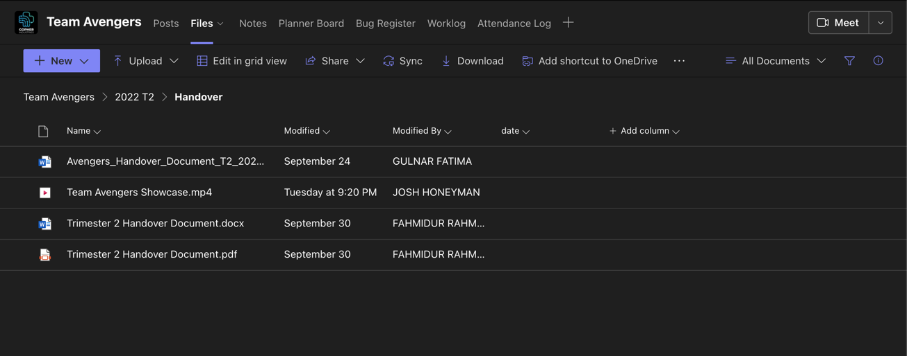

Figure : Handover document folder from previous trimester that I need to review

* Set up worklog and Attendance log by entering my student details

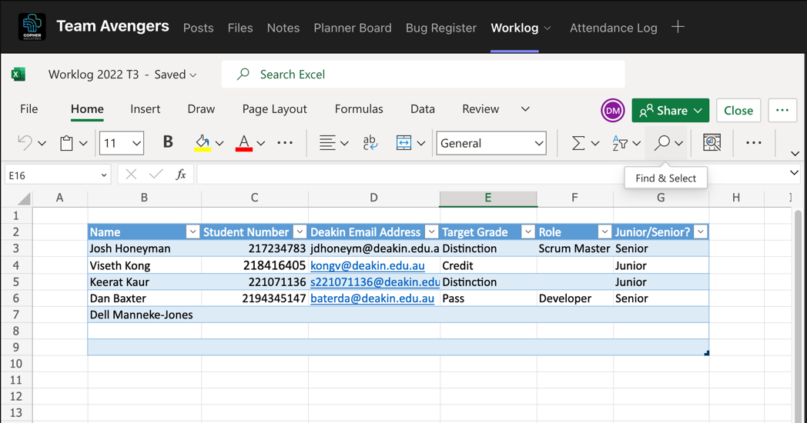

Figure : Our team worklog and attendance log for this trimester

## Wednesday (16-November-2022)

* Interact with Medi Chatbot on the test website <https://gopherindustries.webnode.page/>

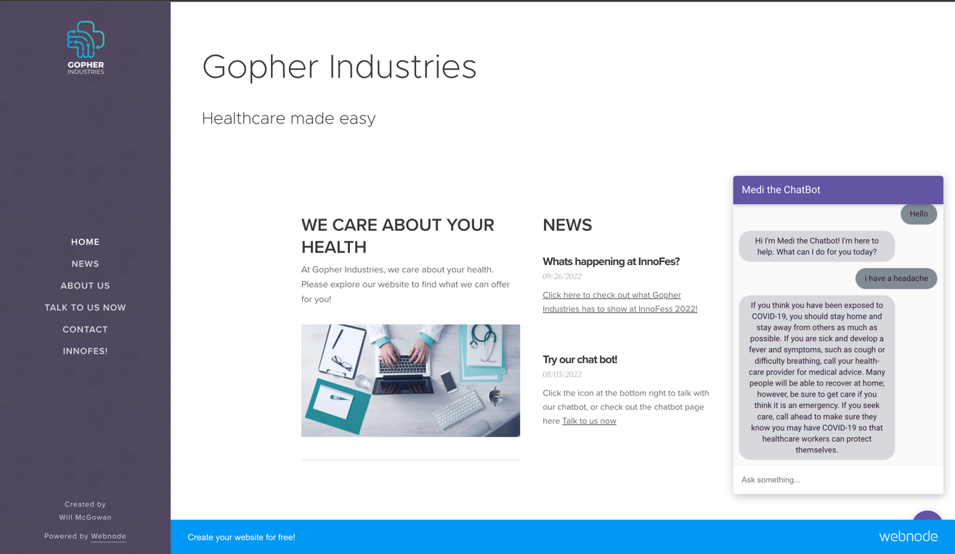

Figure : Testing the chatbot that were built from the previous team members

* Learning through the Google Developers course called Building Chatbots with Dialogflow recommended from the senior members

Figure : Learning how to build chatbots with Dialog

Figure : Testing my first Chatbot on Web Demo

* Complete task 1.1p and 2.1c

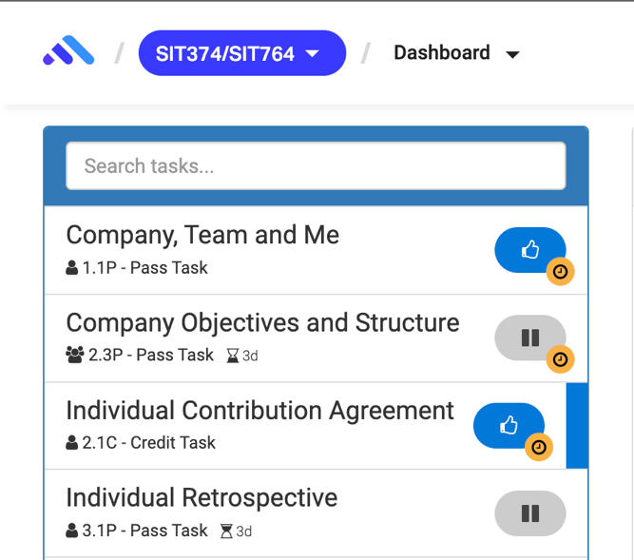

Figure : Submit tasks on Ontrack

## Thursday (17-November-2022)

* Join the Week 2 Lecture Class
* Join Surviving Capstone Meeting - Tips and Tricks from a Capstone Senior

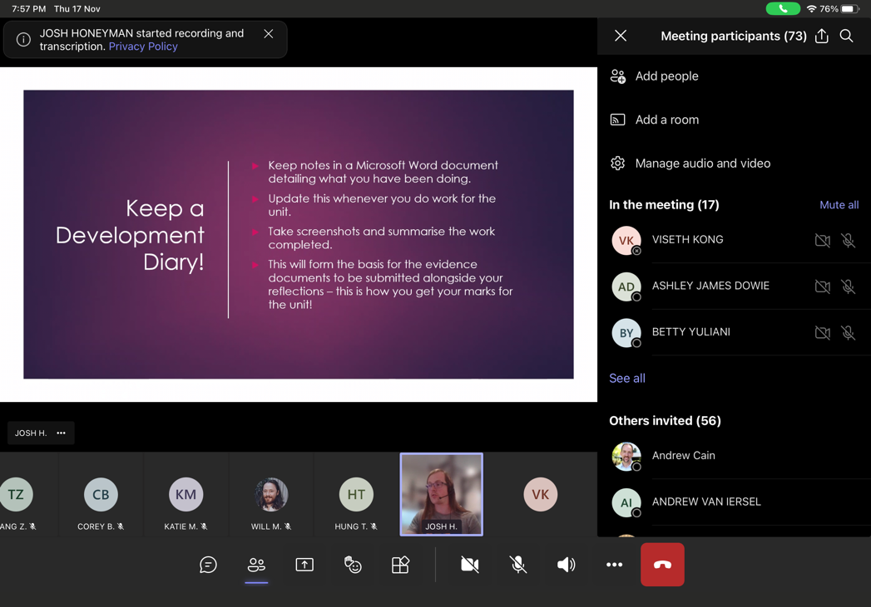

Figure : Meeting with Gopher Company

* Reply to senior member related to the meeting appointment issues

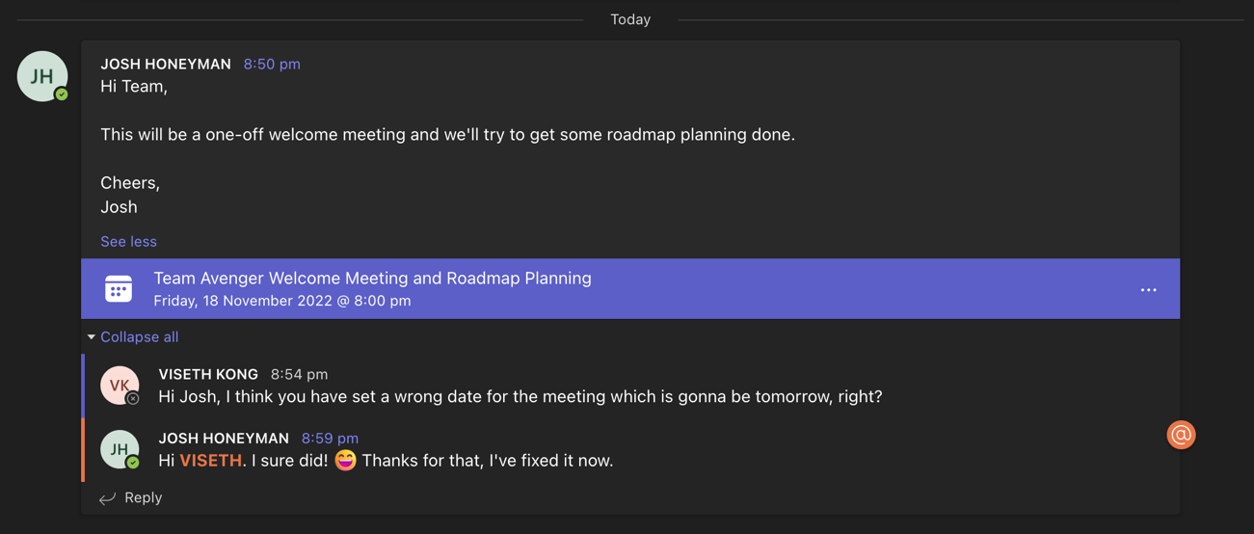

Figure 10: Reminded Josh when he set a wrong date for the meeting

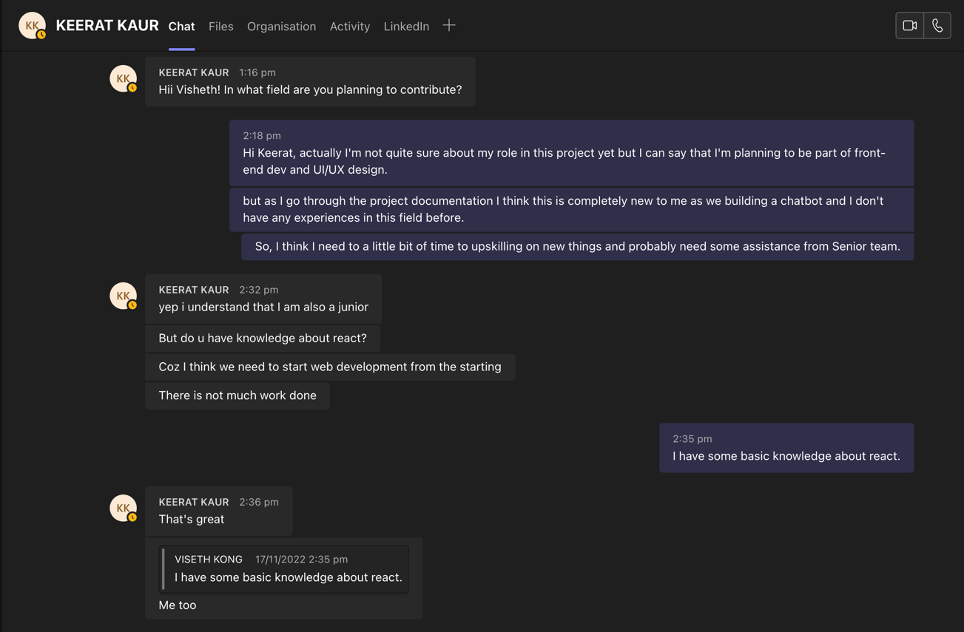

Figure 11: Have some conversation with other junior member about the role in the project

## Friday (18-November-2022)

* Continue learning through the Google Developers course called Building Chatbots with Dialogflow

Figure 12: Integrate a Dialogflow Chatbot with Actions on Google

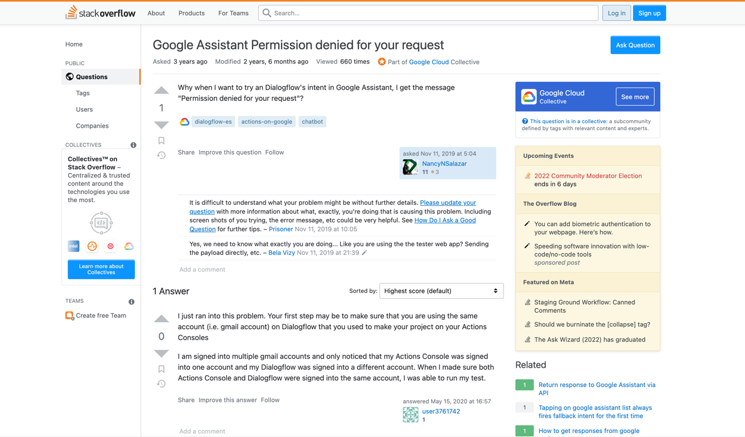

Figure 13: During my upskilling, I have encounter some issues and solve them successfully

* Research and found some essential resources related to the project

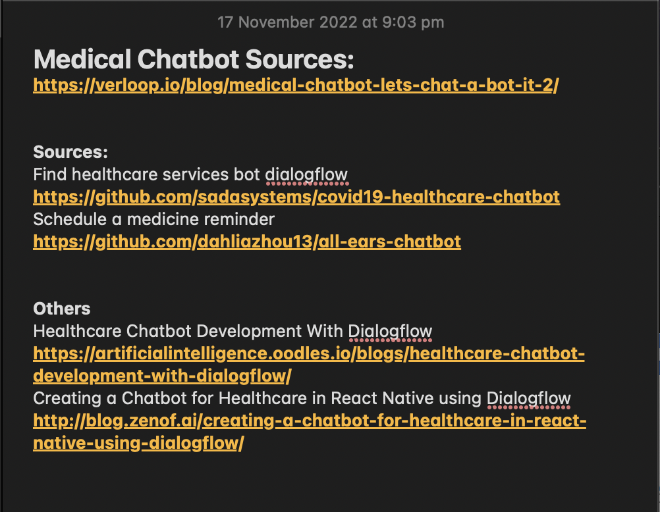

Figure : Some resources I found in google which related to my project