# Sprint 2: Interact between Dialogflow API with Postman to solve a problem when trying to update or edit Patient ID

Following the completion of the most recent sprint, in which we included all of the Authorization information from the previous sprint, we are now able to interact with the Dialogflow API.

When attempting to connect from the team Project X website to the chatbot, we encountered the same session problem as occurred when we were trying to modify the patient ID. During this iteration of the sprint, we are going to collaborate closely with Nathan, a member of team Project X, in order to modify the Patient ID by utilising the PATCH command.

**POST command**

use the Dialogflow API to determine intent using a patient id called "test123."

POST: <https://dialogflow.googleapis.com/v2/projects/sit-22t1-team-avengers-c824a5b/agent/sessions/123:detectIntent>

Request Body:

{

"queryInput": {

"text": {

"languageCode": "en",

"text": "I hurt myself"

}

}

}

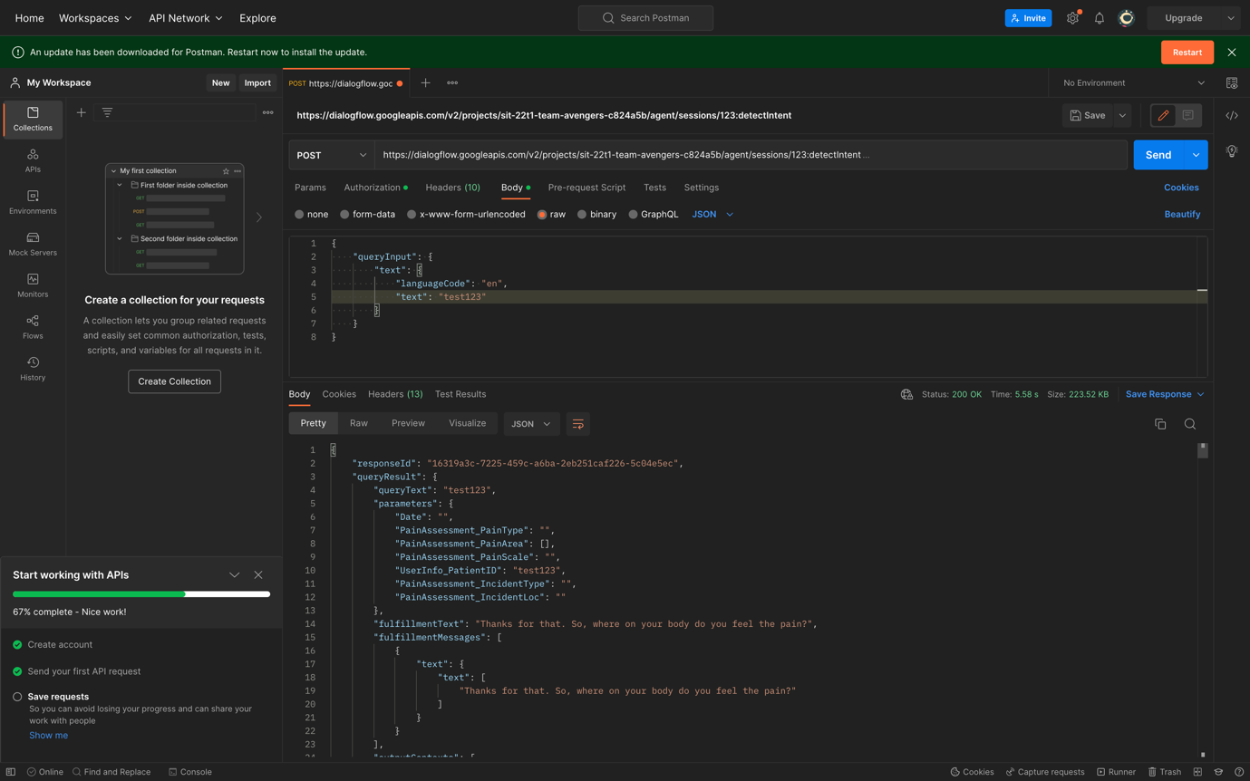

**GET command**

obtain the context information as well as the context ID, both of which will be placed to use in the process of updating the Patient ID.

GET: <https://dialogflow.googleapis.com/v2/projects/sit-22t1-team-avengers-c824a5b/agent/sessions/123/contexts/>

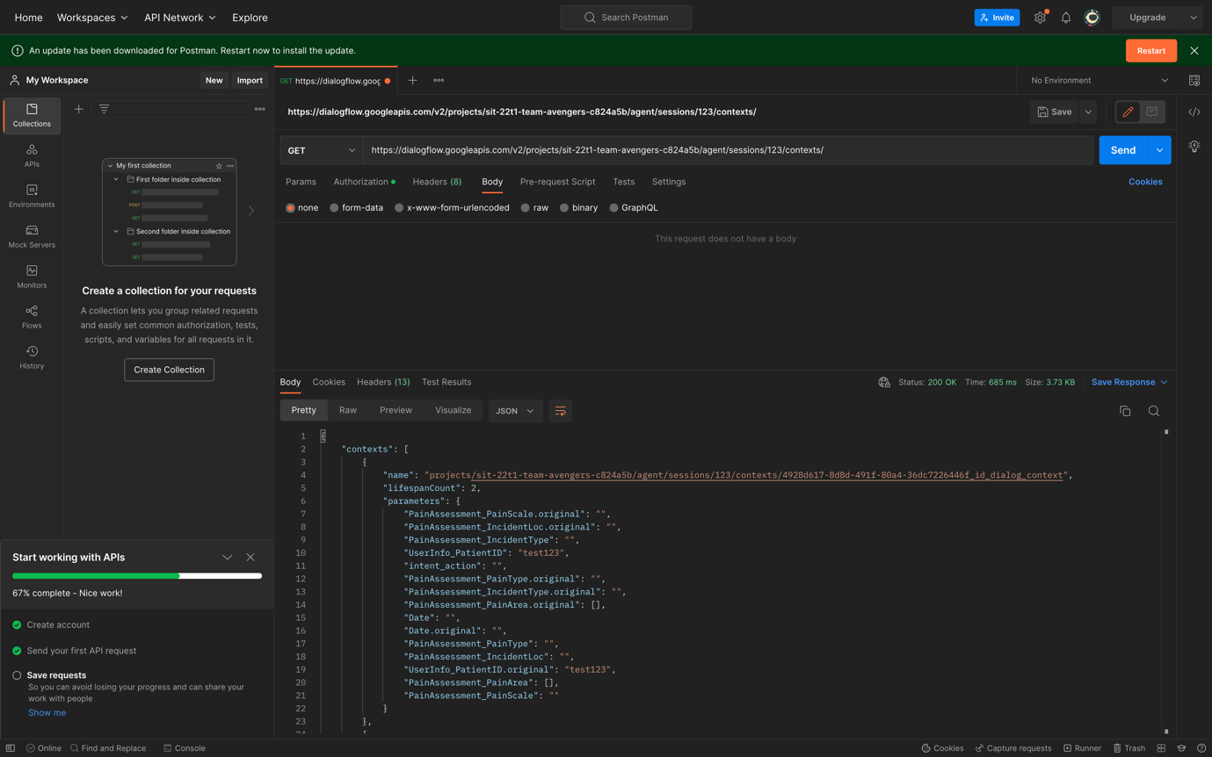

**PATCH command**

update the Patient ID to from “test123” to “newid”.

PATCH: <https://dialogflow.googleapis.com/v2/projects/sit-22t1-team-avengers-c824a5b/agent/sessions/123/contexts/context-id>

Request body:

{

"parameters": {

"PainAssessment_IncidentLoc.original": "",

"intent_action": "",

"Date.original": "",

"PainAssessment_PainType": "",

"PainAssessment_IncidentType.original": "",

"PainAssessment_PainArea": [],

"PainAssessment_PainArea.original": [],

"PainAssessment_PainScale.original": "",

"UserInfo_PatientID.original": "newid",

"PainAssessment_IncidentLoc": "",

"Date": "",

"PainAssessment_PainScale": "",

"UserInfo_PatientID": "newid",

"PainAssessment_PainType.original": "",

"PainAssessment_IncidentType": ""

}

}

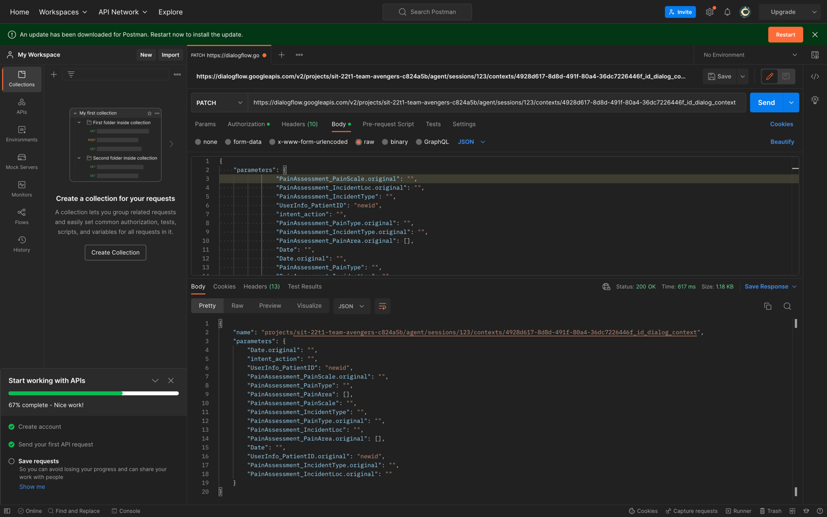

**POST command**

After the Patient ID has been successfully updated, we will now attempt to create a new context in the expectation that the API will recognise another intent on our part without prompting the user to provide their Patient ID.

POST: <https://dialogflow.googleapis.com/v2/projects/sit-22t1-team-avengers-c824a5b/agent/sessions/123:detectIntent>

Request body:

{

"queryInput": {

"text": {

"languageCode": "en",

"text": "I hurt myself"

}

}

}

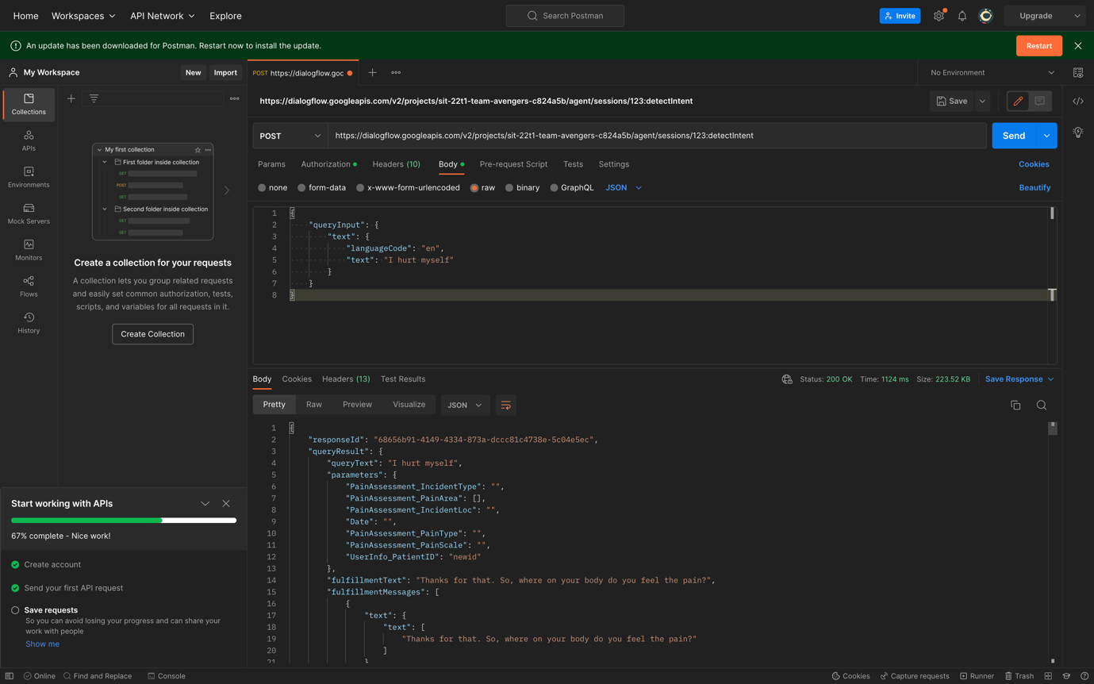

As we can see now, the new Patient ID is now updated, and the chatbot is asking a new question when the user has their Patient ID. This is an update that has just been implemented.