# Introduction

## Market Research and Motivation

A search of 'Online learning’ in the Google Play store was used to discover mobile apps that give a relevant solution to the problem that SocialCollab seeks to solve. The search generated several mobile applications with solutions that are slightly similar and can be compared.

There are several online learning course providers on the market, including Coursera, Udemy, SkillShare, and Creative Live. They provide subscriber-generated courses, but the majority are based on pre-recorded content. Furthermore, some providers, such as Coursera, provide academic courses and tuition, whereas SocialCollab is community-driven, with an emphasis on personal, one-on-one live learning.

I was motivated to develop an app that would educate and assist those who want to develop skills during their free time and facing COVID-imposed lockdowns. During the lockdown period, I have been using many online learning platforms such as SkillShare and Udemy, where I learned a lot of new skills related to software development but somehow it cost me a lot of money to buy each course, and sometimes it is difficult to get in touch with the experts.

## Overview

## To overcome the current issue, I will be creating SocialCollab, a mobile app that allows users to connect with others for guided, and productive interaction. It focuses on two types of users: those who want to share their skills ("tutors") and those who want to learn a skill ("students"). Users will find everything they need to advertise, discover, engage, and interact, whether they are tutors or students, or both. Users can sign up and create a profile, indicating the skills they wish to teach or share. Their profile might include a video introduction, portfolio, and other items. When the potential students discover a tutor they like, they may request to communicate with the tutor by sending a text, voice, or make a video call, or they can arrange a session. This allows users to connect in real-time, for personalized, one-on-one sessions. Users can explore various skills such as yoga, meditation, guitar lessons, and many others.

## The name SocialCollab was chosen because it combines the words "social" and "collaboration." I thought it was essential to include these two terms in the name since they contain the target audience and offer a brief context of what the app is built for.

## Background and Summary

COVID-imposed lockdowns are currently affecting millions of people around the world. People are unable to engage in many face-to-face activities and classes due to physical distance requirements. While physical distance helps to prevent people from contracting the coronavirus, it has contributed to the rise of mental health issues such as depression and anxiety, due to loneliness and isolation (Lim 2020).

Additionally, many people have lost their jobs, with industries such as the performing arts, sports, and fitness among the most impacted by the pandemic. According to Caust (2020), more than half of the arts industry is presently closed, with three out of four Australians working in creative and performing arts at risk of losing their jobs.

The goal of the project proposal is to create a community-driven online platform for skill sharing. It brings people together with the idea of sharing knowledge, assisting each other, and reducing feelings of loneliness. Users may find each other by browsing for activities that interest them and discovering people who have skills and knowledge to share.

## Competitor Analysis

**Online Meetups**

In today's world, several applications, such as Facebook, Snapchat, and WhatsApp, allow for group communication. Since they often classify users into areas of interest, these applications could be considered secondary competition. Their group focus and typically pre-scheduled events are significantly different from SocialCollab's concept. Additionally, they do not provide users with freelancing options to generate income.

**Virtual Classrooms**

Virtual classrooms had increased in popularity in the field of live learning in 2021. Some of the popular options are Zoom, Microsoft Teams, and Blackboard Collaborate. These are delivery platforms, not search engines for learning experiences focused on certain expertise. These are delivery platforms, not specifically designed for finding learning experiences based on a particular skill.

**Friend Finding Apps**

Many applications such as Tinder, Bumble, and others platforms are focused more on socializing and dating. These apps are created for interacting rather than studying, and they focus on meeting people in the same geographic location. Users can use SocialCollab to meet people who share their interests, allowing them to socialize and learn all inside the same app.

# AI/ML Approach

Machine Learning (ML) and Artificial Intelligence (AI) may provide a range of benefits to online learners. Modern Learning Management Systems (LMS) platforms such as Talent LMS, Thinkific, and Learndash, include intuitive algorithms and automated delivery of eLearning content.

**More Personalized eLearning Content**

Machine Learning algorithms predict outcomes, allowing specific eLearning content to be provided based on historical performance and particular learning goals. For example, an online learner's history, suggests that they enjoy tactile eLearning activities. As a result, the technology automatically modifies their eLearning course map to include more complex exercises. In addition, the technology distributes eLearning content in a more personalized style. For example, for more experienced online learners, it may skip certain eLearning modules or undertake a more comprehensive, linear approach for those who still need basic information.

**Automate the schedule and content delivery processes**

The Machine Learning process involves complex and time-consuming behind-the-scenes work, but they are important nonetheless. For example, delivering online materials or arranging coursework for online learners based on their eLearning assessment results or simulation performance. Artificial Intelligence (AI) may be able to take over these functions, allowing for the creation of unique eLearning course maps for each online learner who enrolls in the course.

**Improve the Effectiveness of Online Training Programs**

The Machine Learning system provides an in-depth overview of Big Data and applies it to predict outcomes. AI can also be used to improve the productivity of peer-to-peer interactions. Match tutors to online learners who can learn from their specific skills or prior experiences, for instance.

# Features

## Asset list

**GitHub**: is a platform for hosting code that allows both version control and collaboration. It enables you and others to collaborate on projects from anywhere. By creating my repository on GitHub, I was able to manage and maintain the project code.

**Microsoft Teams:** is a chat-based communication platform that includes document sharing, online meetings, among several other essential features. Microsoft Teams will be used to communicate with other students, tutors, and unit chairs.

**Figma**: is a cloud-based web browser platform for designing and prototyping user interfaces. Figma will be used to help in the design of Social Collab’s UX/UI wireframe designs, as well as to prototype the interaction between each app screen.

**Canva**: is a free online graphical application that helps users produce stunning final products by combining design, photo-editing, and layout. Canva will be used to create posters, user stories, and a presentation slide design.

**Lucidchart**: is a web-based platform for designing and creating diagrams and charts. Lucidchart will be used to generate a use case diagram to support defining Social Collab’s requirements.

**Adobe Photoshop**: is a photo editing, image creation, and graphic design program developed by Adobe. Photoshop will be used to create a logo and color scheme for SocialCollab’s project.

**Android Studio**: is an integrated development environment that is mostly used for the creation of Android apps. This IDE will be used to design and develop SocialCollab using TextViews, ImageViews, RecyclerViews, buttons, widgets, and Scripts.

**Android Studio Emulator**: during the development and testing stages, the emulator will be used to test SocialCollab’s features and functionality on an Android device.

**Java**: Java is an object-oriented programming language that was designed to have fewer implementation dependencies. Because of its capabilities, this programming language will be used for the app as it is dependable, quick, scalable, and cross-platform compatible.

**MySQL**: is a relational database management system that allows us to store, access, and manipulate data in a database. Because of its features and quick data processing, it would be preferable for database design. It is also easy to connect it to the front-end language and write complicated queries in it.

## Product purpose

SocialCollab’s target audience consists of young adult teachers and learners who want to develop an essential skill or re-skill themselves during isolation, offer an activity to earn additional money, or just find a source of inspiration to be productive.

Our primary demographic focuses on those between the ages of 18 and 30, as well as those between the ages of 45 and 60. Both groups are now familiar with the technology.

We expect some involvement from the 30-45 age group, but due to family and job commitments, they will be a secondary market.

SocialCollab provides significant value to its users as an application that seeks to empower them, especially in the current market. Both students and tutors benefit from the human connection that is much more necessary in isolation, with the discovery of new connections being an extra benefit. Users spend their time in SocialCollab productively, whether it's learning a new skill or assisting others and sharing their knowledge. If tutors choose to deliver premium content for a price, the connections they make in SocialCollab have the potential to turn into income sources. This function enables users to achieve financial self-sufficiency, which is a refreshing break in these unpredictable times.

## Three complex components

1. **Course structure**

The course structure is focused on how a course is designed for e-learning. The structure of a course has a crucial role in how the users learn the content provided. Storyboarding is an excellent way to build the framework of your course.

**Organize the content into coherent/logical modules**

Determine the flow of the course and then consider how to present the content to the end-users. Grouping the content into small sections makes it easier for learners to grasp and understand the learning materials.

**Apply Interactive Concepts**

The course structure should strategically include interactive activities throughout the course. An insufficient number of tasks might cause the student to lose interest or forget why they are completing the course. After every third page, a conventional guideline is to include an exercise or one primary activity for each module. This will create a good balance between learning and keeping the learner's motivation.

**Use pictures or illustrations to help clearly outline thoughts, or ideas**

It is best practice to include pictures wherever possible. Using pictures to highlight specific pointers on the page, will attract the learner closer to the content, and will most likely be able to better understand the ideas included within the learning material.

1. **Page design**

The design of an online course's apps is essential to the learning process. The structure of a page can have a significant impact on the learners' learning experience.

**The navigation system must be easy to use**

Make navigation simpler and easier to use and more manageable. The simpler it is to explore, the more interesting the course will be for the users.

**Create the proper balance between textual content and graphics**

Using an excessive amount of text-based content on a page, similarly to the use of pictures, can appear too difficult for the user and can mentally impact the student's ability to absorb the knowledge. As a result, while designing a page, the balance of pictures and content must be considered carefully.

**Consistency includes visual style, formatting**

Following a consistent format throughout the course will enhance the user's learning background. Having consistent elements and text styles across the course will reduce user frustration when navigating the course.

1. **Engagement with content**

Engaging with the material refers to how the student associates with the course contents. Employing interesting information must be balanced, just as it is in a school environment. Too little involvement might cause the student to lose interest in the subject.

**Provide the user with additional choices/options**

Since everyone learns differently, including having a preference for a certain learning style. Many people, for example, find that visual materials help them learn more effectively. On the other hand, audio materials are preferred by several people. By including both visual and audio perspectives in the preparation, it provides the user the option of selecting the one that best matches their learning goals.

**Create interesting exercises, games, or other interactive exercises**

When learning is entertaining, people can focus on the material for longer periods. Gamified learning modules can improve the learning experience.

**Make sure that the exercises are entirely focused on the course goal**

Ensure that the exercises support the course goals. For many, the appeal is to become so involved in interactive activities that the course's objective is usually overlooked.

## How the system will function

In this application, there are three primary types of users. The first one is the learner, also known as a student, who will come to this platform and choose a skill to learn, attend a live class session, present for a practical, and connect and communicate with other students or the instructor. The second type of user is the instructor, who has the ability to teach a live class, share a whiteboard and screen, and upload content, notes, quizzes, and other educational materials. Lastly, the administrator (it can be the instructor), has the ability to supervise learning activities through services such as instructor management, scheduling training, and managing virtual classrooms.

After a user signs up or inputs their credentials at the login page, the credentials are gathered and verified against the security repository, which is stored on the database. If the user is found to be a match, the user will be granted access to the learning portal. The user may then explore various skills or connect with other students or tutors to learn from them virtually face-to-face or attend a live session that the tutor has provided. The user will be able to conduct a live classroom, allowing them to benefit from virtual learning via webcam, microphone, and distance learning without having to physically attend the classroom, and the administrator/instructor will be able to schedule their availability on their profile.

Administrators/Tutors will be able to view the link for uploading static documents, activate or deactivate all related documents such as quizzes, notes, etc., as well as generate learning skills with the function to add, update, and delete. However, all of these external, as well as internal, will not be available to the public users. Furthermore, there is an announcement function that allows users to get any kind of announcement from the administrator. For example, the start of a new class session, file materials, and any adjustments to the tutor profile.

# Milestones of the project plan

|  |  |  |  |
| --- | --- | --- | --- |
| Item # | Deliverable | Outcomes | Timeline |
| 1 | Professional Plan: Project proposal | Create a project plan and framework for a creative mobile app design. | Week 1 - 4 |
| 2 | SocialCollab UI/UX design | In Android Studio, create and design the layout of app pages include selected colors and images to best represent wireframe design. | Week 5 - 6 |
| 3 | SocialCollab UI/UX prototype | Provide navigation and routing across Social Collab pages. | Week 6 - 7 |
| 4 | SocialCollab’s initial functional build | Implement appropriate Java code to make sure the app works properly. | Weel 7 - 8 |
| 5 | Project Portfolio and Application Progress | Wrap up the app's functionality and design for the first SocialCollab demo.  And the last chance to make significant improvements to the design or functionality. | Week 8 - 10 |
| 6 | Finalize the app's testing and prepare for any feedbacks | Make minor changes to SocialCollab in Android Studio based on feedback. | Week 10 - 11 |
| 7 | Product Handover & Presentation | Ensure that the app development is completed and ready for final handover. | Week 11 |

# Detailed UX/UI Design

## User Stories

**User Story 1**

|  |  |  |  |
| --- | --- | --- | --- |
| Statement | Acceptance Criteria | Estimation | Priority |
| As a SocialCollab user, I want the app's UI to be interesting and simple to use. | 1. Arrange and organize the layout and presentation of the content using illustrations.  2. The app's navigation should be intuitive.  3. The design of the application should adhere to UI standards such as typography, white space, and color scheme. | Story Points: **9** | Priority 1: **High** **Priority** |

**User Story 2**

|  |  |  |  |
| --- | --- | --- | --- |
| Statement | Acceptance Criteria | Estimation | Priority |
| As a SocialCollab user, I want the app to be accessible on all platforms with the same functionality. | 1. The functionality should be consistent across all platforms.  2. The chat system and virtual class session must function in the same way across all platforms. | Story Points: **7** | Priority 1: **Medium Priority** |

**User Story 3**

|  |  |  |  |
| --- | --- | --- | --- |
| Statement | Acceptance Criteria | Estimation | Priority |
| As a new SocialCollab’s user , I want to register a new account using the mobile app so that I can quickly interact with others and explore the content. | 1. The user may register and be asked several personal questions.  2. Then the user will add additional validation criteria, such as cell phone or email verification.  3. The user gets an email or SMS confirmation of their application.  4. The user may begin learning and utilizing the app's features. | Story Points: **8** | Priority 1: **High Priority** |

**User Story 4**

|  |  |  |  |
| --- | --- | --- | --- |
| Statement | Acceptance Criteria | Estimation | Priority |
| As a student’s user, I'd want the app to suggest some tutors who are relevant to my chosen skills. | 1. After the user has finished the registration process, a category page will appear.  2. The user may then choose up to three topics or skills to explore.  3. Following that, the system will display any tutors with comparable skills on the application's home page. | Story Points: **6** | Priority 1: **Medium Priority** |

**User Story 5**

|  |  |  |  |
| --- | --- | --- | --- |
| Statement | Acceptance Criteria | Estimation | Priority |
| As a student’s user, I want to engage with and acquire new skills from experts. | 1. On the search page, users can use the search bar to find and view tutor profiles that obtain the relevant skill they're looking for.  2. Once users have found their tutors, they may connect with them by clicking on the connect button.  3. The tutors will then be notified, and they can communicate or arrange for a virtual class. | Story Points: **8** | Priority 1: **High Priority** |

**User Story 6**

|  |  |  |  |
| --- | --- | --- | --- |
| Statement | Acceptance Criteria | Estimation | Priority |
| As a SocialCollab user, I want to engage with instructors and classmates and participate virtual class sessions. | 1. The user can access the inbox by clicking on the message icon in the bottom navigation bar.  2. Select any of the people with whom you have been connected.  3. After that, you can interact with them or have a video call with them.  4. By clicking on the activities icon, students can join any session or the tutor may invite others to join the virtual activities.  5. Additionally, they may form a group of individuals comprised of students and tutors to collaborate on learning. | Story Points: **9** | Priority 1: **High Priority** |

**User Story 7**

|  |  |  |  |
| --- | --- | --- | --- |
| Statement | Acceptance Criteria | Estimation | Priority |
| As a student’s user, I want to review and provide feedback to the tutor. | 1. The user may look up the tutor they want to review.  2. When a user clicks on the tutor profile, a rating and review function will appear at the bottom of the page.  3. Finally, the user may evaluate and feedback on their learning ability and to improve for future learning. | Story Points: **6** | Priority 1: **Medium Priority** |

**User Story 8**

|  |  |  |  |
| --- | --- | --- | --- |
| Statement | Acceptance Criteria | Estimation | Priority |
| As a tutor's user, I want to upload any learning resources on the application. | 1. The user may access their activity page, where they will see a button to create a new activity which available for instructors only  2. The user may then add any short lessons, videos, or images, including tips and techniques, as well as quizzes and other instructional content. | Story Points: **7** | Priority 1: **Medium Priority** |

**User Story 9**

|  |  |  |  |
| --- | --- | --- | --- |
| Statement | Acceptance Criteria | Estimation | Priority |
| As a SocialCollab user, I want the app to remain logged in continuously, so that I may use it without having to log in again. | 1. Every once in a while, the program will log you out and prompt you to re-login.  2. The user may exit the program only by selecting/clicking on the logout button/facility.  3. The app should remain logged in until the user clicks the logout button. | Story Points: **5** | Priority 1: **Medium Priority** |

## Use Cases

To better understand how a user may interact with SocialCollab, a use case diagram was produced in Lucidchart. How a student can find and communicate with tutors is shown in the figure below.

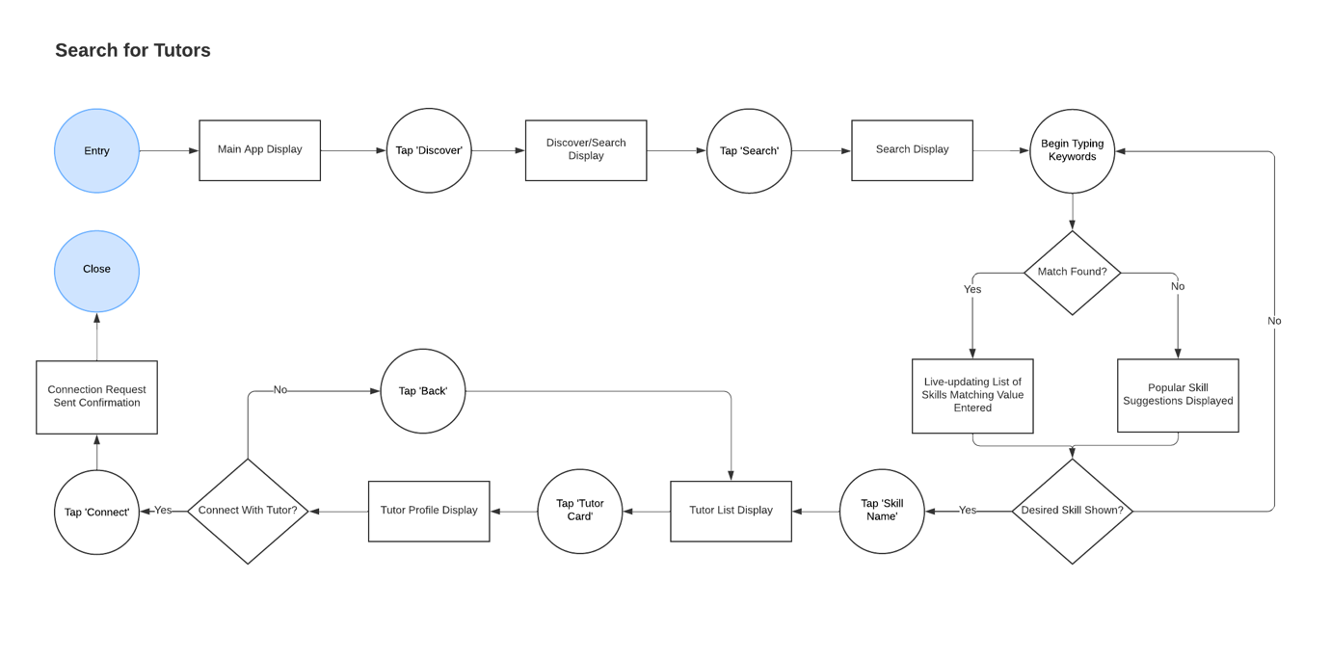

There are additional diagrams showing how the user interacts with the system, and these representations are more detailed. Link to the use case diagram:

<https://drive.google.com/file/d/1nNc_cQ4QvynG0DFUXzo2o1xgQ916Uuap/view?usp=sharing>

## URL to UX/UI

* Low Fidelity Prototype: <https://www.figma.com/file/H8TOyYK1tQ7O3iheo5fyGL/Low-Fidelity-SocialCollab?node-id=0%3A1>
* High Fidelity Prototype: <https://www.figma.com/file/eCpQGCqm4VConE7FE75KQJ/High-Fidelity-SocialCollab?node-id=0%3A1>

# High-Level Wireframes

Figma was used to design wireframe layouts. SocialCollab required a total of 23 screens to properly provide the desired functionality throughout the design process.

SocialCollab's wireframe and screen navigation are shown in Figma:

* **Low Fidelity**

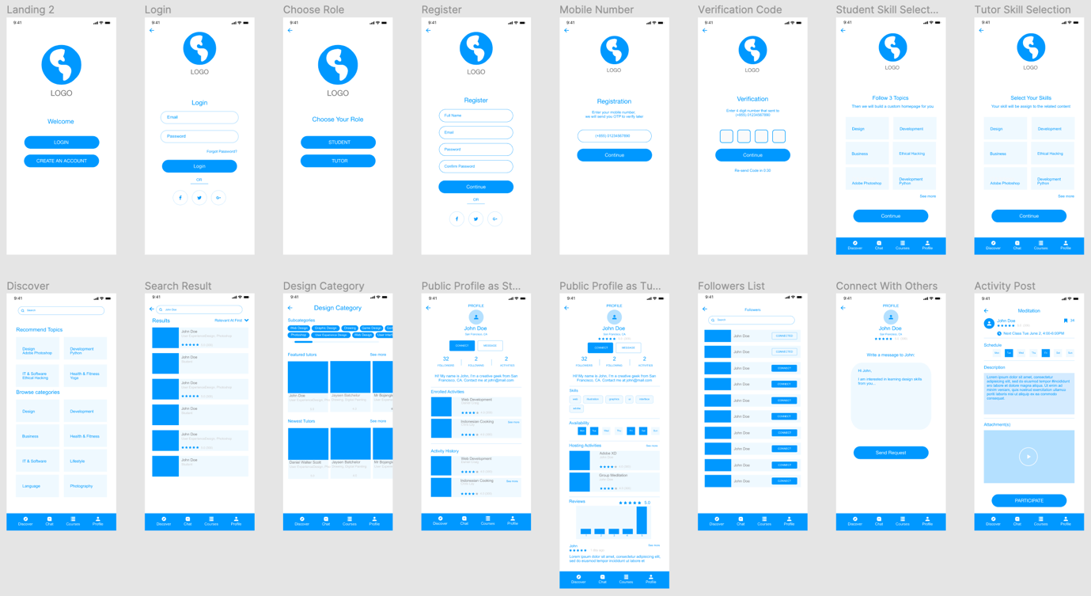

* **High Fidelity**

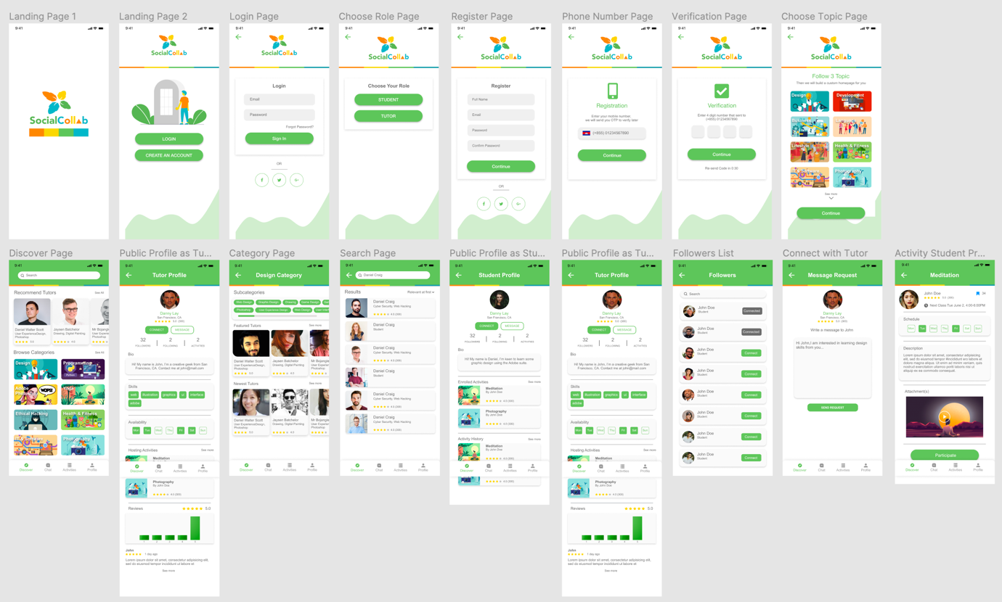

* **Page Navigation Connections**

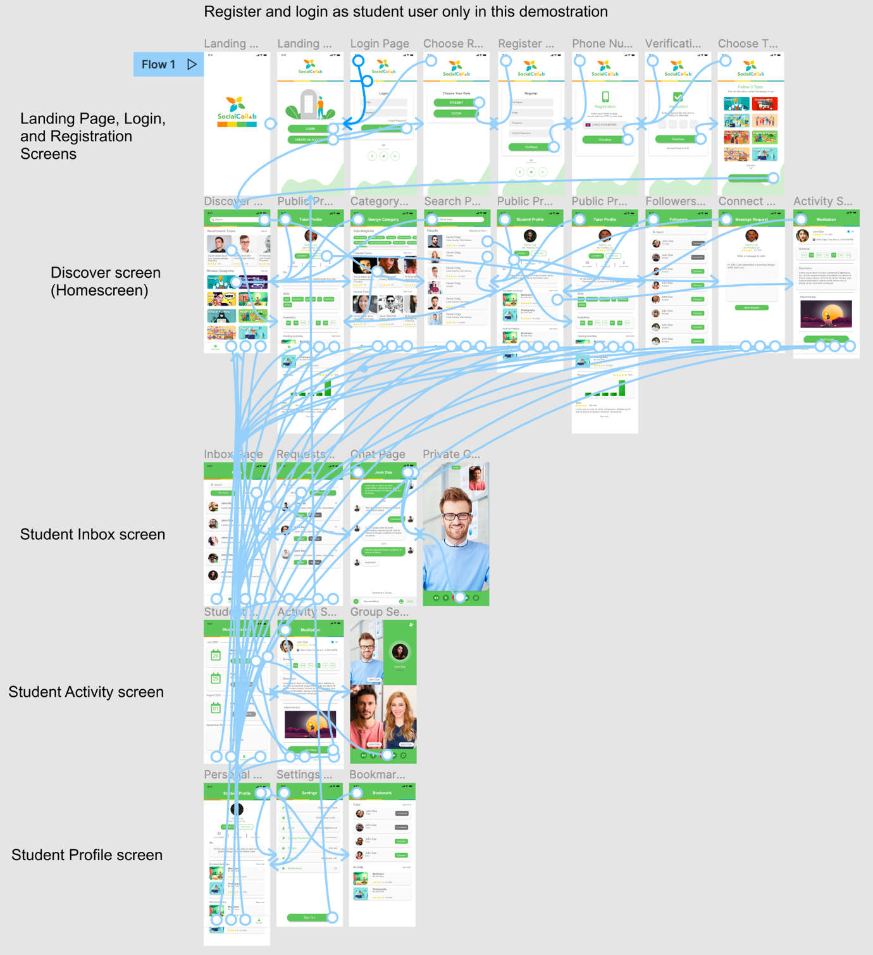

**Key features**

SocialCollab's key features consist of:

* Discover and search for any tutors from various skill sets
* Bookmark/favorite activities and tutors
* Provide tutor reviews to help them improve
* Connect with other users to stay informed about their activity
* Multiple communication methods such as Messages, Voice or Video
* 5GB Cloud Storage for activity resources

# References

* Lim, MH 2020, *Lonely in lockdown? You’re not alone. 1 in 2 Australians feel more lonely since coronavirus*, The Conversation, retrieved 7 March 2022, <<https://theconversation.com/lonely-in-lockdown-youre-not-alone-1-in-2-australians-feel-more-lonely-since-coronavirus-142724>>
* Caust, J 2020, *Coronavirus: 3 in 4 Australians employed in the creative and performing arts could lose their jobs*, The Conversation, retrieved 7 March 2022, <<https://theconversation.com/coronavirus-3-in-4-australians-employed-in-the-creative-and-performing-arts-could-lose-their-jobs-136505>>
* Postles, S 2020, *Coronavirus pandemic job losses from major Australian employers*, ABC News Australia, retrieved 7 March 2022,

<<https://www.abc.net.au/news/2020-06-30/job-losses-coronavirus-australia-covid-19/12401232?nw=0>>

* Clearbridge Mobile 2019, *A step-by-step guide to marketing your mobile app*, Clearbridge Mobile, retrieved 28 March 2022,

<<https://clearbridgemobile.com/step-by-step-guide-marketing-mobile-app/>>

* Statista 2020, *Number of smartphone subscriptions worldwide from 2016 to 2027*, Statista, retrieved 8 March 2022,

<<https://www.statista.com/statistics/330695/number-of-smartphone-users-worldwide/>>

* Varaksina, S 2022, *App funding: how to raise money for your mobile app startup*, Blog – Mind Studios, retrieved 8 March 2022,

<<https://themindstudios.com/blog/how-to-get-funding-for-an-app/>>

* Sharma, S 2019, *5 Core Components of an e-Learning Platform*, Zenesys, retrieved 10 March 2020,

<<https://www.zenesys.com/blog/5-core-components-of-an-e-learning-platform>>

* Shift eLearning, n.d., How Artificial Intelligence is Transforming the eLearning Industry, Shift eLearning, retrieved 12 March 2022,

<<https://www.shiftelearning.com/blog/artificial-intelligence-elearning>>

* Rosrypa, D & Bondarenko, A n.d., How to Create an e-Learning Platform: Tips & Tricks, Stormotion, retrieved 12 March 2022,

<<https://stormotion.io/blog/how-to-create-an-e-learning-platform-of-your-own/>>