python 设置

python .*/getmydata*.*py* --*autopilot* --*images*-*to*-*disk*

./CarlaUE4.sh -carla-server -windowed -benchmark -fps=10

以上两个命令用于server 模式固定fps，保存图片自动导航模式

两个城镇　可在CarlaSettings.ini调整设置

./CarlaUE4.sh -carla-settings=Example.CarlaSettings.ini -windowed -carla-server -benchmark -fps=5

修改日志：

之前：

1. 自动导航去掉了扰动
2. 现在transform是以左手坐标系和右手旋转方向动态旋转为基准，
   1. 注意flip要最后变换
   2. 雷达坐标系只有平移没有旋转，虽然雷达本身确实有旋转
   3. 给sensor 确定相对于车pose的位置时注意引擎内部和transform的差别
   4. 车pose点与地面齐平
3. 利用fov算出内参，外参左手坐标系，x,y,z,pitch,raw,yaw．

8.20:

1.新增了从相机数据获取点云颜色的数据，文件路径改变要在函数中修改，可直接增减相机

8.24:

convert semantic 用于将语义图可视化，修改了cityscape的label来让建筑更明显

特征：

１．车初始pose似乎会变化，导致雷达坐标系也会变化．

２．设置里面调整雷达位置，雷达坐标系似乎只会平移，不会旋转，虽然雷达扫线确实变化了，所以在变换里面把初始pose的旋转去掉了

３．雷达倾角过大似乎会造成一些bug,有一些会yaw会不准,90度时有莫明翻转

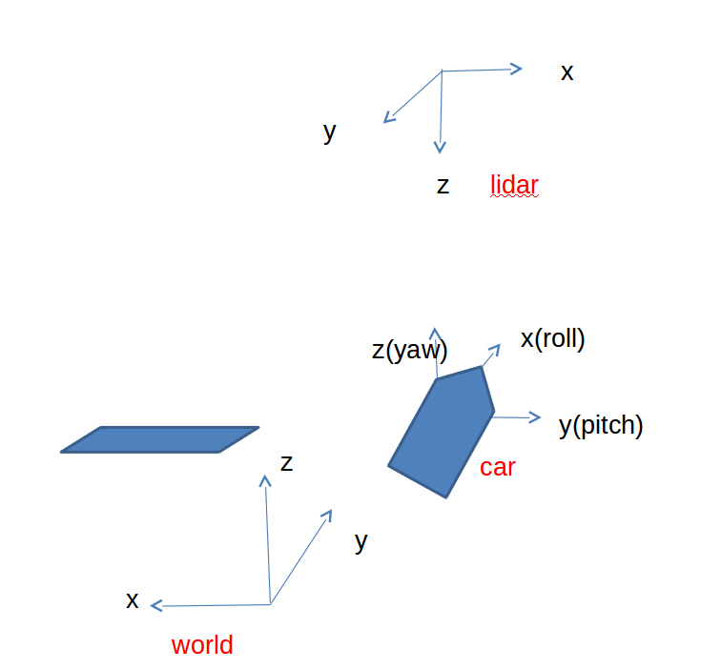

引擎旋转左手坐标系　x右手　　y右手　z左手

Standalone model 不能传递信息

时间间隔：

The simulation tries to keep up with real-time. To do so, the time-step is slightly adjusted each update. Simulations are not repeatable. By default, the simulator starts in this mode

| **File or folder** | **Description** |
| --- | --- |
| carla/ | Contains the "carla" module, the Python API for communicating with the simulator. |
| client_example.py | Basic usage example of the "carla" module. **Get dataset** |
| manual_control.py | A GUI client in which the vehicle can be controlled manually. |
| point_cloud_example.py | Usage example for converting depth images into a point cloud in world coordinates. |
| run_benchmark.py | Run the CoRL'17 benchmark with a trivial agent. |
| view_start_positions.py | Show all the possible start positions in a map |

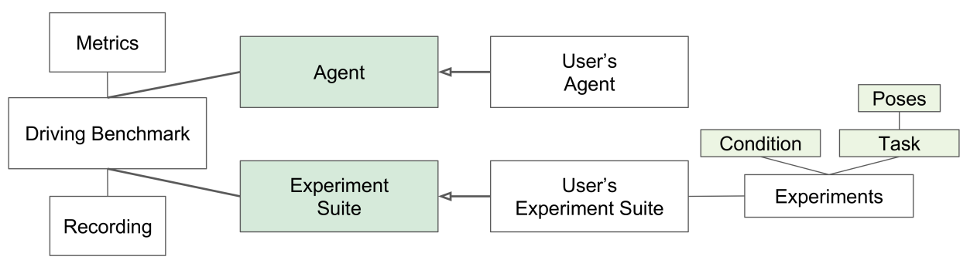

甚至提供了自己建图和添加东西的方式

| **Value** | **Tag** |  |
| --- | --- | --- |
| 0 | None |  |
| 1 | Buildings |  |
| 2 | Fences |  |
| 3 | Other |  |
| 4 | Pedestrians |  |
| 5 | Poles |  |
| 6 | RoadLines |  |
| 7 | Roads |  |
| 8 | Sidewalks |  |
| 9 | Vegetation |  |
| 10 | Vehicles |  |
| 11 | Walls |  |
| 12 | TrafficSigns |  |