VFX FIRST TEST TUTORIAL

1. Reduce the rendering quality:

Modify the macro MAX_PTRACE_SAMPLES on the file s3d-ptrace/core/proj/mmove/main.c

change the beginning of the file from:
#define MAX_PTRACE_SAMPLES 1000

to a small value, for example 10:
#define MAX_PTRACE_SAMPLES 10

save the modified version of s3d-ptrace/core/proj/mmove/main.c

Keep in mind that the quality of the rending is proportional to the square root of this macro, and the amount of time spending rendering is proportional to this macro. It means that increase the quality becomes more and
more expensive in terms of rendering time.

2. Rebuild the project adjusting it to fast and low quality rendering

go to the directory s3d-ptrace/build and type:

cmake -DCMAKE_POLICY_VERSION_MINIMUM=3.5 ../core/
make
make install

4. Convert the video used as background ( s3d-ptrace/demo/video.mp4 ) into HDR frames encoded in .pfm file format

go to the directory s3d-ptrace/demo and type:

./d0.sh

it will demands some time to producing frames: bk0.pfm, bk1.pfm, bk2.pfm... into the directory s3d-ptrace/demo.

3. Render the visual effect in low quality from 3 different view positions

In the directory s3d-ptrace/demo and type:

./d3.sh

It will produce the following images in out2.png, out.150.png and out230.png into the directory s3d-ptrace/demo. They correspond of images of frame 2, 150 and 230.
It will produce also the HDR versions of them: out2.pfm, out.150.pfm and out230.pfm

The figures below corresponds to the images:

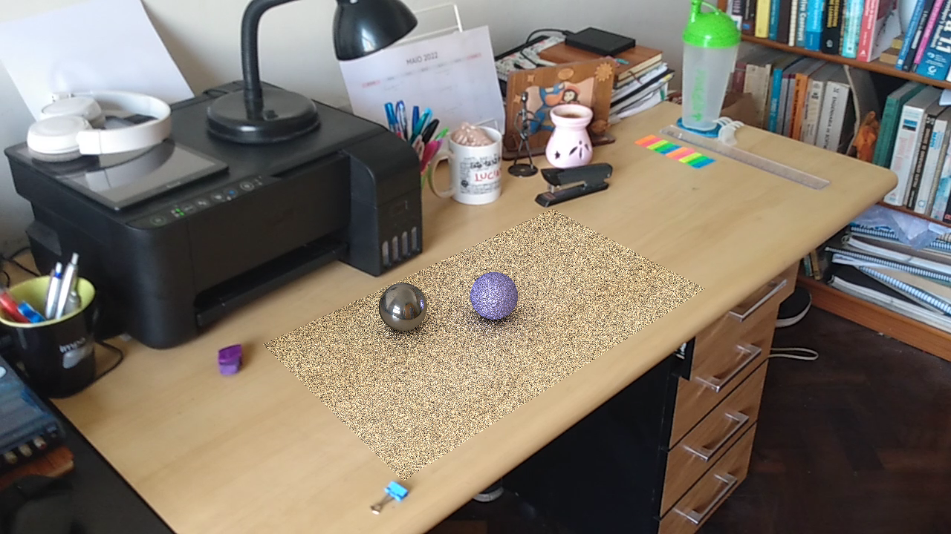

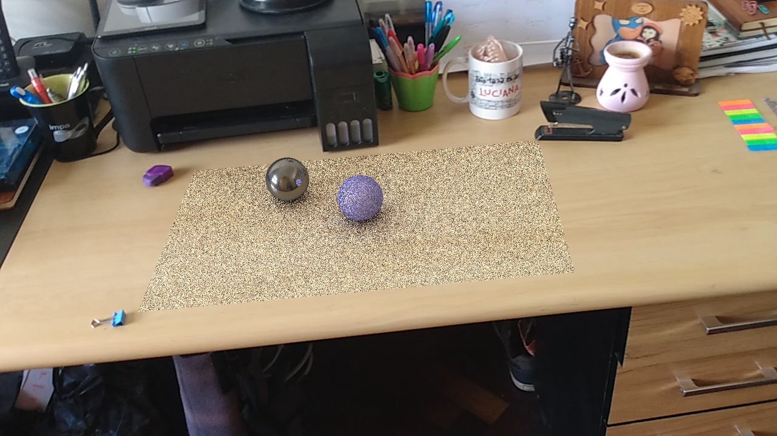

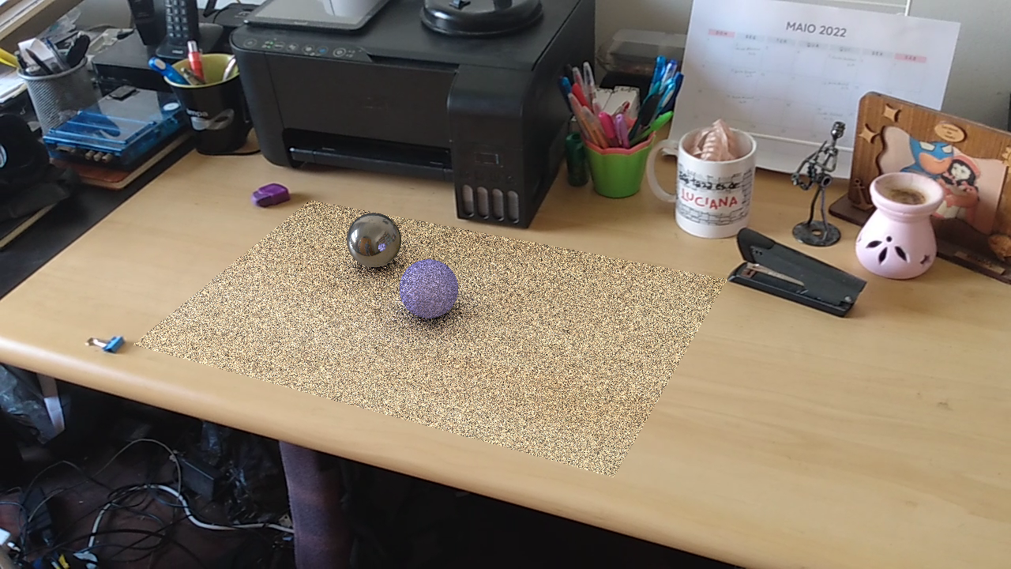

4. Increase the rendering quality:

Modify the macro MAX_SAMPLES_PTRACE on the file s3d-ptrace/core/proj/mmove/main.c

change the beginning of the file from:
#define MAX_PTRACE_SAMPLES 10 to

to a larger value, for example 1000:
#define MAX_PTRACE_SAMPLES 1000

save the modified version of s3d-ptrace/core/proj/mmove/main.c
It means that the rendering time will increase 100 times for each image, and they will have very low noise.

5. Rebuild the project adjusting it to very slow and very high quality rendering

go to the directory s3d-ptrace/build and type:

make
make install

6. Render the visual effect in low quality from 3 different view positions ( it is not necessary to
convert the background int HDR files again )

In the directory s3d-ptrace/demo type:

./d3.sh

It will demands some minutes to render each frame, but it will produce the following images: out2.png, out.150.png and out230.png into the directory s3d-ptrace/demo and also the HDR versions of them: out2.pfm, out.150.pfm and out230.pfm

The figures below corresponds to the images:



