Textual Scene Modeler

1. INTRODUCTION

This document describes a scene modeler tool designed to process files generated by scripts inside this software. It is a textual modeler because it does not have a graphical interface.
The tool is implemented in the file ./s3d-ptrace/core/proj/modeling/main.c, which after compiling produces the application modeling.
This tool can also be tested by using the script ./s3d-ptrace/demo/d5.sh

2. ESTIMATE THE HDR DOME

After running the modeler tool, it uses a file called “r” to calculate the orientation of the Radiance Map as explained in the Section 10.8 of the book. In the sequence, the modeler presents the message

orig = { %lf, %lf, %lf }
south = { %lf, %lf, %lf }

in which %lf are real numbers.
This is the the script necessary for describing the orientation of the radiance map in the scene. More details about how to generate the file “r” are described in the file ./matchmove/README.

3. ESTIMATE THE SHADOW POLYGON

After showing the properties of the HDR Dome, the tool calculates the shape of the polygon that projects the shadows of the synthetic objects.
In order to do this, the program process a file whose name is given by argv[1]. This file contains the 9 real numbers that correspond to the 3D coordinates of 3 points.
These points define a 3D coordinate system, and they can be generated by using the tools ./matchmove/proj/defpcl/main.cxx and ./matchmove/proj/pclcalib/main.c, described in the Chapter 8, and executed by the script ./matchmove/demo/d2.sh . For example, if the user selects the points presented in the Figure 1 it defines the coordinate system presented in Figure 2.

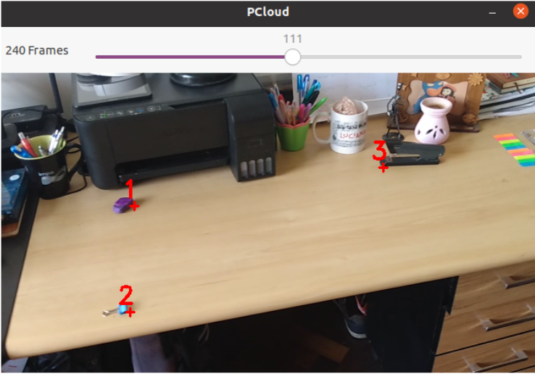

FIGURE 1 – Selected points in the defpcl application

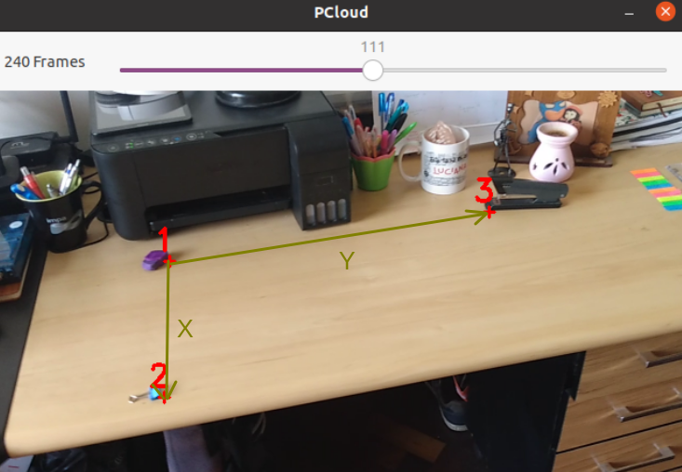

FIGURE 2 – Coordinate system related to the points: 1, 2 and 3.

After presenting on the terminal the HDR Dome parameters, the system shows the message:

origin:

Then, the user must enter two real numbers that correspond to the top left coordinates of the vertice of a rectangle contained in the plane that contains the points: 1, 2 and 3, and using the coordinate system defined in the Figure 2.
After that, the system presents on the terminal:

sx:

Then, the user must enter the size of the rectangle along the direction defined by the vector X of Figure 2.
After that, the system presents the message:

sy:

Then, the user must enter the size of the rectangle along the direction defined by the vector Y of the Figure 1.

After that, the application shows to the user a message with the format:

shape = trilist{{{%lf, %lf, %lf},{%lf, %lf, %lf},{%lf, %lf, %lf}},
{{%lf, %lf, %lf},{%lf, %lf, %lf},{%lf, %lf, %lf}}}

in which %lf corresponds to a real number.
This text can be used to define the geometry of the command plshadow in the scene description.
The color of the polygon can be calculated using the program described in the Section 10.12 of the book, implemented by the file ./s3d-ptrace/core/proj/getcolor/main.c, and executed by the script ./s3d-ptrace/demo/d1.sh

3. ESTIMATING SPHERES OVER THE SHADOW POLYGON

After showing the shape of the shadow polygon, the user can use the modeler tool to specify the shape of spheres over it.
In order to do this the system presents the message:

Sphere radius:

Then, the user must enter the radius of the first sphere.

After that, the tool presents the message:

Sphere center:

Then, the user must enter the 2D coordinates of the contact point of the sphere with the shadow polygon using the referential system presented in Figure 2.

After that, the tool will present the message bellow, that corresponds to the shape of the desired sphere:

shape = sphere{center = {%lf, %lf, %lf}, radius = %lf}

The user can continuous using the tool to define the shape of many others spheres in the same way.

