**JMeter 101**

Apache Jmeter is an Open source software, 100% Java application designed to load test functional behavior and measure performance.

Jmeter can be used to test performance of Web services, Databases, FTP servers and more. It can also be used to simulate heavy load on a server, group of servers or a network to test its strength or to analyze overall performance.

**Test Requirements**

Load testing Containers\servers\web applications to simulate real life customer scenarios.

**Tools Available:**

Apache Bench – Cannot Generate large amount of traffic

HTTPerf – Cannot Generate large amount of traffic

Tsung – Cannot install on containers

Jmeter

Why Jmeter is preferred

* Allows you to send large traffic for an extended period of time
* Concurrent threads
* Graphical Results
* You can obtain delay, throughput, errors

**Options Available in Jmeter**

Type of traffic to be sent

* HTTP
* FTP
* Mail – SMTP, POP, IMAP
* Databases (JDBC)
* MangoDB

Control amount of traffic to be sent

* Number of users to be simulated
* Duration of test
* Ramp up period

How to view results

* Tree table
* Graphs
* Summary Table

**How to install and configure Jmeter**

Jmeter has been successfully installed on Linux (Ubuntu), Windows, VM’s, Containers

Please refer to these steps provided by Herman

[https://w3-connections.ibm.com/wikis/home?lang=en-us - !/wiki/Cloud QA Team/page/Jmeter--http load generation tool](https://w3-connections.ibm.com/wikis/home?lang=en-us#!/wiki/Cloud%20QA%20Team/page/Jmeter--http%20load%20generation%20tool)

**How to Collect logs for Analysis?**

General method is to specify the log file via CLI

Jmeter –n –t <jmx file> -l <logs_file>

However, in case we know the size of the logs file is going to be large, we can enable the summarizer, which will log a summary of the results

* Create a jmeter properties file
* Run jmeter using this command
  + Jmeter –n –t <jmx file> -p <jmeter_properties file> -l <jmeter_logs>

This will return a summary of the results ran so far.

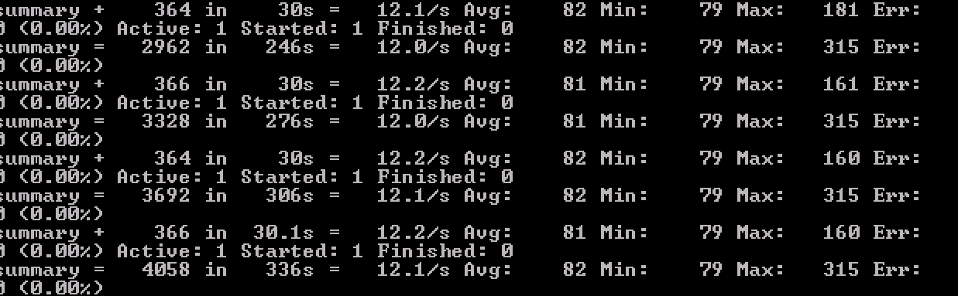

How to read the summary logs:

**Summary 4058 in 336s** 🡪 4058 requests sampled in 336 secs

**12.1/s** 🡪 Throughput – Number of Requests /sec the web server \application can handle

**Avg: 82** 🡪 Avergae delay – Time from just before request is sent to just after response is received (milli secs)

**Min: 79** 🡪 Min delay

**Max: 315** 🡪 Max delay

**Err: 0 (0.0%)** 🡪 Indicates all requests had a corresponding response.

Helpful Resources

1. <http://jmeter.apache.org/index.html>
2. <http://developer.amd.com/community/blog/2009/03/31/using-apache-jmeter-in-non-gui-mode/>
3. https://www.digitalocean.com/community/tutorials/how-to-use-apache-jmeter-to-perform-load-testing-on-a-web-server