Assignment 8: Decision Tree

**by Vishal Doshi (vdoshi3@uic.edu)**

*NOTE: Make sure there is a input file: "dataset.txt" in the root folder*

**Steps:**

1. Extract and Import “DecisionTreeJava.zip” into Eclipse.
2. Run the DesisionTreeJava.java

**Results:**

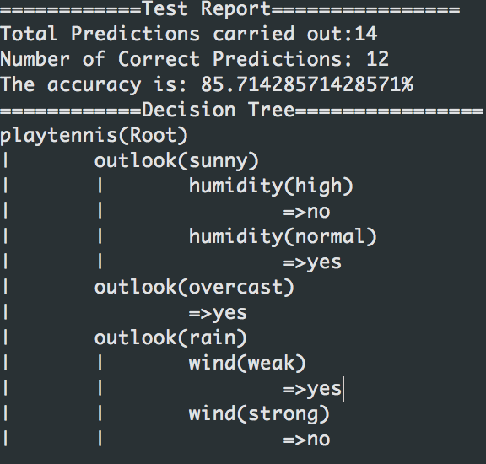

**Implementation Details:**

**DesisionTreeJava.java**: The class where everything is happening.

**Entropy.java**: the method to calculate Entropy resides here.

**Node.java**: The node class of the tree

**Attribute.java**: The class to compose one attribute

**Record.java:** The class that has list of attribute. This class object represents a row in a the dataset.