Assignment 9: Reservoir Sampling

**by Vishal Doshi (vdoshi3@uic.edu)**

*NOTE: The program will generate the input file automatically*

**Steps:**

1. Extract and Import “DecisionTreeJava.zip” into Eclipse.
2. Run the ReservoirSamplingJava.java
3. Provide the size of reservoir

**Results:**

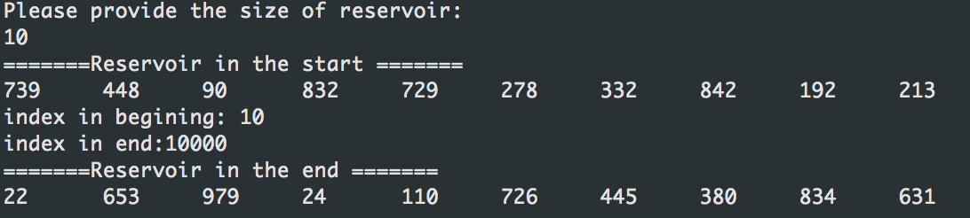

**Implementation Details:**

**ReservoirSamplingJava.java**: The class where everything is happening. We first create the file on random numbers.

Later we create a reservoir of size provided by user.

And the process of sampling returns the final reservoir with random samples.