HTML AND CSS ASSIGNMENT

Ques1) How are inline and block elements different from each other?

Ans1) Block Level Elements: A block-level element always starts on a new line and takes up the full width available.

Examples for Block Level Elements: <div> ,<h1>,<ol>,<ul> ,<title> etc.

Inline Elements: An inline element does not start on a new line and only takes up as much width as necessary.

Examples for Inline Elements: <span>, <a>, <br> etc.

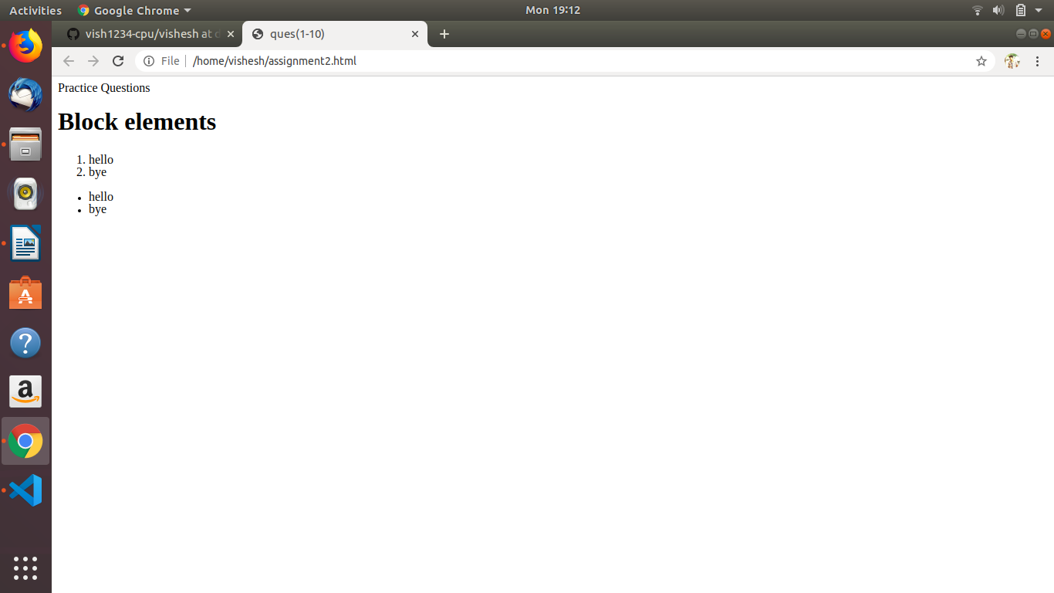

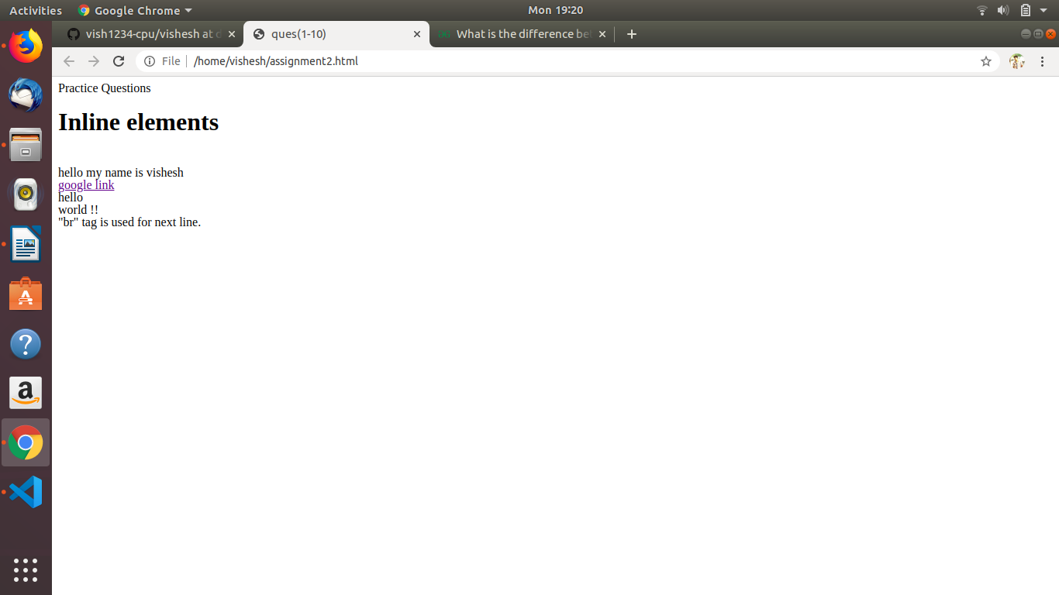

Ques2) Explain the difference between visibility:hidden and display:none.
Ans2.)

display: none; is commonly used with JavaScript to hide and show elements without deleting and recreating them. Take a look at our last example on this page if you want to know how this can be achieved.

The <script> element uses display: none; as default.

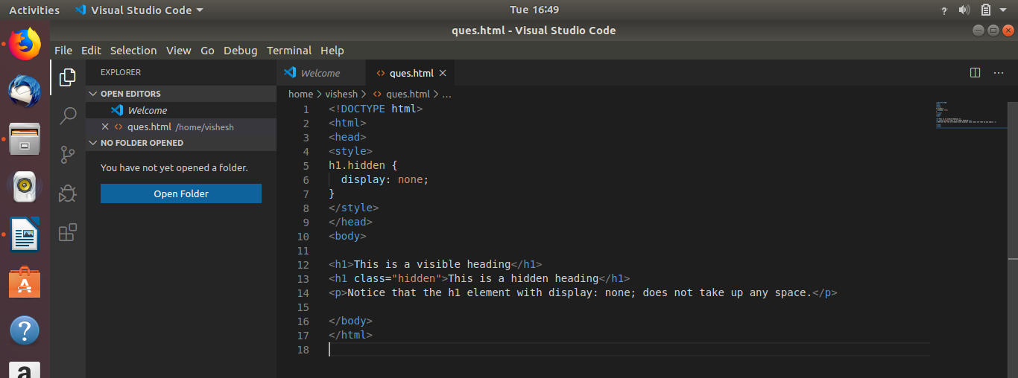

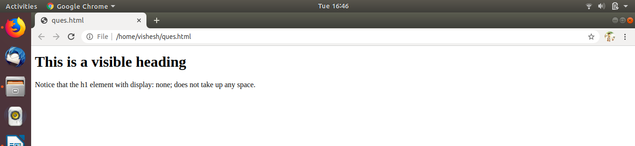

visibility:hidden; also hides an element.
However, the element will still take up the same space as before. The element will be hidden, but still affect the layout.

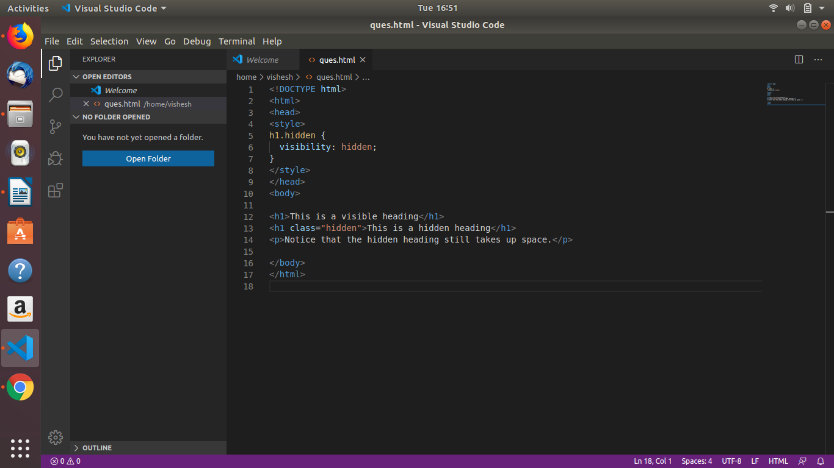
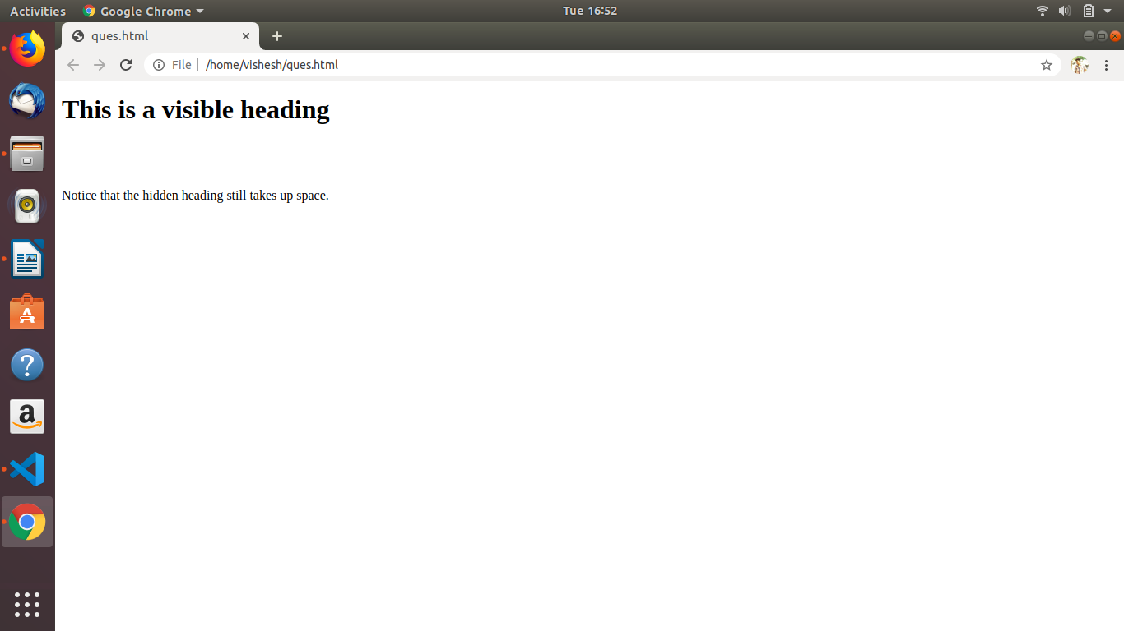

Ques3) Explain the clear and float properties.
Ans3) float Property
The float property is used for positioning and formatting content e.g. let an image float left to the text in a container.
The float property can have one of the following values:
- left - The element floats to the left of its container
- right - The element floats to the right of its container
- none - The element does not float (will be displayed just where it occurs in the text). This is default .

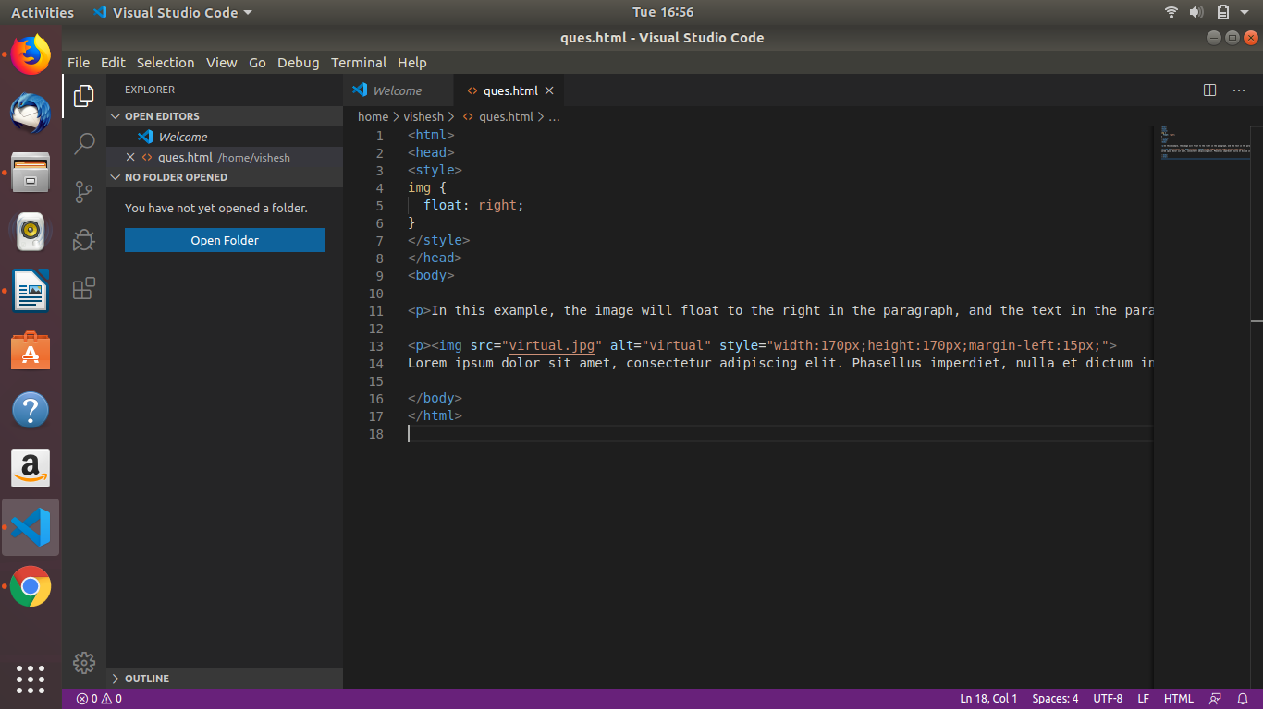
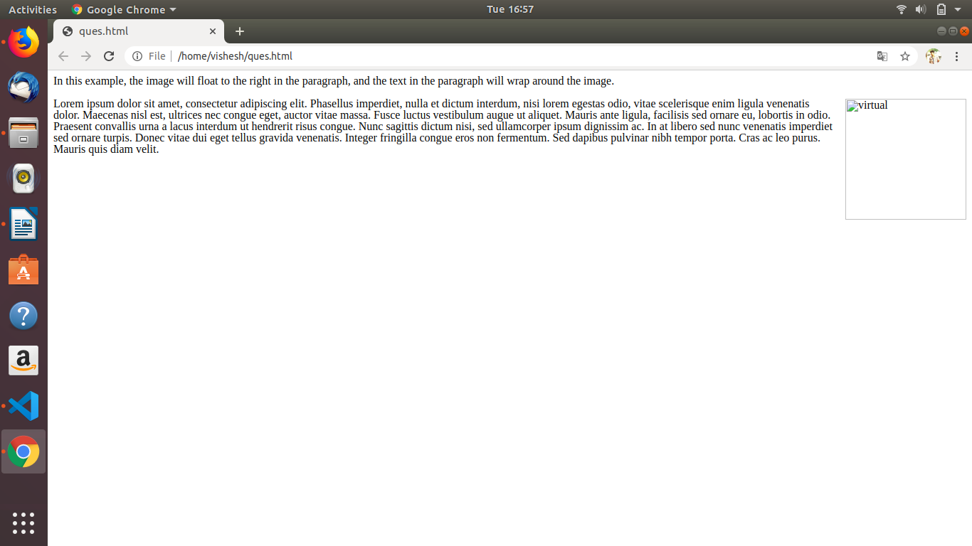

Clear Property
The clear property specifies what elements can float beside the cleared element and on which side.
The clear property can have one of the following values:
- none - Allows floating elements on both sides. This is default
- left - No floating elements allowed on the left side
- right- No floating elements allowed on the right side
- both - No floating elements allowed on either the left or the right side

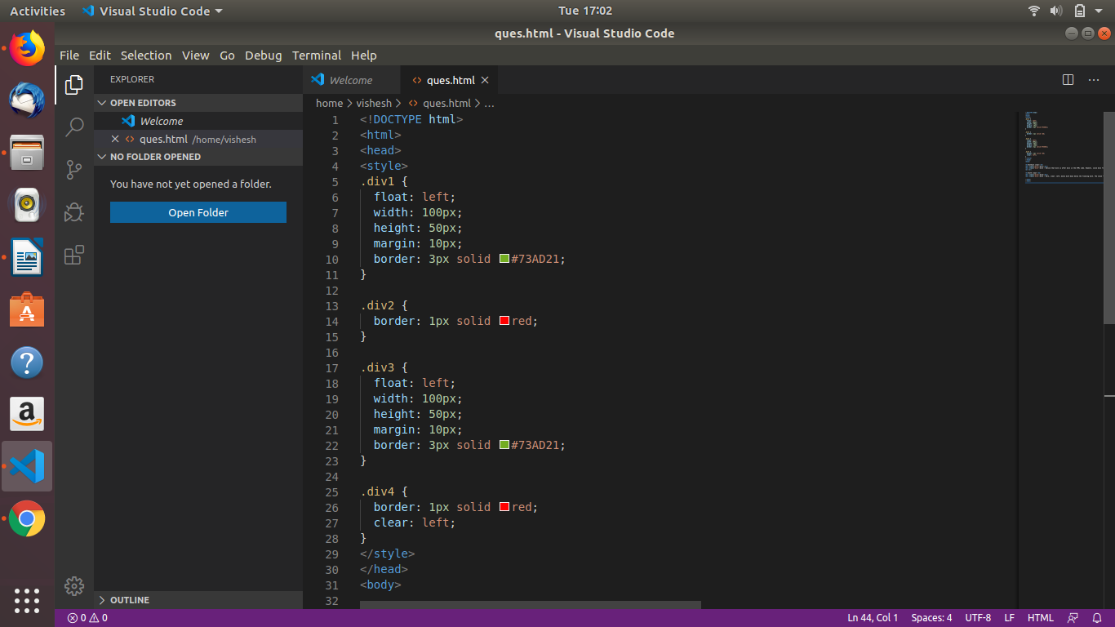
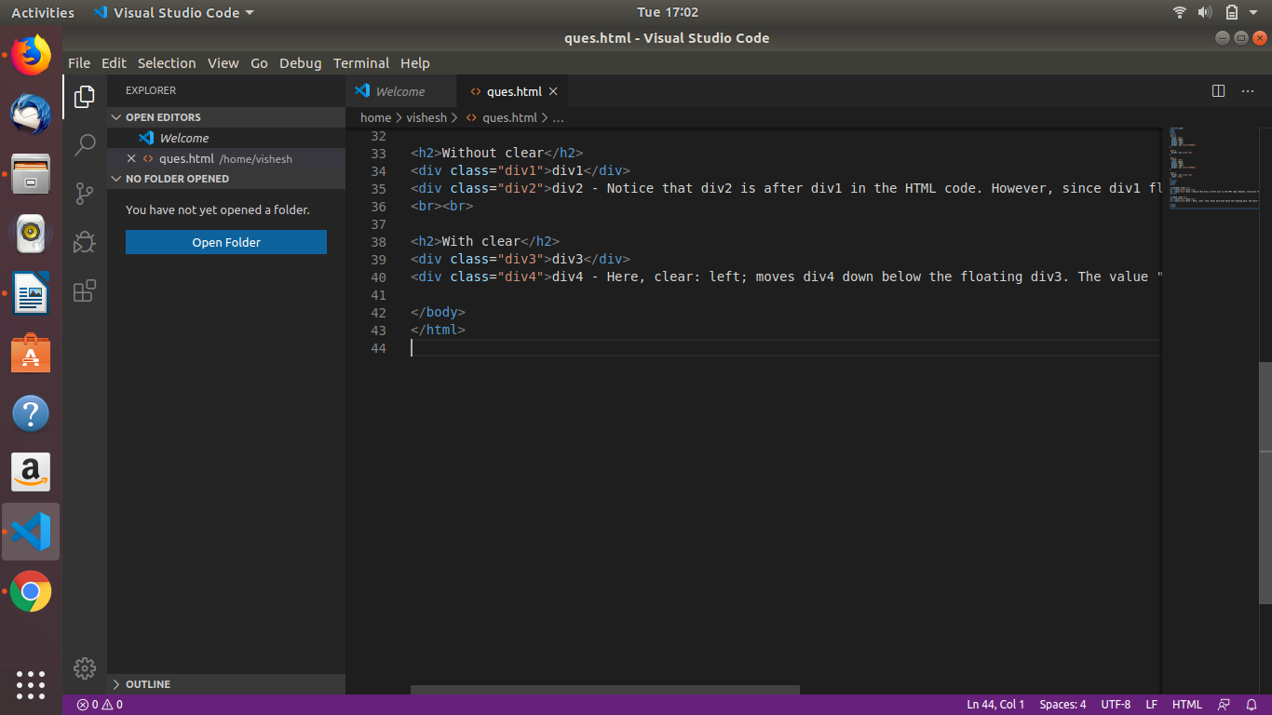
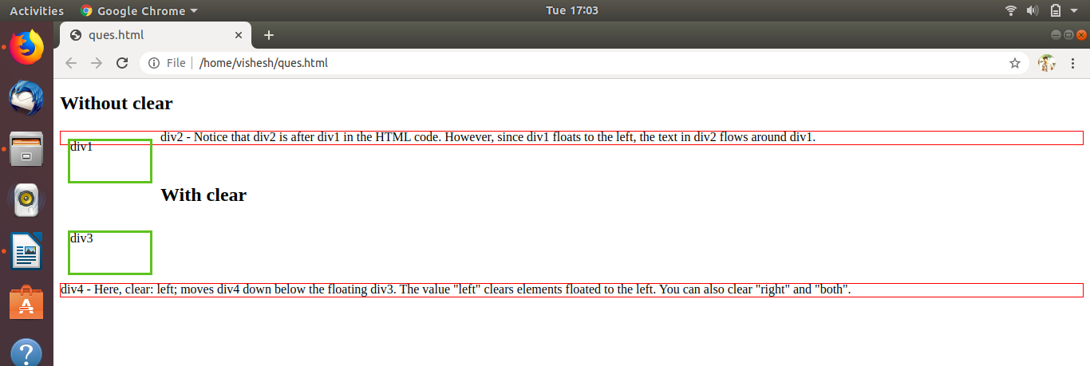
Ques4) explain difference between absolute, relative,fixed and static.
Ans4) There are five different position values:
- static
- relative
- fixed
- absolute
1) static: HTML elements are positioned static by default.
Static positioned elements are not affected by the top, bottom, left, and right properties.
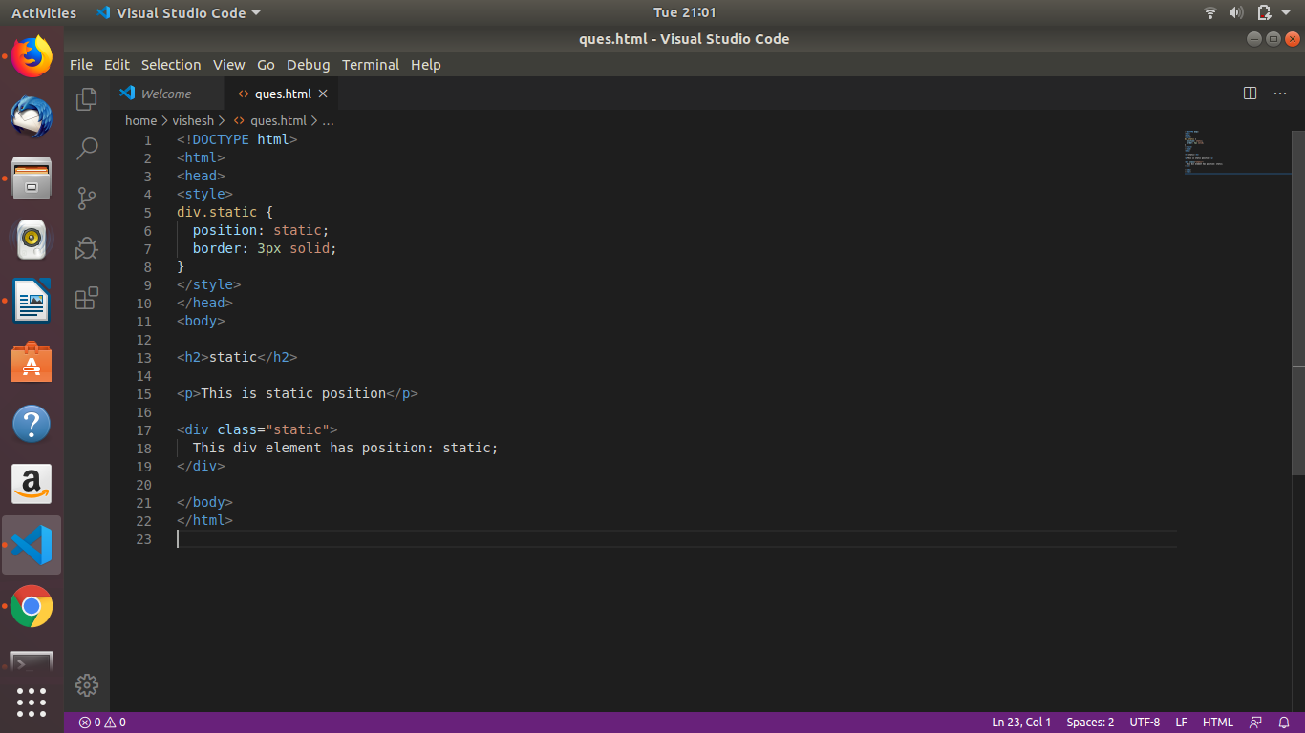
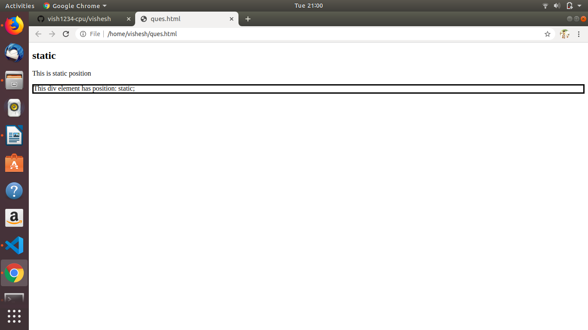

2) Relative: An element with position: relative; is positioned relative to its normal position.
Setting the top, right, bottom, and left properties of a relatively-positioned element will cause it to be adjusted away from its normal position. Other content will not be adjusted to fit into any gap left by the element.
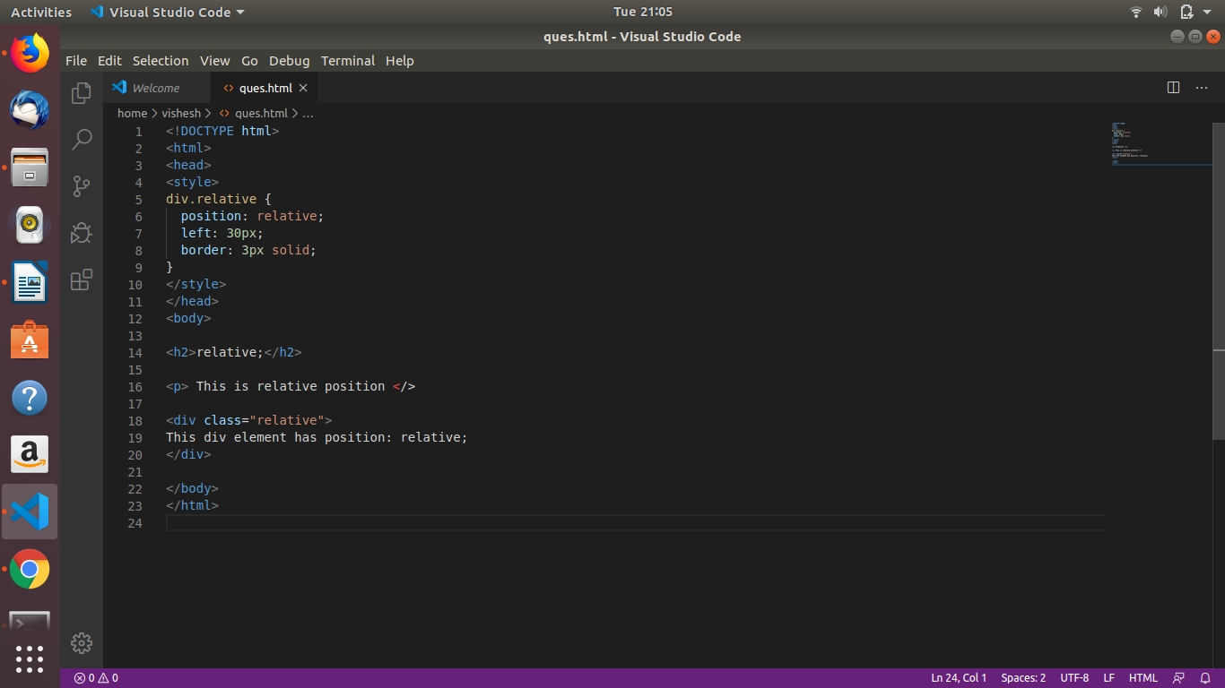
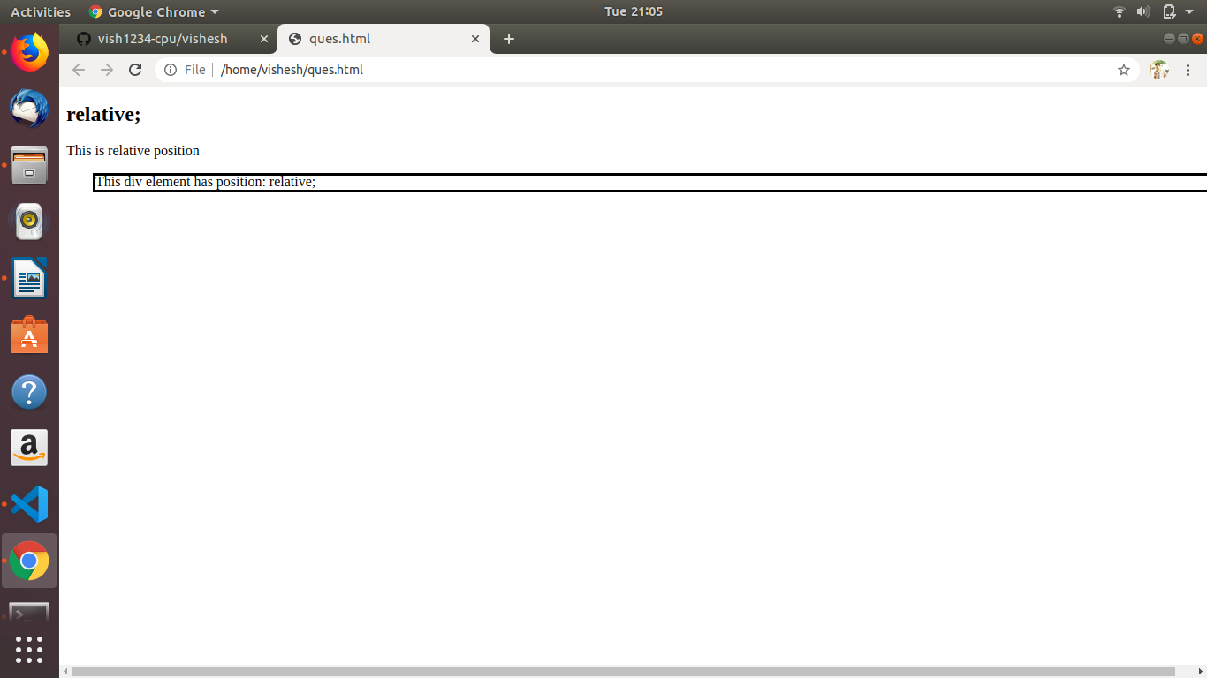
3) Fixed: An element with position: fixed; is positioned relative to the viewport, which means it always stays in the same place even if the page is scrolled. The top, right, bottom, and left properties are used to position the element.

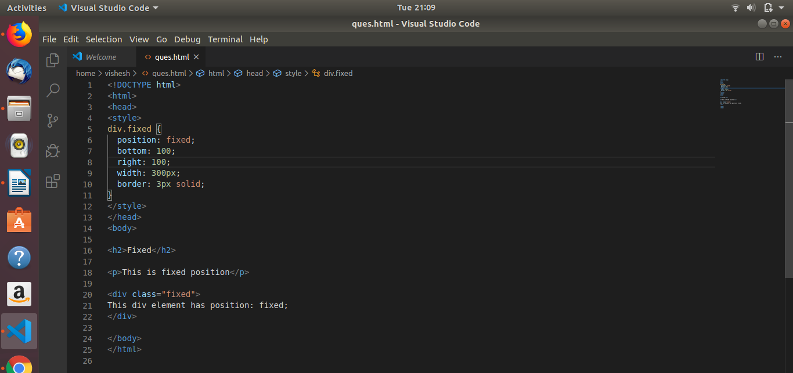
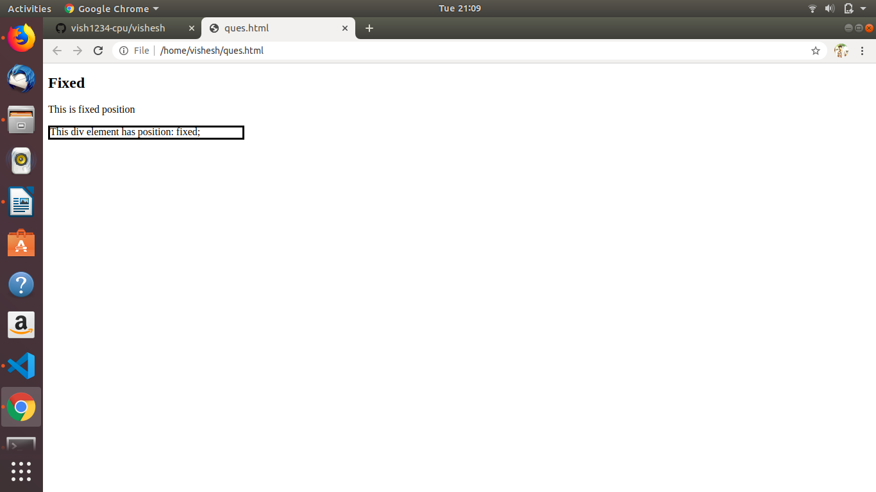
4) Absolute: An element with position: absolute; is positioned relative to the nearest positioned ancestor (instead of positioned relative to the viewport, like fixed).
However; if an absolute positioned element has no positioned ancestors, it uses the document body, and moves along with page scrolling.

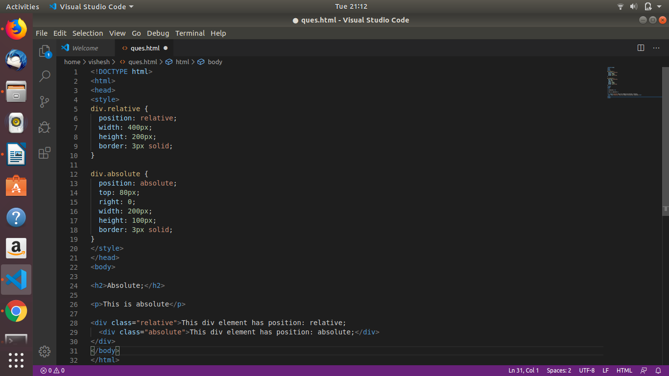
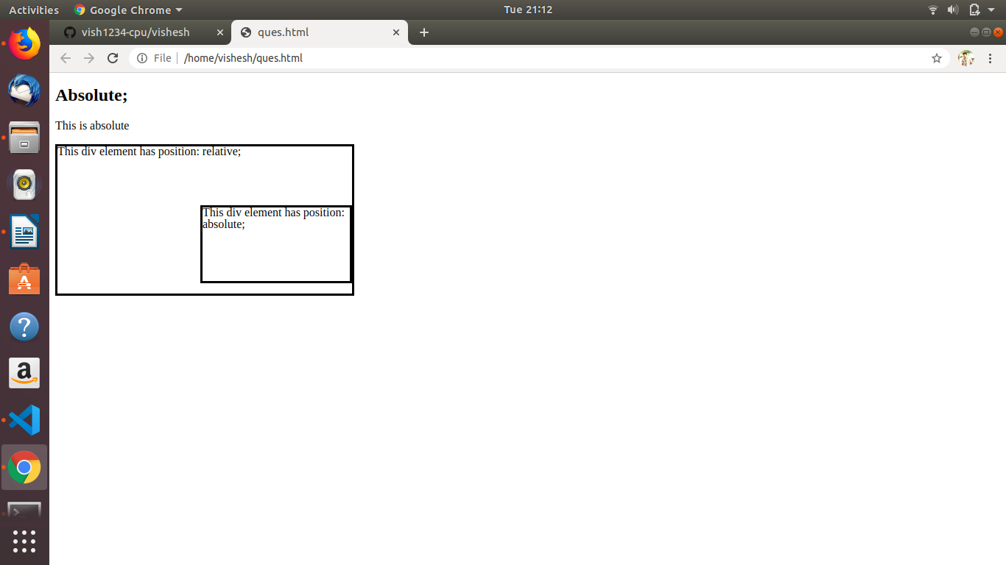

Ques.5) Write the HTML code to create a table in which there are 4 columns( ID , Employee Name, Designation, Department) and at least 6 rows. Also do some styling to it.

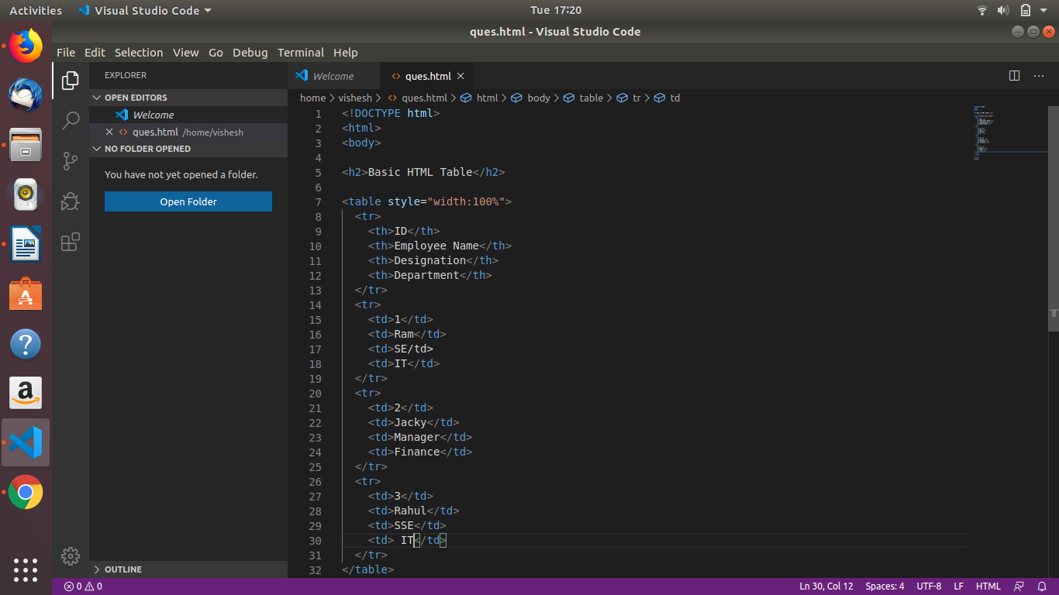
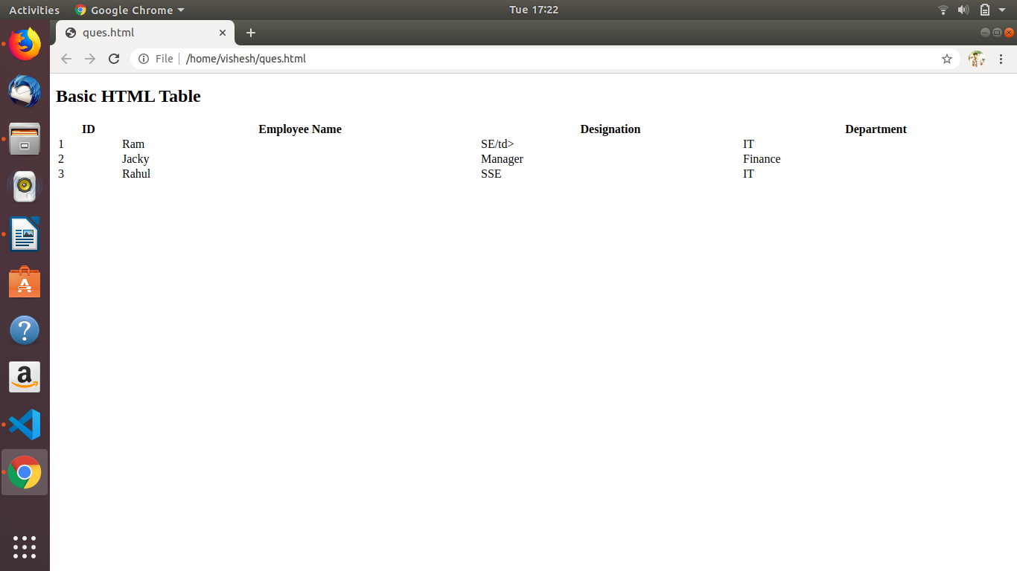

Ques6) Why do we use meta tags?
Ans6) Metadata is data (information) about data.Meta elements are typically used to specify page description, keywords, author of the document, last modified, and other metadata.

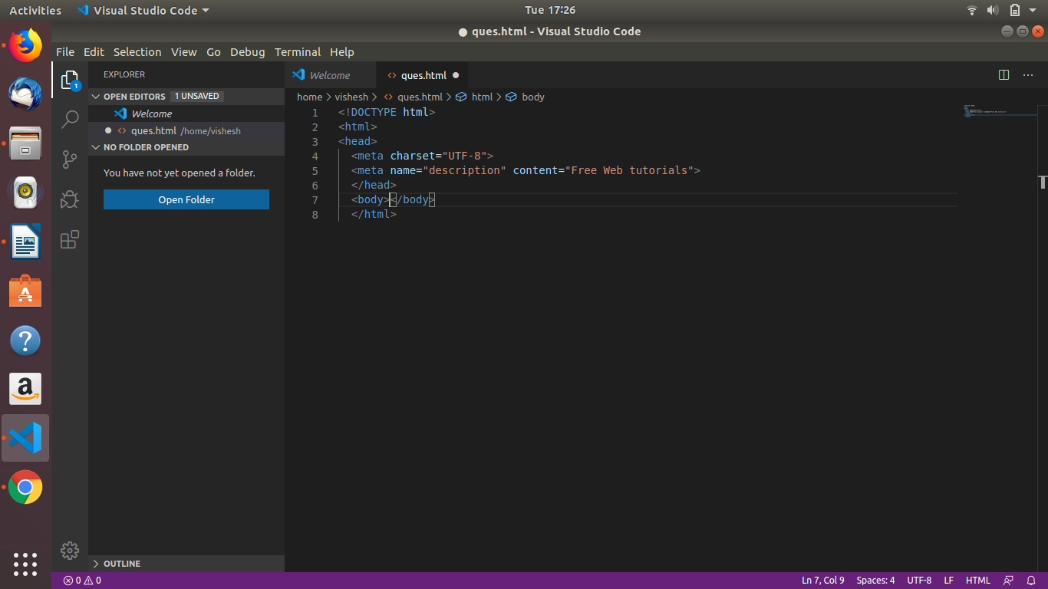

Ques7) Explain box model.
Ans7) All HTML elements can be considered as boxes. In CSS, the term "box model" is used when talking about design and layout.
different parts:
- Content - The content of the box, where text and images appear
- Padding - Clears an area around the content. The padding is transparent
- Border - A border that goes around the padding and content
- Margin - Clears an area outside the border. The margin is transparent
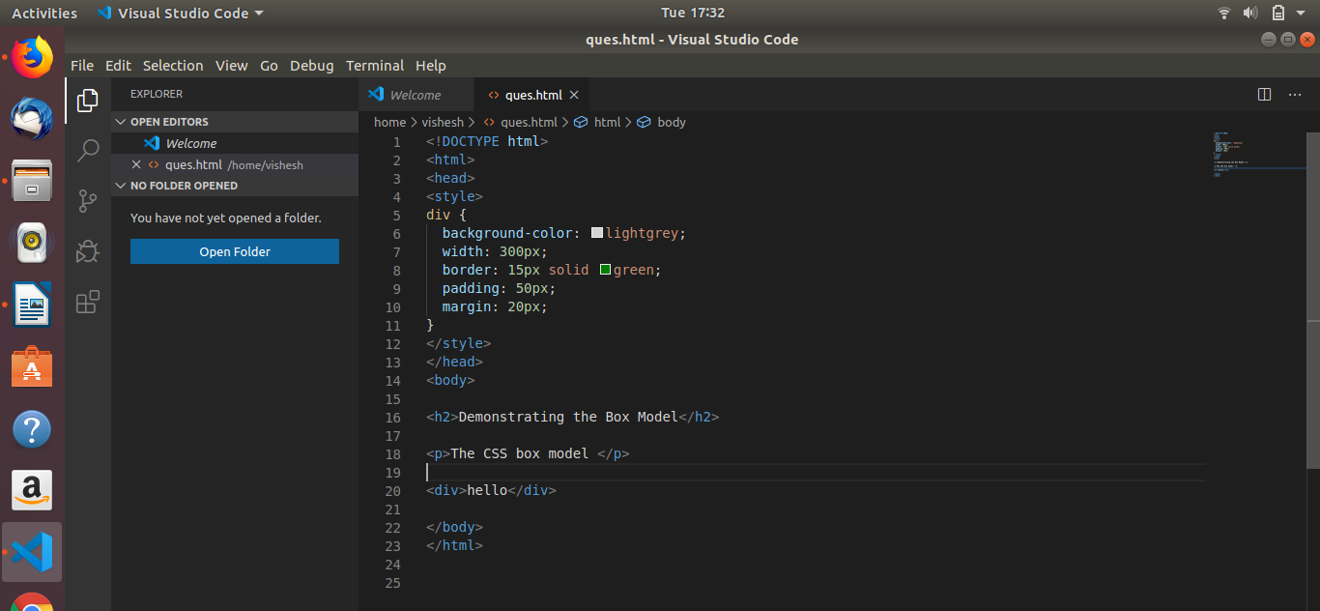
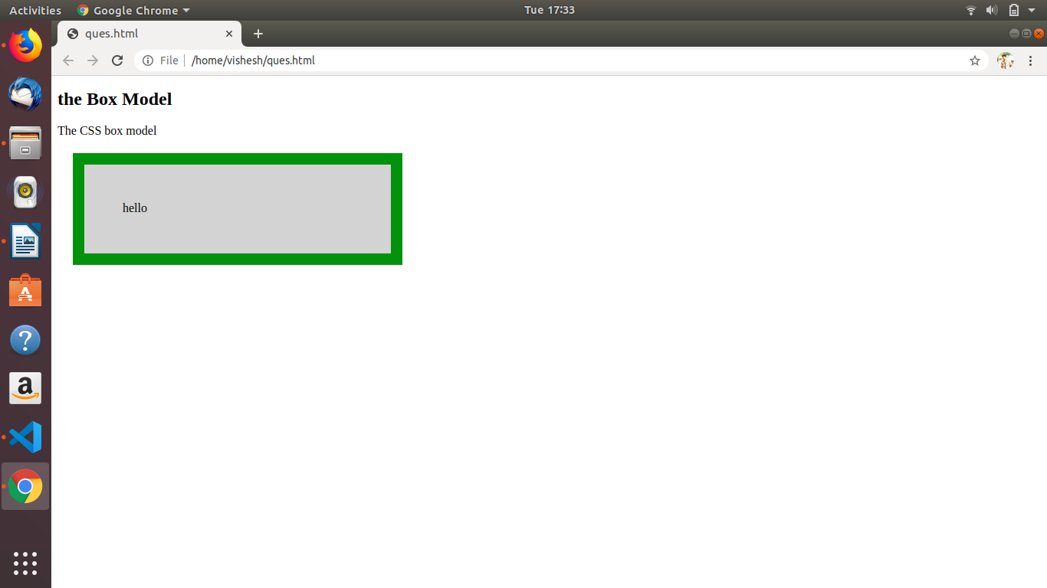

Ques8) What are the different types of CSS Selectors?
Ans8) CSS selectors are used to "find" (or select) the HTML elements you want to style.
We can divide CSS selectors into five categories:
- element selector
- id selector
- universal selector
- class selector

1) element selector : The element selector selects HTML elements based on the element name.
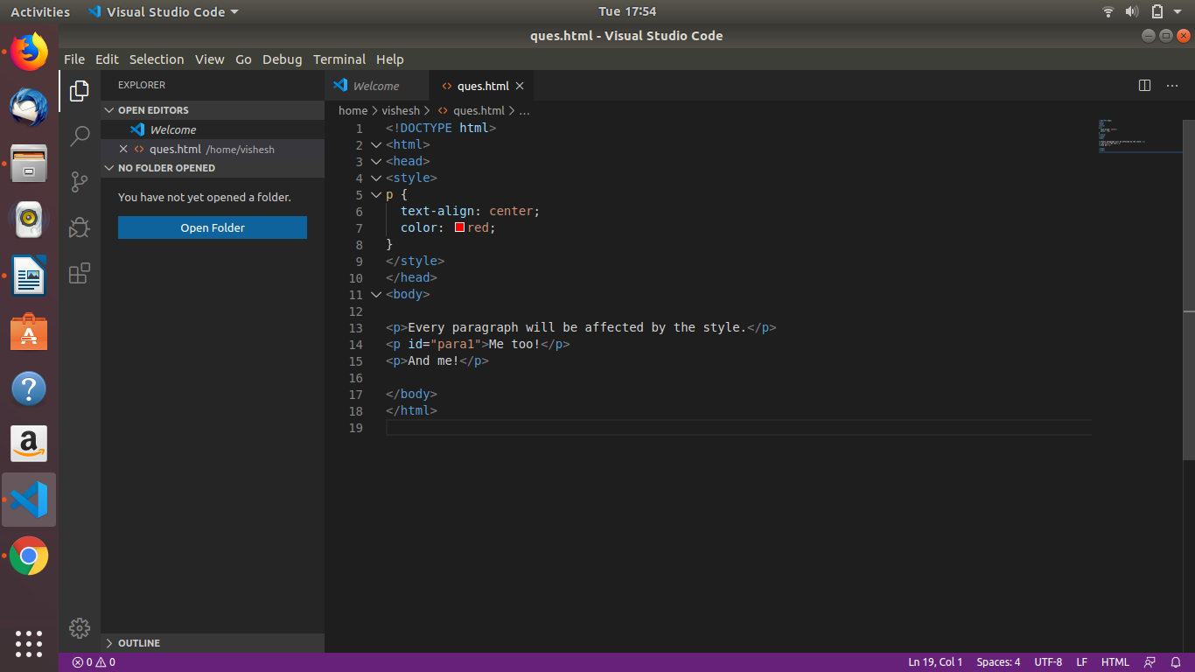

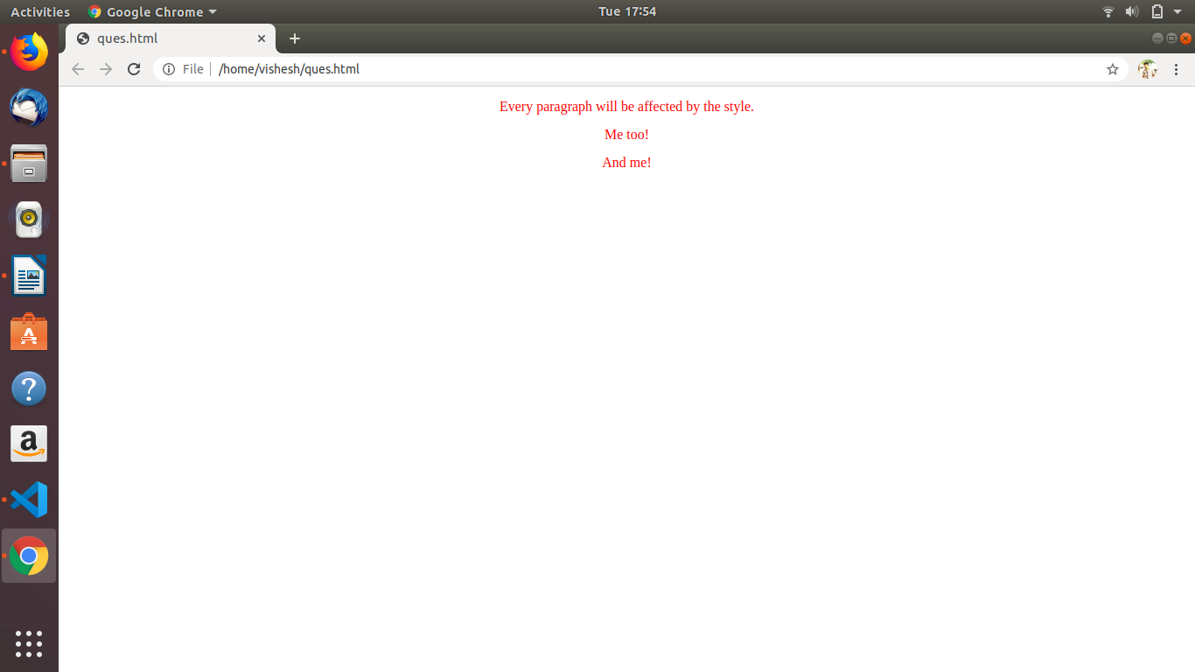

2) id-selector: The id selector uses the id attribute of an HTML element to select a specific element.
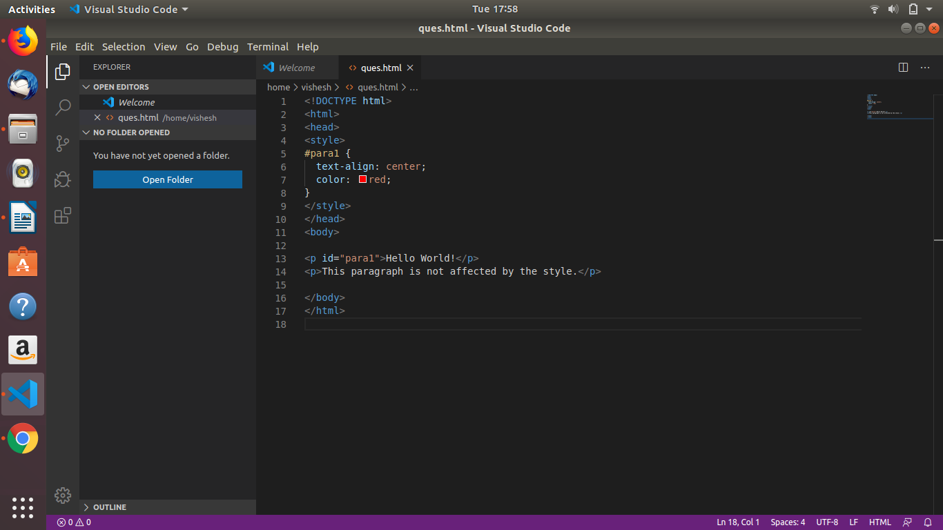
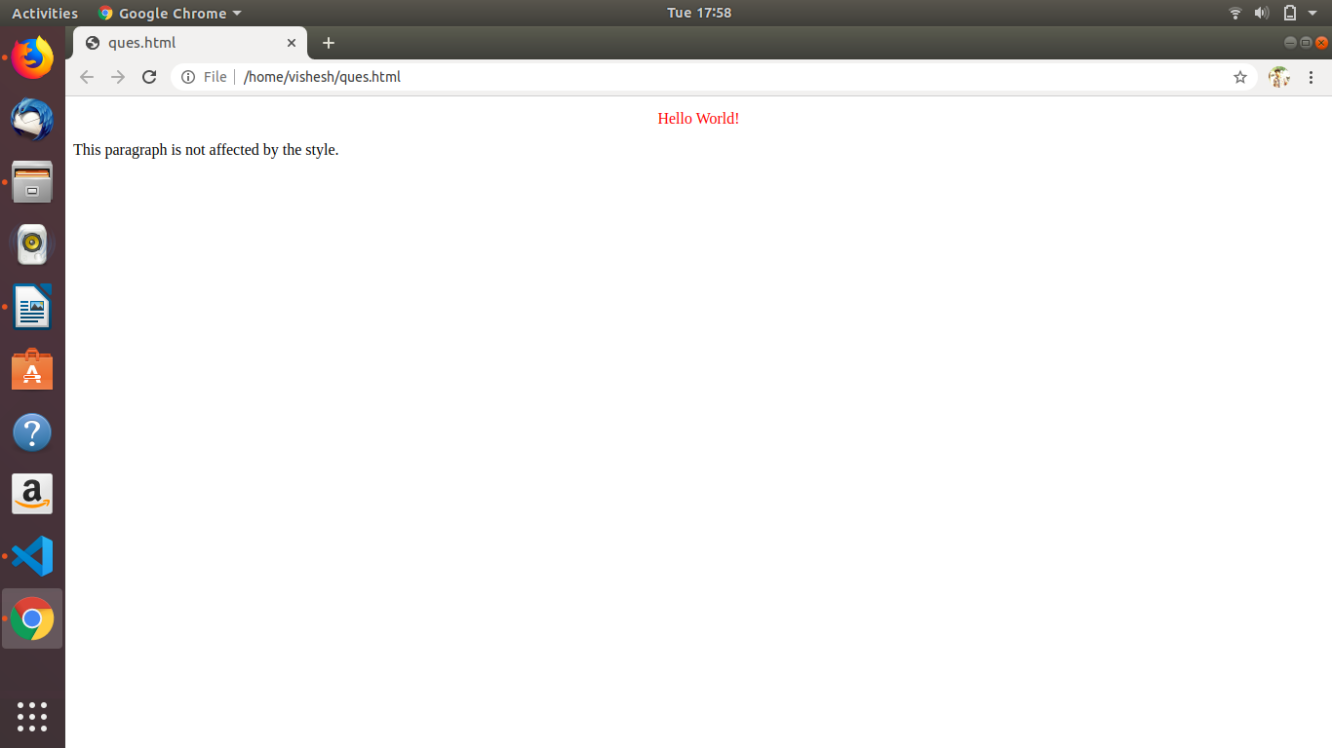

3) class selector: The class selector selects HTML elements with a specific class attribute.
To select elements with a specific class, write a period (.) character, followed by the class name.

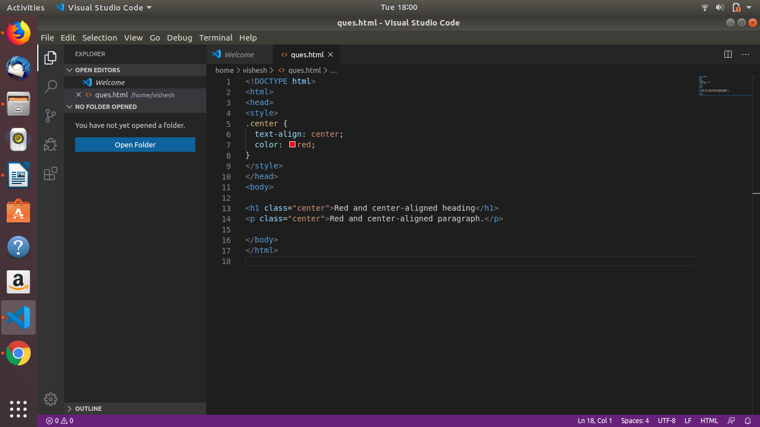
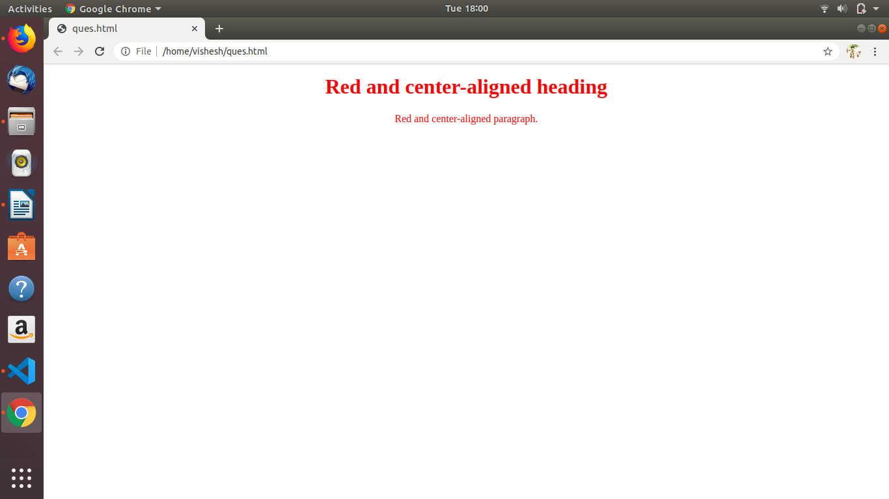

4) universal selector: The universal selector (*) selects all HTML elements on the page.

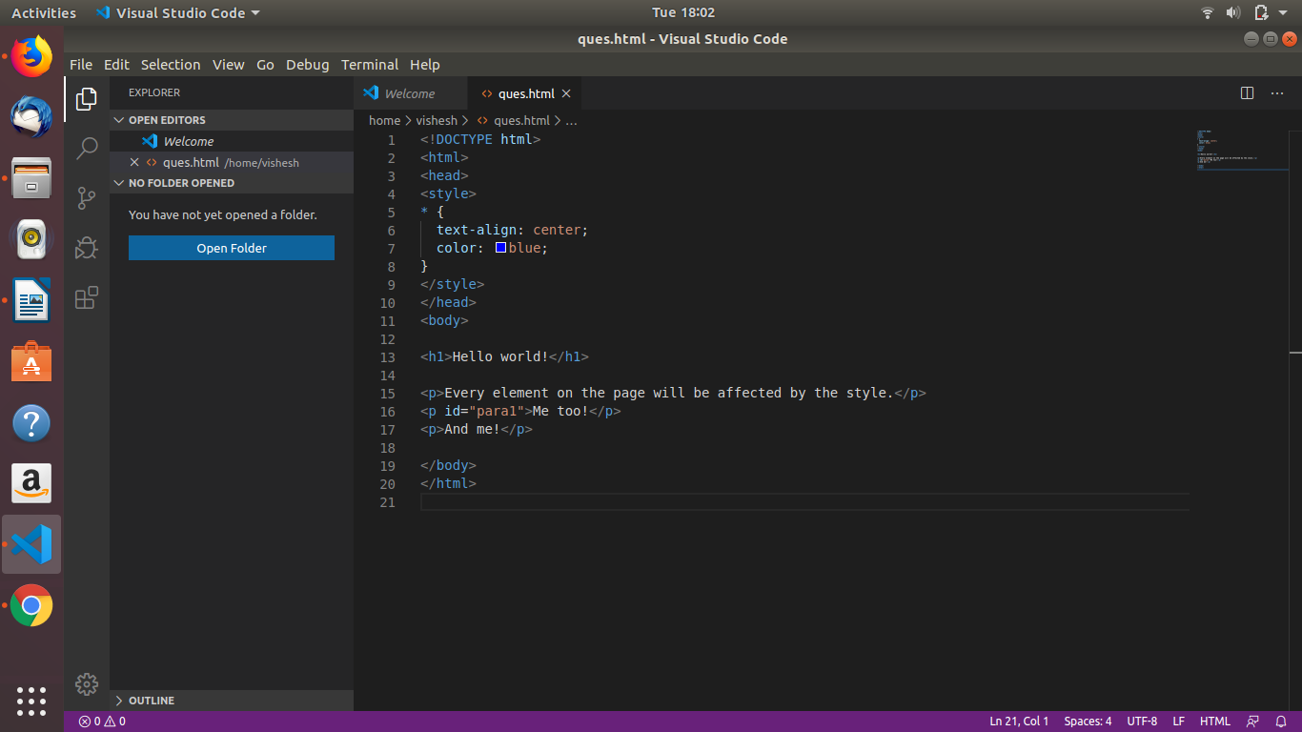

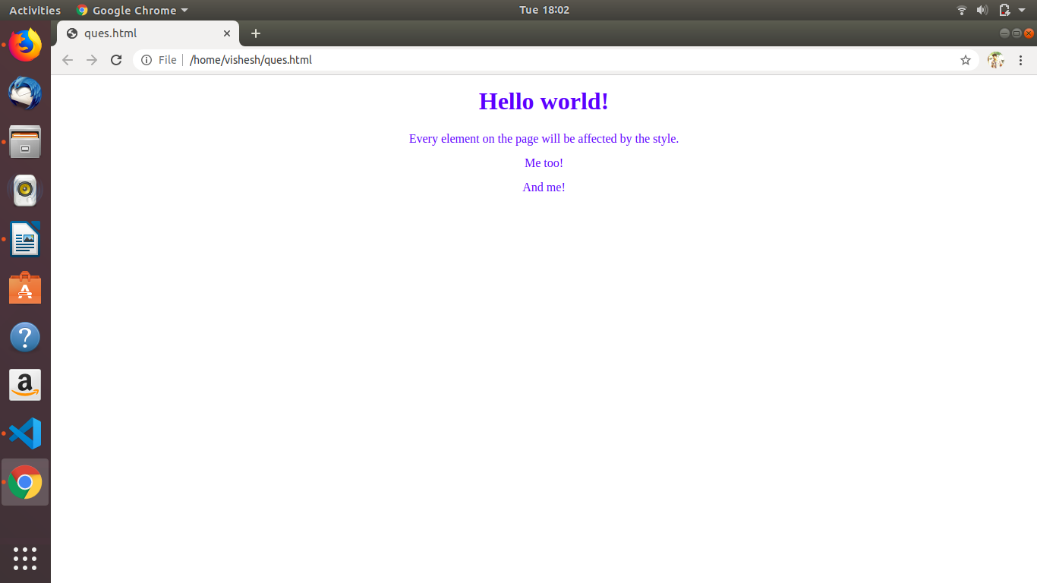

Ques.9) Define Doctype.
Ans.9) The <!DOCTYPE> declaration must be the very first thing in your HTML document, before the <html> tag.
The <!DOCTYPE> declaration is not an HTML tag; it is an instruction to the web browser about what version of HTML the page is written in.

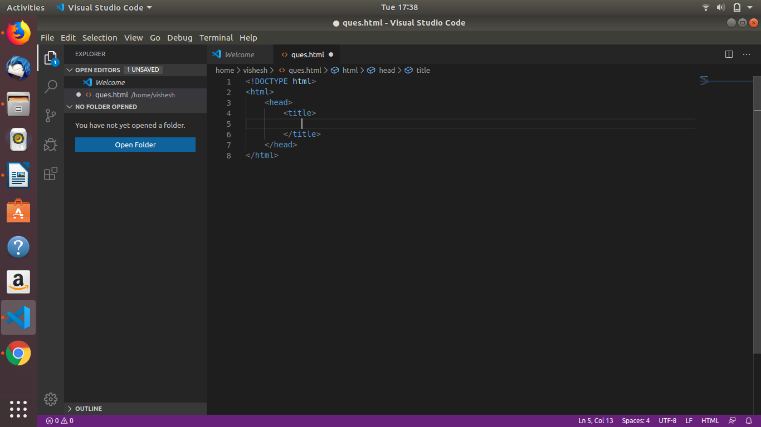

Ques.10) Explain 5 HTML5 semantic tags.
Ans.10) Semantics is the study of the meanings of words and phrases in a language.Examples of semantic elements: <form>, <table>, and <article> - Clearly defines its content.

1) Article
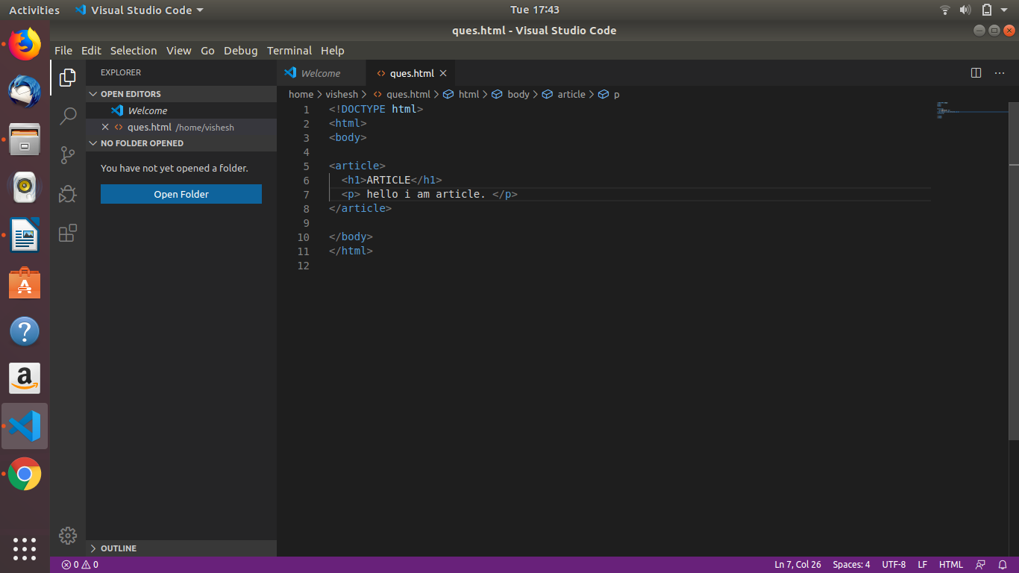
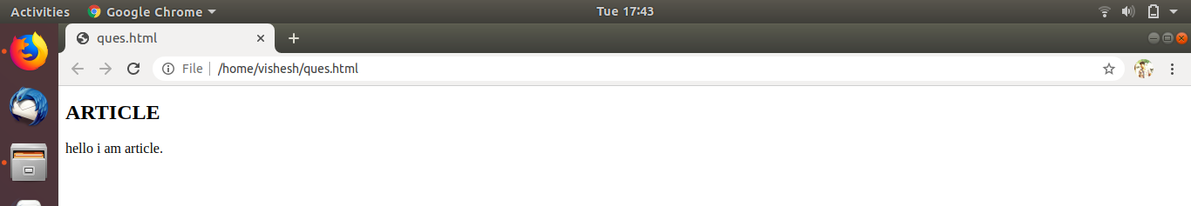

2) Header: The <header> element specifies a header for a document or section.

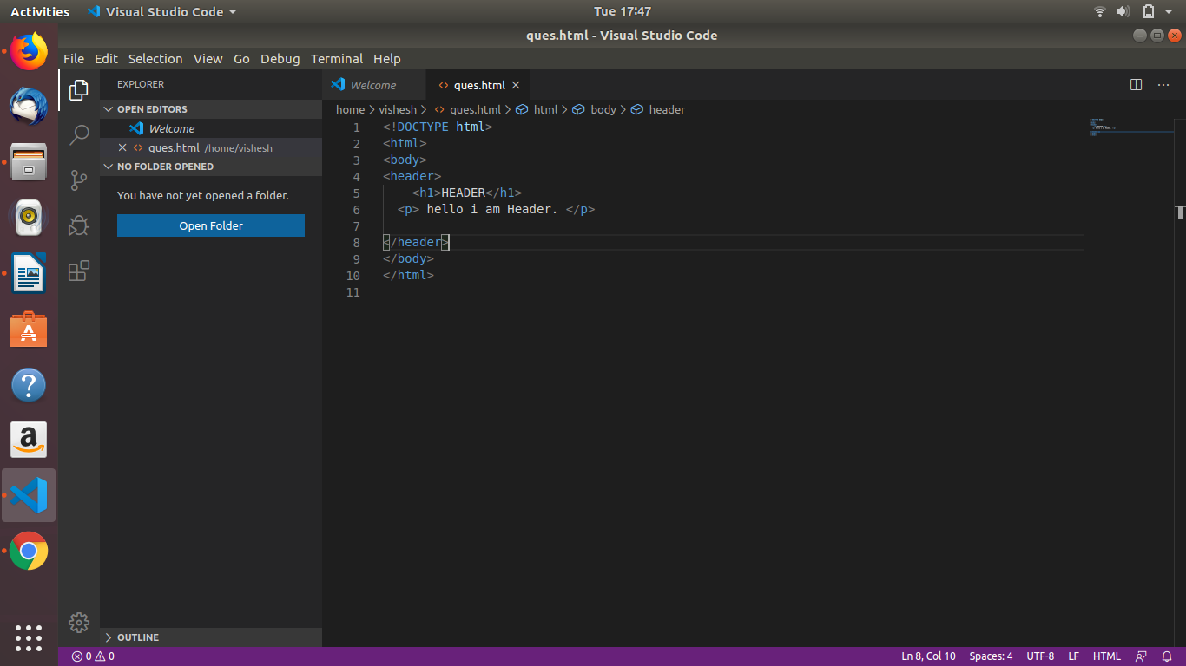
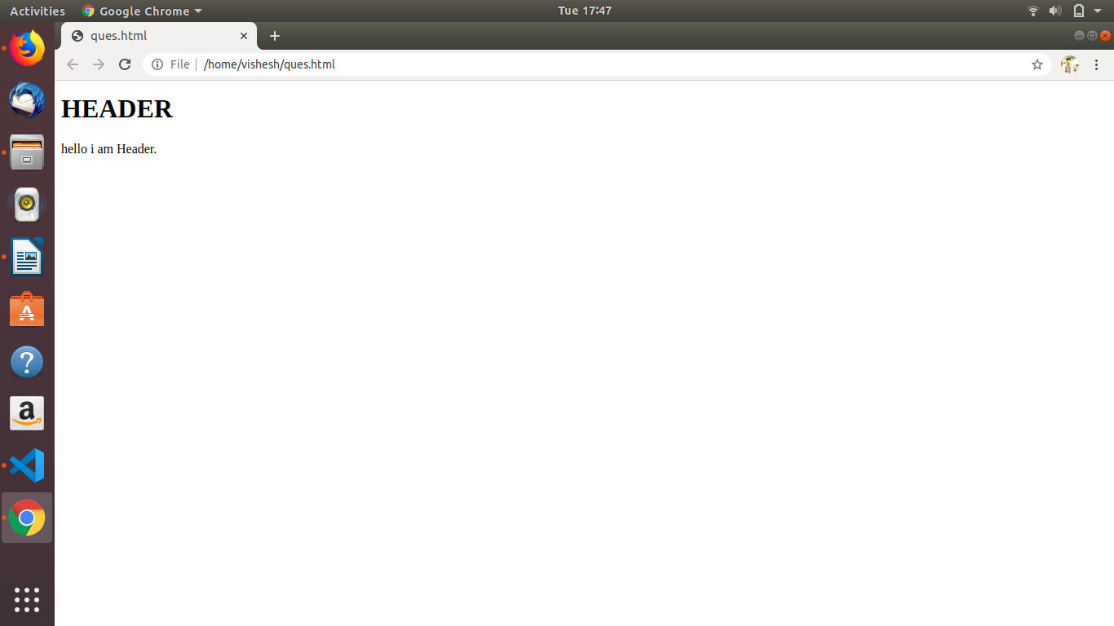
3) Nav Element: The <nav> element defines a set of navigation links.
