Assignment Overview
This assignment demonstrates the use of Git for version control, including branch creation, commits, merging, resetting, rebasing, conflict resolution, and pushing changes to a remote GitHub repository.

Task 1 – Create and Push vish56 Branch
Objective: Create a new branch, add the Flask project files, commit the changes, and push the branch to GitHub.
Commands:
git checkout -b vish56
git add .
git commit -m "Add Flask project on vish56 branch"
git push origin vish56
Explanation: Created a new branch named vish56, committed the Flask project, and pushed it to GitHub.

Task 2 – Create and Push vish56_new Branch
Objective: Modify the JSON data, commit the changes, and push the updated branch.
Commands:
git checkout -b vish56_new
git add data.json
git commit -m "Update JSON data in vish56_new branch"
git push origin vish56_new
Explanation: Updated the JSON file in a separate feature branch and pushed it to GitHub.

Task 3 – Merge Branches
Commands:
git checkout main
git merge master_2
git merge master_1
git push origin main
Explanation: Merged feature branches into the main branch.

Task 4 – Reset and Rebase
Commands:
git reset --soft <commit_hash>
git commit -m "Recommit todo form enhancements"
git rebase main
git push --force-with-lease origin master_1
Explanation: Performed a soft reset, recommitted changes, rebased onto the latest main branch, resolved conflicts, and force-pushed the updated history.

Learning Outcomes
• Created and managed Git branches.
• Performed commits and merges.
• Used Git Reset and Git Rebase.
• Resolved merge conflicts.
• Safely pushed rewritten history using --force-with-lease.

GitHub Repository
https://github.com/vish56/git-module-2

Screenshot
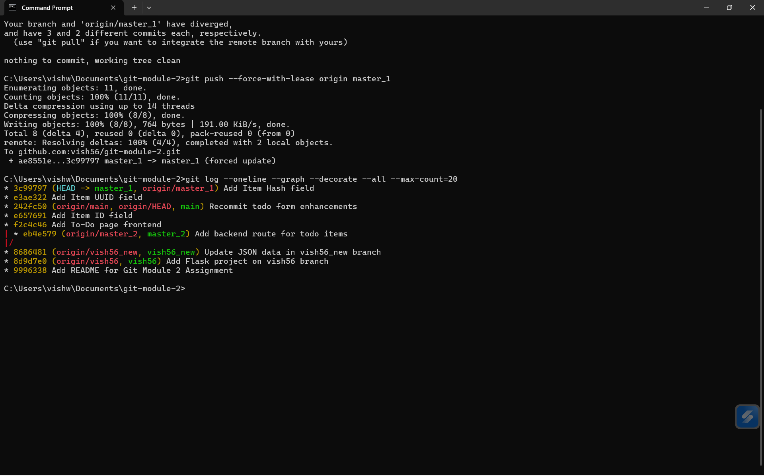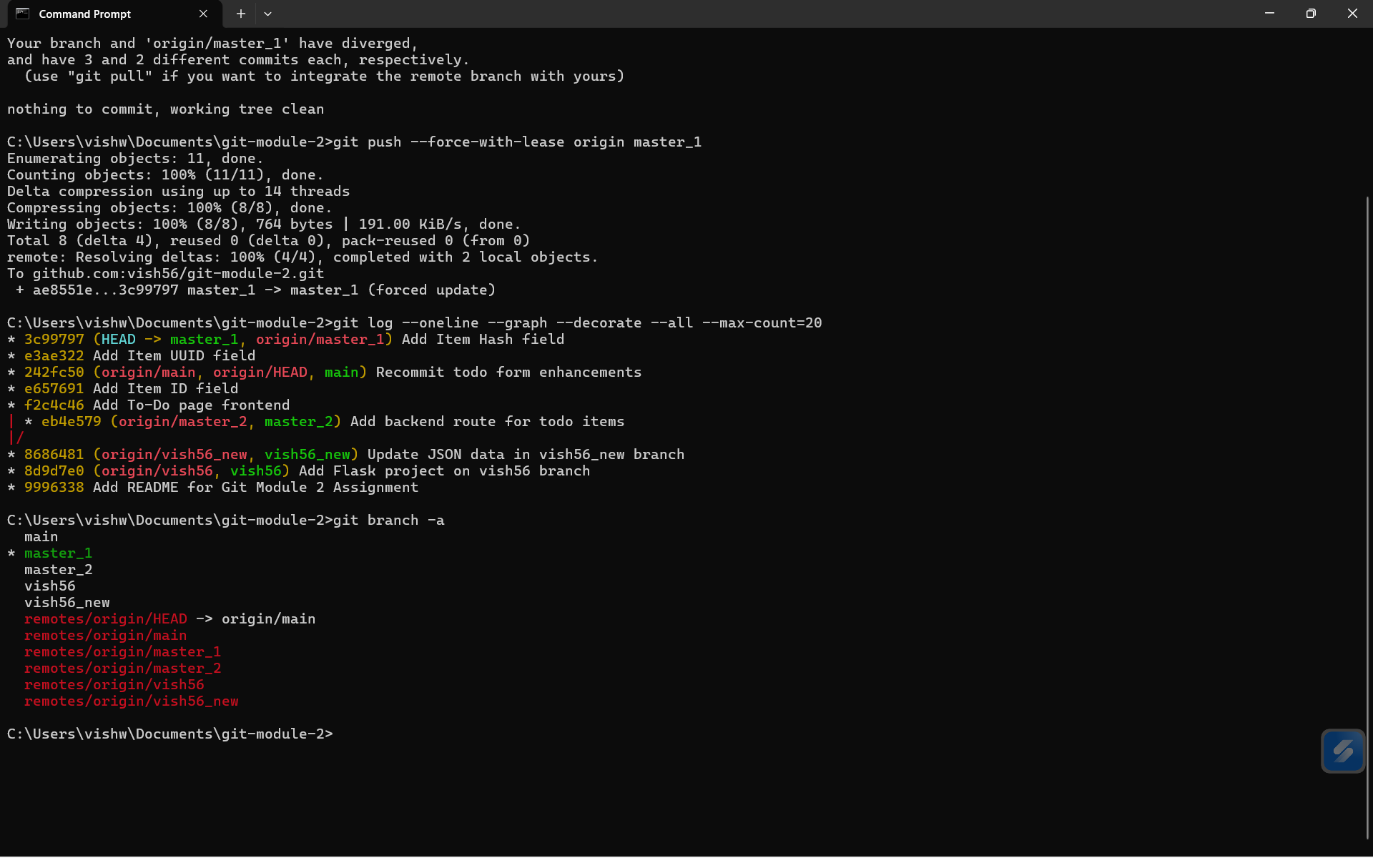

Conclusion
The assignment was completed successfully by implementing branching, merging, reset, rebase, conflict resolution, and GitHub integration.

