Flask Assignment Report

Objective
• Create a Flask application with an /api endpoint that reads data from a backend JSON file and returns it as JSON.
• Create an HTML form that stores data in MongoDB Atlas and redirects to a success page.

Technologies Used
- Python
- Flask
- MongoDB Atlas
- HTML
- Git
- GitHub

Question 1: Flask API
The /api endpoint reads records from data.json using json.load() and returns them using jsonify(). This demonstrates how Flask serves JSON data from a backend file.
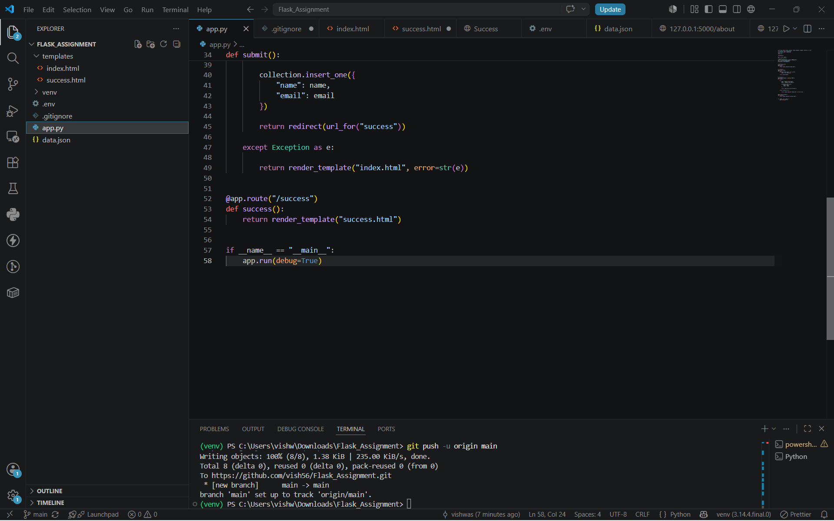
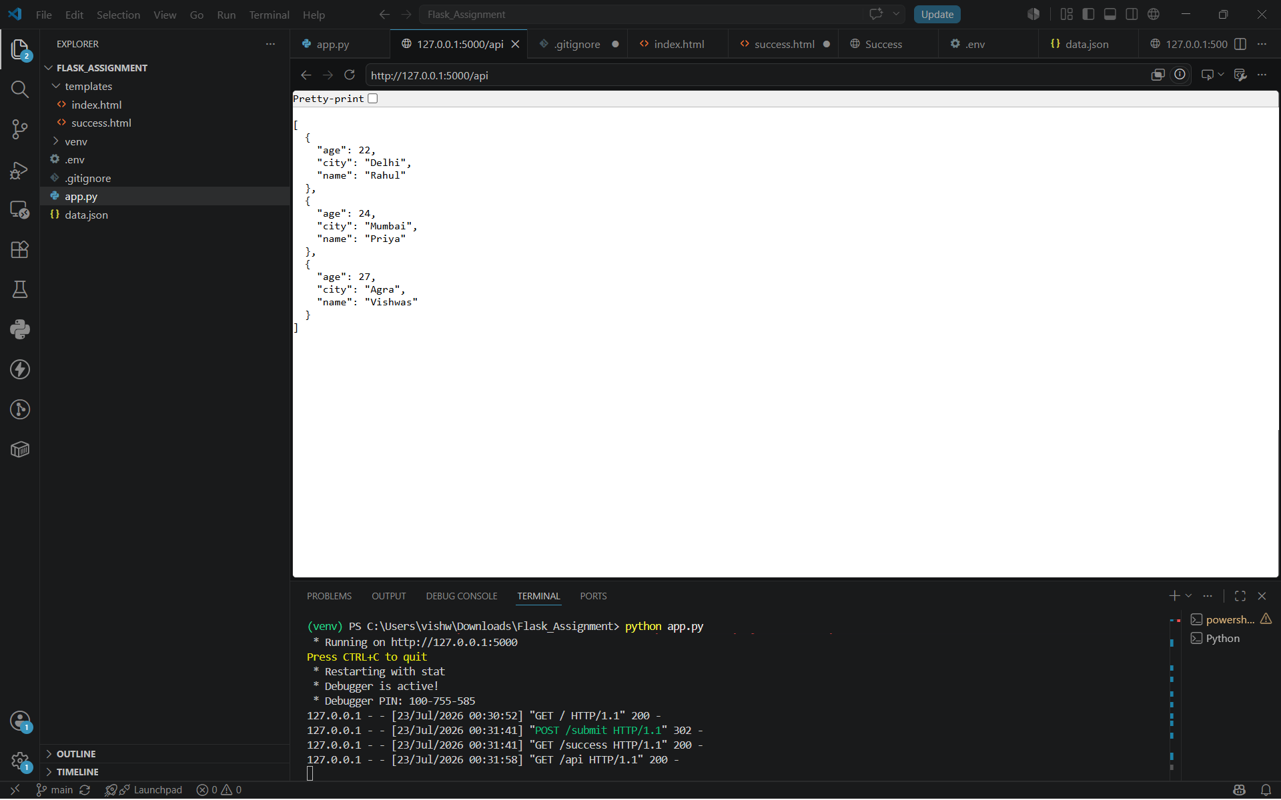

Question 2: MongoDB Form
An HTML form accepts the user's name and email. Flask receives the POST request, connects to MongoDB Atlas using PyMongo, stores the data with insert_one(), and redirects the user to a success page. Errors are displayed on the same page.
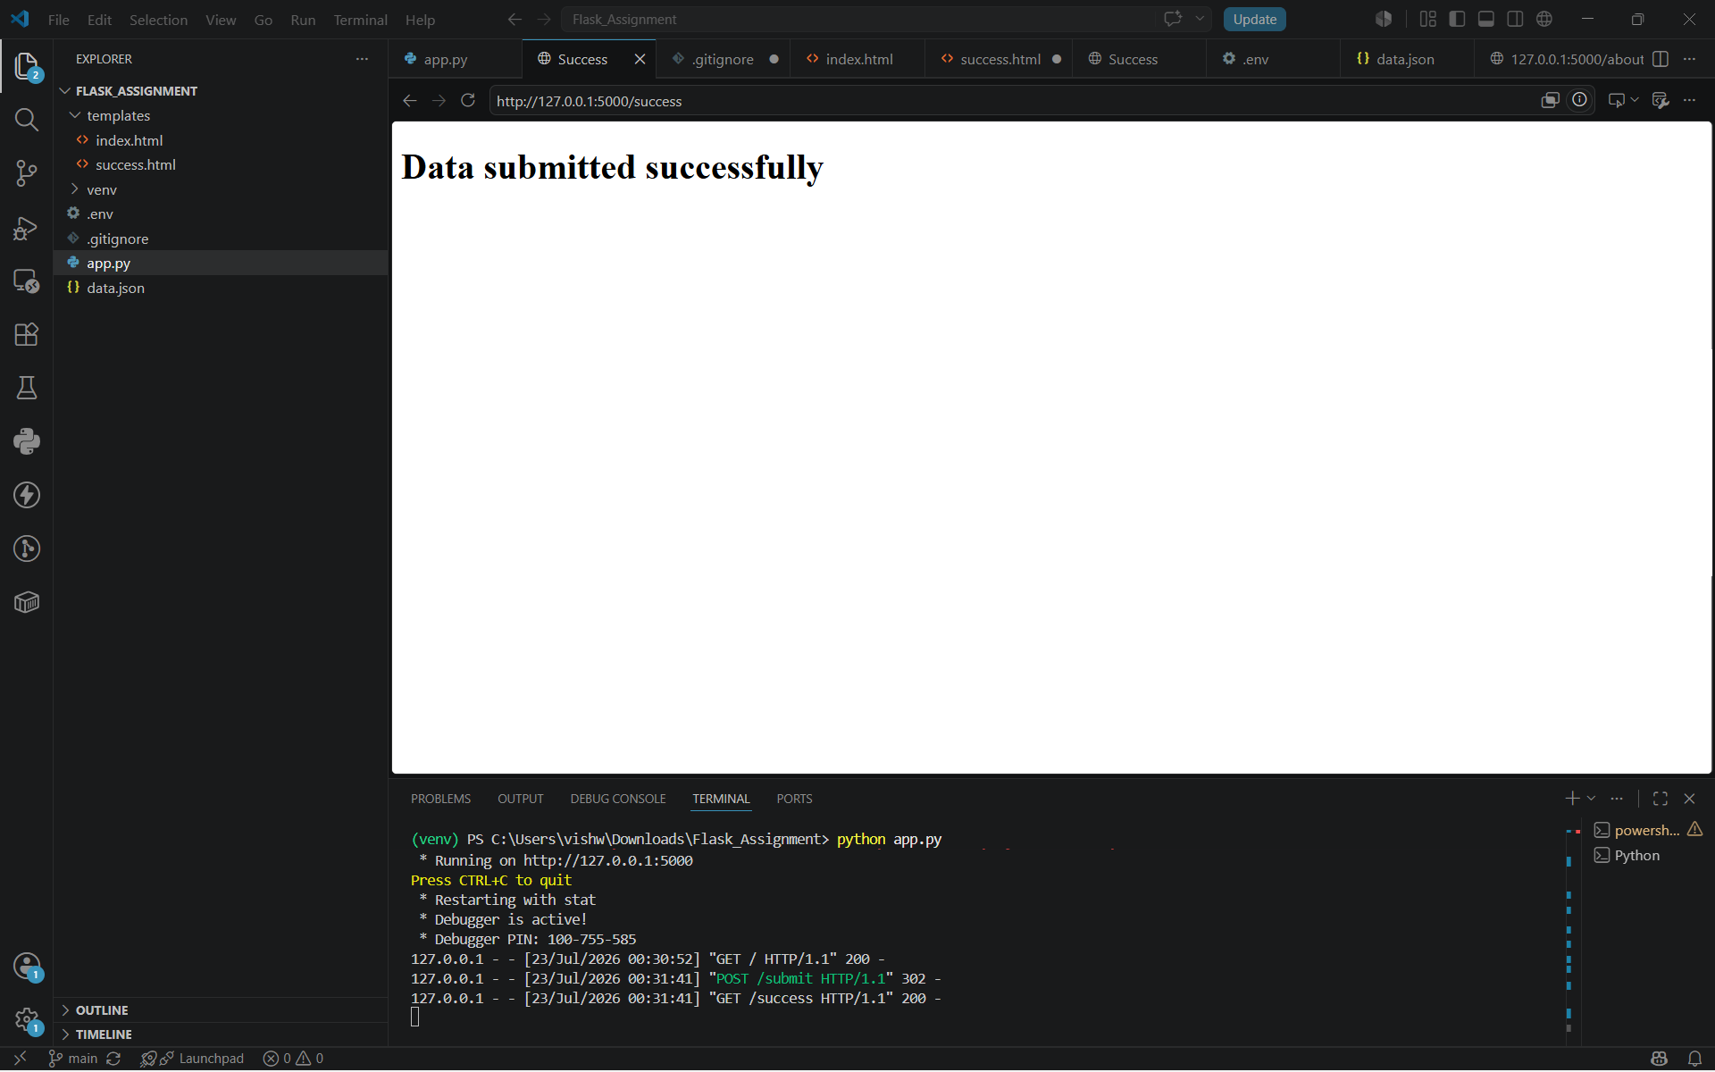
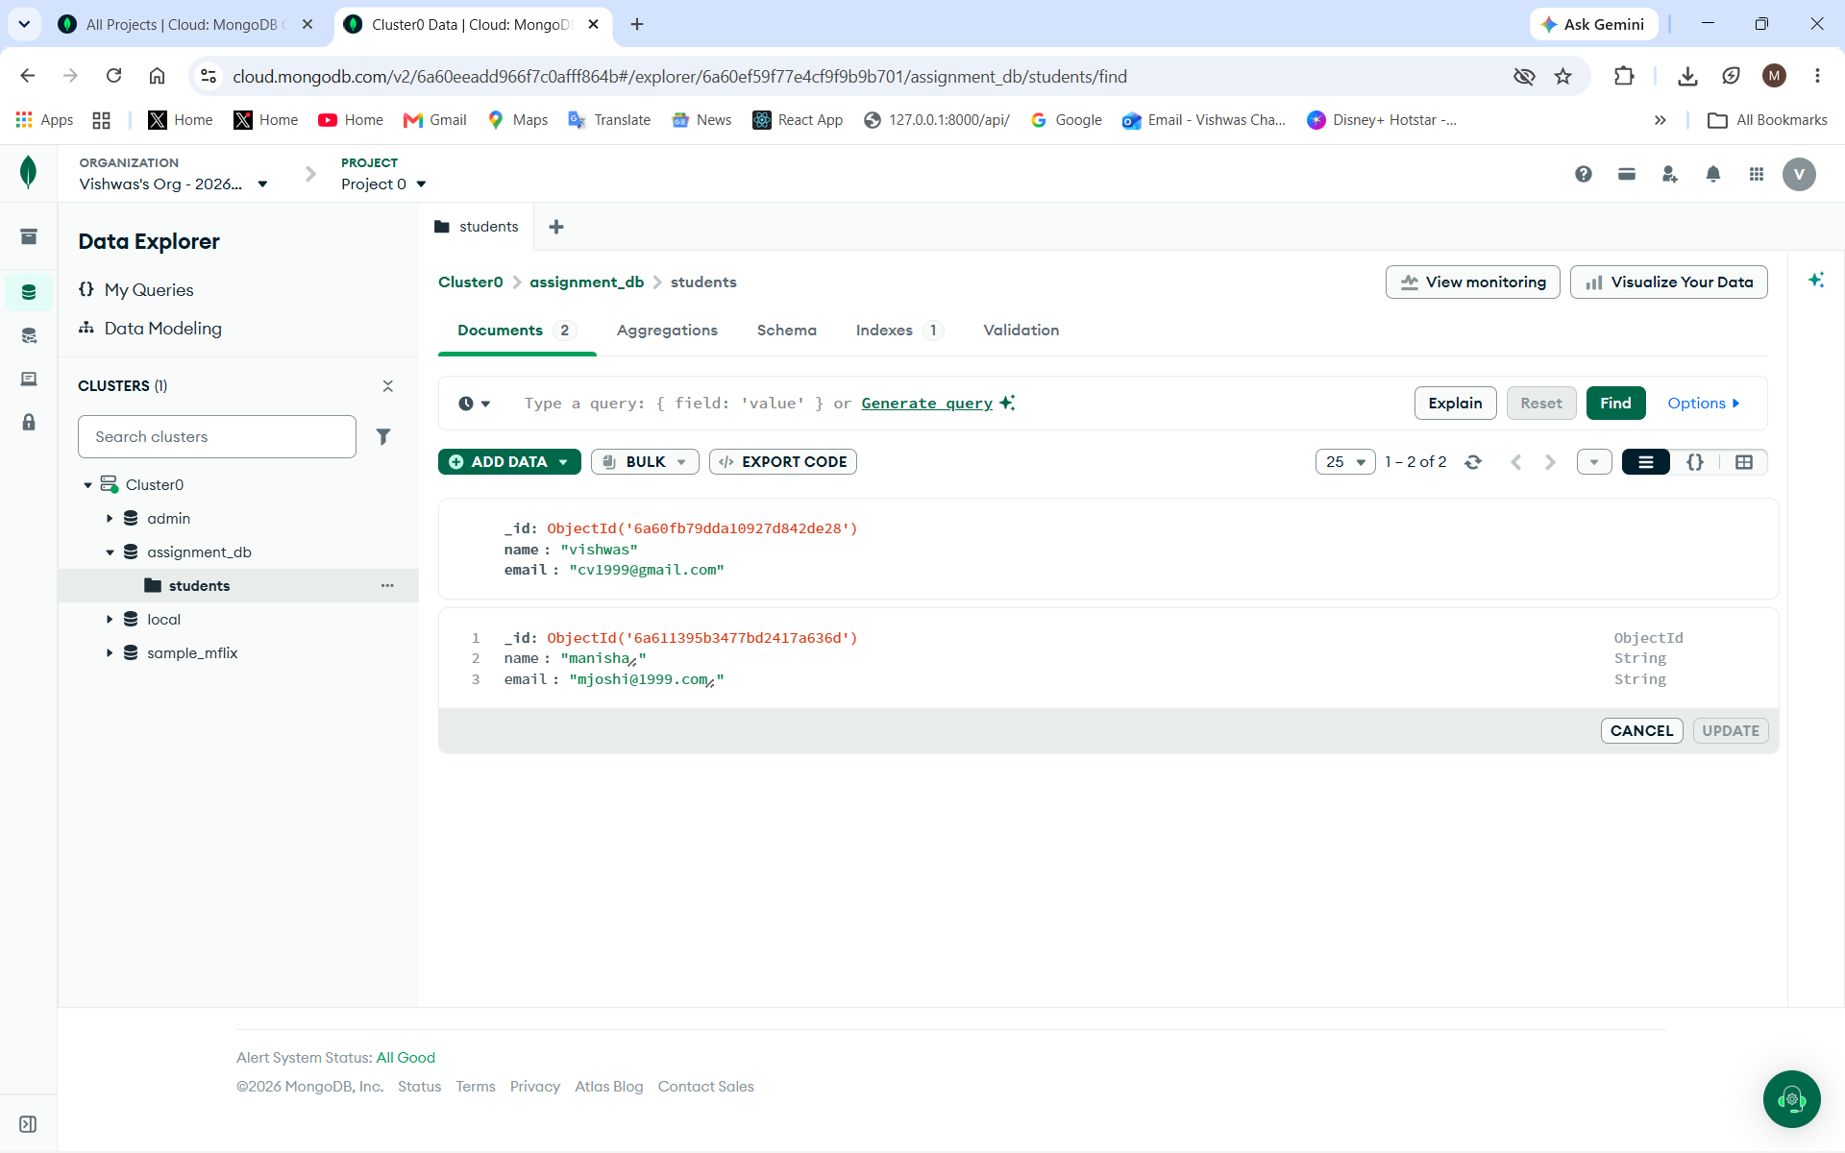

Conclusion
The assignment was completed successfully. The Flask API returns JSON from a backend file, the HTML form stores data in MongoDB Atlas, and the project is managed using Git and GitHub.

