**Methdology**

* **Hardware and Software Requirement**

**Minimum Hardware Requirements for the project:**

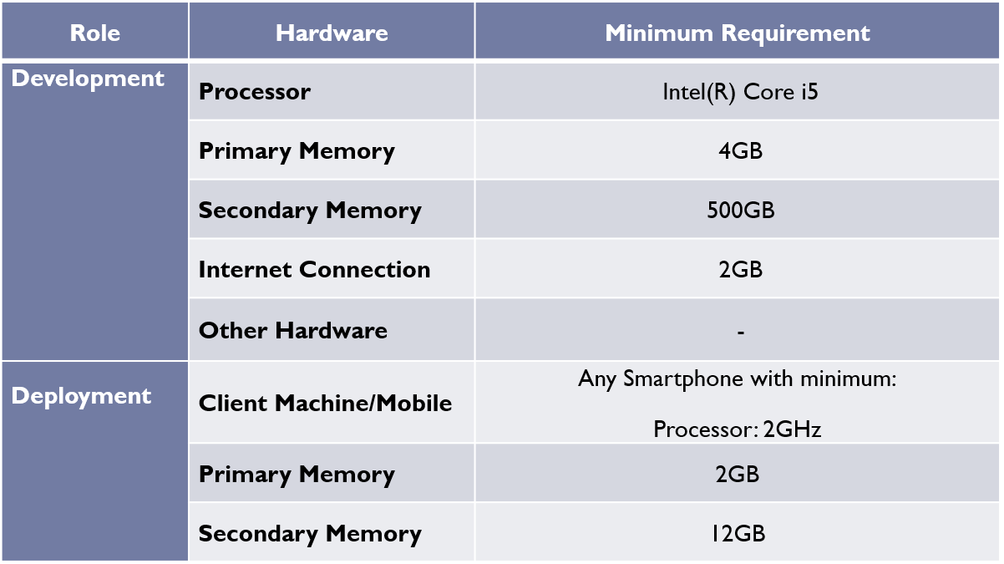

* **Minimum Software Requirements for the project:**

