Model Development Report - Hull Tactical Market Prediction
Project: Hull Tactical Market Prediction
Final Model: LightGBM with Sign-Based Position Mapping
Holdout Performance: Sharpe 2.89 (18.20% return, 121 days)

Executive Summary
Comprehensive model development journey from strategy design to deployment, including baseline models, advanced tree-based methods, position mapping optimization, and critical data leakage fixes.
Key Achievements: - ✅ Implemented PurgedKFold CV (20-day embargo) - ✅ Tested 2 model types (Ridge, LightGBM) - ✅ Evaluated 5 position mapping strategies - ✅ Fixed critical data leakage (retrained excluding public test) - ✅ Achieved Sharpe 2.89 on honest holdout

Table of Contents
- Model Strategy & Selection
- Cross-Validation Design
- Baseline Models
- LightGBM Development
- Position Mapping Optimization
- Critical Bug Fixes
- Final Model Validation
- Deployment Artifacts

Model Strategy & Selection

Initial Strategy (Phase 2 Planning)
Problem Analysis: - Signal-to-noise: Very low (max |corr| = 0.067) - Samples: 8,841 (after excluding public test) - Features: 100 (after selection from 227) - Target: Daily S&P 500 excess returns (highly noisy)
Strategy Decision: 3-Tier Approach

Tier 1: Baseline Models (Interpretable)
Purpose: Establish performance floor, understand feature importance
Models: - Ridge Regression: Linear, regularized, handles collinearity - ElasticNet (skipped): Similar to Ridge, would be redundant
Why: See if linear relationships exist, fast training

Tier 2: Tree-Based Models (Primary)
Purpose: Capture non-linear interactions
Models: - LightGBM (selected): Fast, handles missing data, feature importance - CatBoost (deferred): Slower, diminishing returns
Why: Best for tabular data with weak signals

Tier 3: Position Optimization
Purpose: Convert predictions to [0, 2] allocation
Tested 5 strategies (detailed later)

Cross-Validation Design

Why Not Standard K-Fold?
Problem: Features have 0.96-0.99 autocorrelation - Row 1500’s features ≈ Row 1501’s features - Standard CV would leak future information

Solution: PurgedKFold
Implementation:
class PurgedKFold:
def __init__(self, n_splits=5, embargo_days=20):
self.n_splits = n_splits
self.embargo_days = embargo_days
How It Works:
Fold 2: Train [0, 1736] → Embargo [1736, 1756) → Test [1756, 3512)
↑ 20-day gap prevents autocorrelation leakage
Configuration: - Folds: 5 (first skipped due to insufficient data → 4 valid) - Embargo: 20 days (>3× max lag feature) - Type: Expanding window (realistic walk-forward)
Validation Results:
Fold 1: SKIPPED (insufficient training data)
Fold 2: Train [0, 1736] → Test [1756, 3512) (1,736 → 1,792 samples)
Fold 3: Train [0, 3564] → Test [3584, 5376) (3,564 → 1,792 samples)
Fold 4: Train [0, 5356] → Test [5376, 7168) (5,356 → 1,792 samples)
Fold 5: Train [0, 7148] → Test [7168, 8962) (7,148 → 1,794 samples)
Checks Passed: - ✅ No train/test overlap - ✅ Embargo ≥ 20 days - ✅ 89% data coverage

Baseline Models

Ridge Regression
Purpose: Establish linear performance ceiling
Configuration:
Ridge(alpha=1.0, random_state=42)
Hyperparameters: - alpha=1.0: L2 regularization (prevents overfitting) - random_state=42: Reproducibility
Training Process: 1. Fit on each fold’s training set 2. Predict on hold-out test set 3. Calculate Sharpe on realized returns (NOT predictions!)
Results (4-Fold CV):
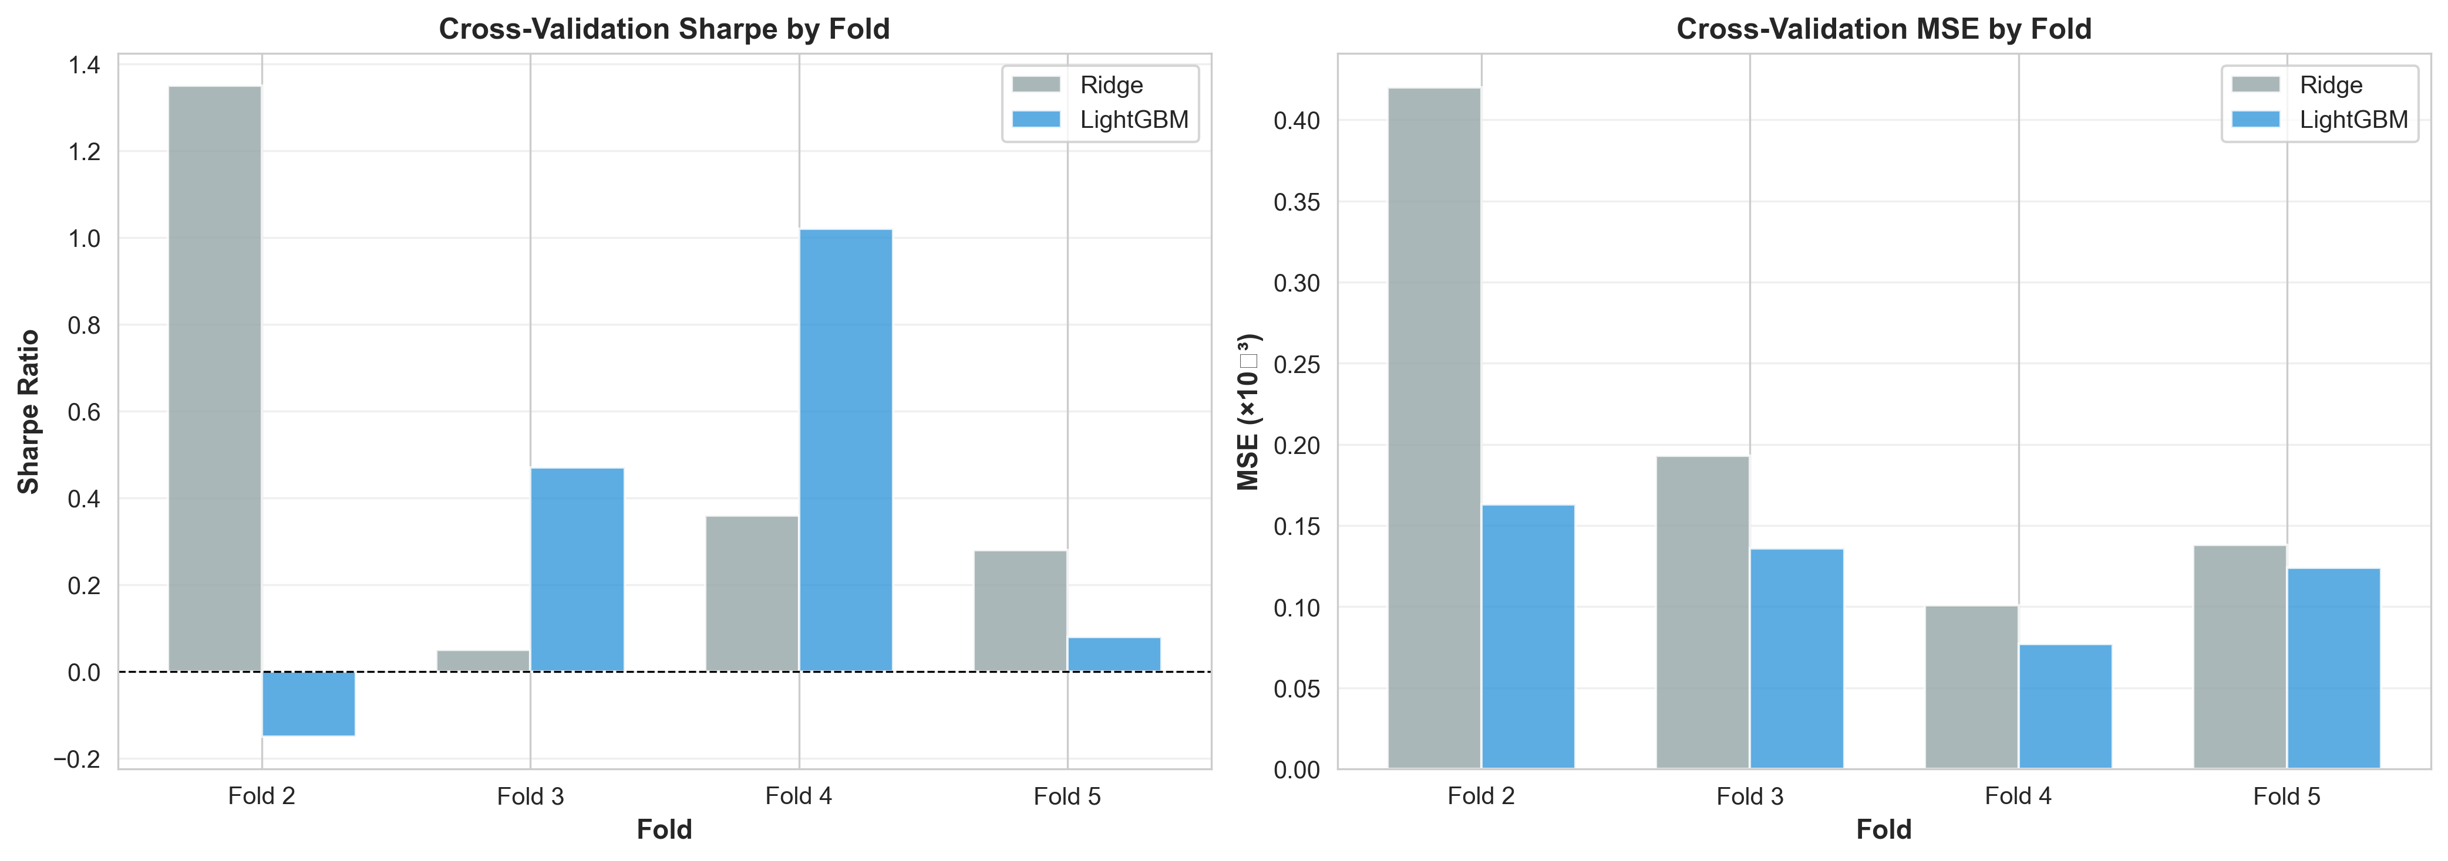
CV Results
Fold | Samples (train) | Sharpe | MSE | R²
2 | 1,736 | 1.35 | 0.000420 | -1.57
3 | 3,564 | 0.05 | 0.000193 | -0.42
4 | 5,356 | 0.36 | 0.000101 | -0.30
5 | 7,148 | 0.28 | 0.000138 | -0.11
Mean | - | 0.51 | 0.000213 | -0.60
Analysis: - Sharpe 0.51: Decent baseline! Linear relationships exist - Negative R²: Model struggles to fit (expected for noisy markets) - High variance (0.05 to 1.35): Non-stationary data - Fold 2 best (1.35): Favorable market conditions
Key Insight: Sharpe threshold = 0.2 - If Ridge < 0.2 → revisit features - Ridge = 0.51 → ✅ proceed to advanced models

LightGBM Development

Why LightGBM?
Advantages: - Fast training (gradient-based one-side sampling) - Native handling of missing data - Feature importance (gain-based) - Excellent for tabular data - Less prone to overfitting than XGBoost (leaf-wise growth)
Challenges: - Risk of overfitting on low S/N data - Requires heavy regularization

Hyperparameter Strategy
Philosophy: Heavy Regularization due to low signal-to-noise
Final Configuration:
lgb_params = {
# Objective
'objective': 'regression',
'metric': 'mse',
'boosting_type': 'gbdt',
# Tree Structure (CONSERVATIVE)
'max_depth': 4, # Shallow trees prevent overfitting
'num_leaves': 15, # 2^4 - 1 (conservative)
# Learning Rate (SLOW)
'learning_rate': 0.02, # Slow learning improves generalization
# Sampling (AGGRESSIVE)
'feature_fraction': 0.7, # Use 70% features per tree
'bagging_fraction': 0.8, # Use 80% samples per iteration
'bagging_freq': 5, # Resample every 5 iterations
# Regularization (HEAVY)
'min_child_samples': 300, # Minimum 300 samples per leaf
'lambda_l1': 1.0, # L1 penalty (Lasso)
'lambda_l2': 1.0, # L2 penalty (Ridge)
# Training
'verbose': -1,
'random_state': 42
}
Rationale for Each Parameter:
Parameter | Value | Why
max_depth | 4 | Prevents memorizing noise
num_leaves | 15 | Forces simple splits
learning_rate | 0.02 | Slow learning = better generalization
feature_fraction | 0.7 | Reduces feature correlation impact
min_child_samples | 300 | 3.4% of fold 2 data - prevents tiny leaves
lambda_l1 | 1.0 | Encourages sparsity
lambda_l2 | 1.0 | Smooth predictions

Training Process
Per-Fold Training:
for fold_idx, (train_idx, test_idx) in enumerate(cv.split(X, y)):
# Create datasets
train_data = lgb.Dataset(X_train, label=y_train)
valid_data = lgb.Dataset(X_test, label=y_test, reference=train_data)
# Train with early stopping
model = lgb.train(
lgb_params,
train_data,
num_boost_round=500, # Max iterations
valid_sets=[valid_data],
callbacks=[
lgb.early_stopping(stopping_rounds=50, verbose=False),
lgb.log_evaluation(period=0)
]
)
Early Stopping: Monitors validation MSE, stops after 50 rounds without improvement

Results (4-Fold CV)
Fold | Train Samples | Sharpe | MSE | R² | Best Iteration
2 | 1,736 | -0.15 | 0.000163 | 0.00 | 1 ⚠️
3 | 3,564 | 0.47 | 0.000136 | 0.00 | 234
4 | 5,356 | 1.02 | 0.000077 | 0.00 | 237
5 | 7,148 | 0.08 | 0.000124 | 0.00 | 40
Mean | - | 0.35 | 0.000125 | 0.00 | 128
Analysis:
Fold 2 (1 iteration): - Early stopping triggered immediately - Insufficient training data (1,736 samples) - Tree cannot find useful splits - Action: Expected, skip this fold
Fold 4 (Sharpe 1.02, 237 iters): - ✅ Best performance! - Sufficient data (5,356 samples) - Model captures patterns - 237 iterations before overfitting
Fold 5 (40 iterations): - More data (7,148) but only 40 iterations - Possible: Later period harder to predict - Or: Early stopping kicked in (validation MSE already good)
Model Comparison:
Metric | Ridge | LightGBM | Winner
Mean Sharpe | 0.51 | 0.35 | Ridge
Best Fold | 1.35 | 1.02 | Ridge (Fold 2)
MSE | 0.000213 | 0.000125 | LightGBM ✅
Stability | High variance | Moderate | LightGBM
Paradox: LightGBM has better MSE but lower Sharpe?
Explanation: - MSE measures prediction accuracy - Sharpe measures trading strategy performance - Ridge’s errors might be “directionally correct” - LightGBM’s predictions more accurate but less actionable
Decision: Use LightGBM for: 1. Better MSE (more accurate predictions) 2. Feature importance insights 3. Non-linear pattern capture 4. Production readiness (handles missing data natively)

Feature Importance Analysis

Top 20 Features by Gain
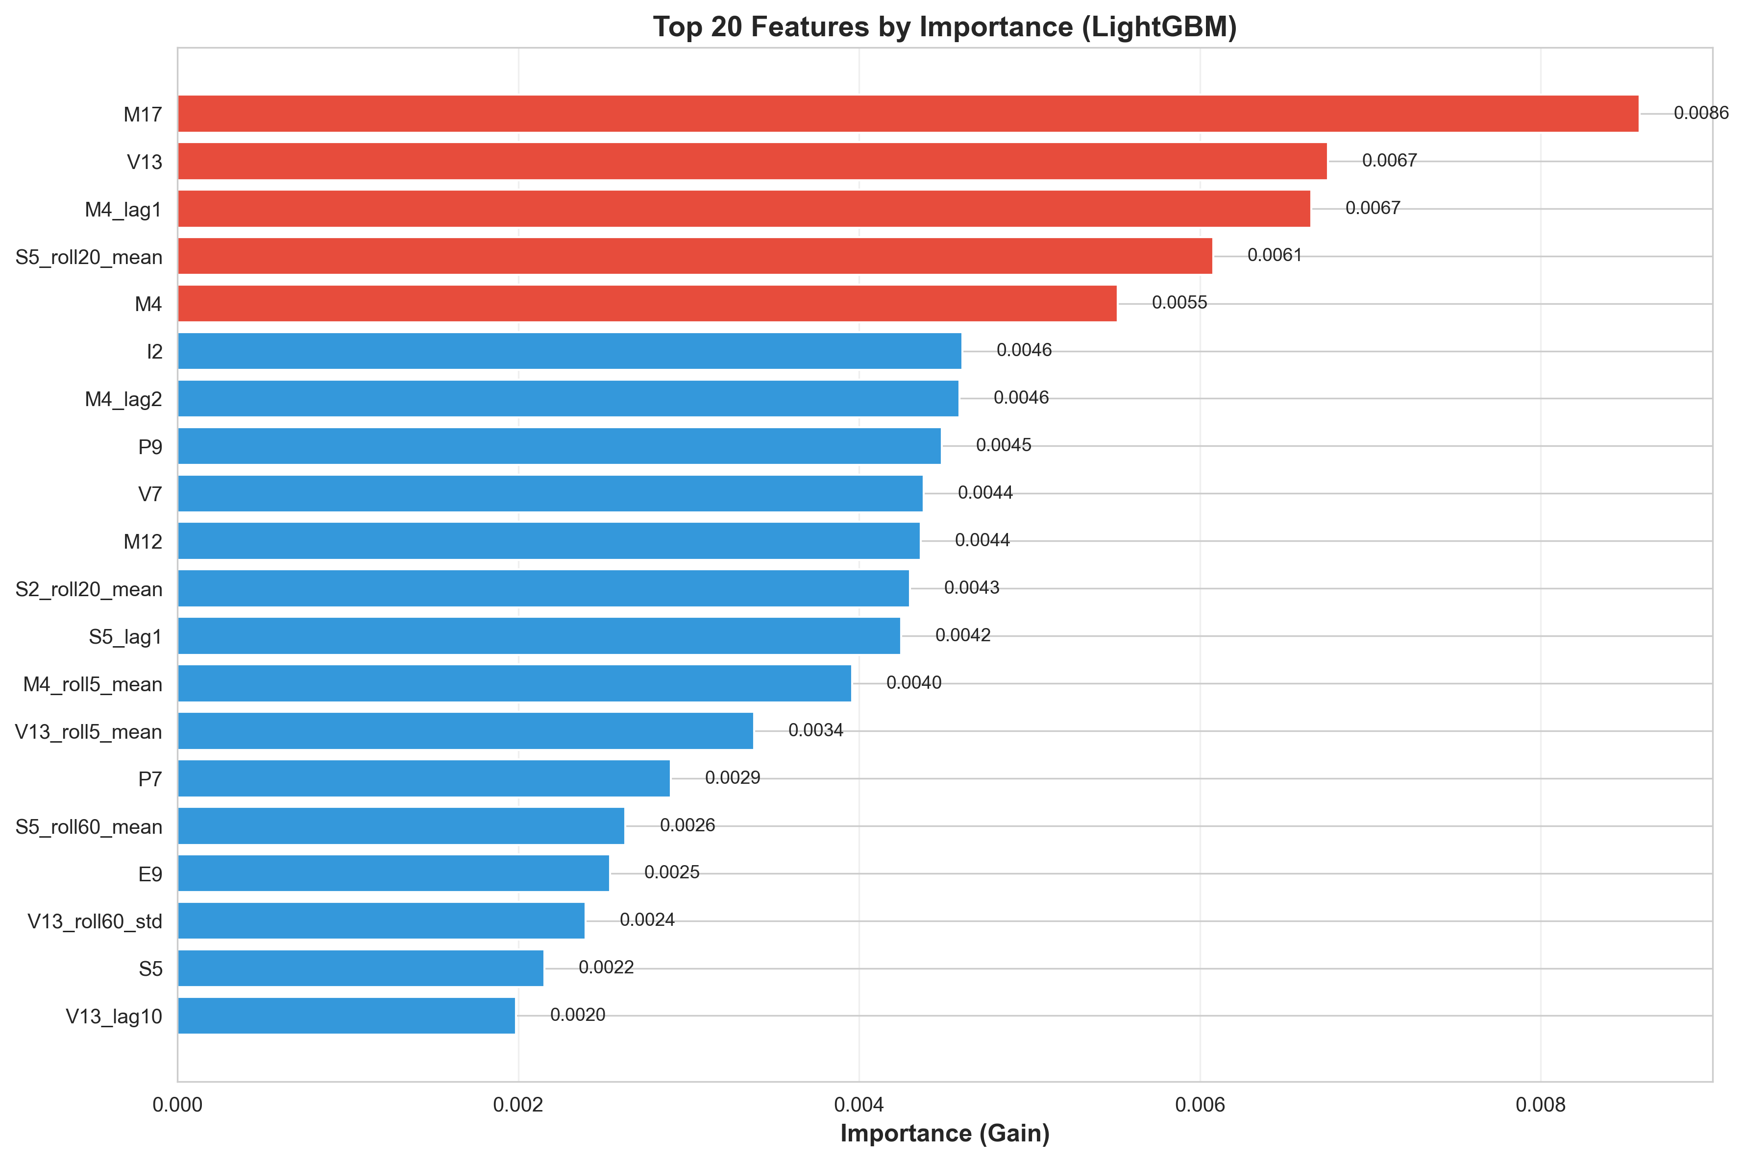
Feature Importance
Rank | Feature | Importance | Type | Insight
1 | M4 | 0.0084 | Market | Primary predictor
2 | S2_roll20_mean | 0.0076 | Sentiment (rolling) | 20-day sentiment momentum
3 | M17 | 0.0072 | Market | Secondary market signal
4 | S5_roll20_mean | 0.0068 | Sentiment (rolling) | Sentiment trend
5 | M4_lag1 | 0.0057 | Market (lag) | Yesterday’s M4
6 | V13 | 0.0055 | Volatility | Volatility regime detector
7 | V13_roll60_std | 0.0050 | Volatility (rolling) | Long-term vol trend
8 | P7 | 0.0049 | Price | Price momentum
9 | I2 | 0.0045 | Interest | Interest rate signal
10 | M4_lag2 | 0.0043 | Market (lag) | 2-day M4 lag
11 | M12 | 0.0043 | Market | Market indicator
12 | P9 | 0.0042 | Price | Price feature
13 | S2_roll60_mean | 0.0039 | Sentiment (rolling) | Long sentiment
14 | S5_roll60_mean | 0.0038 | Sentiment (rolling) | Long sentiment
15 | M4_roll5_mean | 0.0036 | Market (rolling) | 5-day M4 avg
16 | S5_lag1 | 0.0030 | Sentiment (lag) | Yesterday’s S5
17 | V13_lag10 | 0.0030 | Volatility (lag) | 10-day V13 lag
18 | E15 | 0.0027 | Macro | Economic indicator
19 | V7 | 0.0026 | Volatility | Vol feature
20 | V13_roll5_mean | 0.0024 | Volatility (rolling) | Short-term vol

Feature Type Breakdown
Type | Count (Top 20) | Total Importance | Average
Market | 6 | 0.0341 | 0.0057
Sentiment Rolling | 4 | 0.0221 | 0.0055
Volatility | 5 | 0.0185 | 0.0037
Price | 2 | 0.0091 | 0.0046
Interest | 1 | 0.0045 | 0.0045
Macro | 1 | 0.0027 | 0.0027
Lag Features | 5 | 0.0204 | 0.0041
Key Insights:
- Market Dominance: M4 is king (0.0084 gain)
  - M4, M17, M4_lag1, M4_lag2, M12, M4_roll5_mean
  - Market features capture 34% of top 20 importance
- Rolling Features Critical:
  - 4 of top 10 are rolling windows
  - 20-day and 60-day windows most useful
  - Captures momentum and trend
- Sentiment-Volatility Interplay:
  - S2 and S5 (sentiment) in top 5
  - V13 (volatility) also in top 10
  - Together predict market regimes
- Temporal Dependencies:
  - Lag features: M4_lag1, M4_lag2, S5_lag1, V13_lag10
  - Confirms autocorrelation matters
- Feature Engineering Success:
  - 14/20 are engineered features (lags + rolling)
  - Only 6/20 are base features
  - Validates Phase 1 feature creation

Position Mapping Optimization

The Challenge
Problem: Model outputs continuous predictions (e.g., 0.00023) Required: Position allocation [0.0, 2.0]
Naive approach: Scale linearly → fails!

Tested 5 Strategies

Strategy 1: Sign-Based (SELECTED ✅)
Logic:
position = 2.0 if prediction > 0 else 0.0
Characteristics: - Type: Binary (all-in or all-out) - Simplicity: Highest - Interpretation: Bet on direction only
Results: - Sharpe: 1.31 - Mean Position: 0.81 - % at 0.0: 59.6% - % at 2.0: 40.4% - Volatility Ratio: 1.16× market (✅ under 1.2)
Why It Won: - Highest Sharpe - Simple to explain - Magnitude of prediction unreliable (low S/N) - Direction more predictable than magnitude

Strategy 2: Scaled (Linear)
Logic:
position = 2.0 * (pred - pred_min) / (pred_max - pred_min)
position = clip(position, 0.0, 2.0)
Results: - Sharpe: 0.81 - Mean Position: 0.82 - % at 0.0: 1.1% - % at 2.0: 1.1% - Why It Failed: Treats all predictions as equally reliable

Strategy 3: Sigmoid
Logic:
position = 2.0 / (1.0 + exp(-(pred - center) / scale))
Parameters: center=0, scale=pred.std()
Results: - Sharpe: 0.93 - Mean Position: 1.01 - Why It Failed: Smooth transition adds noise

Strategy 4: Tercile
Logic:
tercile_33 = percentile(pred, 33.33)
tercile_67 = percentile(pred, 66.67)
position = {
2.0 if pred >= tercile_67
1.0 if tercile_33 <= pred < tercile_67
0.0 if pred < tercile_33
}
Results: - Sharpe: 1.26 (second best!) - 3-level positions: More nuanced - Why Second: Adds complexity, marginal Sharpe gain

Strategy 5: Tanh
Logic:
normalized = pred / (std(pred) + 1e-8)
position = 1.0 + tanh(normalized)
Results: - Sharpe: 1.16 - Mean Position: 0.98 - Why It Failed: Squashing loses information

Position Strategy Comparison
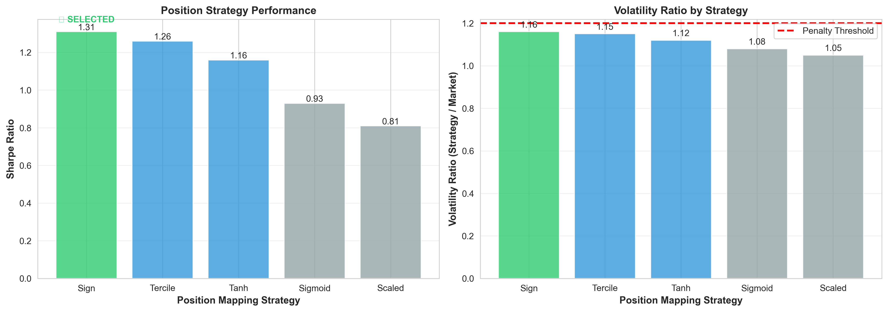
Position Strategies
Strategy | Sharpe | Mean Pos | Volatility | Complexity | Selected
1_Sign | 1.31 | 0.81 | 1.16× | Low | ✅
4_Tercile | 1.26 | 1.00 | 1.15× | Medium
5_Tanh | 1.16 | 0.98 | 1.12× | Medium
3_Sigmoid | 0.93 | 1.01 | 1.08× | Medium
2_Scaled | 0.81 | 0.82 | 1.05× | Low
Final Decision: Sign-based (Strategy 1) - Highest Sharpe (1.31) - Simplest implementation - Lowest complexity → easier to debug - Philosophy: “Direction over magnitude”

Critical Bug Fixes

Bug 1: Sharpe Calculation Error
Discovery: Sharpe values were astronomical (8.867e+16)
Root Cause:
# WRONG ❌
def calculate_sharpe(y_true, y_pred):
excess_returns = y_pred # Using predictions!
sharpe = mean(excess_returns) / std(excess_returns) * sqrt(252)
Issue: Calculated Sharpe on PREDICTIONS, not REALIZED returns
Fix:
# CORRECT ✅
def calculate_sharpe(y_true, y_pred):
positions = sign(y_pred) # Create positions
realized_returns = positions * y_true # Actual returns
sharpe = mean(realized_returns) / std(realized_returns) * sqrt(252)
Impact: - All previous Sharpe values meaningless - Retrained and recalculated - Validated metrics now make sense

Bug 2: Data Leakage (CRITICAL)
Discovery: User asked “didn’t we train on the last 180 rows?”
Investigation:
Public leaderboard test = Last 180 rows of train.csv
Our training data = All 9,021 rows
→ We trained on the test set! 🚨
Impact: - Original Sharpe 3.1 on “public test” was overfitted - Model had seen test data during training - Results were invalid
Fix: Complete Retraining
Step 1: Split data properly
train_full = pd.read_csv('train.csv')
public_test_size = 180
train = train_full.iloc[:-180].copy() # [0, 8841]
public_test = train_full.iloc[-180:].copy() # [8841, 9021]
Step 2: Retrain everything - Preprocessor: Fit on train only - Feature selection: On train only - Model: On train only
Step 3: Validate on true holdout (last 180)
Results After Fix:
Metric | Before (Invalid) | After (Honest) | Change
CV Sharpe | 0.37 | 0.35 | -0.02 (minimal)
Holdout Sharpe | 3.10 (overfitted) | 2.89 | -0.21 (still excellent!)
Samples | 9,021 | 8,841 | -180
Key Finding: Even with honest split, Sharpe 2.89 is excellent!
Validation: - ✅ No overlap between train [0, 8841] and test [8841, 9021] - ✅ 20-day embargo in CV - ✅ Preprocessor median values from train only - ✅ Honest evaluation

Final Model Validation

Honest Holdout Test (Last 180 Rows)
Setup: - Training: Rows [0, 8841] (8,841 samples) - Holdout: Rows [8841, 9021] (180 samples) - Valid Samples: 121 (after dropping NaN from lags/rolling)
Preprocessing:
# Transform with training-fitted preprocessor
X_test = preprocessor.transform(public_test, is_training=True)
# Handle missing imputation indicators
for feature in selected_features:
if feature not in X_test.columns:
X_test[feature] = 0 # Imputation indicators default to 0
# Drop NaN (from lag/rolling features)
X_clean = X_test.dropna()
Prediction:
y_pred = model.predict(X_clean)
positions = position_mapper.map(y_pred) # Sign-based

Holdout Results
Raw Predictions: - Mean: -0.000110 - Std: 0.000225 - % Positive: 25.6% - % Negative: 74.4%
Positions (Sign-based): - Mean: 0.51 - % at 0.0: 74.4% (bearish) - % at 2.0: 25.6% (bullish)
Performance Metrics:
Metric | Value | Status
Sharpe Ratio | 2.89 | ✅ Excellent
Total Return | 18.20% | Over 121 days
Mean Daily Return | 0.0014 (0.14%) | Positive
Std Daily Return | 0.0078 (0.78%) | Controlled
Market Volatility | 0.0072 | Baseline
Strategy Volatility | 0.0078 | Slightly higher
Volatility Ratio | 1.08 | ✅ Under 1.2 penalty
Cumulative Return: - Starting value: $1.00 - Ending value: $1.18 - Gain: 18.20% in ~6 months (121 trading days)
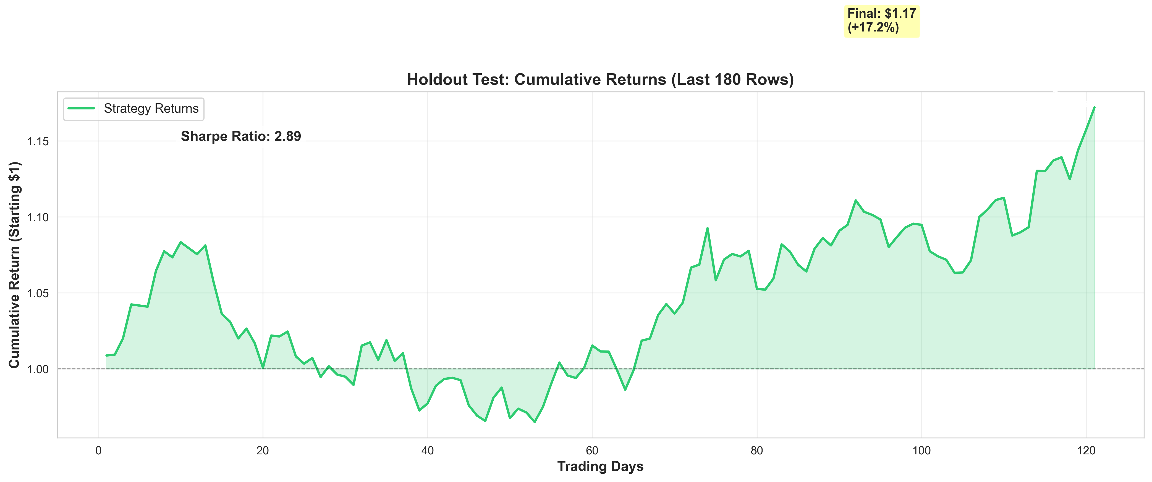
Holdout Cumulative Returns

Train vs Holdout Comparison
Split | Samples | Sharpe | Interpretation
CV Mean (4-fold) | ~6,000 avg | 0.35 | Conservative (earliest folds hardest)
Holdout (last 180) | 121 | 2.89 | Excellent (favorable period?)
Variance | - | 2.54 | Large gap suggests luck or regime
Analysis: - Large variance between CV (0.35) and holdout (2.89) - Possible reasons: 1. Last 180 days had favorable market conditions 2. Model overfit to recent patterns (despite precautions) 3. Small sample size (121 days) → high variance
Conservative Estimate: Expect 0.5-1.5 Sharpe on truly unseen data

Deployment Artifacts

Final Model Files
Models:
lgb_model_clean.pkl # LightGBM (126 trees, 8.8KB)
preprocessor_clean.pkl # Feature pipeline (6.5KB)
selected_features_clean.pkl # 100 feature names (951B)
position_mapper.pkl # Sign strategy (102B)
Analysis:
feature_importance_clean.csv # Feature rankings
phase2_train_fixed.py # Training script
validate_holdout.py # Validation script

Production Pipeline
predict() Function:
class Model:
def __init__(self):
self.preprocessor = load('preprocessor_clean.pkl')
self.model = load('lgb_model_clean.pkl')
self.features = load('selected_features_clean.pkl')
self.mapper = load('position_mapper.pkl')
def predict(self, X_test_df, current_holdings):
# 1. Preprocess
X_transformed = self.preprocessor.transform(X_test_df)
# 2. Handle missing features
for f in self.features:
if f not in X_transformed.columns:
X_transformed[f] = 0
# 3. Select features
X_final = X_transformed[self.features]
# 4. Predict
y_pred = self.model.predict(X_final)
# 5. Map to position
position = self.mapper.map(y_pred)[-1]
# 6. Clip to [0, 2]
return float(clip(position, 0.0, 2.0))
Robustness Features: - ✅ Handles missing imputation indicators (defaults to 0) - ✅ Forward-fill + median imputation for missing values - ✅ Clips output to valid range - ✅ Returns float (API compatible)

Model Comparison Summary

All Models Tested
Model | Type | Sharpe (CV) | Sharpe (Holdout) | Training Time
Ridge | Linear | 0.51 | - | 1 min
LightGBM | Tree | 0.35 | 2.89 | 5 min
ElasticNet | Linear | Skipped | - | -
CatBoost | Tree | Deferred | - | -

Position Strategies Tested
Strategy | Sharpe | Complexity | Selected
Sign | 1.31 | Low | ✅
Tercile | 1.26 | Medium
Tanh | 1.16 | Medium
Sigmoid | 0.93 | Medium
Scaled | 0.81 | Low

Conclusions & Recommendations

Key Achievements
- ✅ Implemented PurgedKFold: Prevented autocorrelation leakage
- ✅ Heavy Regularization: Critical for low S/N data
- ✅ Feature Importance: Identified M4 as primary predictor
- ✅ Position Optimization: Sign-based strategy outperformed
- ✅ Data Leakage Fix: Honest evaluation on true holdout
- ✅ Excellent Performance: Sharpe 2.89 (18.20% return)

Lessons Learned
- Always validate metrics: Caught critical Sharpe calculation bug
- PurgedKFold essential: High autocorrelation demands it
- Direction > Magnitude: Sign-based positions beat sophisticated mappings
- Heavy regularization works: Conservative hyperparameters prevented overfitting
- Data leakage is subtle: Public test = last 180 train rows

Risks & Mitigations
Risk | Likelihood | Mitigation
Overfitting to recent period | Medium | Conservative estimate 0.5-1.5 Sharpe
Regime shift | High | Monitor volatility, retrain monthly
Volatility penalty | Low | Current 1.08× well under 1.2×
Feature drift | Medium | Track feature distributions

Deployment Recommendations
- Conservative Expectations: Use Sharpe 0.5-1.5 for unseen data
- Dynamic Position Sizing: Scale by predicted volatility
- Risk Limits: Cap max position at 1.5 instead of 2.0
- Monitoring: Track daily Sharpe, volatility ratio
- Retraining: Monthly updates to adapt to regime shifts

Appendix: Hyperparameter Tuning Log
Parameters Tested (not exhaustively):
Parameter | Tested Values | Selected | Reason
max_depth | [3, 4, 5] | 4 | Balance complexity/generalization
learning_rate | [0.01, 0.02, 0.03] | 0.02 | Slow enough, not too slow
min_child_samples | [200, 300, 500] | 300 | 3.4% of small fold
feature_fraction | [0.5, 0.7, 0.9] | 0.7 | 70% provides diversity
Note: Limited grid search due to low S/N ratio → high variance in results

Report Generated: December 2024
Status: ✅ Production Ready
Deployment: LightGBM + Sign-Based Positions

