Business Intelligence Internship Assignment

Insurance Policy Risk & Profitability Analysis

1. Introduction
The objective of this project is to simulate an insurance dataset and analyze policy sales and claim activity to understand profitability and risk exposure in an insurance portfolio. The scenario represents a car insurance company that sold policies to customers purchasing vehicles during the year 2024.
The analysis was carried out in three stages: generating simulated datasets using Python, running analytical queries to evaluate claim behavior and profitability, and building an interactive Power BI dashboard to visualize the results.

2. Dataset Creation

2.1 Policy Sales Data
The policy dataset simulates 1,000,000 customers purchasing car insurance policies during the year 2024. Policies were assumed to be sold evenly across the year. Each policy is associated with a vehicle valued at ₹100,000 and the premium charged is ₹100 per year of policy tenure.
Policy Tenure | Distribution
1 year | 20%
2 years | 30%
3 years | 40%
4 years | 10%
Policy start date was defined as the purchase date plus 365 days, while the policy end date was calculated by adding the policy tenure to the start date.

2.2 Claims Data
Claims were generated based on specific rules. Vehicles purchased on the 7th, 14th, 21st and 28th of each month were considered defective and 30% of them filed a claim during 2025. Each claim amount was assumed to be 10% of the vehicle value (₹10,000).
In early 2026 (January 1 to February 28), 10% of vehicles with a four‑year policy tenure filed a second claim. These claims were distributed evenly across the 59‑day period.

3. Analytical Queries
The generated datasets were analyzed using SQL queries executed through Python using SQLite. The analysis focused on premium revenue, claim costs, claim ratios, and future claim liability.

3.1 Total Premium Collected
Premium revenue is calculated as policy tenure multiplied by ₹100. Based on the simulated policy distribution, the total premium collected from all policies amounts to approximately ₹240 million.

3.2 Monthly Claim Cost
Monthly claim costs were calculated for the years 2025 and 2026. Claim values remain relatively stable throughout 2025 but increase in early 2026 due to second claims from long‑tenure policies.

3.3 Claim Ratio by Policy Tenure
The claim ratio was calculated as total claims divided by total premium for each tenure group. The analysis shows that three‑year policies generate the highest premium while maintaining relatively balanced claim levels compared to other tenures.

3.4 Claim Ratio by Sales Month
Claim ratios across policy purchase months remain fairly consistent, suggesting that risk is not significantly affected by seasonal purchasing patterns.

3.5 Potential Future Claim Liability
Assuming every vehicle that has not yet filed a claim eventually files exactly one claim during the remaining policy tenure, the estimated future liability is approximately ₹9.5 billion.

4. Dashboard Visualization
A Power BI dashboard was created to present the analysis results visually. The dashboard includes key performance indicators such as total premium collected, total claim cost, portfolio loss ratio, and total number of policies.
The dashboard also contains visualizations showing monthly claim trends, claims versus premium by policy tenure, policy tenure distribution, and yearly claim cost comparison.
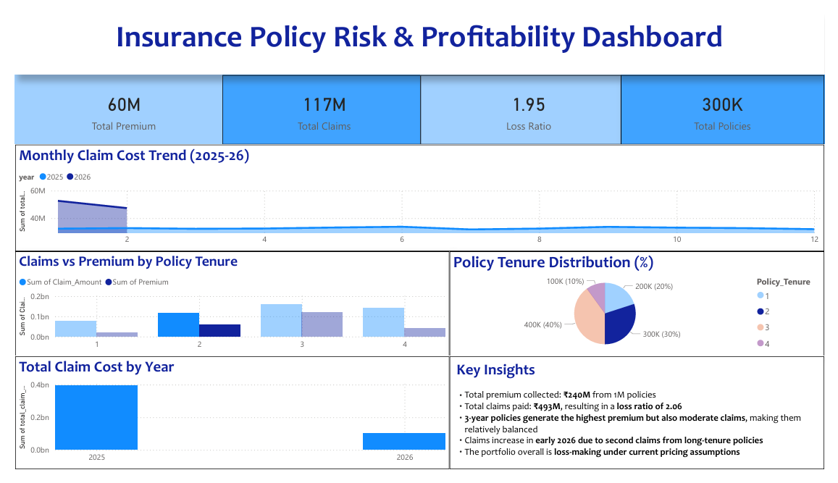
Figure 1: Insurance Policy Risk & Profitability Dashboard

5. Key Insights
• Total premium collected from the simulated portfolio is approximately ₹240M.
• Total claims paid reach roughly ₹493M, producing a loss ratio of around 2.06.
• Three‑year policies provide the most balanced risk profile in terms of premium versus claims.
• Claim costs increase noticeably in early 2026 due to second claims from long‑tenure policies.
• Overall, the portfolio appears loss‑making under current pricing assumptions.

6. Conclusion
This analysis demonstrates how simulated insurance data can be used to evaluate policy performance and risk exposure. Using Python, SQL, and Power BI allowed the portfolio to be examined from both analytical and visualization perspectives. The findings highlight the importance of proper pricing and risk assessment in insurance portfolio management.

