WALCHAND INSTITUTE OF TECHNOLOGY, SOLAPUR
Department of Electronics and Computer Engineering
MINI PROJECT SUBMISSION – INTERNET OF THINGS
Academic Year: 2026–27 | Semester: VII | Class: Final Year
1. Project Details
Project Title | ESP32-Based Smart Irrigation Monitoring and Control System Using MQTT and Node-RED Dashboard
Project Domain / Application | Smart Agriculture – automated irrigation monitoring and control (IoT)
Guide | Dr. R. S. Khamitkar
Brief Problem Statement / Objective | Manual irrigation wastes water and gives no data on soil condition. Objective: to measure soil moisture, temperature and humidity with an ESP32, send the data over Wi-Fi using MQTT to a live Node-RED dashboard, and control an irrigation pump automatically (soil moisture below 40% turns the pump ON) or manually (ON / OFF / AUTO) from the dashboard.
2. Project Team – Maximum 3 Members
Sr. No. | Student Name | Roll No. | Student Enrollment No. (PRN)
1 | Vishakha Mohan Padwalkar | 37 | 2303111035
2 | Ammana Pyare | 38 | 2303111058
3 | Samiya Mujawar | 38 | 2303111059
3. Technical Details
IoT Architecture / Block Diagram | 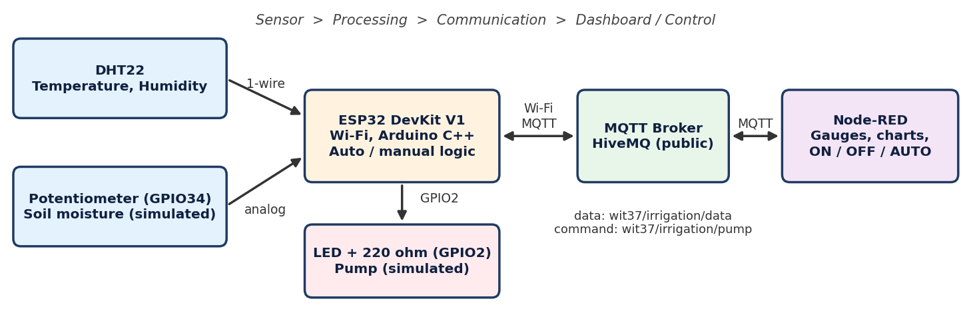
Hardware / Sensors / Actuators Used | ESP32 DevKit V1 (controller, Wi-Fi); DHT22 (temperature and humidity) on GPIO4; potentiometer on GPIO34 (simulates soil moisture sensor); LED with 220 Ω resistor on GPIO2 (simulates irrigation pump / relay). Prototype built and tested in the Wokwi simulator.
Software / Tools / Platforms Used | Wokwi ESP32 simulator; Arduino libraries WiFi, PubSubClient, DHT sensor library; HiveMQ public MQTT broker (broker.hivemq.com, port 1883); Node-RED v5.0.8 with node-red-dashboard; Node.js v24; Google Chrome.
Programming Language(s) | C/C++ (Arduino framework) for the ESP32; JavaScript (Node-RED function nodes); JSON payload format.
Communication Protocol(s) | MQTT over Wi-Fi (other: JSON over TCP/IP). Topics: wit37/irrigation/data (ESP32 publishes every 5 s); wit37/irrigation/pump (ESP32 subscribes; commands ON / OFF / AUTO).
Algorithm / Pseudocode | START: connect Wi-Fi -> connect MQTT broker -> subscribe to pump topic  LOOP every 5 s:  soil <- map(analogRead(GPIO34), 0..100 %) temp, hum <- DHT22.read()  if mode == AUTO : pump <- (soil < 40)  else : pump <- (mode == ON)  write pump to GPIO2 (LED); publish JSON {soil,temp,hum,pump,mode}  ON MQTT command (ON / OFF / AUTO): set mode; apply and publish at once  NODE-RED: mqtt-in -> function nodes -> gauges / charts / pump status;  dashboard buttons -> mqtt-out (pump topic)

WALCHAND INSTITUTE OF TECHNOLOGY, SOLAPUR
Department of Electronics and Computer Engineering
MINI PROJECT SUBMISSION – INTERNET OF THINGS
4. Implementation and Output Evidence
Screenshot 1 – Hardware / Prototype
  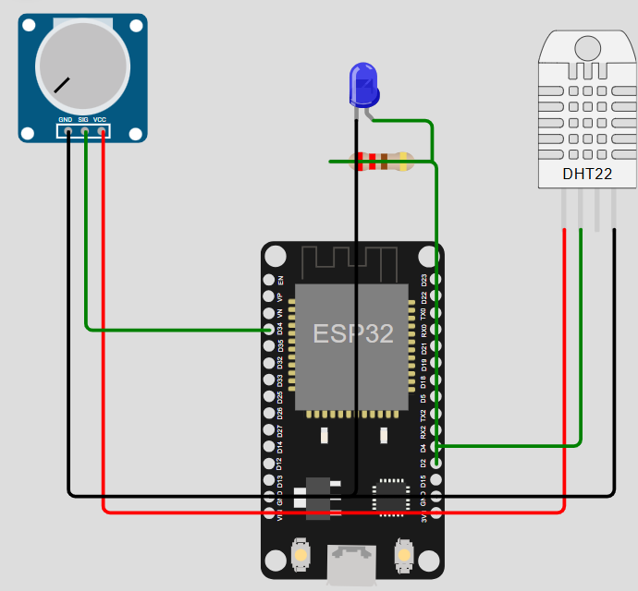 | Caption: Wokwi prototype – ESP32 with DHT22 (GPIO4), potentiometer as soil moisture sensor (GPIO34) and LED as pump (GPIO2). Proves sensor and actuator interfacing.
Screenshot 2 – Software / Tool / Code / Flow
  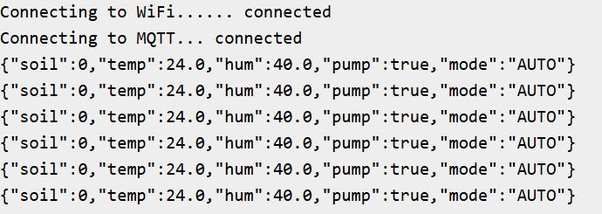 | Tool/Software: Wokwi serial monitor (Arduino sketch running) – Wi-Fi and MQTT connected, JSON published every 5 s (soil 0%, AUTO mode, pump ON).
Screenshot 3 – Final Output / Dashboard | 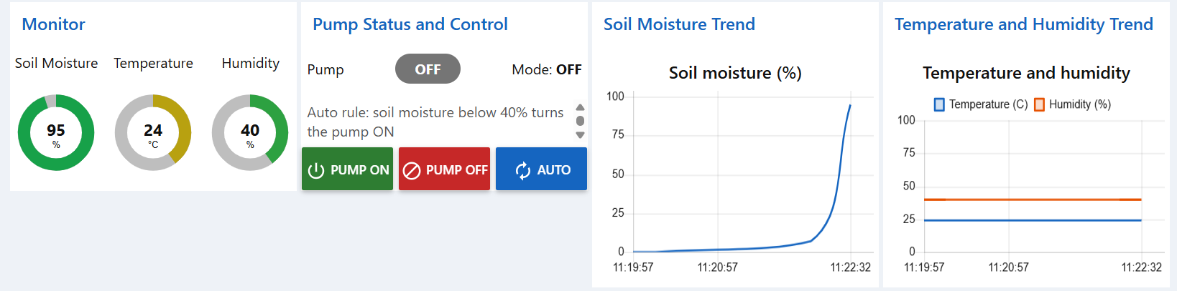  Result shown: Node-RED dashboard – live soil moisture, temperature, humidity, pump status (OFF, Mode OFF), trend charts and ON / OFF / AUTO control.
Additional Screenshot (if required) | [Paste Node-RED flow screenshot here]  Purpose: Node-RED flow (mqtt in -> function -> dashboard widgets / mqtt out) showing the data path.
5. Results and Testing
Expected Result | AUTO mode: soil moisture below 40% turns the pump ON, otherwise OFF. Dashboard PUMP ON / PUMP OFF override auto control and AUTO restores it. Sensor data reaches the dashboard every 5 s over MQTT.
Actual Result / Observation | MQTT connection established; JSON data published every 5 s and displayed live on the dashboard. At soil 0% the pump was ON (AUTO); at soil 84–95% the pump was OFF. The soil trend chart followed the potentiometer from about 0% to 95%. PUMP OFF from the dashboard set Mode: OFF.
Test Case / Performance Metric | Test 1: soil 0%, AUTO -> pump ON (pass). Test 2: soil 84%, AUTO -> pump OFF (pass). Test 3: PUMP OFF button -> Mode OFF on dashboard (pass). Metric: data update interval 5 s; broker broker.hivemq.com.
6. Video / Source Links (if Prepared)
Project Demonstration Video | YouTube / Google Drive link: ______________________________
Source Code / GitHub (if available) | Link: ______________________ (ESP32 sketch.ino and Node-RED flow JSON)
Other Reference / Dataset Link | Wokwi ESP32 simulator (wokwi.com); PubSubClient and Adafruit DHT libraries; Node-RED and node-red-dashboard; HiveMQ public broker (broker.hivemq.com).
7. Conclusion
A smart irrigation monitoring and control prototype was developed using an ESP32 (simulated in Wokwi) with a DHT22 sensor, a potentiometer emulating a soil moisture sensor and an LED emulating the pump. Sensor data is published as JSON over Wi-Fi using MQTT to a Node-RED dashboard that shows live gauges, trend charts and pump status. The pump runs automatically from a 40% soil moisture threshold and can be forced ON, OFF or returned to AUTO from the dashboard. The project demonstrates sensor interfacing, embedded programming, Wi-Fi communication, MQTT publish/subscribe, data visualization and remote actuation. The soil sensor and pump are simulated, so testing on real hardware is future work.
Guide Verification ________________
Declaration: The submitted project work and evidence are prepared by the above team and are presented for academic evaluation.

