**Data Connection And Display Plugin**

**Prepared by**

VishakhaPatel (16IT093)

Aastha Yadav (16IT147)

**Under the supervision of**

Prof. Hemant Yadav

Prof. Ravi Patel

A Report Submitted to

Charotar University of Science and Technology

for Partial Fulfillment of the Requirements for the

Degree of Bachelor of Technology

in Information Technology

IT345 Software Group Project- III (5th sem)

**Submitted at**



**DEPARTMENT OF INFORMATION TECHNOLOGY**

**Chandubhai S. Patel Institute of Technology**

**At: Changa, Dist: Anand – 388421**

**Nov-Dec 2018**



**CERTIFICATE**

This is to certify that the report entitled “**Data Connection And Display Plugin**

” is a bonafied work carried out by **Vishakha Patel(16IT093), Aastha Yadav (16IT147)** under the guidance and supervision of **Prof. Hemant Yadav and Prof. Ravi Patel** for the subject **Software Group Project-III(IT345)** of **5th** Semester of Bachelor of Technology in **Information Technology** at Faculty of Technology & Engineering – CHARUSAT, Gujarat.

To the best of my knowledge and belief, this work embodies the work of candidate herself, has duly been completed, and fulfills the requirement of the ordinance relating to the B.Tech. Degree of the University and is up to the standard in respect of content, presentation and language for being referred to the examiner.

|  |
| --- |
| Under supervision of,  Prof. Hemant Yadav  Assistant Professor  Dept. of Information Technology  CSPIT, Changa, Gujarat. |
| Prof. Parth Shah  Head & Associate Professor  Department of Information Technology  CSPIT, Changa, Gujarat. |

**Chandubhai S Patel Institute of Technology**

At: Changa, Ta. Petlad, Dist. Anand, PIN: 388 421. Gujarat

**TABLE OF CONTENTS:**

* Abstract………………………………………………………………………iii
* Acknowledgement……………………………………………………………iv
* Introduction 05
* Project Overview 05
* Objective 05
* System Analysis 06
* User Characteristics 06
* Programming Language 06
* Wordpress plugin 07
* Database Connectivity plugin 08
* How wordpress plugins work? 08
* Snapshots 09
* Constraints And Future Enhancement 11
* Conclusion……………………………………………………………………12
* References 13

**LIST OF FIGURES**

* Figure 1.1 About activate and deactivate plugin 08
* Figure 1.2 Data Display on webpage 08

**ACKNOWLEDGEMENT**

A scholarly and quality work like designing of any project work can be accomplished by motivation, guidance and inspiration of certain quarters besides the individual efforts. Let me in this page express my heartiest gratitude to all those who helped me in various stages of this study.

We are very much thankful to **Mr. Parth Shah**, HOD, IT for giving me the permission to undergo this project and providing all the necessary facilities. During my project period all the staff members of department have helped us with their skills. Here by I express our sincere thanks to project guide **Mr. Hemant Yadav and Mr. Ravi Patel** Assistant Professor, IT whose valuable guidance and kindcooperation without which this project would have not been possible.

Vishakha Patel(16IT093)

Aastha Yadav (16IT147)

**ABSTRACT**

The project is about the Database Connection and display plugin for Charusat E-Notice Board. The purpose to developing this project is to learn how to make plugin for wordpress. Plugin will help wordpress users to connect with database and displays the data On webpage. Plugin will display data on Charusat E-notice Board.

**INTRODUCTION**

* 1. **Project Overview:**

Students in colleges and universities like to be remain informed of what new events,

schedules, competitions etc. are happening in their college or university. Students had to

physically go to a notice board in their college/university and get their desired information. I, as a student, personally felt this problem. I saw an opportunity to devise a solution to this

problem. Building a complete software system for the CHARUSAT university is the solution. It involves various software components like web app deployed to the local CHARUSAT internet, a REST API deployed on the same local internet, an Android app which displays notices using the REST API and also integrates IBM Watson chatbot where users can push their queries and it will give the desired response back to the user. Moreover, there are Wordpress plugins which will be deployed to the main CHARUSAT website where users can view the notices or live updates provided in the system.

To turn this idea into reality, I really had to learn a lot of new things and had to shift

my point of view from a programmer’s one to the user’s one. I often motivated myself by

thinking that my project will be used by thousands of people in my college and thereby had to put a lot of effort. My efforts and hard work had led me to creating a high-quality software product, which will help people get notified of what’s happening around in their college or university.

**1.2 Objective:**

The main objective of project is to learn and develop a plugin for wordpress user. It helps us to gain knowledge about how to make plugin for wordpress along with its practical implementation and how to deal with real time application

**SYSTEM ANALYSIS**

* 1. **User Characteristics:**
* Every system has their own characteristics but all gives different functionality from each other.
* User has to install this plugin to their wordpress. And then have to write shortcode on page wherever they want to display the data. And the shortcode is [notice].
  1. **Programming Language:**
* php
* JavaScript
* HTML
* CSS
* jQuery
* **Plugin:**

A plug-in is a collection of code files that adds one or more features to your website. After you install the core code for your CMS, you can install your choice of plug-ins.

* **Use of plugin**

A plugin is a piece of software containing a group of functions that can be added to a WordPress website. They can extend functionality or add new features to your WordPress websites. WordPress plugins are written in the PHP programming language and integrate seamlessly with WordPress. In the WordPress community, there is a saying that goes around: “there’s a plugin for that”. They makes it easy for users to add features to their website without knowing a single line of code.

* **Wordpress Plugin:**

WordPress plugins are apps that allow you to add new features and functionality to your WordPress website. WordPress plugins are small software apps that integrate and run on top of the WordPress software. This allows you to create almost any kind of website with WordPress (not just blogs).

* **Plugin Basics:**

* **Header Requirements**

**Plugin Name**

**Plugin URI**

**Description**

**Version**

**Author**

**Author URI**

**License**

**License URI**

* **Including a software license**
* Most WordPress plugins are released under the [GPL](http://www.gnu.org/licenses/gpl.html), which is the same license that WordPress itself uses. However, there are other options available. It is always best to clearly indicate the license your plugin uses.
* In the [Header Requirements](https://developer.wordpress.org/plugins/the-basics/header-requirements/) section, we briefly mentioned how you can indicate your plugin’s license within the plugin header comment. Another common, and encouraged, practice is to place a license block comment near the top of your main plugin file (the same one that has the plugin header comment).
* **Activation / Deactivation Of Hooks**

Activation and deactivation hooks provide ways to perform actions when plugins are activated or deactivated. On activation, plugins can run a routine to add rewrite rules, add custom database tables, or set default option values.

On deactivation, plugins can run a routine to remove temporary data such as cache and temp files and directories

register_activation_hook( __FILE__, 'pluginprefix_function_to_run' );

register_deactivation_hook( __FILE__, 'pluginprefix_function_to_run' );

* **Uninstall Methods**

## 

Your plugin may need to do some clean-up when it is uninstalled from a site.

A plugin is considered uninstalled if a user has deactivated the plugin, and then clicks the delete link within the WordPress Admin.

When your plugin is uninstalled, you’ll want to clear out any plugin options and/or settings specific to to the plugin, and/or other database entities such as tables.

Less experienced developers sometimes make the mistake of using the deactivation hook for this purpose.

* **Database Connectivity plugin:**

This plugin will connect with database of the user and then it can also retrieve the data from the database and it will display the same of the webpage with attractive CSS.

* **How Wordpress plugins work?**
* WordPress is written in a way so that other developers can add their own code into it. The WordPress plugin API offers a robust set of hooks and filters which allow developers to modify existing WordPress functionality or add new functionality.
* WordPress also allows developers to store data in the [WordPress database](https://www.wpbeginner.com/glossary/database/" \o "What is WordPress Database?). Plugins can utilize WordPress [content types](https://www.wpbeginner.com/glossary/post-types/), [taxonomies](https://www.wpbeginner.com/wp-tutorials/create-custom-taxonomies-wordpress/), and [custom fields](https://www.wpbeginner.com/wp-tutorials/how-to-show-hidden-custom-fields-in-wordpress/) which allow users to store different types of content not just post and pages.
* Each WordPress plugin installed on your site is registered in your WordPress database. You can activate and deactivate them at any time you want.

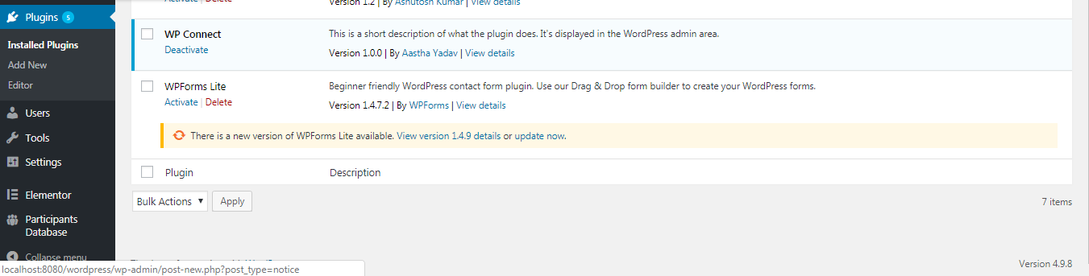

**Figure 1.1 About activate and deactivate plugin**

* And after installing plugin user has to write shortcode of plugin.

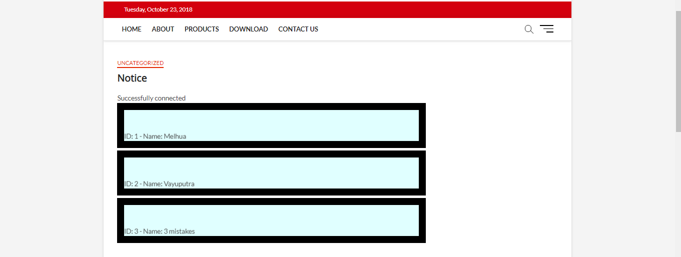

**Figure 1.2 Data Display on webpage**

**Constraints And Future Enhancement**

* This plugin has static content.
* And will also enhance the automatic deletion of the notice after some particular period of time.
* So the future enhancement is to make it more user friendly and deploy it on Charusat

E-notice board website.

**CONCLUSION**

As we are know that the team work is the best work and we and our other team mates have experienced this .We learned a lot and various new things and techniques which has brought us to a different level. Our guide Prof. Hemant Yadav and Prof. Ravi Patel has supported us a lot throughout this journey. And we are glad to come to the conclusion that we had learned many new things and has successfully completed our plugin development project and we are also glad to contribute our work to the Charusat University.

**REFERENCES**

* <https://console.bluemix.net/docs/services/CloudLogAnalysis/index.html>
* How to add shortcode - <https://www.youtube.com/watch?v=mm9aQiLEa10>
* To generate plugin - <https://wppb.me/>
* How to make plugin – <https://scotch.io/tutorials/how-to-build-a-wordpress-plugin-part-1>