1.How are inline and block elements different from each other?

**Inline elements**-It takes the required width of the content. And stays in the same line.

Example <span>

**Block elements**-It takes new line and stretches to the entire width of the page

Example <div>

2.Explain the difference between visibility:hidden and display:none

**Display:none** -It removes the element from the page and does not show any blank space in it’s place.As it collapses the space.

**Visibility:hidden** It also doesnot show the element but it shows the space of the text hidden.

3. Explain the clear and float properties.

**float**-It is used for the content formatting and positioning of it.

Float:left,float:right,float:none(default),float:inherit(takes value of parent)

The element floats on the page according to the above given values.

**clear**-It is usually used after float property.Decides where the element can be placed beside the cleared element.

4. explain difference between absolute, relative,fixed and static.

**Static:**

HTML elements are positioned static by default.

Static positioned elements are not affected by the top, bottom, left, and right properties.

An element with **position: static;** is not positioned in any special way; it is always positioned according to the normal flow of the page:

**Relative:**

An element with **position: relative;** is positioned relative to its normal position. Setting the top, right, bottom, and left properties of a relatively-positioned element will cause it to be adjusted away from its normal position. Other content will not be adjusted to fit into any gap left by the element.

**Fixed:**

An element with **position: fixed;** is positioned relative to the viewport, which means it always stays in the same place even if the page is scrolled. The top, right, bottom, and left properties are used to position the element.

A fixed element does not leave a gap in the page where it would normally have been located.

**Absolute:**

An element with **position: absolute;** is positioned relative to the nearest positioned ancestor (instead of positioned relative to the viewport, like fixed).

However; if an absolute positioned element has no positioned ancestors, it uses the document body, and moves along with page scrolling.

5. Write the HTML code to create a table in which there are 4 columns( ID , Employee Name, Designation, Department) and at least 6 rows. Also do some styling to it.

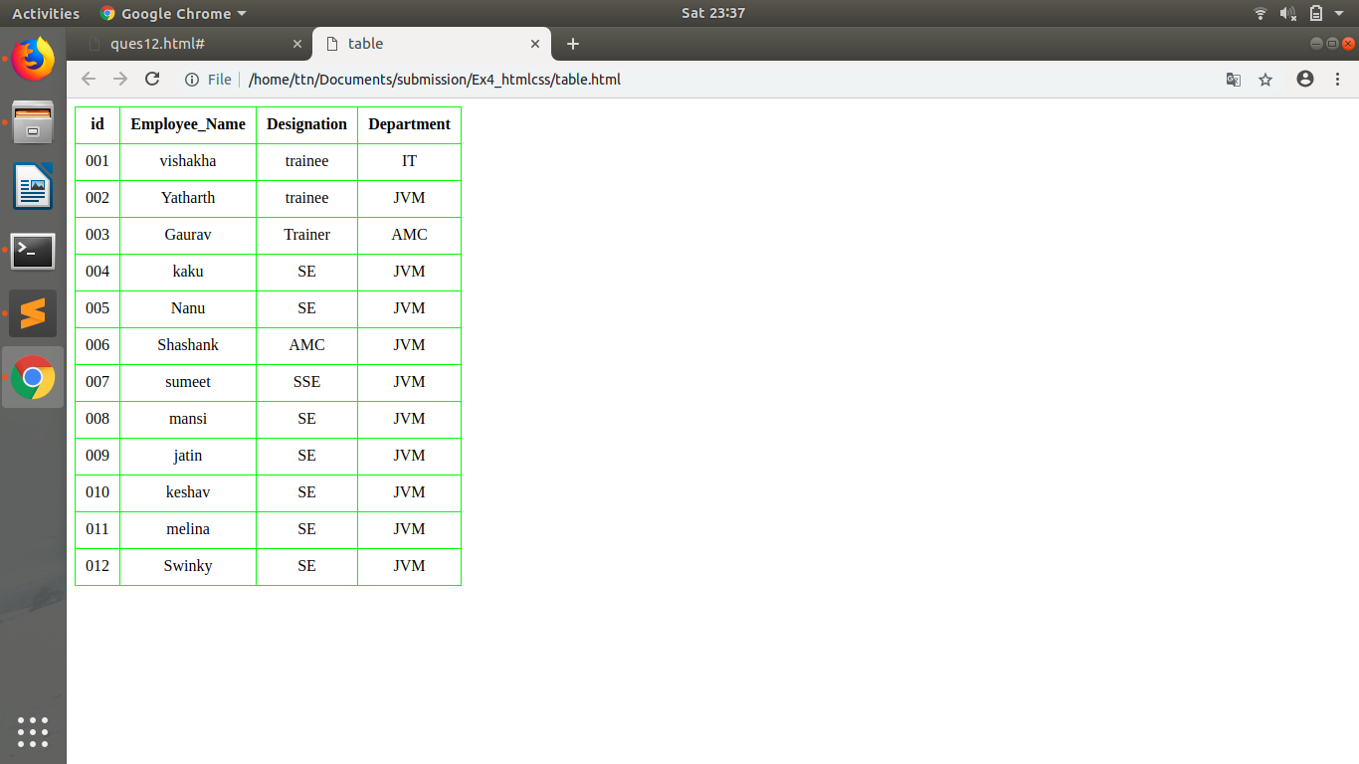

6. Why do we use meta tags?

It is metadata about the page or the document.It is not displayed on the page.It has values as description,keywords,author,viewport.This tag goes inside head.

<meta name=” ” content=””>

It is an empty tag.

Description for description of the page.

Author-author of the document

Keywords are used in search engine optimization.

Viewport is used for the visible area in all kind of devices.

7. Explain box model.

All html elements can be considered as boxes.part of css concept.

Margin,border,padding ,content.

Content is text.

Padding is distance around content which is transparent.between content and border

Border is the outline after paddig .

Margin-it is like simple margin /distance between the border an the main page.

Given in px(Pixels,% and rem) units

8. What are the different types of CSS Selectors?

Pattern to select elements in page.

Id #-it is unique

Class .-need not to be unique

* select all.

Can be achieved using tags

9. Define Doctype.

the <!DOCTYPE> declaration is not a tag but instruction to the web browser about what version of HTML the page is written in.

10. Explain 5 HTML5 semantic tags.

* <aside>used to define content beside from the content it is placed in.
* <footer> specifies footer.
* <header> specifies header in the doc.
* <mark> defines marked text.
* <nav>specifies set of navigation links.
* <section> defines section in a doc.
* <time> defines date time.
* <article>defines article in the document.

11. Create HTML for web-page.jpg (check resources, highest weightage for answers)

12. Create HTML for form.png (check resources, highest weightage for answers)

Note: 50% of marks are for last 2 exercises of creating html pages