**JQuery**

1. Console "Hello Word" in document.ready function

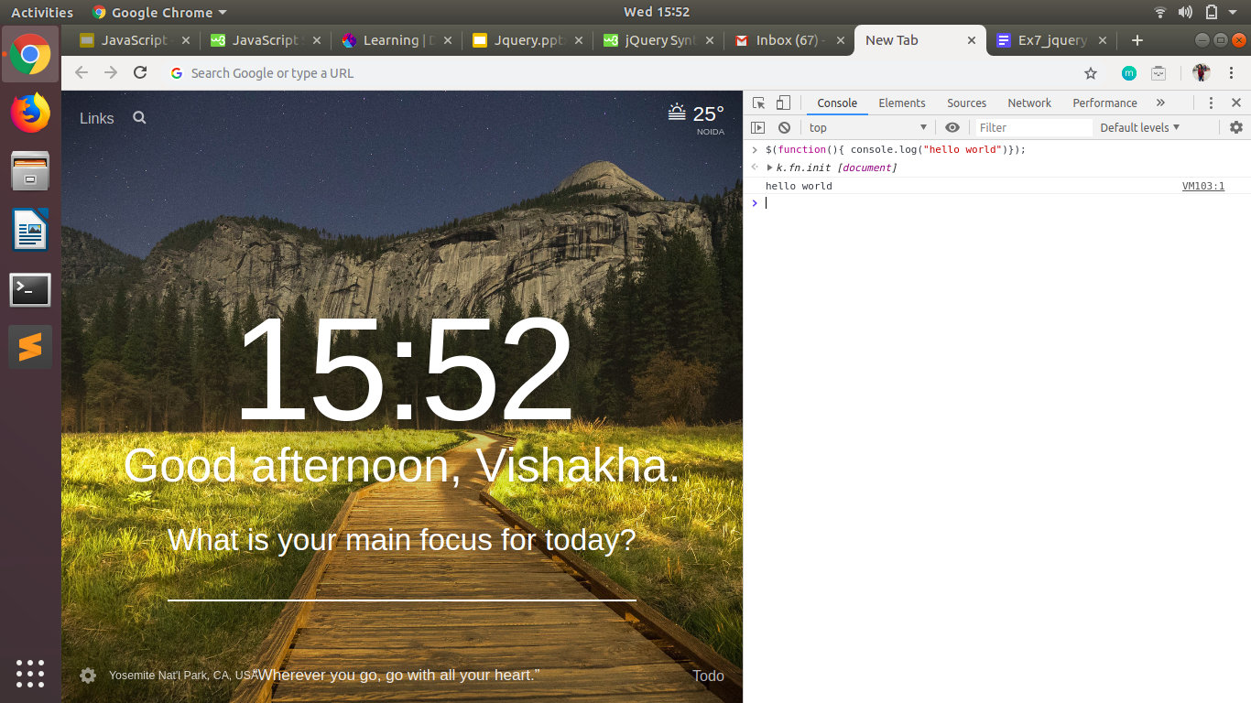

1. Select a ID name "#test" and add class "load" when DOM is loaded

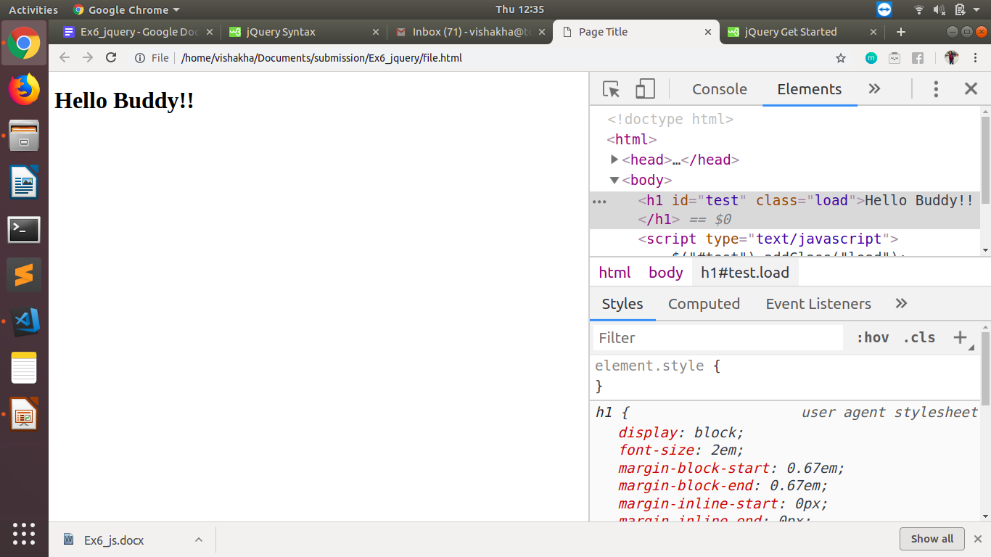

1. Change the color of element which class name end with "-new"

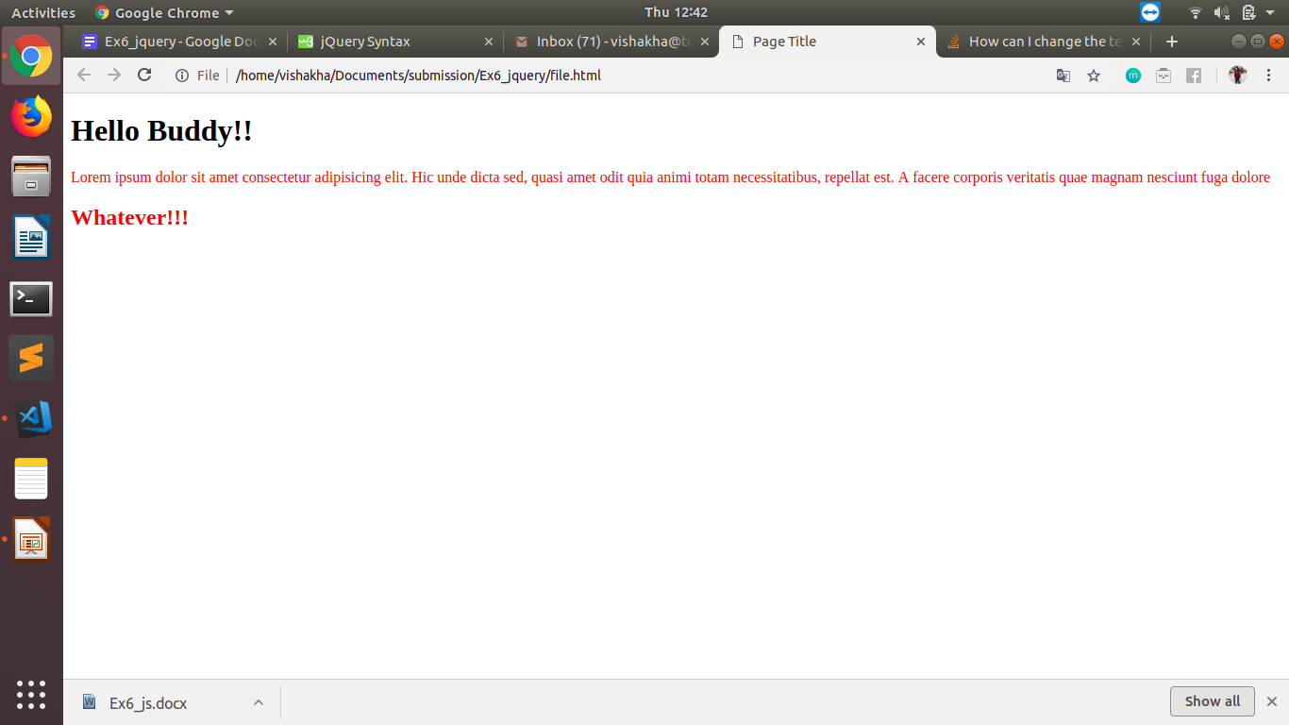

1. Disable submit button using jquery attr method

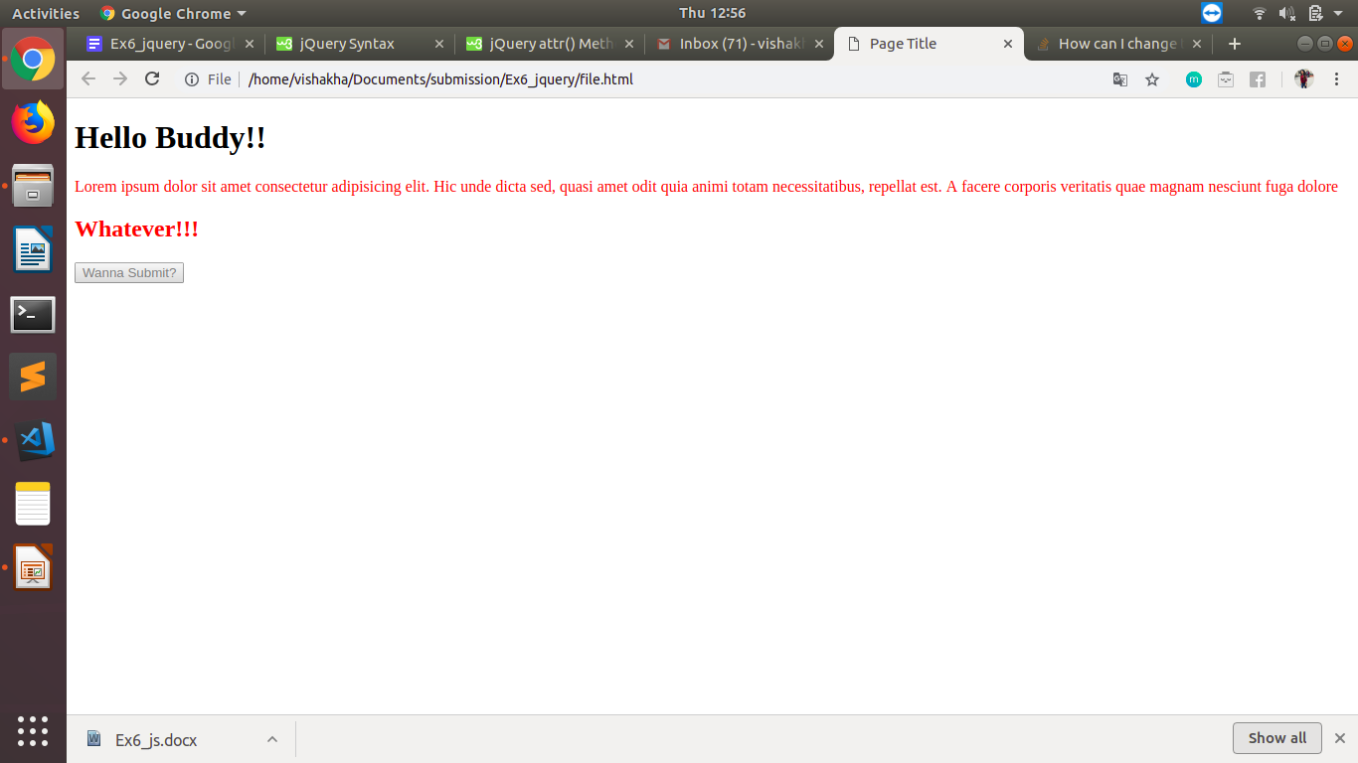

1. Change the font size of ".target" which has parent element with id name "#main"

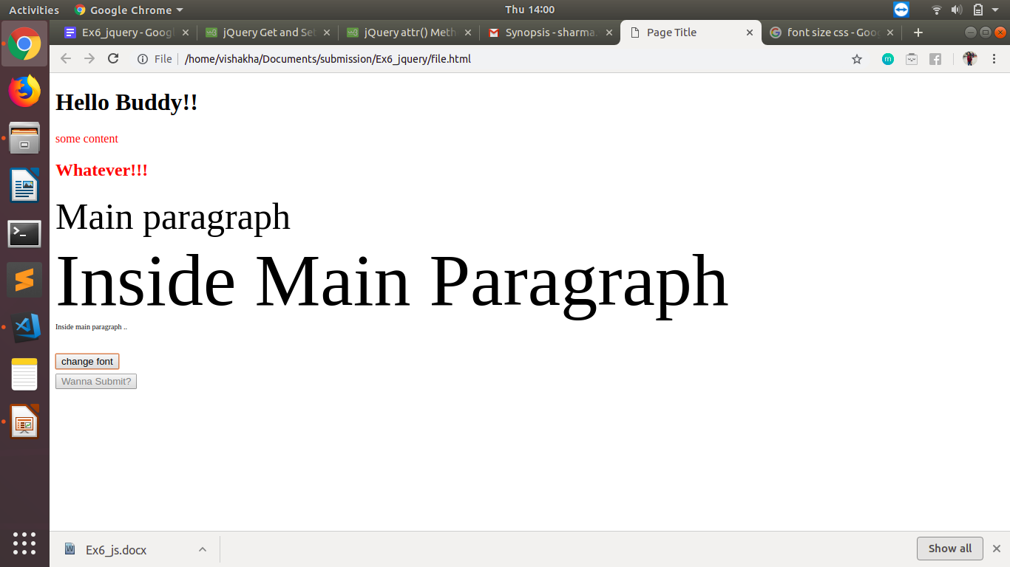

1. After page load change the HTML of div element with "p" element

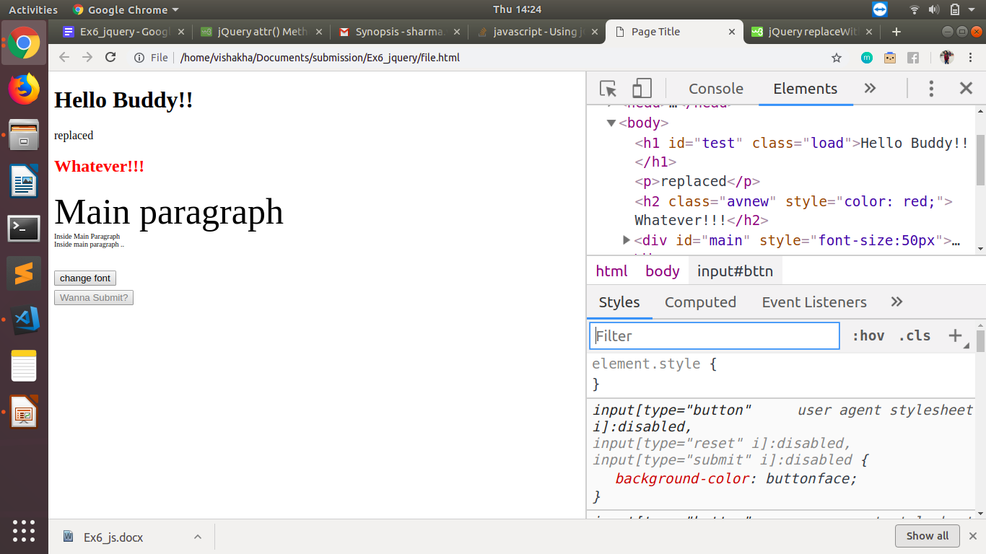

1. Bind a click function to an "click" element and append next "click" next to it.

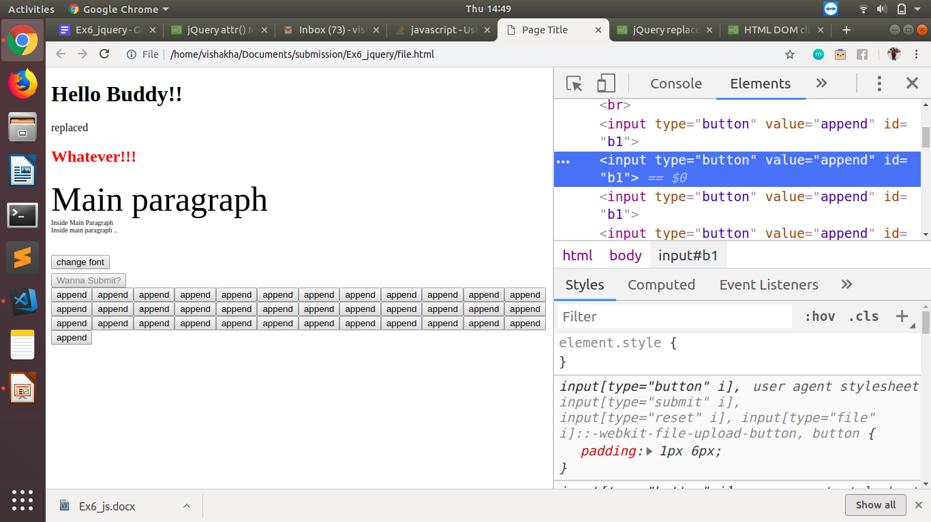

1. Click event not working on element which added dynamically or via script, make it work using .on method.

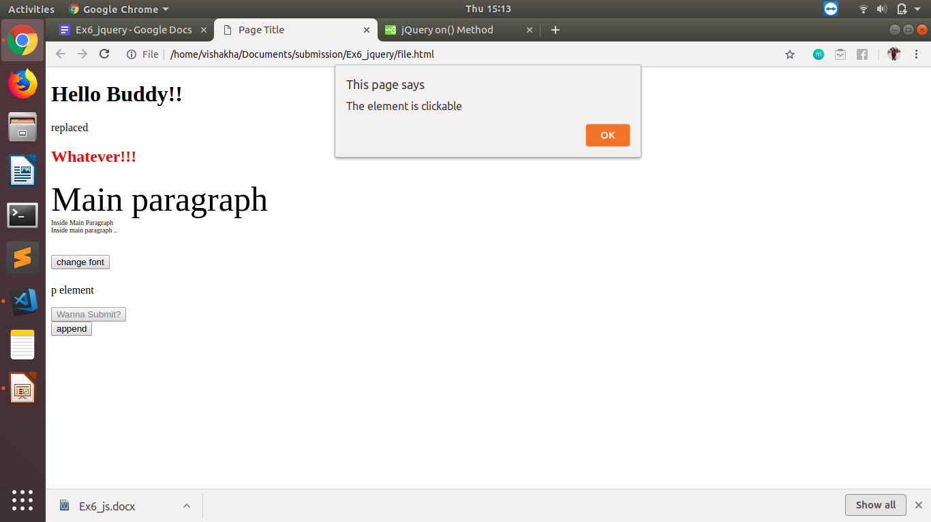

1. Get dropdown selected value on onchange event and append in div container.

1. Create a dropdown menu using hover method in jquery
2. On clicking on "[google](https://www.google.com/)" tag. It is taking us to google homepage. Stop it from happening.
3. We have bind a click function to parent div but we want to stop it from performing when user clicks on its child li.
4. Get the max height of elements using jquery each method
5. Change color of every cell which has number larger than 10.
6. Retrive the data from server using ajax get call
7. Add cross button on row and bind click function which make a delete request to server, after success event remove the row from dom
8. Create a image array and in div create a slideshow to animate images of delay of 500ms.