Task 2 — API Integration
Weather / Crypto / News • Python Internship
Vishakha Ojha • GitHub: vishakhaojha57/pythondev-task2
📌 Project Overview

Goal | Fetch API data using Python requests library, parse JSON response, and apply search/filter logic with robust error handling.

API Used | JSONPlaceholder — https://jsonplaceholder.typicode.com/posts

Language | Python 3.x

Library | requests (pip install requests)

GitHub | https://github.com/vishakhaojha57/pythondev-task2

✅ Requirements Checklist

Requirement | Status | Details
Use requests module | ✅ Done | requests.get() used
Parse JSON response | ✅ Done | response.json() parsed
Add search/filter | ✅ Done | Keyword + userId filter
Error handling | ✅ Done | 5 exception types covered
Python script | ✅ Done | main.py created
Screenshots | ✅ Done | 3 outputs captured

🗂️ File Structure

pythondev-task2/
│
├── main.py ← Main Python script (all 3 sections)
├── README.md ← Project documentation
└── screenshots/
├── output1.png ← Section 1: Fetching & displaying posts
├── output2.png ← Section 2: Search/filter output
└── output3.png ← Section 3: Error handling demo

Section 1 — Fetching Data with requests
Used Python's requests library to send a GET request to the JSONPlaceholder API. The response is parsed using .json() which converts the raw JSON into a Python list of dictionaries. The first 3 posts are then displayed with their ID, Title, and Body.

Code Snippet:
import requests

api_url = 'https://jsonplaceholder.typicode.com/posts'
response = requests.get(api_url)

if response.status_code == 200:
posts = response.json() # Parse JSON response
print(f'Total posts fetched: {len(posts)}')
for i, post in enumerate(posts[:3]):
print(f'Post {i+1}:')
print(f' ID: {post["id"]}')
print(f' Title: {post["title"][:50]}...')
print(f' Body: {post["body"][:100]}...')
print('-' * 20)

Output Screenshot:
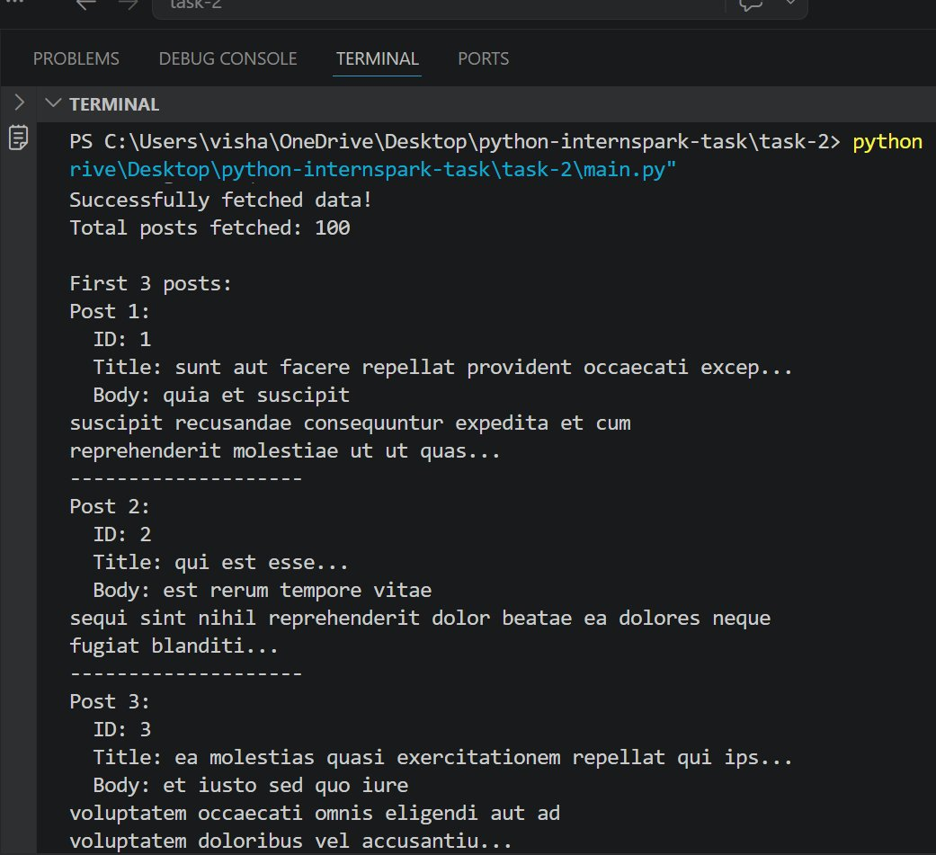

Section 2 — Search & Filter Logic
Two filtering approaches were implemented:
- 1. Keyword search — user enters a keyword, all post titles are searched case-insensitively using list comprehension
- 2. User ID filter — posts are filtered by userId field to show only posts from a specific user

Code Snippet:
# Keyword search in post titles
keyword = input('Enter keyword to search: ').strip().lower()
filtered = [p for p in posts if keyword in p['title'].lower()]
print(f"Posts containing '{keyword}': {len(filtered)} found")

# Filter by userId
user_id = 1
by_user = [p for p in posts if p['userId'] == user_id]
print(f'Posts by User ID {user_id}: {len(by_user)} found')

Output Screenshot:
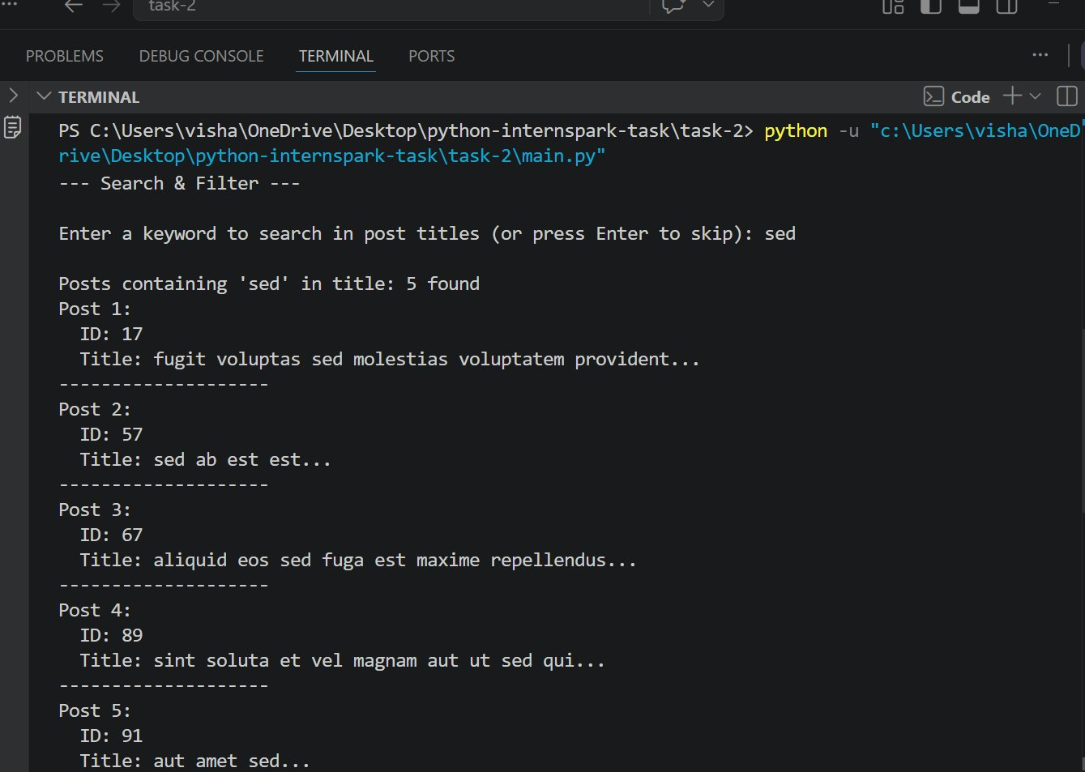

Section 3 — API Error Handling
A dedicated function wraps all API calls in try/except blocks. Five different error scenarios are handled:
- HTTPError — 4xx/5xx responses via response.raise_for_status()
- ConnectionError — no internet or invalid host
- Timeout — request took too long
- RequestException — any other requests-related error
- ValueError — response is not valid JSON

Three scenarios are demonstrated live:
- Successful request to /posts/1 (200 OK)
- Non-existent resource /nonexistent-endpoint (404 Not Found)
- Malformed URL http://invalid.url.example/test (Connection Error)

Code Snippet:
def fetch_data_with_error_handling(url):
try:
response = requests.get(url)
response.raise_for_status()
return response.json()
except requests.exceptions.HTTPError as e:
print(f'HTTP error: {e}')
except requests.exceptions.ConnectionError as e:
print(f'Connection error: {e}')
except requests.exceptions.Timeout as e:
print(f'Timeout error: {e}')
except requests.exceptions.RequestException as e:
print(f'Unexpected error: {e}')
except ValueError:
print('JSON decode error')
return None

Output Screenshot:
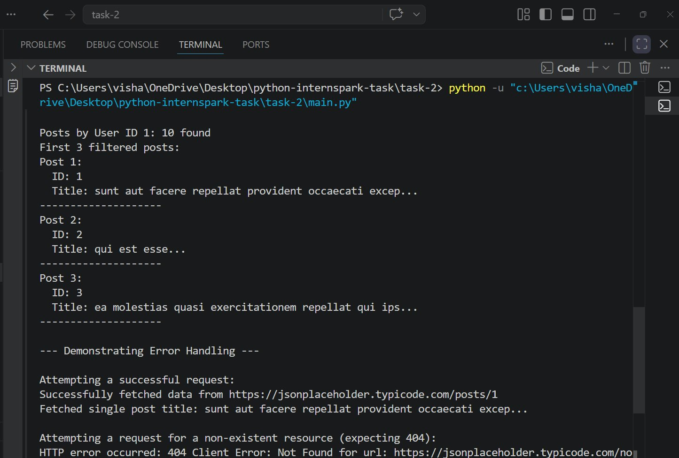

🚀 How to Run

# 1. Clone the repository
git clone https://github.com/vishakhaojha57/pythondev-task2
cd pythondev-task2

# 2. Install dependencies
pip install requests

# 3. Run the script
python main.py

# 4. When prompted, enter a keyword (e.g. 'sed') or press Enter to skip

💡 Key Learnings
- requests.get() sends HTTP GET requests and returns a Response object
- response.json() deserializes JSON into Python dicts/lists
- List comprehensions provide clean, readable filtering logic
- raise_for_status() simplifies HTTP error detection for 4xx/5xx codes
- Specific exception types allow granular error messages for debugging

GitHub Repository: https://github.com/vishakhaojha57/pythondev-task2

