Global Malnutrition Trends: A Power BI Analysis (1983-2019)
Student Name: Vishakha Durwas Padole
Domain: Data Analytics with PowerBI
Dataset: Global Child Malnutrition Estimates

Abstract

Child malnutrition is still one of the public health problems, in the world in low‑ and middle‑income countries. I created a data‑driven dashboard that looks at long‑term trends in child malnutrition. The dashboard uses three measures: stunting, underweight and wasting. I ran the analysis in Power BI on a data set that covers the years 1983, to 2019. The dashboard lets users compare countries see trends and judge severity with charts, formatting and summary indicators. I see the insights, from this analysis help people make decisions based on evidence and also point out areas that need nutrition help. I see the project shows data tools can turn public health data into insights.

Keywords: Child Malnutrition, Data Visualization, Power BI, Stunting, Underweight, Wasting, Dashboard Analytics

Introduction

Child malnutrition is a sign of the countrys social progress the health system and the food supply. Child malnutrition hurts. I see that child malnutrition includes growth, low weight and wasting. Child malnutrition shows both the term and the short term lack of nutrition, in the children. Child malnutrition links to the body growth and the brain development. I also see that the world programs and the rules try to fix child malnutrition. Child malnutrition still appears more in some places and, among the families.

I see the need, for a project that designs and builds a Power BI dashboard. The Power BI dashboard will show country child malnutrition trends in an easy format. The Power BI dashboard will use data from 1983 to 2019. The project will help policymakers, researchers and non‑technical people understand patterns, gaps and severity of child malnutrition.

Problem Statement

When I look at the global malnutrition datasets I see that the global malnutrition datasets are huge and have parts. The raw numbers are hard to read. The usual tables do not give clues, about trends, country comparisons or how severe the malnutrition numbers are. Because of that the stakeholders have a time finding risk countries and checking progress over time. The global malnutrition datasets need an visual solution that makes the data simple but still deep. I built the visual solution as a Power BI–based dashboard. The Power BI–based dashboard lets the user explore the global malnutrition datasets by country by year and, by severity level.

Objectives

The primary objectives of this project are:

To analyze historical trends of child malnutrition indicators from 1983 to 2019

To compare countries based on average stunting levels

To identify high-risk countries using ranking techniques and conditional formatting

To summarize key malnutrition statistics using KPI indicators

To design a professional, client-ready, and interactive dashboard using Power BI

Dataset Description

I got the dataset, for this project, from the groups UNICEF WHO and the World Bank. The dataset includes country wise malnutrition estimates. Lists the attributes:

Country

Year

Average Stunting (%)

Average Underweight (%)

Average Wasting (%)

Severe Wasting (%)

Income Classification (Low, Lower-Middle, Upper-Middle, High)

Survey Sample Size (N)

The dataset spans multiple decades, enabling longitudinal analysis and comparison of nutritional outcomes across different economic and geographic contexts.

Tools and Technologies

Power BI Desktop: Used for data modeling, visualization design, and dashboard development

DAX (Data Analysis Expressions) is used to compute the averages. DAX (Data Analysis Expressions) also computes the rankings and the aggregated measures.

Microsoft Excel: Used for preliminary data validation and structure review prior to visualization.

Methodology

Global child malnutrition data is there. People do not use child malnutrition data because there are no easy ways to see global child malnutrition data. I notice that stakeholders need a view of trends, severity levels and country, by country comparisons. Stakeholders need that view to write policies and to watch progress.

I built an interactive dashboard that turns malnutrition data into clear visual insights. The dashboard lets users explore trends. The dashboard lets users find risk countries. The dashboard lets users read severity levels quickly.

Imported and cleaned the dataset within Power BI

Created calculated measures using DAX for average malnutrition indicators

I designed multi‑line charts. The multi‑line charts show year‑wise trends.

Developed bar charts to rank the top 10 countries by average stunting

Implemented donut charts to represent relative contribution of indicators

Applied rule-based conditional formatting (Red–Orange–Green) to indicate severity

Added KPI cards to display global averages and total survey coverage

The dashboard shows child malnutrition trends in an interactive way. With the dashboard I can quickly find high‑risk countries. With the dashboard I can see long‑term improvements. With the dashboard I can interpret the data without needing skills.

Dashboard Visualization

Trend Analysis: A multi‑line chart that shows the year by year trends, for stunting, underweight and wasting from 1983 to 2019. The chart shows a drop in malnutrition across the globe. The chart also shows that wasting rates move up and down more, than the two.

Country Ranking: The horizontal bar chart lists the ten countries by their stunting percentage. The horizontal bar chart helps you spot the regions that have malnutrition. I use the bar chart to see the data.

KPI cards show the statistics, including: Average Stunting (%), Average Underweight (%), Average Wasting (%), Total Survey Sample Size (N).

Relative Distribution: The donut chart shows the share of each malnutrition indicator. The donut chart helps compare each malnutrition indicator and judge how serious each malnutrition indicator is.
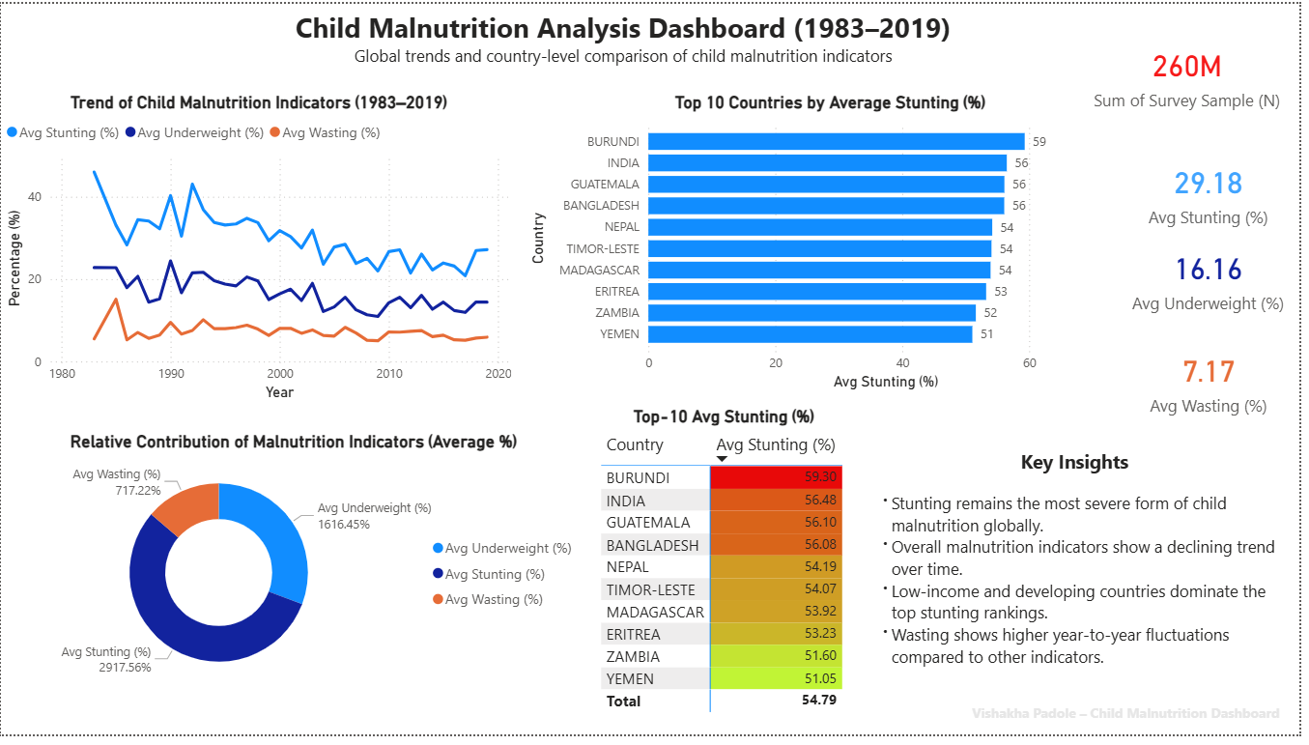

Key Insights

Stunting stays the most lasting form of child malnutrition, in the world. Stunting hurts the children everywhere.

From my view the malnutrition indicators are going down slowly over time.

Income and developing countries lead the stunting rankings. Income and developing countries have the children who are short, for their age.

Wasting exhibits higher year-to-year variability compared to other indicators

Limitations

I notice that the data availability varies across countries. The survey frequency also varies across countries.

The overall average can hide the differences. I see that the overall average can hide the differences.

I do not explicitly model the influences. The external influences include the conflict, the climate events and the policy interventions.

Future Enhancements

Integration of geographic maps for spatial analysis.

Drill-through analysis by income classification and region.

Predictive analytics for future malnutrition trends.

Inclusion of healthcare expenditure and policy indicators.

Conclusion
The Child Malnutrition Analysis Dashboard demonstrates the value of data visualization in transforming complex public health datasets into actionable insights. By combining analytical rigor with intuitive dashboard design, the project supports informed decision-making and underscores the role of business intelligence tools in addressing global health challenges.

References
[1] World Health Organization, Child Malnutrition Estimates, WHO, Geneva.
[2] UNICEF, The State of the World’s Children, UNICEF Publications.
[3] Microsoft, Power BI Documentation, Microsoft Learn.

