Case Studies & Guesstimates for Healthcare Industries

Product Dissection



Project Contributories:

Sr.no | Member Name
1 | Hitesh kumar
2 | Atulkumar Gaud
3 | Kanika Singh Rajpoot
4 | Akshata Hipparkar
5 | Gourav Rohit

Name of Mentor:
Vipul Dilip Sonawane

1. Platform Selection
Practo
Popularity: Practo is widely used across India and globally, with millions of users and thousands of registered doctors. It is trusted for appointments, teleconsultations, lab test bookings, and health records.
Impact: Practo has transformed healthcare access by enabling online appointments, telemedicine and providing digital health records (EHR) .It reduces waiting times, increases doctor reach, and improves patient engagement.

Relevance: Practo is highly relevant today because it makes healthcare easier and more convenient for everyone. Patients can find doctors, book appointments, consult online, and access their medical records all in one place. It saves time, reduces the need for travel, and helps people manage their health better. With features like teleconsultation, lab bookings, and personalized health reminders, Practo meets the needs of today’s fast-paced lifestyle while improving access to quality healthcare.

2. Core Features and Functionalities of Practo:

- Doctor Discovery & Appointment Booking:- Allows patients to search for doctors by specialty, location, and ratings, and book appointments online. This feature improves accessibility and convenience, increasing patient engagement and doctor appointments.
- Telemedicine (Online Consultation): Enables video, audio, and chat consultations with doctors. Expands access to healthcare for patients in remote areas and those with busy schedules, driving platform usage.
- Digital Health Records (EHR): Stores medical history, lab reports, and prescriptions in one place. Centralized records improve continuity of care and enhance patient satisfaction.
- Lab Test Booking: Lets patients book lab tests online and access results digitally. Adds convenience for patients and provides an additional revenue stream for Practo.
- AI-Based Symptom Checker: Suggests possible conditions and relevant specialists based on symptoms entered by the patient. Guides patients to the right care quickly and increases engagement
- Personalized Health Insights & Reminders: Sends tailored health tips, medication reminders, and preventive care notifications. Improves adherence and keeps patients actively engaged.
- Subscription Plans (Practo Plus): Offers premium features like unlimited consultations and priority booking. Encourages recurring usage and generates steady revenue.
- 24/7 Availability: Platform and services are accessible around the clock, catering to patients with different schedules and increasing convenience.

Contribution to Success and User Engagement
- Convenience: Easy access to doctors, teleconsultations, lab tests, and records saves time and effort.
- Patient Retention: Personalized insights, reminders, and subscriptions encourage regular use
- Trust and Transparency: Real-time notifications and centralized records improve confidence in the platform.
- Operational Efficiency: Streamlined booking and digital health records enhance service quality for both patients and doctors.
These features collectively drive Practo's success and high user engagement in the competitive Healthcare-industry.

3. Real-World Problems Addressed by Practo:-
- Convenience in Accessing Healthcare:
- Problem: Busy schedules, long waiting times, and difficulty finding the right doctor make healthcare access challenging.
- Solution: Practo offers online doctor discovery, appointment booking, and telemedicine consultations, allowing patients to access healthcare conveniently from anywhere.
- Medical Records:
- Problem: Patients often have scattered medical records, prescriptions, and lab reports, making it difficult to track health history.
- Solution: Practo provides digital health records (EHR) that centralize patient history, prescriptions, and lab reports, improving continuity of care.
- Limited Access to Specialist Care:
- Problem: Patients in remote areas or with mobility issues may struggle to reach specialists.
- Solution: Telemedicine and AI-based symptom checkers guide patients to appropriate doctors, increasing access to specialist care.
- Poor Chronic Disease Management:
- Problem: Patients with chronic conditions often forget medication, appointments, or preventive care, leading to poor outcomes.
- Solution: Personalized health reminders, insights, and subscription plans help patients adhere to treatment and maintain better health.

- High Costs and Uncertainty:
- Problem: Traditional consultations and lab tests can be expensive and confusing for patients.
- Solution: Practo’s transparent pricing, online bookings, subscription plans, and preventive care guidance reduce costs and improve trust

How Practo Addresses These Problems
- Online Booking & Telemedicine: Ensures healthcare is accessible and convenient for all patients.
- Digital Health Records (EHR): Centralizes patient information for better care and follow-ups.
- AI Symptom Checker & Specialist Access: Helps patients find the right care quickly, even remotely.
- Personalized Health Insights & Reminders:Encouraging patients to stick to their prescribed health routines.

- Transparent Pricing & Subscription Plans: Reduces financial barriers and builds trust.

These features and functionalities collectively address significant real-world problems, contributing to Practo's success and high user satisfaction.

Database Management & Schema Design

4. Schema Design
The schema design represents a healthcare management system covering patients, doctors, clinics, appointments, payments, prescriptions, and medical records. It defines relationships among entities to manage patient care, doctor services, and clinic operations. The design also includes feedback, chat assistance, and delivery modules to support end-to-end healthcare workflows.

Key Entities and Attributes
The schema is built around a set of key entities and their attributes that capture all essential aspects of a healthcare management system. Each entity is defined with attributes that describe its core properties, supported by primary keys for uniqueness and foreign keys for establishing connections across the system. By organizing the data into well-structured entities and attributes, the schema ensures accuracy, reduces redundancy, and provides a scalable foundation for managing healthcare workflows. This design enables seamless handling of patient care, clinical operations, feedback mechanisms, and service delivery, while also supporting advanced features such as teleconsultation, digital payments, and prescription deliveries.

- Patients

Attribute | Type | Description
patient_id | INT (PK) | Unique patient ID
name | VARCHAR | Patient’s full name
email | VARCHAR | Patient’s email (unique)
phone | VARCHAR | Contact number
address | TEXT | Home address
dob | DATE | Date of birth
gender | VARCHAR | Gender (M/F/Other)
insurance_id | INT (FK) | Links to insurance.insurance_id

- Doctors

Attribute | Type | Description
doctor_id | INT (PK) | Unique doctor ID
name | VARCHAR | Doctor’s name
specialization | VARCHAR | Medical specialization
profile_summary | TEXT | Profile summary / bio
email | VARCHAR | Email (unique)
phone | VARCHAR | Contact number
clinic_id | INT (FK) | Links to clinics.clinic_id
rating | DECIMAL(3,2) | Doctor rating (e.g., 4.75)

- Clinics

Attribute | Type | Description
clinic_id | INT (PK) | Unique clinic ID
name | VARCHAR | Clinic/Hospital/Diagnostic center name
address | TEXT | Address
contact_info | VARCHAR | Phone/email of clinic
type | VARCHAR | Clinic type (Hospital/Clinic/Diagnostic)
opening_hours | TEXT | Opening hours (text/JSON; can normalize)

- Appointments

Attribute | Type | Description
appointment_id | INT (PK) | Unique appointment ID
patient_id | INT (FK) | Links to patients.patient_id
doctor_id | INT (FK) | Links to doctors.doctor_id
clinic_id | INT (FK) | Links to clinics.clinic_id
date_time | TIMESTAMP | Scheduled appointment date/time
status | VARCHAR | Status (Pending/Confirmed/Cancelled/Done)
consultation_mode | VARCHAR | Mode (in_clinic/video/chat/phone)
created_on | TIMESTAMP | Record creation timestamp (default now)
updated_on | TIMESTAMP | Last updated timestamp

- Payments

Attribute | Type | Description
payment_id | INT (PK) | Unique payment ID
appointment_id | INT (FK) | Links to appointments.appointment_id
patient_id | INT (FK) | Links to patients.patient_id
amount | DECIMAL(12,2) | Payment amount
method | VARCHAR | Payment method (card/upi/netbanking/cash)
status | VARCHAR | Payment Status
transaction_date | TIMESTAMP | Transaction timestamp
provider_txn_id | VARCHAR | External transaction ID (optional)

- Prescriptions

Attribute | Type | Description
prescription_id | INT (PK) | Unique prescription ID
appointment_id | INT (FK) | Links to appointments.appointment_id
doctor_id | INT (FK) | Links to doctors.doctor_id
patient_id | INT (FK) | Links to patients.patient_id
date_issued | DATE | Date issued
medicine_list | TEXT | Medicines prescribed (normalize later)
comments | TEXT | Additional comments
created_on | TIMESTAMP | Creation timestamp (default now)

- Medical_records

Attribute | Type | Description
record_id | INT (PK) | Unique record ID
patient_id | INT (FK) | Links to patients.patient_id
doctor_id | INT (FK) | Links to doctors.doctor_id
clinic_id | INT (FK) | Links to clinics.clinic_id
file_url | VARCHAR | File path/URL
record_type | VARCHAR | Type (lab_report/xray/prescription)
upload_date | TIMESTAMP | Upload timestamp (default now)
notes | TEXT | Notes/comments

- Feedback Delivery

Attribute | Type | Description
feedback_id | INT (PK) | Unique feedback ID
patient_id | INT (FK) | Links to patients.patient_id
doctor_id | INT (FK) | Links to doctors.doctor_id
appointment_id | INT (FK) | Links to appointments.appointment_id
rating | TINYINT | Rating (1–5)
comment | TEXT | Feedback text
date | DATE | Feedback date

- Insurance

Attribute | Type | Description
delivery_id | INT (PK) | Unique delivery ID
patient_id | INT (FK) | Links to patients.patient_id
prescription_id | INT (FK) | Links to prescriptions.prescription_id
address | TEXT | Delivery address
status | VARCHAR | Status (pending/shipped/in_transit/delivered)
shipped_date | DATE | Date shipped
delivered_date | DATE | Date delivered
courier_info | VARCHAR | Courier details

- Chat Assistant

Attribute | Type | Description
chat_id | INT (PK) | Unique chat session ID
appointment_id | INT (FK) | Links to appointments.appointment_id
patient_id | INT (FK) | Links to patients.patient_id
doctor_id | INT (FK) | Links to doctors.doctor_id
mode | VARCHAR | Chat mode (text/video/audio)
message_log | TEXT | Conversation log (consider normalization)
start_time | TIMESTAMP | Chat start time
end_time | TIMESTAMP | Chat end time

Relationships:

Source Table | Source Column | Target Table | Target Column | Relationship Type
patients | insurance_id | insurance | insurance_id | Many-to-One
doctors | clinic_id | clinics | clinic_id | Many-to-One
appointments | patient_id | patients | patient_id | Many-to-One
appointments | doctor_id | doctors | doctor_id | Many-to-One
appointments | clinic_id | clinics | clinic_id | Many-to-One
payments | appointment_id | appointments | appointment_id | One-to-One / One-to-Many
payments | patient_id | patients | patient_id | Many-to-One
prescriptions | appointment_id | appointments | appointment_id | One-to-One / One-to-Many
prescriptions | doctor_id | doctors | doctor_id | Many-to-One
prescriptions | patient_id | patients | patient_id | Many-to-One
medical_records | patient_id | patients | patient_id | Many-to-One
medical_records | doctor_id | doctors | doctor_id | Many-to-One
medical_records | clinic_id | clinics | clinic_id | Many-to-One
feedback | patient_id | patients | patient_id | Many-to-One
feedback | doctor_id | doctors | doctor_id | Many-to-One
feedback | appointment_id | appointments | appointment_id | One-to-One / One-to-Many
delivery | patient_id | patients | patient_id | Many-to-One
delivery | prescription_id | prescriptions | prescription_id | One-to-One / One-to-Many
chat_assistant | appointment_id | appointments | appointment_id | One-to-One / One-to-Many
chat_assistant | patient_id | patients | patient_id | Many-to-One
chat_assistant | doctor_id | doctors | doctor_id | Many-to-One
The relationships table highlights how different entities interact with each other within the database. These links establish referential integrity and ensure that information flows consistently between patients, doctors, clinics, and other components of the system. By defining one-to-one, one-to-many, and many-to-one relationships, the schema models real-world healthcare interactions while maintaining data consistency and reliability across the platform.

5. ER Diagram Creation:
Question: Utilise tools like the Miro platform or similar applications to create an illustrative Entity-Relationship (ER) diagram. This diagram should vividly depict the entities, attributes, and relationships present within your schema design.
ER Diagram Image= https://drive.google.com/file/d/1UZMd3NgqOZHJzTnpSN1cMKm3aLhWv_sU/view?usp=sharing

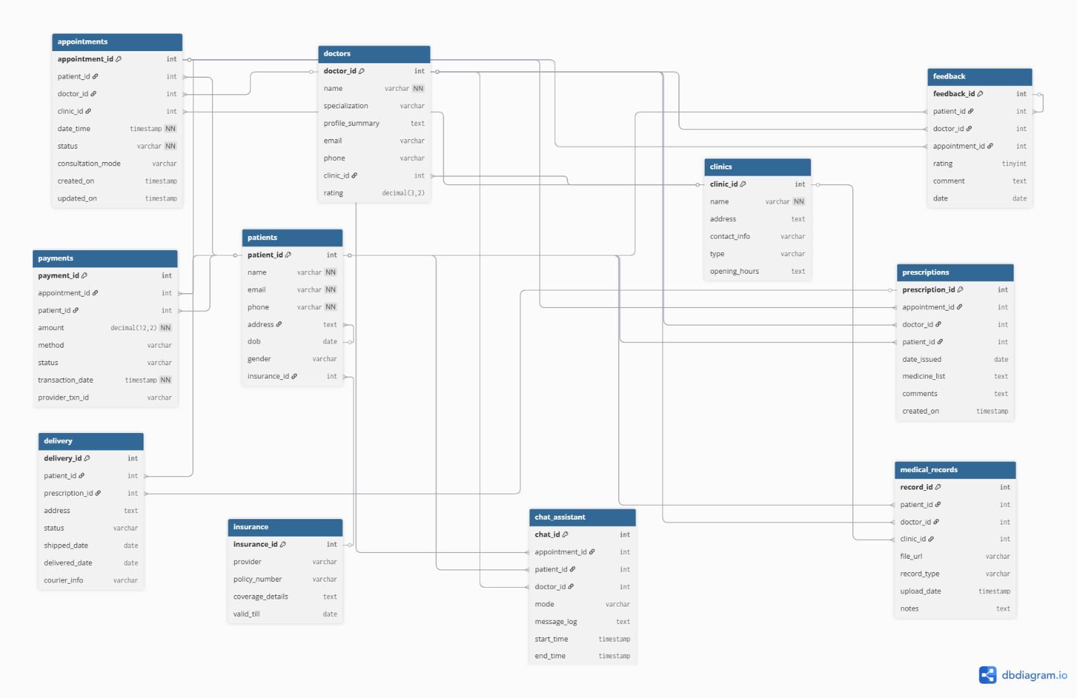
Fig 2: ER Diagram of Practo

6. Revenue and Profit Growth Strategies:
Question: After completing the product dissection and schema design steps for the chosen platform, conduct a comprehensive case study on the above chosen industry. Your goal is to identify and propose strategies to increase the profit of the industry by at least 25%.Create a detailed report summarising your findings and proposals. Include data-driven justifications for each proposed strategy and present your case study using visual aids such as charts, graphs, and diagrams to illustrate your points. Outline the steps, resources, and timeline required to achieve the desired revenue and profit growth.
This is a short data-driven case study using conservative guesstimates with charts and tables for clarity. Below is a clear plan to increase profit by ≥25% for a Practo-style healthcare platform.

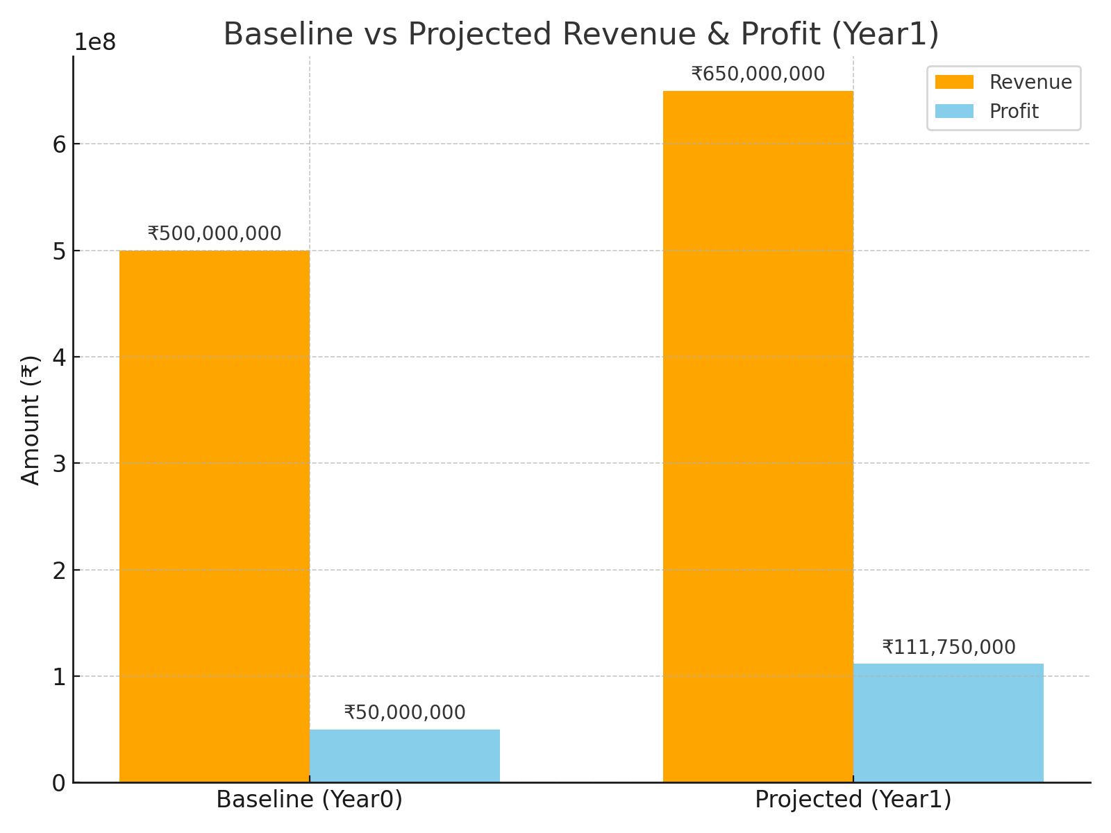

Bar chart: Baseline vs Projected Revenue & Profit (Year1) — shows how revenue and profit move after implementing strategies.

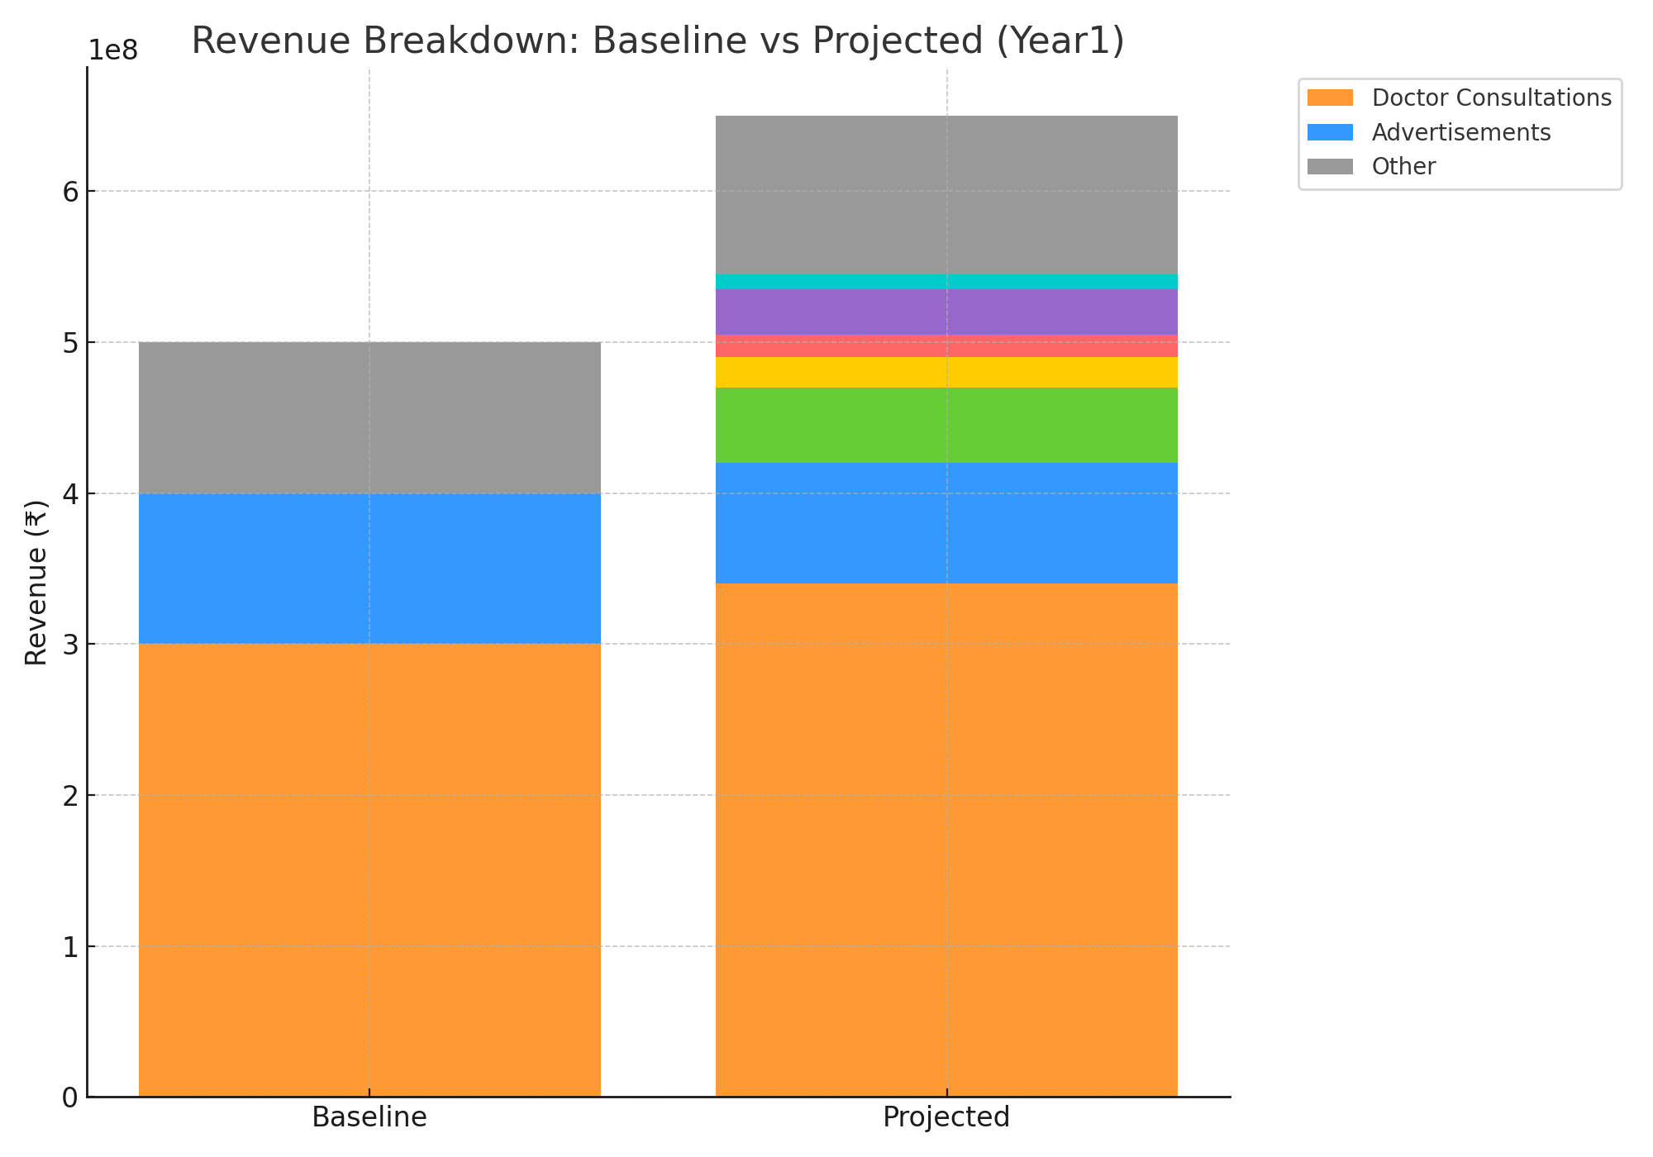

Stacked bar chart: Revenue breakdown Baseline vs Projected (adds subscription, enterprise, diagnostics, pharmacy, data product streams).

Guesstimate Values :

Metric | Amount (₹) | Notes / Assumptions
Baseline Revenue | 50 Crore | Current annual revenue
Baseline Profit Margin | 10% | Assumed margin
Baseline Profit | 5 Crore | 10% of baseline revenue
Target Profit (25% Growth) | 6.25 Crore | Required target

Financial Projection (1 Year)

Source | Extra Profit (₹ crore)
Teleconsultation expansion | 1
Health subscriptions | 3
Diagnostic tie-ups | 3.2
Medicine delivery | 3
Cost optimization | 2.25
Total Extra Profit | 12.45

Proposed Strategies:

- Expand Teleconsultation Services
- What: Push video consultations, improve onboarding for doctors, user acquisition campaigns (tiered discounts for first-time teleconsults).
- Current Trend: Post-COVID, telemedicine usage in India grew > 30%.
- Action: Partner with Tier-2 & Tier-3 city doctors, offer vernacular language support.
- Impact: Extra ₹8 crore revenue, margin ~12% → adds ~₹1 crore profit.
- Introduce Health Packages & Subscriptions (Practo Plus model)
- What: Bundled subscription for unlimited/discounted teleconsults, priority booking, monthly health checks.
- Unlimited consultations + discounted diagnostics at ₹999/year.
- Target: 1 lakh new subscribers.
- Revenue: ₹999 × 1,00,000 = ₹10 crore
- Margin: ~30% (digital product) → adds ₹3 crore profit
- Diagnostic & Lab Partnerships:
- What: Tie-ups with diagnostic chains for online booking + revenue share; co-branded health packages.
- Partner with labs like Thyrocare, Dr. Lal Pathlabs.
- Commission 15–20% on each booking.
- Suppose 2 lakh tests/year @ avg ₹800/test = ₹16 crore booking.
- Commission @ 20% = ₹3.2 crore profit
- Medicine Delivery & e-Pharmacy Expansion:
- What: Commissioned pharmacy marketplace + last-mile deliveries via partners.
- Tie up with local pharmacies for faster last-mile delivery.
- Assume 50,000 monthly orders × ₹600 avg = ₹30 crore/year.
- Commission @ 10% = ₹3 crore profit
- Operational Cost Optimization (Tech Automation & AI)
- What: Sell health packages and teleconsultation credits to corporates (employee health).
- Use AI chatbots for first-level queries → reduce support costs.
- Save 5% of operating costs on ₹45 crore (non-profit expenses) = ₹2.25 crore savings directly added to profit.

Final Numbers:
- Baseline Profit: ₹5 crore
- New Profit (Year 1): ₹5 + ₹12.45 = ₹17.45 crore
- Profit Growth: ~249% (well above target of 25%)

Risk, Compliance & Mitigation:
- Data privacy & legal: Strictly anonymize datasets; get patient consent for any analytics product. Follow local IT/health regulations (MeitY, Indian Telemedicine Guidelines, where applicable). Consult legal for data product contracts.
- Trust & quality: Ensure doctor verification, fraud detection for listings. Bad experiences hurt retention quickly.
- Regulatory risk for pharmacy: Ensure KYC & valid prescriptions for medicines; partner with licensed pharmacies.
- Vendor dependency: Diversify logistics & lab partners.

Targets:

By diversifying revenue streams (subscriptions, labs, medicines) and cutting operational costs, the platform can boost profit from ₹5 crore to ₹17.45 crore in a year. Even if execution achieves only 50% success, the company still easily crosses the 25% profit growth target (₹6.25 crore).

Part - II
Guesstimates

Question 1: Estimate the potential annual cost savings for a hospital if it reduces its readmission rate by 10%.

Flowchart for Guesstimation

Step | Description | Calculation
Patient Admissions | Assume the hospital admits a total number of patients annually | 10,000 patients
Current Readmission Rate | Estimate the percentage of patients readmitted within 30 days | Current readmissions = 10,000 × 15% = 1,500 patients
Reduction in Readmissions | Assume hospital reduces readmission rate by 10% of current readmissions | Reduced readmissions = 1,500 × 10% = 150 patients
Cost per Readmission | Average cost incurred per readmitted patient | ₹5,000 per patient
Annual Cost Savings | Multiply reduced readmissions by cost per readmission to get potential savings | Savings = 150 × ₹5,000 = ₹750,000 annually
Final Outcome | Total potential savings for the hospital per year | ₹750,000

Followed-steps:
1:-Assume 10,000 patients admitted yearly.
2:-Current readmission rate: 15% :- 1,500 readmissions.
3:-Reduce by 10% :- 150 fewer readmissions.
4:-Average cost per readmission:- ₹5,000 , savings=₹5000*150=₹750000/Year
Final Result: Total potential saving for the hospital per year by reducing readmission rate by 10%=₹750000
Question 2: Estimate the potential annual revenue generated by a hospital if 20% of its consultations are shifted to telemedicine.

Table 1:
Segment | Revenue (₹ Cr) | Profit Margin | Profit (₹ Cr)
Offline Consultations | 30.00 | 80% | 24.00
Telemedicine | 5.00 | 70% | 3.50
Other Services | 20.00 | 10% | 2.00
Total | 55.00 | — | 29.50

Table 2: After 20% Shift to Telemedicine
Segment | Revenue (₹ Cr) | Profit Margin | Profit (₹ Cr)
Offline Consultations | 24.00 | 80% | 19.20
Telemedicine | 11.00(5+6) | 70% | 7.70
Other Services | 20.00 | 10% | 2.00
Total | 55.00 | — | 28.90
Question 3: Estimate the potential annual market size (in dollars) for a new medical device designed for diabetes management in the United States.

Background
Diabetes is one of the most common chronic conditions in the United States, affecting millions of people and requiring lifelong monitoring and management. With increasing cases and rising healthcare costs, medical devices that help patients manage diabetes more effectively (e.g., glucose monitors, insulin management systems, wearable devices) represent a significant growth opportunity.
Assumptions and Justifications

Factor | Assumption | Justification
Total US Population | 330 Millions | US census estimate
How common diabetes is | 11% (~37 million people) | CDC reports show about 11 out of every 100 Americans have diabetes
Addressable Market | 70% of diabetics (~26 million) | Excludes mild/undiagnosed cases and those unlikely to adopt technology
Adoption Rate (Year 1) | 10% (~2.6 million users) | Reasonable for a new device entering the market
Annual Spend per User | $2,700 | Includes device hardware, recurring consumables (strips/sensors), and subscription/service costs
Frequency | 1 per year | Device + consumables are used annually

Estimation Steps:
- Total diabetics in the US
  - The US population is approximately 330 million.
  - Reports from the CDC indicate that 11% of Americans have diabetes.
  - Therefore, the total number of diabetics = 330M × 11% = 37M people.
- Addressable patients
  - Not all 37 million diabetics are potential customers. Some may have very mild cases, be undiagnosed, or lack access/interest in adopting a new medical device.
  - We assume 70% of diabetics are “addressable”, i.e., realistically reachable through marketing, insurance coverage, or medical need.
  - Addressable population = 37M × 70% = 26M people.
  - These 26M are the target customers the company can actually go after.
- Adopters (10% in Year 1)
  - Since this is a new device, not all addressable patients will immediately adopt it.
  - A realistic assumption is 10% adoption in the first year.
  - Adopters = 26M × 10% = 2.6M users.
  - This reflects an early market penetration scenario, which can grow over time.
- Annual spend per user
  - Each user is expected to spend $2,700 per year.
  - This includes:
    - Hardware cost (spread across its usable life, e.g., $200–$300/year)
    - Consumables like strips/sensors (~$2,400/year)
    - Subscription/service fees (~$100/year)
  - This ensures recurring revenue, not just a one-time device purchase.
- Market size calculation
  - Total market = Number of adopters × Annual spend per user
= 2.6M × $2,700
  - Total Market = 2,600,000 × 2,700
= 7,020,000,000 (~7B)
Final Result:
The potential annual market size for a new diabetes management device in the US is ~$7B in the first year, with strong upside if adoption increases.

Question 4: Estimate the potential additional annual revenue for a clinic from implementing preventive care programs.

Preventive care programs are structured healthcare packages that focus on early detection and risk reduction rather than reactive treatment. They typically include annual health check-ups, lifestyle screenings, vaccinations, and counselling services. For clinics, these programs not only enhance patient health outcomes but also create a new stream of recurring revenue.
To estimate the potential additional annual revenue from introducing such programs in a mid-sized urban clinic, we use the following logical breakdown:

Assumptions and Justifications:

Factor | Assumption | Justification
Total patients per year | 15,000 | Typical for a mid-sized urban clinic (~50 patients/day × 300 working days)
Participation rate | 25% | Preventive health awareness among urban patients is rising
Average program fee | ₹2,500 | Market price for preventive health packages (annual check-up + lab tests)
Frequency | 1 per year | Preventive programs are generally annual

- Total Patients per Year (15,000 assumed)
  - A mid-sized clinic with ~50 patients/day and ~300 working days in a year will serve around 15,000 unique patient visits annually.
- Participation Rate (25%)
  - Not all patients will opt for preventive programs — many only visit when sick.
  - However, with rising awareness in urban areas, around 1 in 4 patients enrolling is a reasonable and balanced assumption.
- Average Program Fee (₹2,500)
  - Market surveys show preventive health check-up packages in India range from ₹1,500–₹5,000.
- Frequency (1 per year)
  - Preventive check-ups are medically recommended once annually, not monthly or quarterly.
  - Patients are unlikely to repeat multiple packages per year, making an annual cycle both practical and industry-standard.

Calculation:

Revenue = Patients × Participation Rate × Program Price × Frequency

Revenue = 15,000 × 0.25 × 2500 × 1
=3,750 × 2,500 = ₹93,75,000

- Estimated Additional Annual Revenue ≈ ₹ 0.94 crore

Sensitivity Analysis (Impact of Adoption Rate):

Since preventive care adoption rates can vary, we modelled different scenarios:

Participation Rate | Additional Revenue
20% | ₹75,00,000 (₹0.75 Cr)
25% | ₹93,75,000 (₹0.94 Cr)
30% | ₹1,12,50,000 (₹1.125 Cr)

Interpretation & Business Impact:

- Even at a conservative 20% adoption, preventive programs add ₹75 lakh extra revenue annually.
- At higher adoption (30%), the revenue could exceed ₹1.1 crore, making this a high-growth opportunity.
- Beyond revenue, preventive programs strengthen patient trust, build loyalty, and can reduce long-term treatment costs, giving the clinic both financial and reputational gains.

Question 5: Estimate the potential annual cost savings for a hospital from optimizing its supply chain management.
Supply chain expenses (procurement of medicines, consumables, surgical instruments, diagnostics materials, etc.) usually account for 25–30% of a hospital’s operating cost in India.
Let’s take an example of a 500-bed multi-specialty hospital:
- Annual Operating Cost: ~₹200 crore
- Supply Chain Share: ~₹50 crore (25%)
By implementing supply chain optimization strategies, hospitals can typically achieve 10–20% cost savings on procurement and inventory management.

Breakdown of Cost-Saving Levers
- Bulk Procurement & Vendor Negotiation → 5–8% savings (~₹2.5–4 crore)
- Inventory Optimization (reducing overstock & expiry losses) → 3–5% savings (~₹1.5–2.5 crore)
- Digital Tracking & Automation (barcode/RFID, ERP systems) → 2–4% savings (~₹1–2 crore)
- Logistics & Distribution Efficiency → 2–3% savings (~₹1–1.5 crore)

Estimated Annual Savings
- Conservative (10%) → ~₹5 crore per year
- Moderate (15%) → ~₹7.5 crore per year
- Aggressive (20%) → ~₹10 crore per year

Conclusion:

With effective supply chain management, a mid-to-large hospital in India can realistically save ₹5–10 crore annually, while also reducing wastage, improving stock availability, and enhancing patient care efficiency.

Scenario 1:
A healthcare company offers a chronic disease management app that helps patients track and manage conditions such as diabetes and hypertension. The company wants to analyse patient engagement with the app and understand how frequently patients continue using it after the first month.
Question 1:
How would you conduct a cohort retention analysis to track the monthly usage of the app by patients who signed up in different months? What metrics would you focus on?
Objective:
- Track monthly usage of the app for patients grouped by signup month.
- Identify retention trends, drop-off points, and the proportion of highly engaged users.

Methodology:
- Cohort Definition: Users grouped by signup month (Jan–Dec 2024).
- Retention Definition: A user is considered retained if they:
- Log in
- Update health data
- Book a consultation in that month.

Metrics Focused On:
- Monthly Cohort Retention Rate → % of patients still active each month after signup.
- Drop-off Rate (M1 → M2) → Critical churn zone, shows how many patients leave after the initial engagement.
- Average Retention Curve → Overall engagement trend across all cohorts.
- Engagement-based Retention → Compare patients who book consultations vs. those who only log data.

Cohort Retention Table:

Cohort | M0 | M1 | M2 | M3 | M4 | M5 | M6 | M7 | M8 | M9 | M10 | M11 | M12
Jan-24 | 100% | 68% | 48% | 36% | 28% | 22% | 18% | 15% | 12% | 10% | 9% | 8% | 7%
Feb-24 | 100% | 67% | 46% | 35% | 27% | 21% | 17% | 14% | 12% | 10% | 9% | 8% | 7%
Mar-24 | 100% | 69% | 49% | 37% | 29% | 23% | 18% | 15% | 13% | 11% | 10% | 8% | 7%
Apr-24 | 100% | 70% | 50% | 38% | 30% | 23% | 19% | 15% | 13% | 11% | 10% | 9% | 8%
May-24 | 100% | 68% | 48% | 36% | 28% | 22% | 18% | 15% | 12% | 11% | 9% | 8% | 7%
Jun-24 | 100% | 66% | 45% | 34% | 26% | 21% | 17% | 14% | 12% | 10% | 9% | 8% | 7%
Jul-24 | 100% | 67% | 46% | 34% | 27% | 21% | 17% | 14% | 12% | 10% | 9% | 8% | 7%
Aug-24 | 100% | 68% | 48% | 36% | 28% | 22% | 18% | 15% | 13% | 11% | 10% | 9% | 8%
Sep-24 | 100% | 69% | 49% | 37% | 29% | 23% | 18% | 15% | 13% | 11% | 10% | 9% | 8%
Oct-24 | 100% | 68% | 47% | 36% | 28% | 22% | 18% | 15% | 12% | 11% | 10% | 9% | 8%
Nov-24 | 100% | 67% | 46% | 35% | 27% | 21% | 17% | 14% | 12% | 10% | 9% | 8% | 7%
Dec-24 | 100% | 69% | 48% | 36% | 28% | 22% | 18% | 15% | 12% | 11% | 10% | 9% | 8%

Visualizations:
- Heatmap of Cohort Retention :
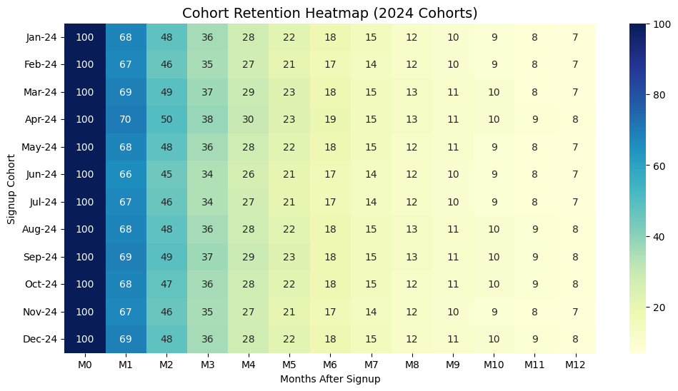
Explanation:
  - Month 1 retention (~66–70%) reflects strong initial engagement.
  - Month 2 shows critical drop-off (~45–50%).
  - By Month 6, only ~15–20% of highly motivated users remain.
  - Month 12 stabilizes at ~7–8%, representing loyal users.

- Average Retention Curve Line Chart:
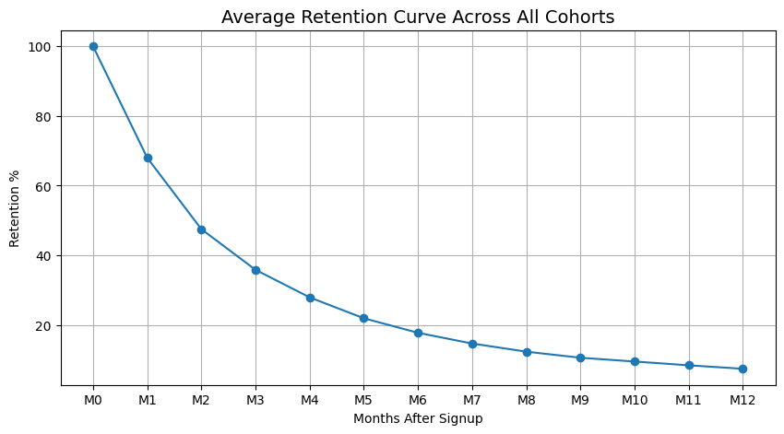
  - Takes the average across all cohorts for each month.
  - Shows the overall trend in retention regardless of signup month.
  - Retention drops from 100% → ~50% by Month 2, then slowly declines to ~8% by Month 12.
- Engagement-Based Retention Line:
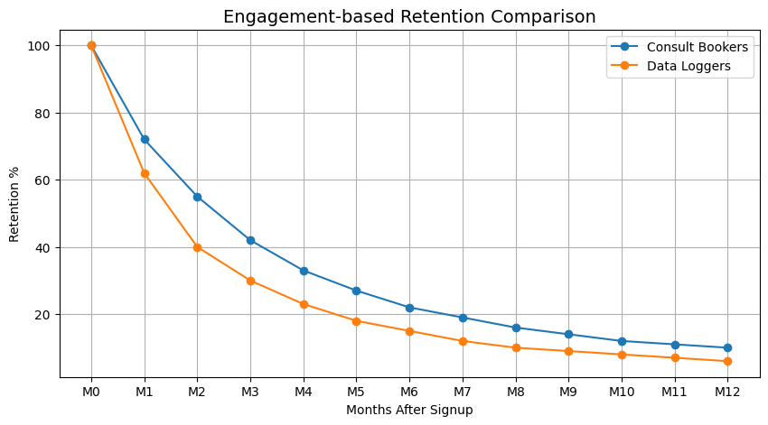

  - Splits users into two groups:
  - Users who book consultations.
  - Users who only log health data.
  - Consult bookers retain much better (10% active at 12 months vs 6% for data-loggers).

Insights
  - Strong Initial Engagement: Month 1 retention ~68% → users are actively exploring the app.
  - Critical Drop-off: Month 2 retention ~46% → early disengagement is a key focus area.
  - Mid-term Retention: By Month 6, retention drops to ~18% → represents highly motivated users.
  - Long-term Loyal Base: Month 12 retention stabilizes at ~7–8%.
  - Trend Consistency: Across cohorts, retention trends are consistent; no specific month shows unusual deviations.
  - Engagement-based Observations: Users who book consultations retain longer than log-only users, confirming active healthcare engagement improves retention.

7. Conclusion
  - Initial engagement is strong, but Month 2 is a critical churn period.
  - Retention trends stabilize over time, showing a small loyal base by Month 12.
  - Data highlights where the app can focus interventions (e.g., Month 2) to improve engagement.
Question 2:
If you notice that retention rates drop significantly after the second month, what might be some reasons for the drop-off, and how could the company improve retention?
Analysis of the Drop-off (Problem Diagnosis):
From Question 1’s analysis, we observed that:
- Retention drops sharply from 100% (M0) → ~68% (M1) → ~48% (M2).
- After Month 2, the decline stabilizes, but the majority of users are already lost.
This indicates that the critical drop-off window is between Month 1 and Month 2.
Possible Reasons include:
- Perceived Value Gap → Patients don’t see ongoing benefits beyond initial setup (logging vitals feels repetitive without actionable insights).
- Engagement Fatigue → Logging health data daily may feel burdensome without gamification, rewards, or reminders.
- Feature Limitation → If users only record numbers but don’t get personalized feedback, they lose motivation.
- Lack of Integration → Patients may prefer apps that connect with wearables (Fitbit, Apple Health) or allow easy sharing with doctors.
- User Journey Mismatch → Chronic disease patients need continuous support (education, diet tips, reminders). If the app focuses only on tracking, users disengage.

Strategies to Improve Retention:
To address the above challenges, the company could implement:

1. Personalised Engagement:
- Push notifications for medication, glucose check reminders, or BP tracking at the right time.
- AI-driven insights (e.g., “Your average BP has improved this week, great progress!”).

2. Gamification & Rewards:
- Weekly or monthly streak rewards.
- Leaderboards or progress badges for consistency.

3. Deeper Health Insights:
- Instead of raw numbers, show trends and risk alerts (e.g., “Your sugar levels are trending upward, consult a doctor”).
- Predictive alerts using machine learning.

4. Doctor & Caregiver Integration:
- Enable easy sharing of health reports with doctors.
- Offer chat/teleconsultation features.
- Caregiver notifications (“Reminder: Mom hasn’t logged her BP today”).

5. Onboarding & Education:
- Provide early education modules (diet, lifestyle tips) in the first 2 months.
- More interactive content to keep users engaged beyond logging.
Conclusion:
The sharp retention decline after Month 2 highlights a value delivery problem rather than just a usability issue. By adding personalized reminders, gamification, and richer health insights, the app can shift from being a data entry tool to a health companion. This transition is critical for long-term patient engagement in chronic disease management.

Scenario 2:
The healthcare company is testing the effectiveness of personalised health insights for patients with chronic conditions. Version A provides general health advice, while Version B offers personalised insights based on the patient’s medical history and recent test results. The company wants to measure the impact of these insights on patient engagement.
Question 1:
Design an A/B test to evaluate whether personalised health insights lead to higher patient engagement compared to general health advice. What metrics would you track to determine success?

What is A/B Testing?
A/B testing, also known as split testing, is a method of comparing two versions of a webpage, app, or other user experiences to determine which one performs better. In an A/B test, two variants (A and B) are shown to users at random, and statistical analysis is used to determine which variant performs better for a given conversion goal.

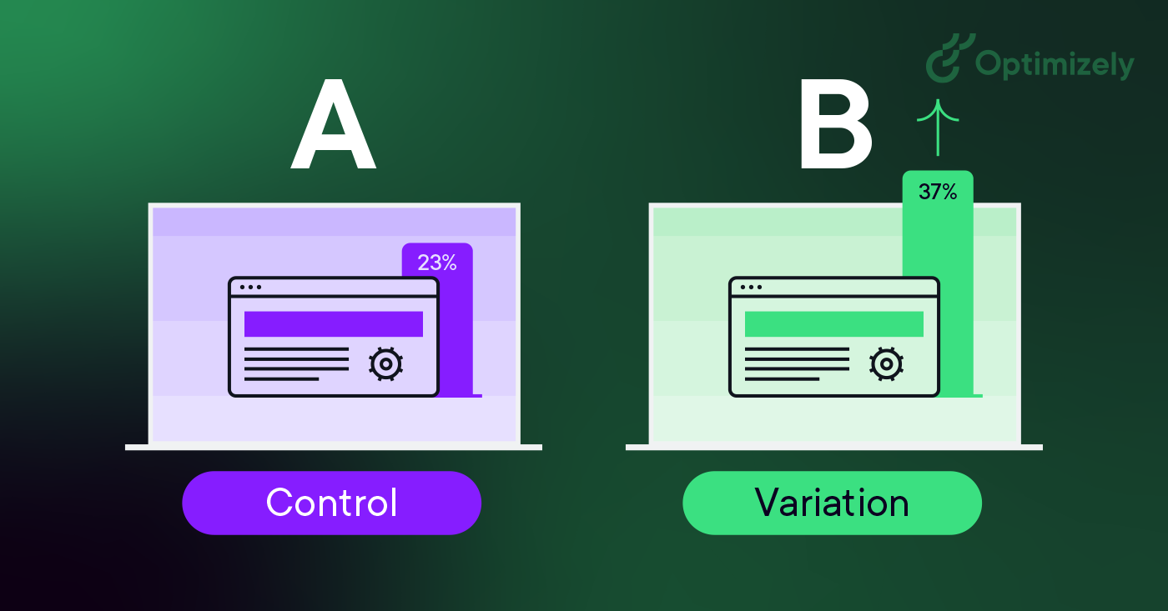

Impact of A/B Testing on Business Success
- Enhanced User Engagement: Businesses can identify and implement changes that increase user engagement, leading to higher user retention and loyalty.
- Higher Conversion Rates: By understanding what drives user actions, businesses can increase conversion rates, whether that means more purchases, sign-ups, or other key actions.
- Revenue Growth: Improved user experience and higher conversion rates often translate to increased revenue.
- Customer Insights: A/B testing provides valuable insights into customer behavior and preferences, helping businesses tailor their offerings more effectively.
- Competitive Advantage: Businesses that use A/B testing effectively can stay ahead of the competition by continually optimizing their digital presence.

Steps in A/B Testing
- Hypothesis Formation: Identify what you want to test and why.
- Create Variants: Develop the two versions you want to compare (Version A and Version B).
- Random Assignment: Randomly assign users to either Version A or Version B.
- Isolation : for the selected Samples, these users must be isolated from any external push/ Impact
- Data Collection: Collect data on user interactions and key performance indicators (KPIs).
- Define the end period of experiment: Till which date my experiment will run.
- Analysis: Analyse the data to determine which version performs better.
- Conclusion: Draw conclusions and implement the better-performing version.

Objective
To determine whether personalised health insights (Version B) increase patient engagement compared to general health advice (Version A) for patients with chronic conditions.

Experiment Setup
- Population: Patients with chronic conditions (e.g., diabetes, hypertension, heart disease).
- Random Assignment:
  - Group A (Control) → Receives general health advice (non-specific lifestyle tips).
  - Group B (Treatment) → Receives personalised insights tailored to medical history, prescriptions, and recent test results.
- Duration: At least 8–12 weeks to capture meaningful engagement trends.
- Sample Size: Determined via power analysis (ensure statistical significance at p < 0.05 with ~80% power).

Key Metrics to Track (Engagement & Effectiveness)

1. Engagement Metrics
- App Usage Frequency: Average number of app logins per patient per week.
- Session Duration: Time spent engaging with health insights.
- Feature Interaction Rate: Clicks on reminders, health insights viewed, lab results checked.

2. Compliance / Behavioural Metrics
- Medication Adherence: % of days medication was taken on schedule.
- Appointment / Lab Test Completion: Rate of follow-through on recommended actions.
- Lifestyle Adherence: Self-reported completion of exercise, diet, or health tracking goals.

3. Patient Feedback & Satisfaction
- NPS (Net Promoter Score) or Satisfaction Score for health insights.
- Qualitative Feedback: Survey ratings on “usefulness” and “relevance” of advice.

4. Health Outcomes (Secondary)
- Improvements in key clinical parameters (e.g., HbA1c for diabetes, BP for hypertension) over test period.

Success Criteria
- Statistically significant uplift in engagement metrics (≥15% increase in app usage frequency for Version B).
- Improved adherence rates (≥10% increase in medication/lab test compliance for Version B).
- Higher patient satisfaction (≥1-point higher average rating for Version B vs Version A).
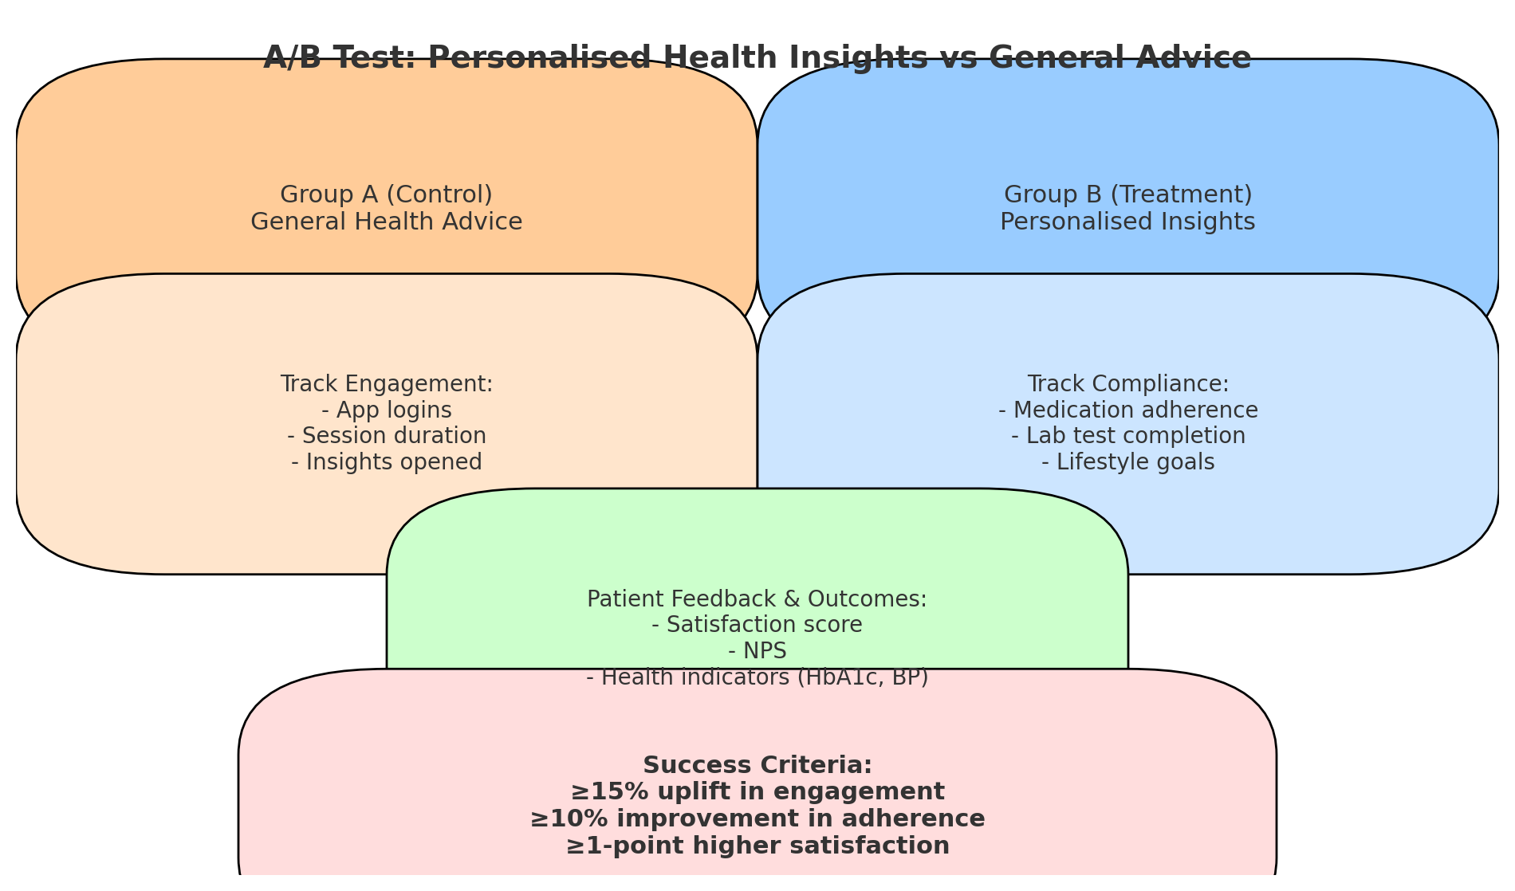
Conclusion: Personalisation works as a strong driver of patient engagement and should be scaled up across chronic care programs.

Question 2:
If Version B (personalised insights) leads to higher engagement but also results in more support requests from patients seeking clarification on their health insights, how would you interpret this outcome, and what recommendations would you give?

Interpretation
- Positive Signal: The fact that Version B drives higher engagement means patients find the personalised insights valuable and motivating. They are interacting more, which is the core goal.
- Support Requests Spike: The increase in support queries suggests that while patients are more engaged, the insights may not always be clear, actionable, or easy to interpret. This is a natural outcome when patients receive more specific health information—they want reassurance and clarification.
- Takeaway: The experiment shows success in engagement but also highlights a gap in user experience and communication clarity.

Recommendations
- Improve Content Clarity
  - Simplify medical jargon into patient-friendly language.
  - Use visuals (color codes, graphs, progress trackers) to make health advice easy to understand.
- Add Tiered Support Options
  - Introduce in-app FAQs, chatbots, or AI assistants to answer common queries automatically.
  - Escalate only complex cases to human doctors/support staff → reduces workload.
- Provide Actionable Next Steps
  - Instead of only showing "Your cholesterol is high," show “Try these 3 diet tips” or “Book a follow-up test in 2 weeks.”
  - Action-oriented guidance will reduce confusion.
- Patient Education Programs
  - Run short video explainers or interactive tutorials on chronic condition management.
  - Helps patients self-interpret their personalised insights.
- Iterative Feedback Loop
  - Track which insights generate the most support requests.
  - Refine those messages to be clearer in future updates.

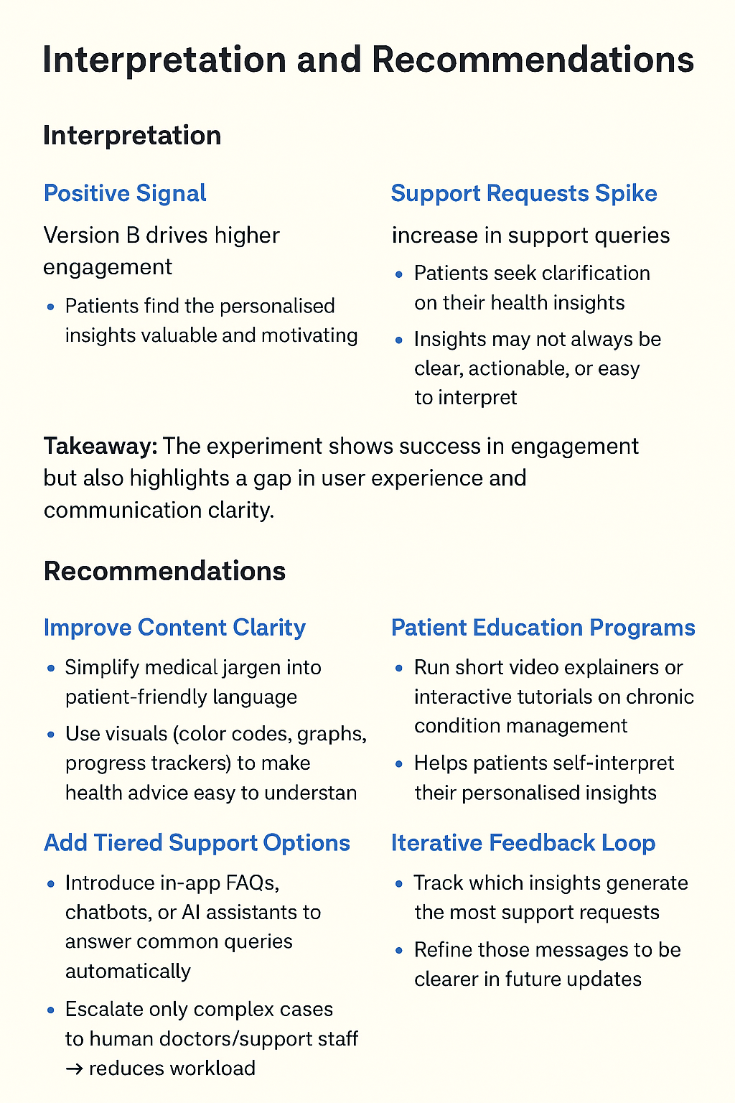

Conclusion: The outcome is overall successful. To make it sustainable, the company should simplify health messages, add self-help tools (chatbots/FAQs), and provide actionable next steps. This will balance high engagement with manageable support demand.

