INFO 5100 Application Engineering and Development

**Assignment 3**

University Quality Monitoring

horizontal line

*Project By :*

**TEAM NO 25**

Madhurima Chatterjee (001003806)

Arthi Ganesan (001038375)

Vishakha Vinayak (001550683)

# Content:

1. Problem Statement
2. Proposed Solution

2.1 Class Diagram

2.2 Components involved

2.3 Detailed Analysis

1. Dashboard

# 1. Problem Statement

The objective of this assignment is to instill the techniques for turning an object model into a machine for information gathering and data aggregation.We want to use software engineering techniques to improve the quality of education anywhere and hold people accountable for improving the quality of life through education, learning to learn, and feedback. We create a performance measurement solution to enable universities to measure the quality of the education they deliver to their students. The approach will be to look into how an educational system in terms of faculty and courses contribute to the growth of their graduates over a 5-year period. We figure out ways to track the jobs and promotions graduates get over time and assign rankings accordingly. In addition, track the connection of courses and their relevance to graduates' growth.

# 2.1 Class Diagram

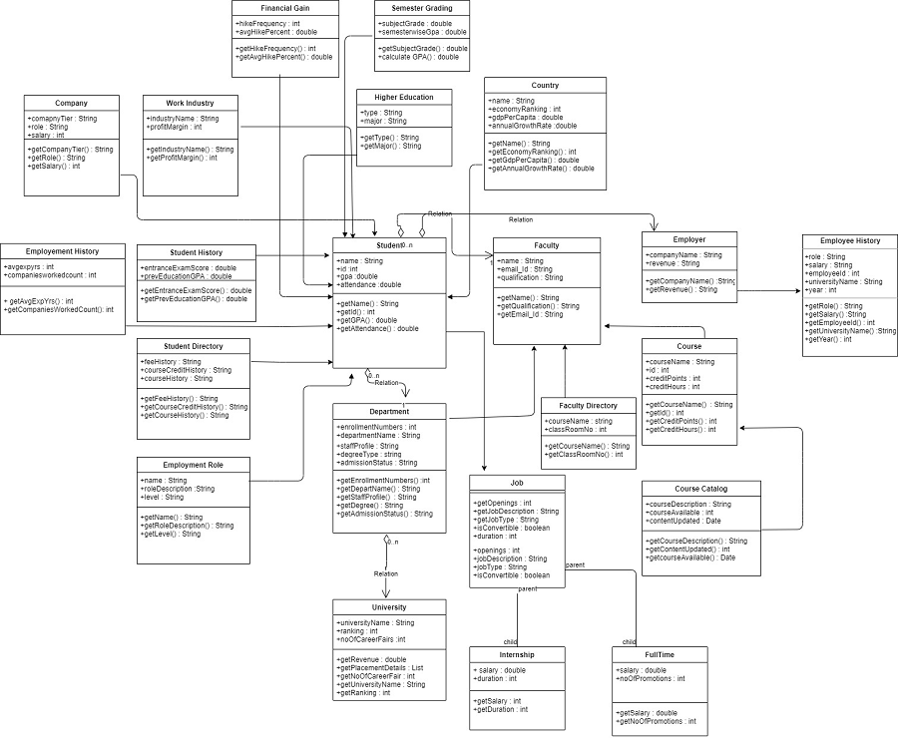

# 2.2 Components Involved:

1. **Department:**

This component contains all the department details.

|  |  |  |
| --- | --- | --- |
| **Attribute** | **Data Types** | **Description** |
| departmentName | String | Name of the department |
| enrollmentNumbers | int | Number of students enrolled in specific department |
| staffProfile | String | Overall staff details |
| degreeType | String | Degree type |
| admissionStatus | String | Admission details |

**Methods:** getEnrollmentNumbers(), getDepartmentName(), getStaffProfile(), getDegree(), getAdmissionStatus().

1. **Student**

This component contains details with respect to the student profile.

|  |  |  |
| --- | --- | --- |
| **Attribute** | **Data Types** | **Description** |
| studentName | String | Name of the student |
| studentId | int | Unique id of student |
| gpa | double | Student overall score till now |
| attendanceDetails | double | Attendance percent till now |

**Methods:** getStudentName(), getStudentId(), getgpa(), getAttendanceDetails(),

1. **Faculty**

This will contain details about various faculties and research work details.

|  |  |  |
| --- | --- | --- |
| **Attribute** | **Data Types** | **Description** |
| facultyName | String | Name of the faculty |
| email_Id | String | Email id of the faculty to contact them for doubts |
| qualification | String | Highest qualification of the faculty |

**Methods:** getfacultyName(), getEmailId(), getQualification()

1. **Financial Gain**

This will contain details on the financial gains received by that student.

|  |  |  |
| --- | --- | --- |
| **Attribute** | **Data Types** | **Description** |
| hikeFrequency | int | How often is the hike received |
| avgHikePercent | double | The average percentage of the hike received |

**Methods:** getHikeFrequency(), getAvgHikePercent()

1. **Semester Grading**

This will contain details of the grading as well as the semester-wise GPA received by the student per semester.

|  |  |  |
| --- | --- | --- |
| **Attribute** | **Data Types** | **Description** |
| subjectGrade | double | Total grade for that semester |
| semesterwiseGpa | double | GPA of that semester |

**Methods:** getSubjectGrade(), getSemesterwiseGpa()

1. **Company**

This will contain details of the company where the student is employed after graduation.

|  |  |  |
| --- | --- | --- |
| **Attribute** | **Data Types** | **Description** |
| companyTier | string | Tier level at which the company belongs |
| role | string | Role of the student at the company |
| salary | int | Salary earned per annum |

**Methods:** getCompanyTier(), getRole(), getSalary()

1. **Work Industry**

This will contain details of the industry the student is a part of.

|  |  |  |
| --- | --- | --- |
| **Attribute** | **Data Types** | **Description** |
| industryName | string | Name of the industry |
| profitMargin | int | Profits of that industry |

**Methods:** getIndustryName(), getProfitMargin()

1. **Higher Education**

This will contain details of higher education completed by the student prior to joining the University

|  |  |  |
| --- | --- | --- |
| **Attribute** | **Data Types** | **Description** |
| type | string | Type of higher education |
| major | double | Major pursued |

**Methods:** getType(), getMajor()

1. **Country**

This will contain details of the country the student belongs to.

|  |  |  |
| --- | --- | --- |
| **Attribute** | **Data Types** | **Description** |
| name | string | Name of the country |
| economyRanking | int | Country’s economic ranking |
| gdpPerCapita | double | Its GDP per capita |
| annualGrowthRate | double | The country’s annual growth rate |

**Methods:** getName(), getEconomicRanking(), getGdpPerCapita(), getAnnualGrowthRate()

1. **Employment History**

This will contain details of the employment history of the student

|  |  |  |
| --- | --- | --- |
| **Attribute** | **Data Types** | **Description** |
| avgExpYears | int | Years of experience of the student |
| companiesWorkedCount | int | Number of companies that the student worked for |

**Methods:** getAvgExpYears(), getCompaniesWorkedCount()

1. **Student History**

This will contain details of the previous education and the scores attained by the student

|  |  |  |
| --- | --- | --- |
| **Attribute** | **Data Types** | **Description** |
| entranceExamScore | double | Score from entrance exam |
| prevEducationGpa | double | GPA of previous education |

**Methods:** getEntranceExamScore(), getPrevEducationGpa()

# 2.3 Detailed Analysis

There are various aspects that need to be considered for a better quality of education system for the long run. Below are few points which we have highlighted:

* **Research Papers:**

If better research papers are delivered, this might increase the funds received for the implementation and will the product patented. Overall infrastructure will improve.

* **Company Feedback:**

Students already placed will deliver quality of work when the coursework is good enough for them to be industry ready which will increase in the placement for the future students and increase the enrollment of the students every year. University overall revenue and ranking will improve.

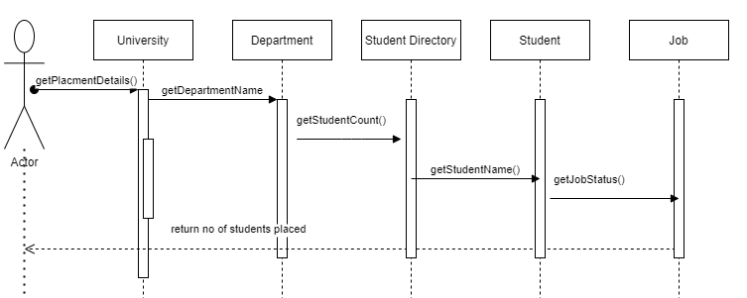

* **Industry :**

The Industry to which a student eventually belongs to from his career helps an University visualize which department/Course related students end up at which Industry category. This helps the University understand, whether their vision about their students ending up at a certain Industry bucket has been achieved. If there is a misalignment in the results, the University can explore as to what went wrong with a good set of students and how they could not align with University’s Vision.

* **Company:**

Apart from the Industry itself, a Firm/Company into which a student gets into determines the level of talent the student gains from his education in the University. If a majority of a student set goes into Tier-1 or Tier-2 buckets, the University is definitely doing good. If that does not happen to be the case, more filtering on which student set, belonging to which course-department can reveal more on what the University has to improve itself on.

* **Employment History:**

History of Employment is a key driver to show how good a Student is and to which Companies he is easily able to crack his interviews for. Apart from this, this history talks more on the career path a Student intends to choose based on his learnings from his previous jobs. All of this information ties back to which category of Departments - Course catalogs - Faculty combination the student belonged to. It can even be attributed to his history of Grades in and outside the University, may be in his Academic education, etc. A University can learn a lot about what to improve, having known about this information.

* **Employment Role:**

The Role a student eventually holds, belongs to in his future also describes if he aligned with the University’s vision for his category of students. If a major subset of this category went away from University’s vision of a career path, then the University will be under serious criticism in improving themselves towards this.

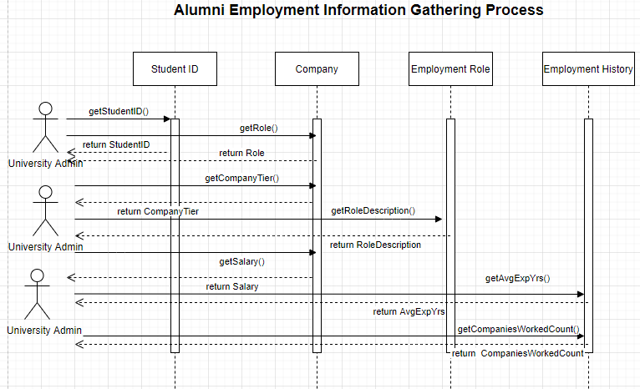

* **Higher Studies:**

A Student getting motivated to pursue higher education comes from the University where he learnt his basics properly. There is usually a vision that the student gets while pursuing his Under Graduation/ Post Graduation, that pushes the student to think beyond into a Masters’/Doctorate degree. Students belonging to this bucket are a proof to the Department, courses, Faculty, etc under which he/she studied. Such Departments, Courses, Faculty should be an example for the rest of the less-improved areas under an University.

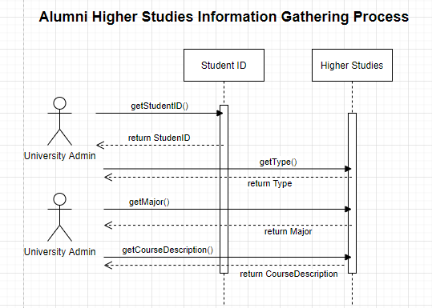

* **Country:**

Sometimes there is a major subset of students who go abroad to start working in other countries. Depending on the Country’s economy ranking, the University can also understand the upgrade/degrade factor the student ended up picking. This can go back to how the Student’s choice and mentoring were in the times when he/she belonged to the College Education days. Universities can use this future information to improve on the relevant parameters.

* **Financial Gain:**

One of the key factors determining how well a student is doing after stepping out of the University period is this. With the help of monetary parameters, one can determine how well a Student has excelled in his career. A University can also have this as one of the metrics to measure its success on its Alumni and look for areas of improvement.

# 3. Dashboard

