INFO 5100 Application Engineering and Development

**Assignment 4**

Travel Agency Serviceshorizontal line

*Project By:*

**TEAM NO 25**

Madhurima Chatterjee (001003806)

Arthi Ganesan (001038375)

Vishakha Vinayak (001550683)

# 

# Class Diagram: Car Rental from Rental Companies

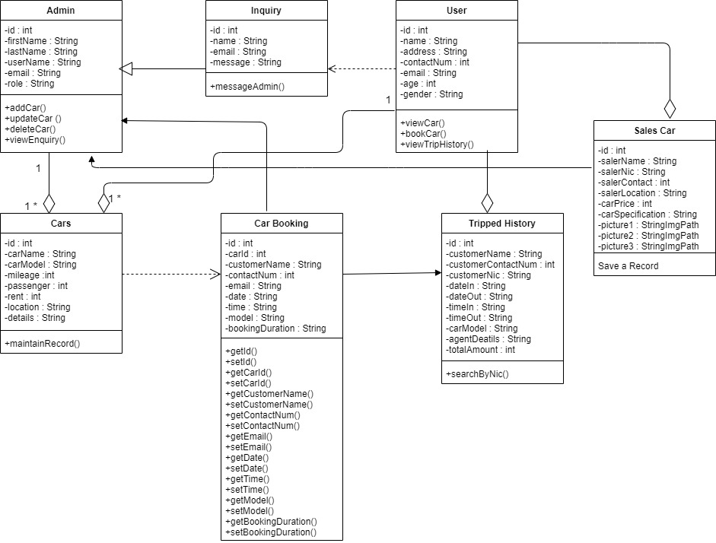

**Detailed Analysis:**

In our online car rental, the user can register in the database as a user. After the registration process is finished, the user will be able to log in to the login form and will be able to search and book a ride according to their requirements and budget. In car rental service, the user can book a ride for a short period of time and pay according to their duration of using this service. This service will work 24 hours a day and 7 days a week.

The online rental also give the sale and purchase service to our user in which the user wants to sell their car, the user has to provide the description and picture of the car. When the user who wants to buy a car, they can search the available cars list in the online rental website. In the admin panel of this website, the administrator will be able to see the order of the car and give a response to the user.

The administrator will also able to add, update and delete the record of the car. In short, our online car rental and sale service will provide flexibility to the users to save their time and cost.

**Functional Requirements for Rent and Purchase Vehicles:**

* **View Available Cars:**In this service, the user can view available cars on the website
* **Booking Car:** The user can view Available cars and can book a ride according to their requirements and budget.
* **Easily Get the Car on rent:** The user can easily get the car whenever they need to on the rent with the use of this system from anytime and anywhere and get the service at their own doorstep.
* **Give Feedback:**The user will give the feedback to the admin about their getting and using service.
* **Inquiry:** The inquiry can easily be done by the user about the service and the administrator check the inquiry.
* **Add Car:** The Admin can add the car so that the user can see the available cars and book the car.
* **Update Car:**The administrator can update the record of the car so that the user can see the updated info about the car.
* **Delete Car:** The administrator can delete the unavailable record of the car so that the user cannot see the unavailable info about the car.
* **Manage Rent:** The Admin can manage the rent so that the user can see the rent and book the car.
* **View Feedback:** The admin easily views the feedbacks and solve the query.

# Class Diagram: Hotel reservations from local hotels

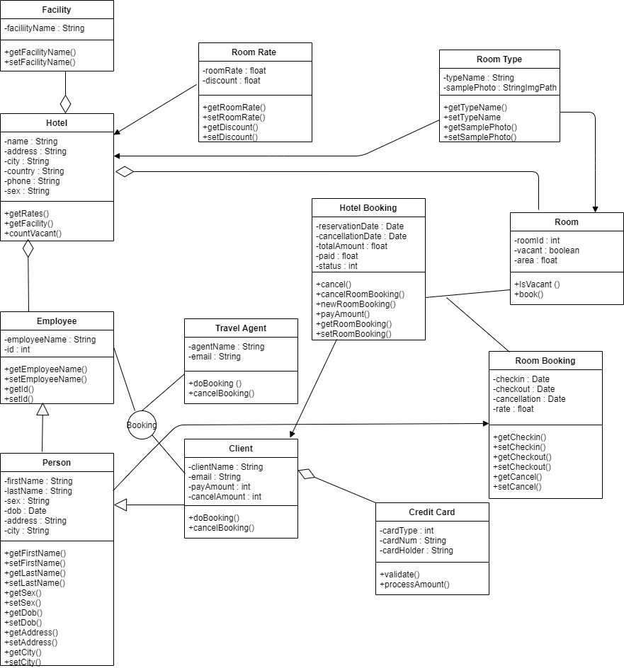

**Detailed Analysis:**

In this system, we maintain two data bases. These databases include hotel rooms and customer’s information. These can be modified by the end users. The room databases will include the room numbers and if they are vacant or occupied. The customers’ information database maintains all the information about the customer such as name, number of occupants, assigned room, default room rate, phone number, whether or not the room is guaranteed, credit card number etc.

**Interfaces for Reservation System:** Booking is an interface which can be declared to provide the operations such as doBooking(), cancelBooking() to the classes Employee, Travel Agent and Client where the implementation of those methods can be done. Here the relationship between the class and interface is that the interface gives the contract and the classes need to carry out that work. This is the brief description about the class diagram and the classes, interfaces declared for the online hotel reservation system.

**Functional Requirements for Reservation and Booking system:**

* Allows for typing in customer information.
* Has a default room rate that is adjustable.
* Includes a description field for the changed rate.
* When a customer checks in, the room number will be changed to occupied in the database.
* Ability to modify a reservation.
* When a customer checks out the amount owed is displayed.
* Records that room is vacant.
* Records payment.
* Allows for space to write customer’s feedback for General Manager Services and Automated Tasks System.
* Reports generated to audit hotel occupancy, future occupancy and room revenue.
* Exception reports listing to the normal cost.
* Allows addition, deletion and modification of information on rooms and rates.
* Creation of users and assigning passwords.