1.Prompt for amount, interest rate and no. of years and calculate simple interest.
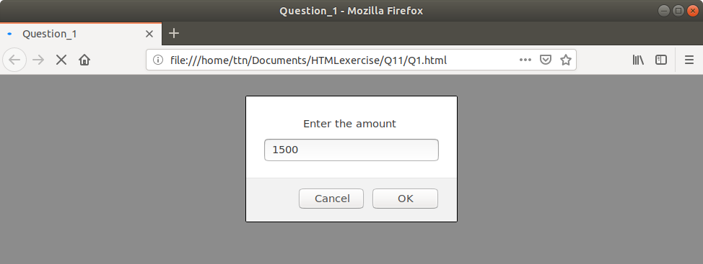
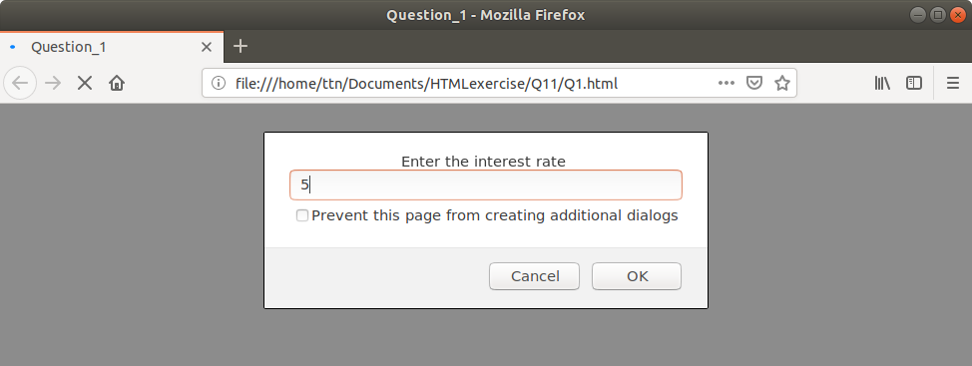
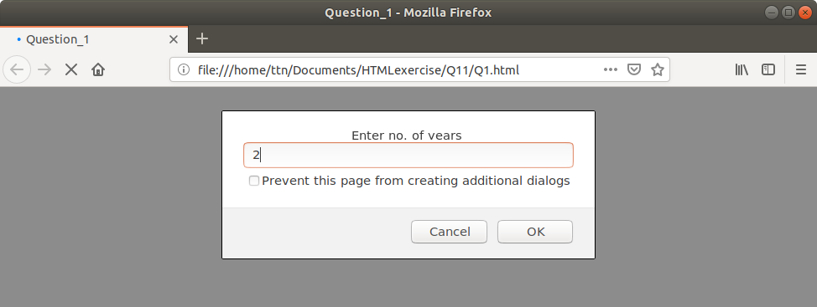
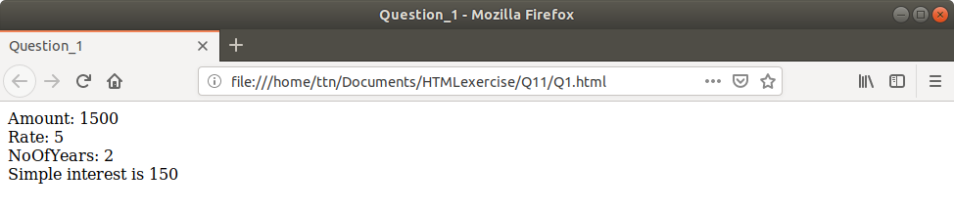
Click here for code

2. Is palindrome string.

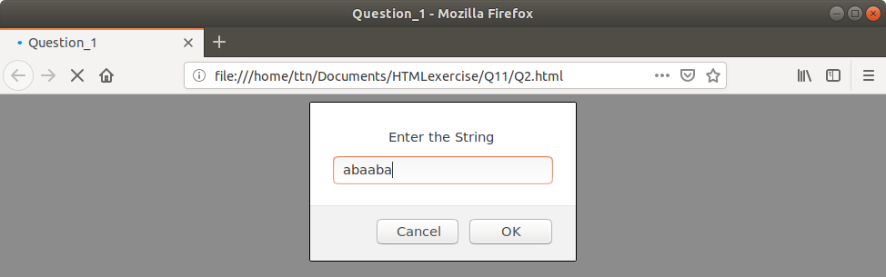
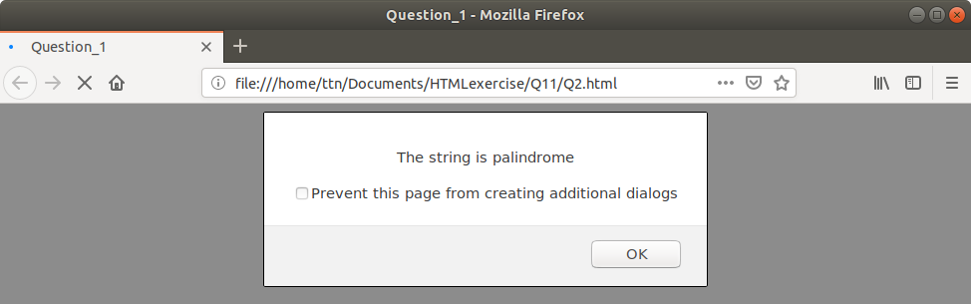
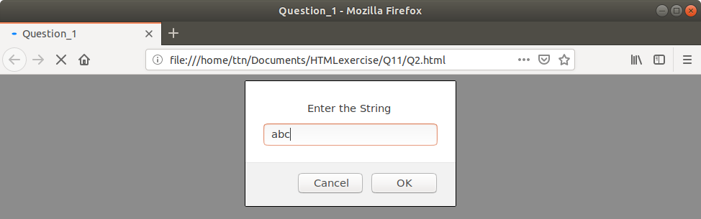
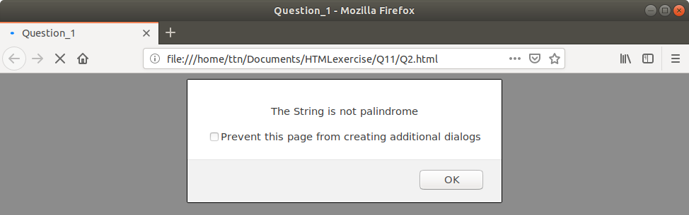
Click here for code

3. Area of circle

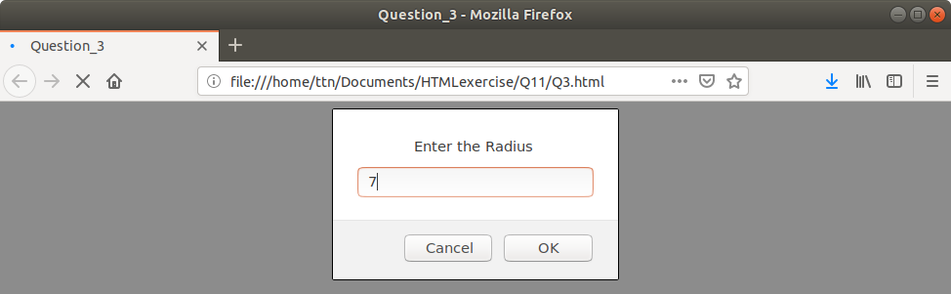
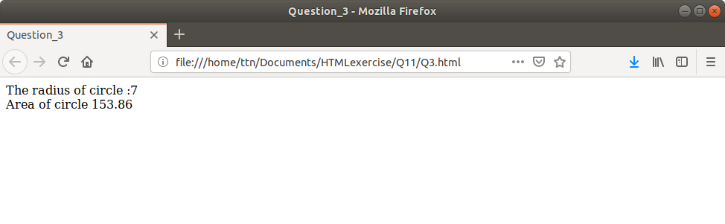

Click here for code

4. Copy information of one object to another and log it to console.

Using console:
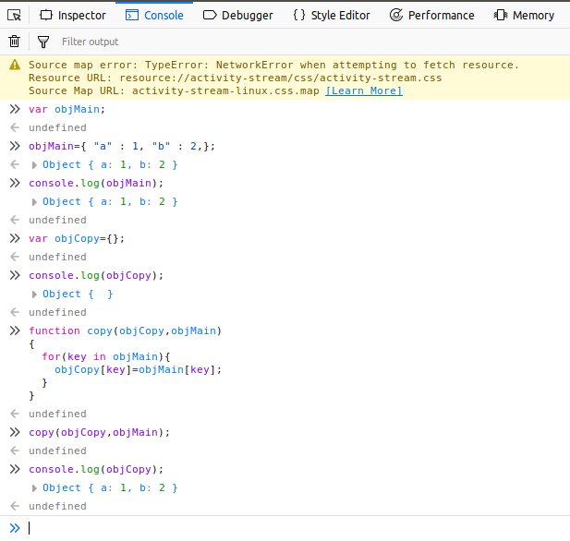
Using javaScript in html file:

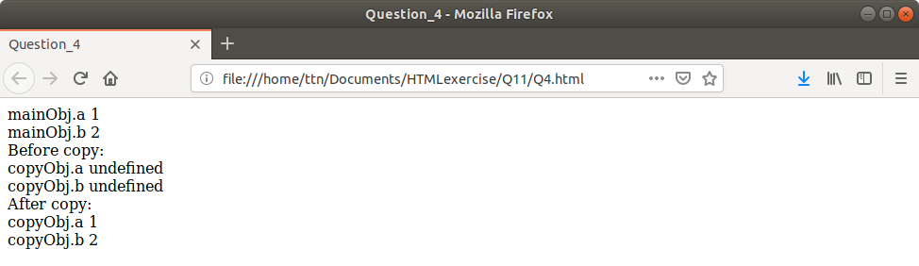
click here for code

5. create a list of objects of Employee with info as follow :
- Name, age, salary ,DOB
- filter all employees with salary greater than 5000
- group employee on the basis of their age
- fetch employees with salary less than 1000 and age greater than 20. Then give them an increment 5 times their salary.
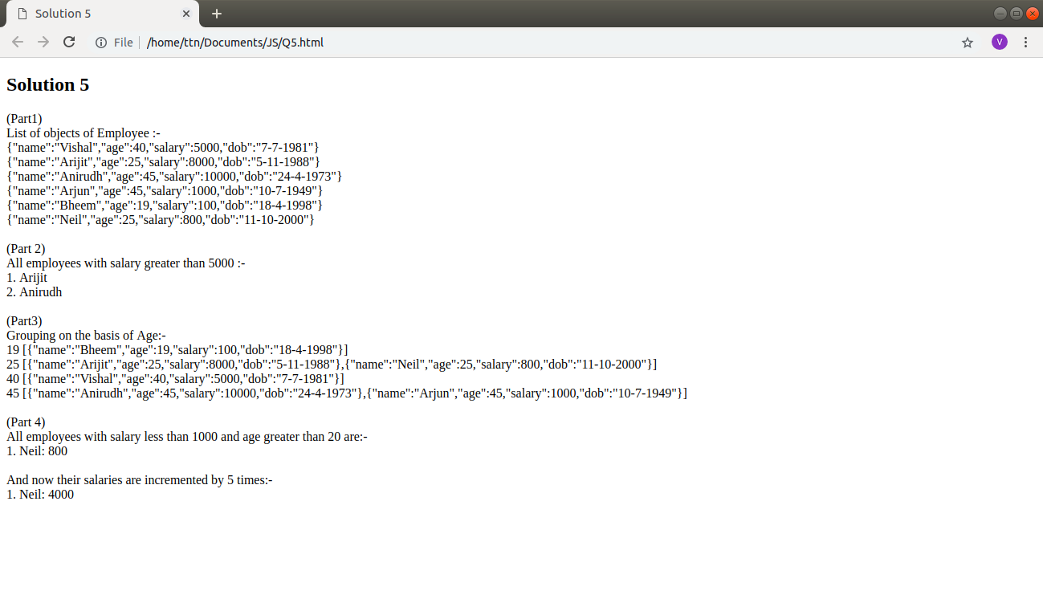

Click here for code
JS file

