Q1. Write a program to replace a substring inside a string with other string ?
import java.util.Scanner;
public class Question1 {
public static void main(String[] args) {
Scanner sc = new Scanner(System.in);
System.out.println("Enter any String ");
String currentString = sc.next();
String subString = sc.next();
String replaceBy = sc.next();
String updatedString = currentString.replace(subString,replaceBy);
System.out.println("Updated String is: "+ updatedString);
}
}
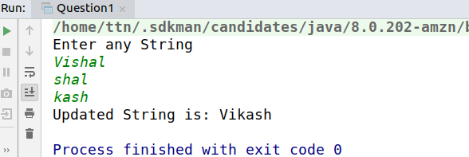
//Q2. Write a program to find the number of occurrences of the duplicate words in a string and print them ?

import java.util.Scanner;
public class Question2 {
public static void main(String[] args)
{
Scanner sc = new Scanner(System.in);
System.out.println("Enter a sentence ");
String string = sc.nextLine();
string = string.toLowerCase();
String[] words = string.split(" ");
System.out.println("Duplicate words are: ");
for (int i=0;i<words.length;i++){
int count = 0;
for (int j=i+1; j<words.length;j++){
if(words[i].equals(words[j])){
words[j] = "O";
count = count+1;
}
}
if(count>0 && !words[i].equals("O"))
System.out.println(words[i]+"........"+(count+1));
}
}
}

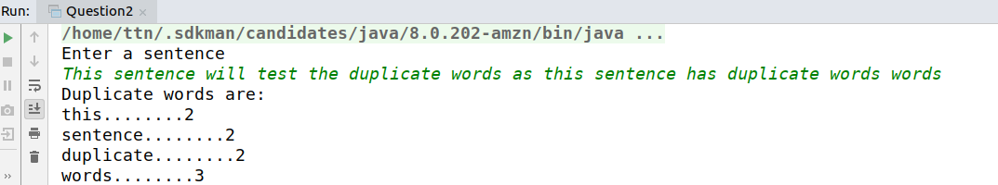
// Q3. Write a program to find the number of occurrences
// of a character in a string without using loop?
import java.util.Scanner;
public class Question3 {
public static void main(String[] args) {
Scanner sc = new Scanner(System.in);
System.out.println("Enter any string ");
String str = sc.next();
System.out.println("Enter the character ");
String removedChar = sc.next();
String str1 = str.replaceAll(removedChar,"");
System.out.println("The number of occurences of "+removedChar+" are "+ (str.length()-str1.length()));
}
}

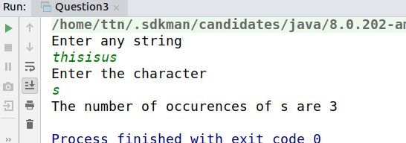
//Q4. Calculate the number & Percentage Of Lowercase Letters,Uppercase Letters, Digits And Other Special Characters In A String
import java.util.Scanner;
public class Question4 {
public static void main(String[] args) {
Scanner sc = new Scanner(System.in);
System.out.println("Enter any String ");
String str = sc.nextLine();
int lowerCount = 0;
int upperCount = 0;
int digitCount = 0;
int specialCount =0;
int length = str.length();
for (int i=0;i<length;i++){
char ch = str.charAt(i);
if(ch>=97 && ch<=122)
lowerCount++;
else if (ch>=48 && ch<=57)
digitCount++;
else if (ch>=65 && ch<=90)
upperCount++;
else
specialCount++;
}
double lowPercent = (lowerCount*1.0/length)*100;
double uppPercent = (upperCount*1.0/length)*100;
double digitPercent = (digitCount*1.0/length)*100;
double specPercent = (specialCount*1.0/length)*100;
System.out.println("No. of lowercase letters : "+lowerCount+" percent : "+lowPercent);
System.out.println("No. of uppercase letters : "+upperCount+" percent : "+uppPercent);
System.out.println("No. of digits : "+digitCount+" percent : "+digitPercent);
System.out.println("No. of special characters : "+specialCount+" percent : "+specPercent);
}
}
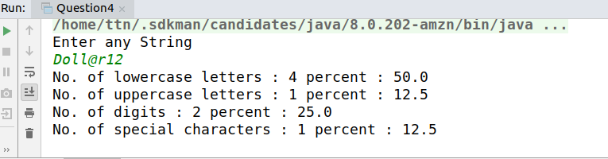

Q5. Find common elements between two arrays.
import java.util.Scanner;
public class Question5 {
public static void main(String[] args) {
Scanner sc = new Scanner(System.in);
System.out.println("Enter the size of the first array ");
int size1 = sc.nextInt(); //Size of array 1
int arr[] = new int[size1];
System.out.println("Enter the elements in the first array ");
for (int i=0;i<size1;i++)
arr[i] = sc.nextInt(); //Intializing element in array 1
System.out.println("Enter the size of the second array ");
int size2 = sc.nextInt(); // Size of array 2
int[] arr1 = new int[size2];
System.out.println("Enter the elements in the second array ");
for (int i=0;i<size2;i++)
arr1[i] = sc.nextInt(); //Intializing element in array 2
System.out.println("Common elements are: ");
for (int i=0;i<size1;i++){
for (int j=0;j<size2;j++){
if (arr[i]==arr1[j]){ //comparing elements
System.out.println(arr[i]); //printing the common elements
break;
}
}
}
}
}
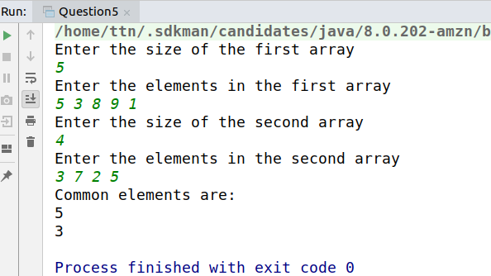
Q6. There is an array with every element repeated twice except one.Find that element
import java.util.Arrays;
import java.util.Scanner;
public class Question6 {
public static void main(String[] args) {
Scanner sc = new Scanner(System.in);
System.out.println("Enter the size of the array ");
int size = sc.nextInt();
int[] arr = new int[size]; // size of array
System.out.println("Enter the elements in the array ");
for (int i=0;i<size;i++){
arr[i] = sc.nextInt(); // initializing elements of array
}
Arrays.sort(arr); // sorting of element
int []stack = new int[size];
int top=-1;
for (int i=0;i<size;i++){
if(top==-1){
stack[++top] = arr[i];
}
else if(stack[top]==arr[i]){
top--;
}
else
stack[++top] = arr[i];
}
System.out.println("Unique element is: ");
System.out.println(stack[top]); // printing the element
}
}

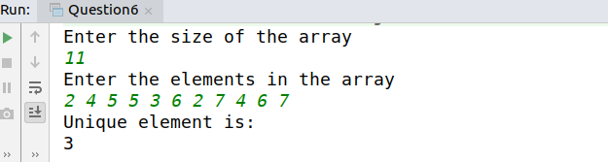
//Q7. Write a program to print your Firstname,LastName & age using static block,static method & static variable respectively
public class Question7 {
static String firstName; //Static variable
static String lastName;
static int age;
static { //Static block
firstName = "Vishal";
lastName = "Aggarwal";
age = 22;
}
public static void main(String[] args) { //Static method
System.out.println("First Name : "+firstName+"\nLast Name : "+lastName);
System.out.println("Age : "+age);
}
}

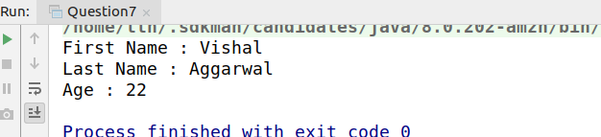

Q8. Write a program to reverse a string and remove character from index 4 to index 9 from the reversed string using String Buffer
import java.util.Scanner;
public class Question8 {
public static void main(String[] args) {
Scanner sc = new Scanner(System.in);
System.out.println("Enter any string ");
String string = sc.next();
StringBuffer stringBuffer = new StringBuffer(string);
stringBuffer = stringBuffer.reverse(); //Reversing the element
stringBuffer = stringBuffer.delete(4,10); //Removing element from index 4 to 9.
System.out.println(stringBuffer);
}
}
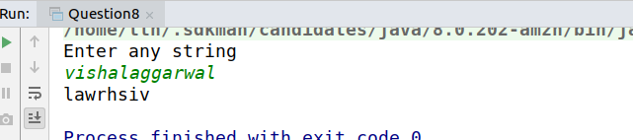

//Q9.Write a program to display values of enums using a constructor & getPrice() method (Example display house & their prices)
public class Question9 {
enum Rent{
TheTaj(5000),
PalatialGrand(7500),
AnsalGardenia(8500),
Amrapali(9500);
private int price;
Rent(int price) {
this.price = price;
}
public int getPrice() {
return price;
}
}
public static void main(String[] args) {
for(Rent house : Rent.values()){
System.out.println("House name : "+house+" Rent : "+house.getPrice());
}
}
}

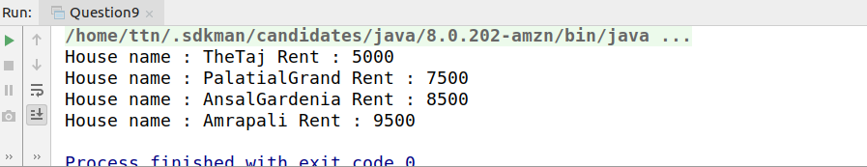

Q10.Write a single program for following operation using overloading
A) Adding 2 integer number
B) Adding 2 double
C) multiplying 2 float
D) multiplying 2 int
E) concate 2 string
F) Concate 3 String
Q10.Write a single program for following operation using overloading
public class Question10 {
// A) Adding 2 integer number
private static void add(int a, int b){
System.out.println("Addition of ints " + (a+b));
}
// B) Adding 2 double
private static void add(double a, double b){
System.out.println("Addition of doubles " + (a+b));
}
// C) multiplying 2 float
private static void multiply(float a, float b){
System.out.println("Multiplication of floats "+a*b);
}
// D) multiplying 2 int
private static void multiply(int a, int b){
System.out.println("Multiplication of ints "+a*b);
}
// E) concate 2 string
private static void concatString(String str, String str1)
{
str.concat(str1);
System.out.println("Concatenation of two strings "+str);
}
// F) Concate 3 String
private static void concatString(String str1, String str2, String str3){
String str= new String("");
str= str.concat(str1).concat(str2).concat(str3);
System.out.println("Concatenation of Three strings "+str);
}
public static void main(String[] args) {
add(2,3);
add(3.5,4.5);
multiply(2,3);
multiply(3.2f,2.3f);
concatString("str", "str1");
concatString("first","second","third");
}
}
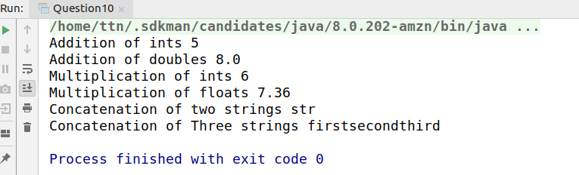
Q11.Create 3 sub class of bank SBI,BOI,ICICI all 4 should have method called getDetails which provide there specific details like rateofinterest etc,print details of every banks
interface Bank{
void getBankDetails();
}
class SBI implements Bank{
private String bankName = "SBI";
private String branch = "Greater Noida";
private float rateOfInterest = 4.0f;
@Override
public void getBankDetails() {
System.out.println("Bank name : "+bankName+" Branch Name : "+branch+" Rate Of Interest : "+rateOfInterest);
}
}
class BOI implements Bank {
private String bankName = "BOI";
private String branch = "Greater Noida";
private float rateOfInterest = 4.2f;
@Override
public void getBankDetails() {
System.out.println("Bank name : "+bankName+" Branch Name : "+branch+" Rate Of Interest : "+rateOfInterest);
}
}
class ICICI implements Bank {
private String bankName = "ICICI";
private String branch = "Noida";
private float rateOfInterest = 4.9f;
@Override
public void getBankDetails() {
System.out.println("Bank name : "+bankName+" Branch Name : "+branch+" Rate Of Interest : "+rateOfInterest);
}
}
public class Question11 {
public static void main(String[] args) {
SBI sbi = new SBI();
BOI boi = new BOI();
ICICI icici = new ICICI();
sbi.getBankDetails();
boi.getBankDetails();
icici.getBankDetails();
}
}
