Problem Statement: There can be multiple customers, who can place multiple orders on the site. Now a sales person can handle these orders will distribute into multiple sales persons (One order will be assign to one salesperson only). So a sales person can have multiple orders of multiple customers
- Create Database
- Design Schema
- Create tables
- Insert sample data
- Find the sales person have multiple orders.
- Find the all sales person details along with order details
- Create index
- How to show index on a table
- Find the order number, sale person name, along with the customer to whom that order belongs to
Q1.

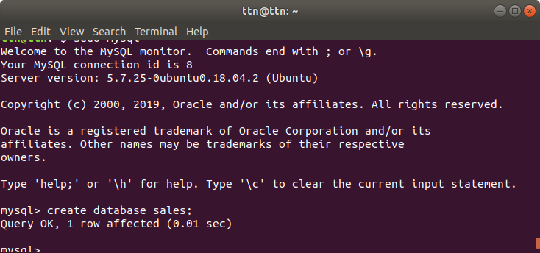

Q2.

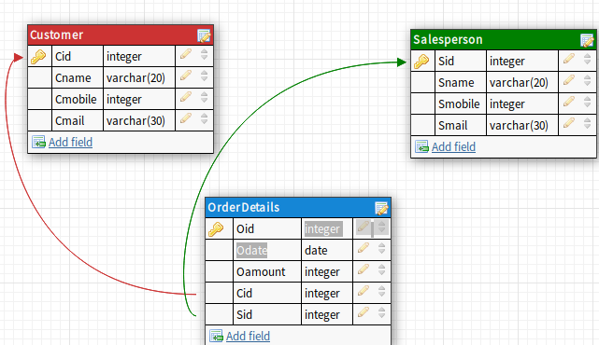

Q3.

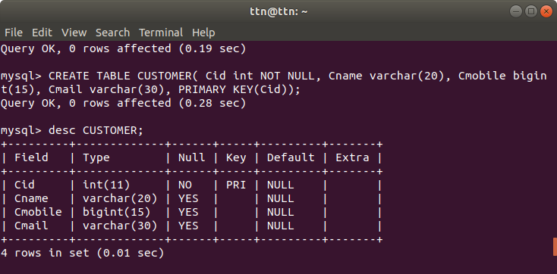

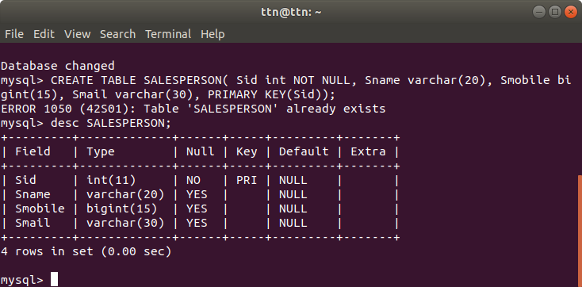

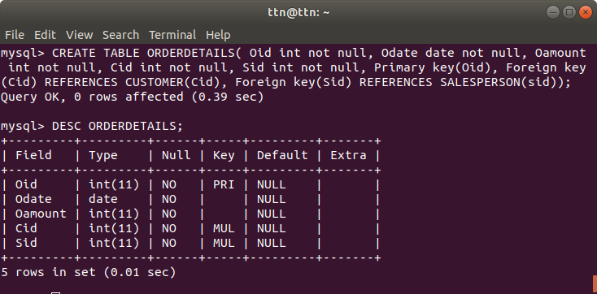

Q4.Insert sample data

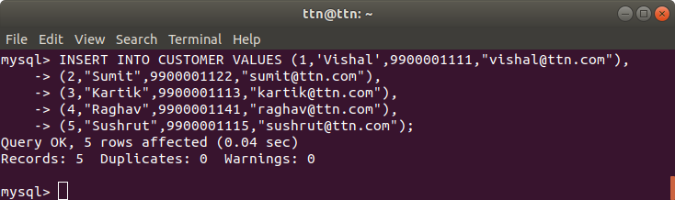

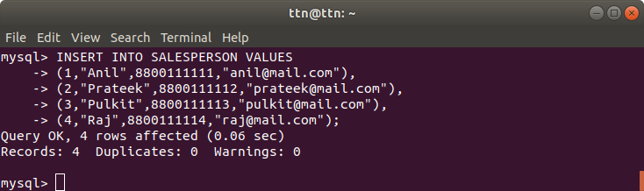

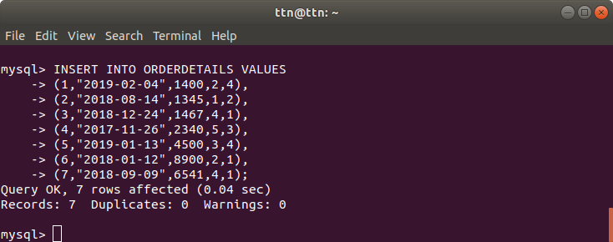

Q5. Find the sales person have multiple orders.

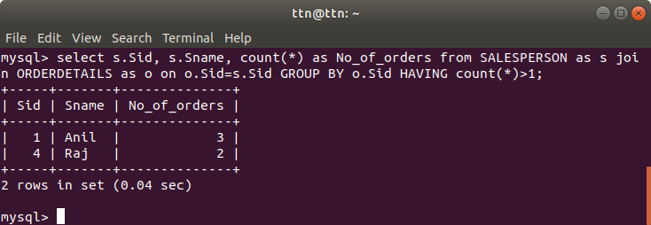

6. Salesperson details with corresponding orders.

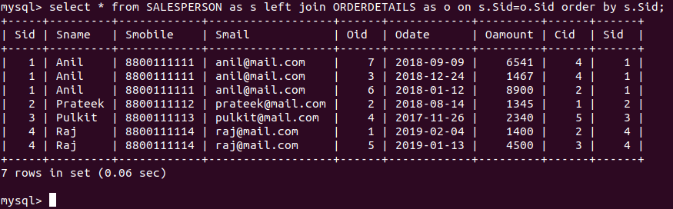

Q7. Create index

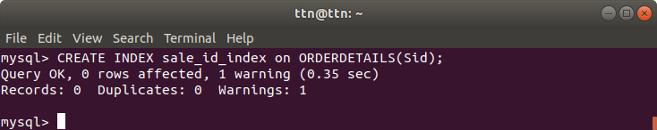

Q8.How to show index on table.

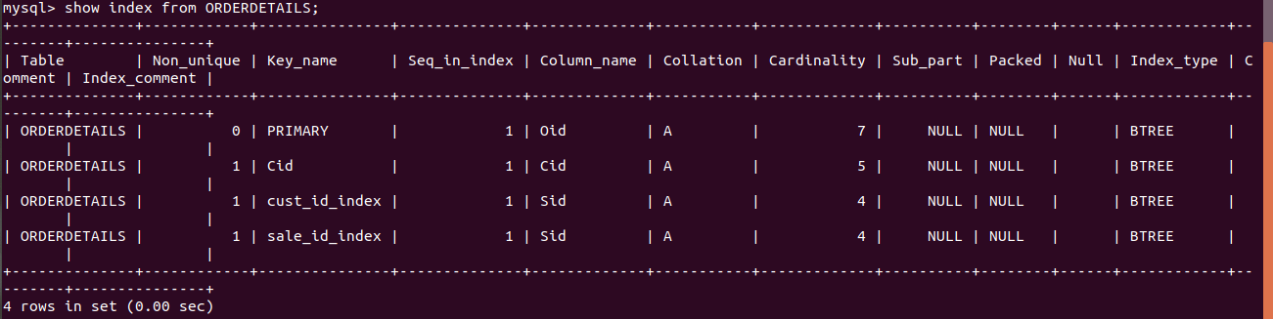

Q9.Find the order number, sale person name, along with the customer to whom that order belongs to

