**CS F212 – Database Systems**

**< CYCLE RENTAL SYSTEM>**

|  |  |
| --- | --- |
| TEAM MEMBERS ID | NAMES |
| 1 2022A7PS0183H(Leader) | Sri Jaitra Saketh G |
| 2 2022A7PS0174H | B Vishal Varma |
| 3 2022A7PS0233H | J Harshith Reddy |
| 4 2022A7PS0077H | Vishwesh Suri |
| 5 2022A7PS1672H | Tejasvini Goel |

**GROUP ID* - 29**

# 1. INTRODUCTION/DESCRIPTION

The Cycle Rental System (CRS) for our college is a platform designed to facilitate seamless bicycle rentals within the campus community, catering to both students and faculty members. Users, identified by their unique and distinct college IDs, can register their bicycles on the system, providing essential details. The rental process involves presenting the User_ID and specifying the duration, with bicycles available for a maximum of one day. The CRS meticulously records each transaction, taking in several attributes. Policies are in place for timely returns, extensions, and reporting lost or stolen bicycles, ensuring accountability. Regular maintenance schedules guarantee the safety and functionality of bicycles. User feedback is recorded to ensure continuous improvement. Customization requests, such as accessory additions are also available. The CRS aims to enhance the overall user experience, making intra campus transportation convenient and eco-friendly.

**Business Rules**

**Getting started with CRS:**

* + A user can be a student or faculty member and is allowed to participate in the CYCLE RENTAL SYSTEM [CRS] with a valid college ID
  + College ID is unique and separate for students and faculty.
  + Users provide their details, including name, college ID [User_ID], mail, and contact number.

**Bicycle Listing:**

* + Any member of the college community, including students and faculty, who owns a bicycle can list it on the CRS platform.
  + Each bicycle is registered with its model type and assigned a unique Bicycle_ID. The owner's information, (User_ID), is recorded to track ownership.

**Renting a Cycle:**

* + In order to rent a bicycle, a user must present their User_ID and provide the duration for which they are going to rent the cycle. Bicycles can be rented for a maximum duration of one day and a minimum of one hour.
  + A user can only rent one bicycle at a time.
  + Upon rental, the CRS records details like the Rental_ID[ that is unique for a particular transaction], User_ID, Bicycle_ID, Rental_Date, Return_Date, Return_Status,Return_Status ,Late_Fees and Bicycle_Status.

**Policy of Return:**

* + Bicycles must be returned by the specified return time (deadline) to avoid late fees.
  + The return process involves updating the Return_Date and Return_Status columns in the rental ledger in CRS.

**In case of damages:**

* + Any damages done to the Bicycles will incur additional charges
  + The system tracks Bicycle_Status to indicate whether it is available for rent, under usage, damaged, or stolen.

**Rental Duration Extension:**

* Users can request to extend the rental duration before the return time expires, subject to availability.
* Rental duration extensions are granted based on bicycle availability and may incur additional charges if the extended duration exceeds the initial rental agreement.
* It includes attributes like Rental_ID, Extended_Duration, Additional_Charges

**Lost or Stolen Bicycles:**

* In the event of a lost or stolen bicycle, the user who rented the bicycle (or the owner) is responsible for reporting the incident to campus security and the CRS administrator.
* It is in the Rental_Statues field in the rental ledger that indicates this case.
* The system marks the bicycle as lost or stolen, and appropriate actions are taken to recover or replace the bicycle.

**Maintenance of the bicycles:**

**•** Regular maintenance schedules are established to ensure the safety and functionality of bicycles such as tire inflation, brake adjustments, and lubrication. It includes attributes like Maintenance_ID, Bicycle_ID, Maintenance_Date, Maintenance_Task

**User Feedback and Improvement:**

**•** The system collects feedback from users regarding their rental experience and suggestions for improvement.

**•** User feedback is used to identify areas for enhancement and implement changes to improve the overall user experience and system efficiency. Feedback_ID, User_ID, Rating and Comments

**Customization Requests:**

**•** Users can request bicycle customization, and accessory additions for example bottle holders, gear cycles, front lights etc. It includes attributes like Request_ID, Bicycle_ID, Request_Type, Request_Description, Approval_Status

By adhering to these business rules, the cycle rental system ensures efficient management of bicycle rentals within the college campus, promoting sustainability and providing convenient transportation options for students, faculty, and staff.

# 2. ER Model

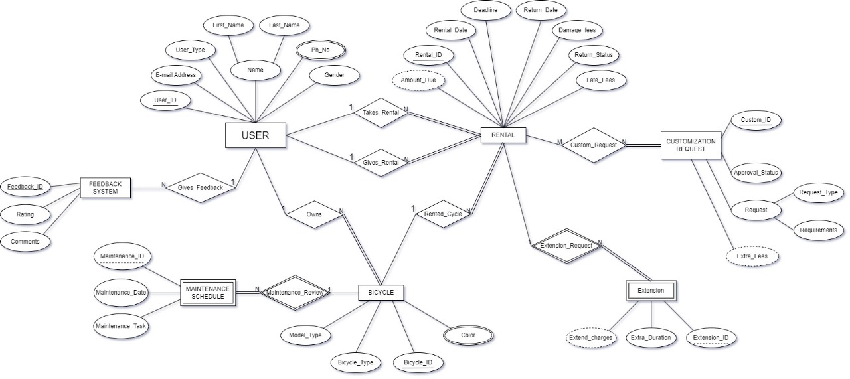

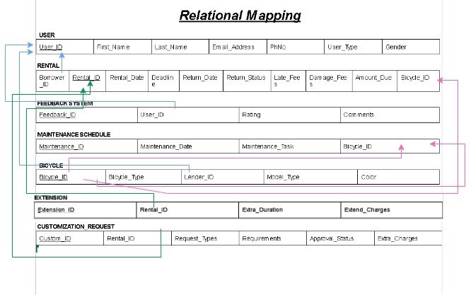**3. RELATIONAL MAPPING**