**Exercise 2: Error Handling**

**Scenario 1:** Handle exceptions during fund transfers between accounts.

* + **Question:** Write a stored procedure **SafeTransferFunds** that transfers funds between two accounts. Ensure that if any error occurs (e.g., insufficient funds), an appropriate error message is logged and the transaction is rolled back.

CREATE TABLE Customers (

CustomerID NUMBER PRIMARY KEY,

Name VARCHAR2(100),

DOB DATE,

Balance NUMBER,

LastModified DATE

);

CREATE TABLE Accounts (

AccountID NUMBER PRIMARY KEY,

CustomerID NUMBER,

AccountType VARCHAR2(20),

Balance NUMBER,

LastModified DATE,

FOREIGN KEY (CustomerID) REFERENCES Customers(CustomerID)

);

INSERT INTO Customers (CustomerID, Name, DOB, Balance, LastModified)

VALUES (1, 'Amit Verma', TO_DATE('1990-01-01', 'YYYY-MM-DD'), 0, SYSDATE);

INSERT INTO Customers (CustomerID, Name, DOB, Balance, LastModified)

VALUES (2, 'Riya Sen', TO_DATE('1992-01-01', 'YYYY-MM-DD'), 0, SYSDATE);

INSERT INTO Customers (CustomerID, Name, DOB, Balance, LastModified)

VALUES (3, 'Suresh Reddy', TO_DATE('1985-05-01', 'YYYY-MM-DD'), 0, SYSDATE);

INSERT INTO Customers (CustomerID, Name, DOB, Balance, LastModified)

VALUES (4, 'Pooja Patel', TO_DATE('1988-08-08', 'YYYY-MM-DD'), 0, SYSDATE);

INSERT INTO Accounts (AccountID, CustomerID, AccountType, Balance, LastModified)

VALUES (99, 1, 'Savings', 5000, SYSDATE);

INSERT INTO Accounts (AccountID, CustomerID, AccountType, Balance, LastModified)

VALUES (100, 2, 'Savings', 2000, SYSDATE);

INSERT INTO Accounts (AccountID, CustomerID, AccountType, Balance, LastModified)

VALUES (101, 3, 'Savings', 200, SYSDATE);

INSERT INTO Accounts (AccountID, CustomerID, AccountType, Balance, LastModified)

VALUES (102, 4, 'Savings', 1500, SYSDATE);

COMMIT;

CREATE OR REPLACE PROCEDURE SafeTransferFunds (

p_FromAccountID NUMBER,

p_ToAccountID NUMBER,

p_Amount NUMBER

)

IS

v_FromBalance NUMBER;

BEGIN

SELECT Balance INTO v_FromBalance

FROM Accounts

WHERE AccountID = p_FromAccountID;

IF v_FromBalance < p_Amount THEN

RAISE_APPLICATION_ERROR(-20001, 'Insufficient funds in source account.');

END IF;

UPDATE Accounts

SET Balance = Balance - p_Amount

WHERE AccountID = p_FromAccountID;

UPDATE Accounts

SET Balance = Balance + p_Amount

WHERE AccountID = p_ToA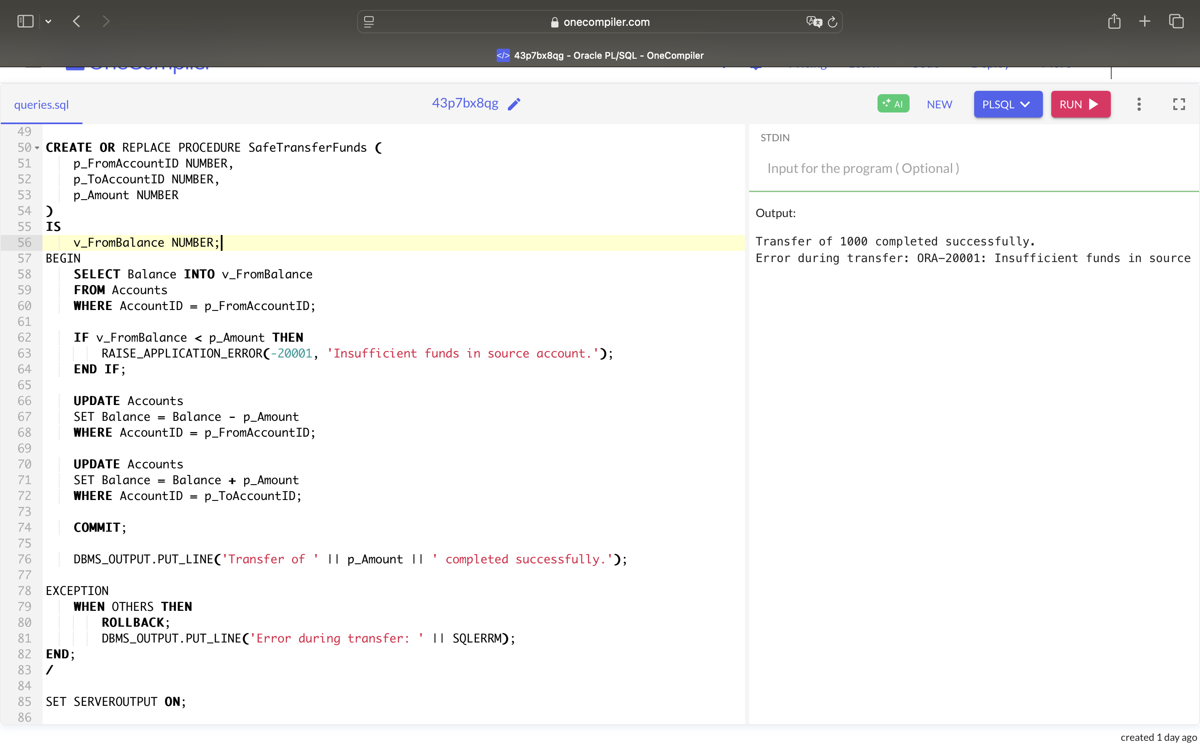ccountID;

COMMIT;

DBMS_OUTPUT.PUT_LINE('Transfer of ' || p_Amount || ' completed successfully.');

EXCEPTION

WHEN OTHERS THEN

ROLLBACK;

DBMS_OUTPUT.PUT_LINE('Error during transfer: ' || SQLERRM);

END;

/

SET SERVEROUTPUT ON;

-- Successful Transfer

EXEC SafeTransferFunds(99, 100, 1000);

-- Insufficient Funds (Should give error message)

EXEC SafeTransferFunds(101, 102, 500);

**Scenario 2:** Manage errors when updating employee salaries.

* + **Question:** Write a stored procedure **UpdateSalary** that increases the salary of an employee by a given percentage. If the employee ID does not exist, handle the exception and log an error message.

CREATE TABLE Employees (

EmployeeID NUMBER PRIMARY KEY,

Name VARCHAR2(100),

Position VARCHAR2(50),

Salary NUMBER,

Department VARCHAR2(50),

HireDate DATE

);

INSERT INTO Employees (EmployeeID, Name, Position, Salary, Department, HireDate)

VALUES (1, 'Rahul Mehra', 'Manager', 80000, 'Operations', TO_DATE('2015-06-10', 'YYYY-MM-DD'));

INSERT INTO Employees (EmployeeID, Name, Position, Salary, Department, HireDate)

VALUES (2, 'Sneha Kapoor', 'Developer', 60000, 'IT', TO_DATE('2018-02-15', 'YYYY-MM-DD'));

INSERT INTO Employees (EmployeeID, Name, Position, Salary, Department, HireDate)

VALUES (3, 'Amit Joshi', 'Analyst', 50000, 'Finance', TO_DATE('2020-01-01', 'YYYY-MM-DD'));

COMMIT;

CREATE OR REPLACE PROCEDURE UpdateSalary (

p_EmployeeID NUMBER,

p_PercentIncrease NUMBER

)

IS

BEGIN

-- Attempt to update salary

UPDATE Employees

SET Salary = Salary + (Salary * p_PercentIncrease / 100)

WHERE EmployeeID = p_EmployeeID;

-- Check if any row was affected

IF SQL%ROWCOUNT = 0 THEN

RAISE_APPLICATION_ERROR(-20002, 'Employee ID does not exist.');

END IF;

COMMIT;

DBMS_OUTPUT.PUT_LINE('Salary updated successfully for Employee ID: ' || p_EmployeeID);

EXCEPTION

WHEN OTHERS THEN

ROLLBACK;

DBMS_OUTPUT.PUT_LINE('Error updating salary: ' || SQLERRM);

END;

/

SET SERVEROUTPUT ON;

BEGIN

UpdateSalary(2, 10);

END;

/

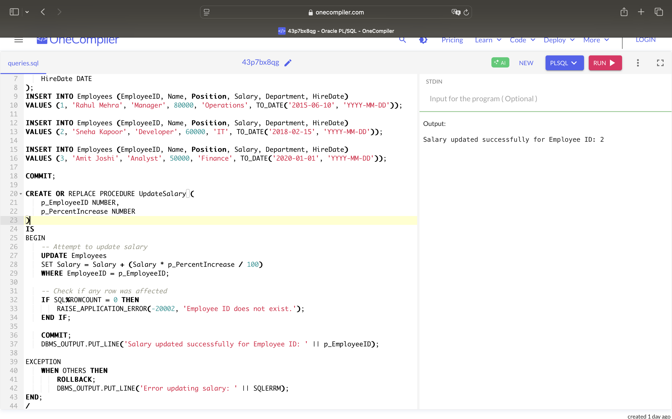

**Scenario 3:** Ensure data integrity when adding a new customer.

* + **Question:** Write a stored procedure **AddNewCustomer** that inserts a new customer into the Customers table. If a customer with the same ID already exists, handle the exception by logging an error and preventing the insertion

CREATE TABLE Customers (

CustomerID NUMBER PRIMARY KEY,

Name VARCHAR2(100),

DOB DATE,

Balance NUMBER,

LastModified DATE

);

INSERT INTO Customers (CustomerID, Name, DOB, Balance, LastModified)

VALUES (1, 'Anjali Sharma', TO_DATE('1995-03-10', 'YYYY-MM-DD'), 5000, SYSDATE);

INSERT INTO Customers (CustomerID, Name, DOB, Balance, LastModified)

VALUES (2, 'Rohit Mehra', TO_DATE('1990-07-22', 'YYYY-MM-DD'), 10000, SYSDATE);

COMMIT;

CREATE OR REPLACE PROCEDURE AddNewCustomer (

p_CustomerID NUMBER,

p_Name VARCHAR2,

p_DOB DATE,

p_Balance NUMBER

)

IS

v_Count NUMBER;

BEGIN

SELECT COUNT(*) INTO v_Count

FROM Customers

WHERE CustomerID = p_CustomerID;

IF v_Count > 0 THEN

RAISE_APPLICATION_ERROR(-20003, 'Customer with this ID already exists.');

END IF;

INSERT INTO Customers (CustomerID, Name, DOB, Balance, LastModified)

VALUES (p_CustomerID, p_Name, p_DOB, p_Balance, SYSDATE);

COMMIT;

DBMS_OUTPUT.PUT_LINE('New customer added successfully. Customer ID: ' || p_CustomerID);

EXCEPTION

WHEN OTHERS THEN

ROLLBACK;

DBMS_OUTPUT.PUT_LINE('Error adding customer: ' || SQLERRM);

END;

/

SET SERVEROUTPUT ON;

EXEC AddNewCustomer(3, 'Neha Gupta', TO_DATE('1998-11-15', 'YYYY-MM-DD'), 7500);

