**Exercise 3: Stored Procedures**

**Scenario 1:** The bank needs to process monthly interest for all savings accounts.

* + **Question:** Write a stored procedure **ProcessMonthlyInterest** that calculates and updates the balance of all savings accounts by applying an interest rate of 1% to the current balance.

CREATE TABLE Accounts (

AccountID NUMBER PRIMARY KEY,

CustomerID NUMBER,

AccountType VARCHAR2(20),

Balance NUMBER,

LastModified DATE

);

CREATE TABLE Customers (

CustomerID NUMBER PRIMARY KEY,

Name VARCHAR2(100),

DOB DATE,

Balance NUMBER,

LastModified DATE

);

INSERT INTO Customers (CustomerID, Name, DOB, Balance, LastModified)

VALUES (1, 'Priya Rao', TO_DATE('1990-05-15', 'YYYY-MM-DD'), 0, SYSDATE);

INSERT INTO Customers (CustomerID, Name, DOB, Balance, LastModified)

VALUES (2, 'Arjun Singh', TO_DATE('1985-11-20', 'YYYY-MM-DD'), 0, SYSDATE);

INSERT INTO Accounts (AccountID, CustomerID, AccountType, Balance, LastModified)

VALUES (101, 1, 'Savings', 10000, SYSDATE);

INSERT INTO Accounts (AccountID, CustomerID, AccountType, Balance, LastModified)

VALUES (102, 2, 'Savings', 20000, SYSDATE);

INSERT INTO Accounts (AccountID, CustomerID, AccountType, Balance, LastModified)

VALUES (103, 1, 'Checking', 5000, SYSDATE);

COMMIT;

SELECT AccountID, Balance FROM Accounts;

CREATE OR REPLACE PROCEDURE ProcessMonthlyInterest

IS

BEGIN

UPDATE Accounts

SET Balance = Balance + (Balance * 0.01),

LastModified = SYSDATE

WHERE AccountType = 'Savings';

COMMIT;

END;

/

EXEC ProcessMonthlyInterest;

SELECT AccountID, Balance FROM Accounts;

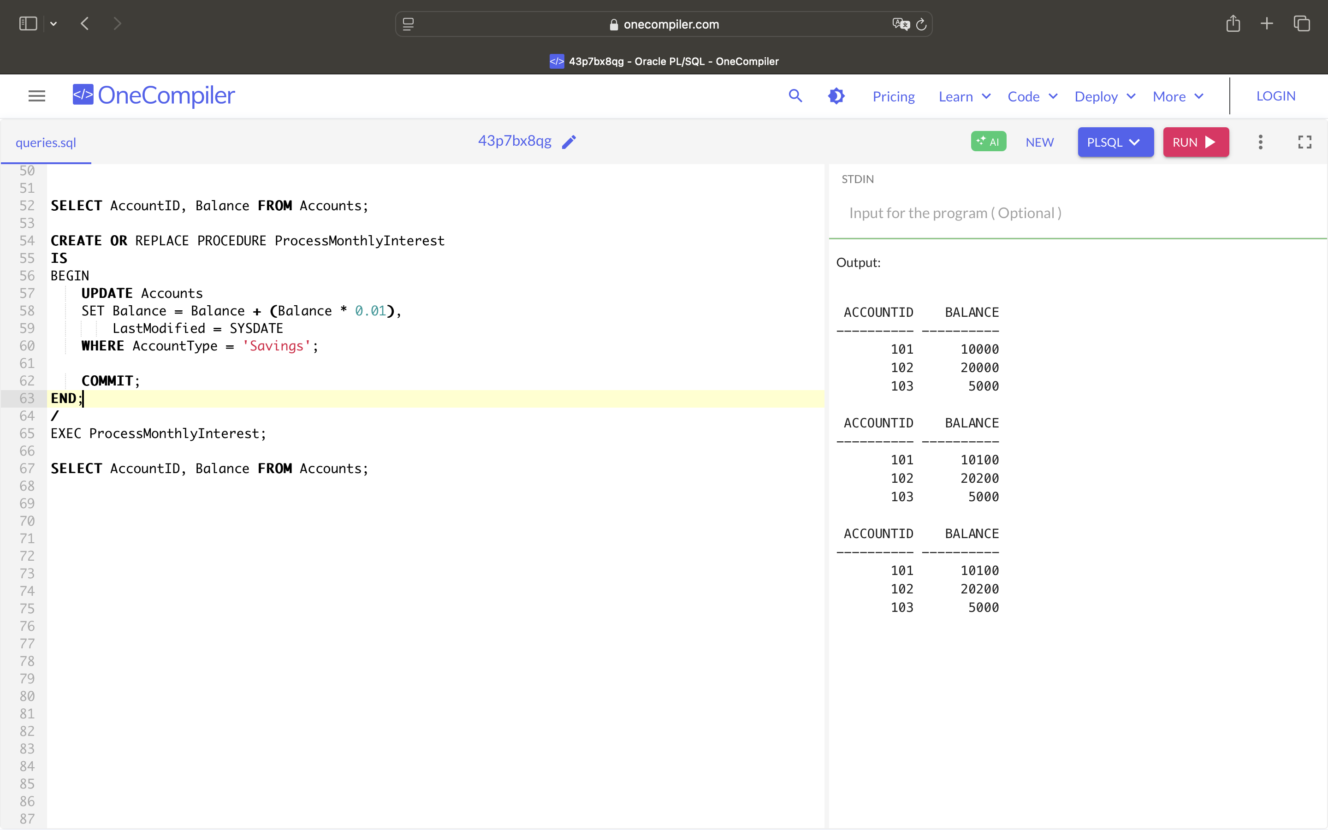

**Scenario 2:** The bank wants to implement a bonus scheme for employees based on their performance.

* + **Question:** Write a stored procedure **UpdateEmployeeBonus** that updates the salary of employees in a given department by adding a bonus percentage passed as a parameter.

CREATE TABLE Employees (

EmployeeID NUMBER PRIMARY KEY,

Name VARCHAR2(100),

Position VARCHAR2(50),

Salary NUMBER,

Department VARCHAR2(50),

HireDate DATE

);

INSERT INTO Employees (EmployeeID, Name, Position, Salary, Department, HireDate)

VALUES (1, 'Ravi Kumar', 'Manager', 80000, 'HR', TO_DATE('2016-03-10', 'YYYY-MM-DD'));

INSERT INTO Employees (EmployeeID, Name, Position, Salary, Department, HireDate)

VALUES (2, 'Sneha Reddy', 'Developer', 60000, 'IT', TO_DATE('2019-07-20', 'YYYY-MM-DD'));

INSERT INTO Employees (EmployeeID, Name, Position, Salary, Department, HireDate)

VALUES (3, 'Amit Patel', 'Analyst', 50000, 'Finance', TO_DATE('2021-01-15', 'YYYY-MM-DD'));

INSERT INTO Employees (EmployeeID, Name, Position, Salary, Department, HireDate)

VALUES (4, 'Priya Sharma', 'Developer', 55000, 'IT', TO_DATE('2020-11-05', 'YYYY-MM-DD'));

COMMIT;

SELECT EmployeeID, Name, Department, Salary FROM Employees;

CREATE OR REPLACE PROCEDURE UpdateEmployeeBonus (

p_Department VARCHAR2,

p_BonusPercent NUMBER

)

IS

BEGIN

UPDATE Employees

SET Salary = Salary + (Salary * p_BonusPercent / 100)

WHERE Department = p_Department;

COMMIT;

END;

/

EXEC UpdateEmployeeBonus('IT', 10);

SELECT EmployeeID, Name, Department, Salary FROM Employees;

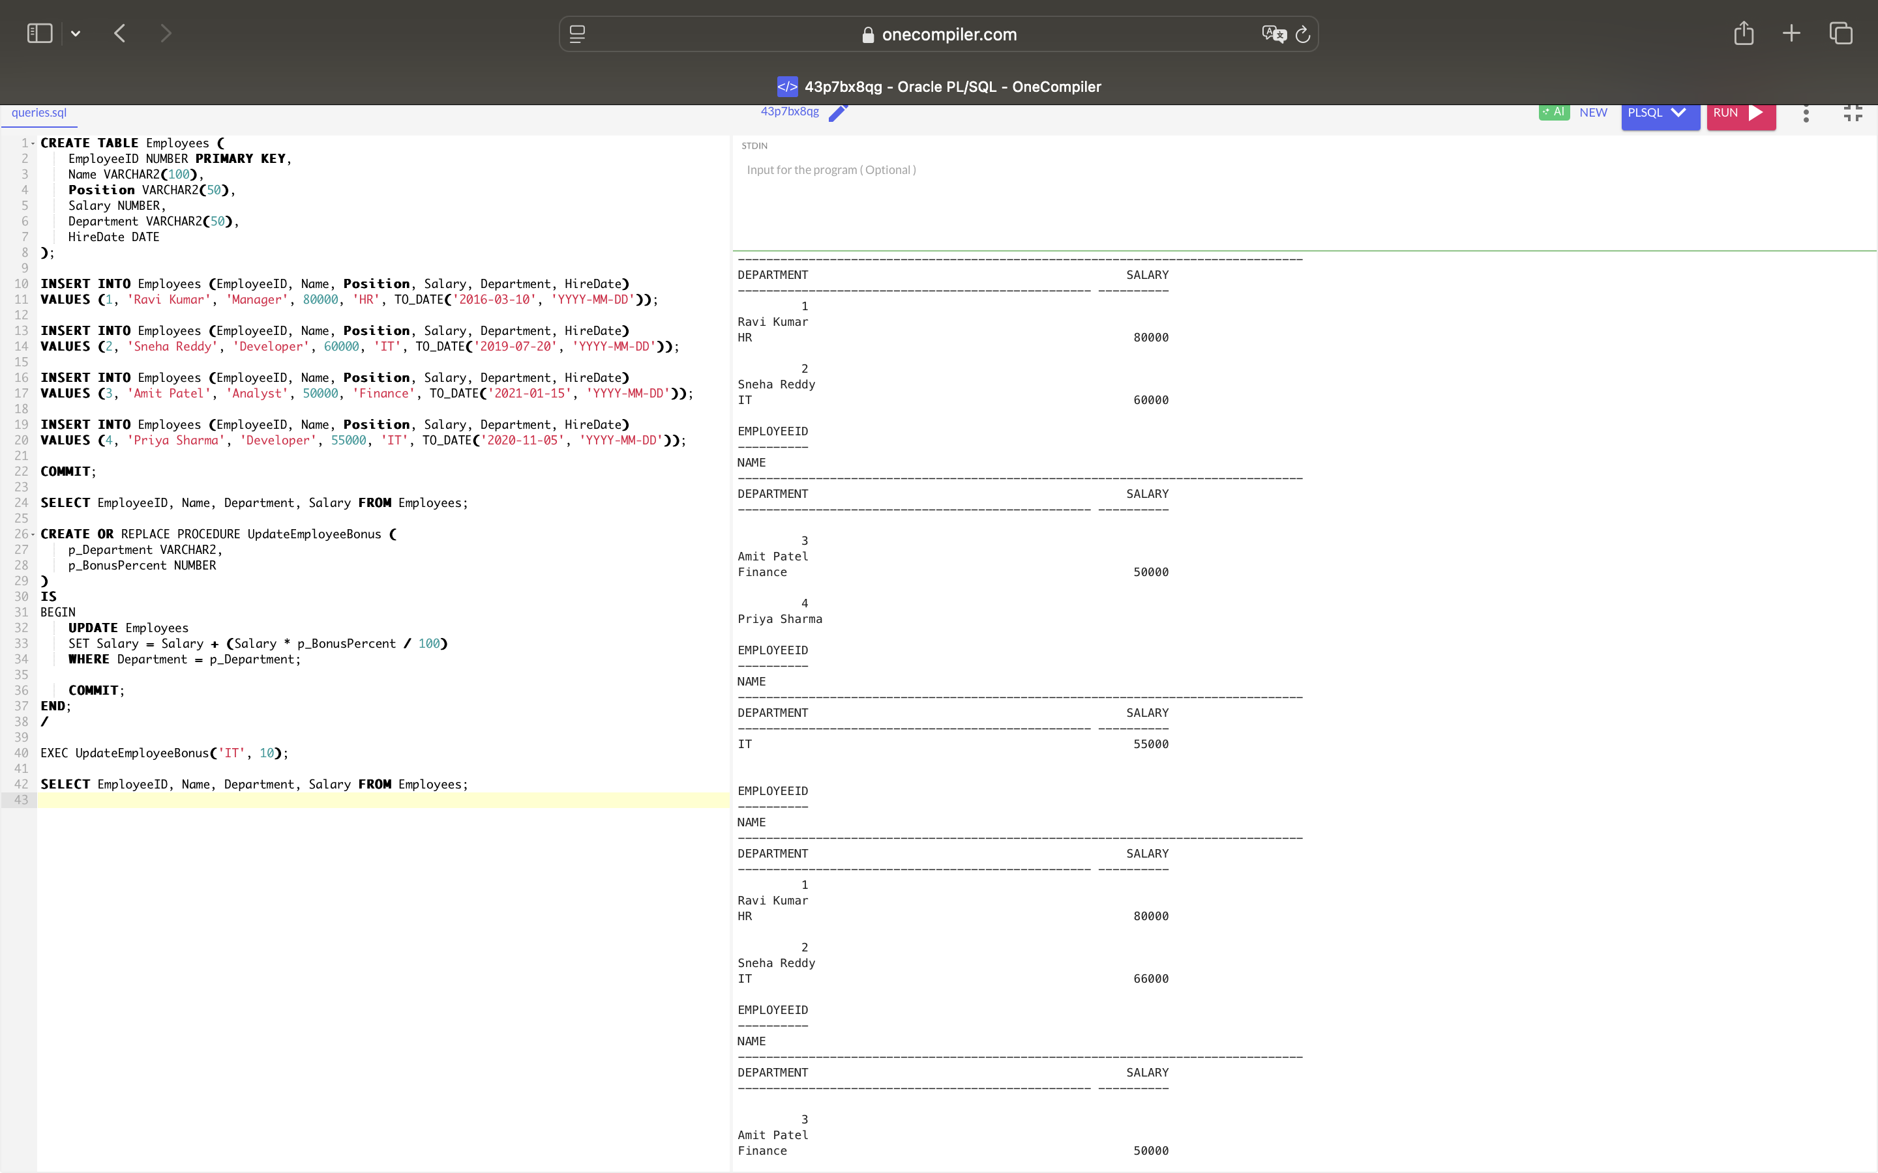

**Scenario 3:** Customers should be able to transfer funds between their accounts.

* + **Question:** Write a stored procedure **TransferFunds** that transfers a specified amount from one account to another, checking that the source account has sufficient balance before making the transfer.

CREATE TABLE Accounts (

AccountID NUMBER PRIMARY KEY,

CustomerID NUMBER,

AccountType VARCHAR2(20),

Balance NUMBER,

LastModified DATE

);

INSERT INTO Accounts (AccountID, CustomerID, AccountType, Balance, LastModified)

VALUES (201, 1, 'Savings', 10000, SYSDATE);

INSERT INTO Accounts (AccountID, CustomerID, AccountType, Balance, LastModified)

VALUES (202, 1, 'Checking', 5000, SYSDATE);

INSERT INTO Accounts (AccountID, CustomerID, AccountType, Balance, LastModified)

VALUES (203, 2, 'Savings', 15000, SYSDATE);

COMMIT;

SELECT AccountID, Balance FROM Accounts;

CREATE OR REPLACE PROCEDURE TransferFunds (

p_FromAccountID NUMBER,

p_ToAccountID NUMBER,

p_Amount NUMBER

)

IS

v_FromBalance NUMBER;

BEGIN

SELECT Balance INTO v_FromBalance

FROM Accounts

WHERE AccountID = p_FromAccountID;

IF v_FromBalance < p_Amount THEN

RAISE_APPLICATION_ERROR(-20001, 'Insufficient funds in source account.');

END IF;

UPDATE Accounts

SET Balance = Balance - p_Amount,

LastModified = SYSDATE

WHERE AccountID = p_FromAccountID;

UPDATE Accounts

SET Balance = Balance + p_Amount,

LastModified = SYSDATE

WHERE AccountID = p_ToAccountID;

COMMIT;

END;

/

EXEC TransferFunds(201, 202, 1000);

SELECT AccountID, Balance FROM Accounts;

