**SAVITRIBAI PHULE PUNE UNIVERSITY**

**INTERNSHIP PROJECT REPORT ON**

**“Result Management System”**

SUBMITTED TO THE SAVITRIBAI PHULE PUNE UNIVERSITY, PUNE IN THE PARTIAL FULFILLMENT OF THE REQUIREMENTS FOR THE T.E. COMPUTER ENGINEERING

### BACHELOR OF ENGINEERING

### **(Computer Engineering)(SEMVI)**

### SUBMITTED BY

### **Name Roll No**

### Laulkar Om Shreekant 3168

### Morankar Arnav Jitendra 3207

### Narawade Bhushan Bhausaheb 3212

### Ukade Vishal Hiralal 3268

### Under The Guidance of

**Miss. Praktiksha Karvate**

**Miss. Pooja Dalvi**



### DEPARTMENT OF COMPUTER ENGINEERING

**Amrutvahini College of Engineering, Sangamner**

**Amrutnagar, Ghulewadi - 422608**

### 2023-24

### ACKNOWLEDGEMENT

First, we would like to thank **Miss. Sonali Gorade** Founder, Head, of **Sumango Infotech Pvt.Ltd, Nashik** for giving us the opportunity to do an internship within the organization.

we also would like all the people that worked along with me **Sumango Infotech Pvt.Ltd, Nashik** with their patience and openness they created an enjoyable working environment.

we would like to thank **Miss. Pratiksha Karavate, Pooja Dalvi** organization internship coordinator for positive an enriching learning environment

It is indeed with a great sense of pleasure and immense sense of gratitude that we acknowledge the help of these individuals.

We are highly indebted to and Principal **Dr. M. E. Venkatesh**, for the facilities

provided to accomplish this internship.

we would like to thank our Head of the Department **Dr. S. K. Sonkar** for his constructive criticism throughout my internship.

we would like to thank **Prof. R. S. Gaikwad,** College internship coordinator

Department of Computer Engineering for their support and advices to get and complete internship in above said organization.

we are extremely great full to my department staff members and friends who helped us in successful completion of this internship.

# ABSTRACT

Student Result Analysis website is a feature-rich blogging platform that leverages the power of HTML, CSS, Bootstrap, JavaScript, React JS, Node JS and MongoDB to provide a seamless and dynamic user experience. It involves the identification of high-performing students, those at risk of academic difficulties, and the factors influencing their outcomes. The website allows teacher to add, read, update, and delete student marks.The website allows student only read the marks.

Student Result Analysis Website represents a harmonious integration of HTML, CSS, Bootstrap, JavaScript, React JS, Node JS and MongoDB to create a dynamic and engaging platform for the student. The combination of a responsive design, user authentication, dynamic content loading, and interactive features makes it a versatile and user-friendly platform for both teacher and student.

**INDEX**

|  |  |
| --- | --- |
| **Title** | **Page No.** |
| **Introduction**   * Motivation * Problem Statement * Purpose * Scope |  |
| **System Analysis**   * Existing System * Feature * Stakeholder * Requirement Analysis-Functional Requirement, Security Requirement |  |
| **System Design**   * Design Constraints * System Model * Data Model * User Interface |  |
| **Implementation Details**   * Software/Hardware Specification |  |
| **Output and Report Testing** |  |
| **Future Enhancement** |  |
| **Conclusion** |  |
| **Bibliography** |  |

**Introduction**

The introduction of a dedicated website for student result analysis signifies a progressive leap towards efficiency, accessibility, and transparency in the education sector. Such a platform can streamline the collection, organization, and interpretation of vast amounts of student data, providing teacher with real-time information to identify patterns and trends. By leveraging technology, educational institutions can not only enhance the speed and accuracy of result analysis but also enable personalized interventions tailored to individual student needs. The development of a website dedicated to result analysis is a strategic endeavor to harness the power of digital tools for the betterment of education, fostering an environment where insights gleaned from data contribute significantly to the continuous improvement of teaching and learning processes.

**Motivation:**

The motivation behind creating a student result analysis website is to make things easier. Traditional ways of looking at how students are doing take a lot of time and effort. This website is like a helpful tool for teachers and school staff to quickly understand how well students are doing and figure out if there are any issues.

The website also aims to bring everyone involved - like teachers, parents, and students - onto the same page. It helps in sharing information easily and working together to support students. By using the website, college can look at different aspects of student performance , all in one place. This helps to see the bigger picture and catch any problems early so that everyone can work together to improve things. Overall, the motivation is to use technology to make understanding and helping students in college much simpler and more effective

**Problem Statement:**

In colleges, there's a problem because checking how students are doing takes a lot of time and is not very organized. Teachers and staff have to handle a large amount of data manually, like grades and attendance, which can be overwhelming and slow. Also, there's a lack of a central system, making it hard for everyone involved - teachers, students, and parents - to easily access and understand the information they need. This makes it difficult to help students who might be struggling because issues are only noticed after they've become serious. The solution is to create a website that makes it easy to organize and understand student data, helping teachers and everyone else work together to support students more effectively.

**Purpose:**

The purpose of creating a student result analysis website for college students is to make things easier and better in higher education. The goal is to replace time-consuming manual processes with a user-friendly platform that quickly shows how students are doing academically. By automating the result analysis, the website helps teachers identify trends and areas for improvement faster, allowing for timely support to students. It also aims to centralize information, making it easy for everyone - teachers, administrators, students, and parents - to access real-time updates on student progress. The website's purpose is to foster collaboration, ensuring that everyone involved is well-informed and engaged in supporting students. Additionally, the website promotes personalized interventions by providing a comprehensive view of each student's academic profile, allowing educators to tailor their support to individual needs. Overall, the purpose is to use technology to simplify result analysis, improve teaching practices, and enhance the overall educational experience in college.

**Scope:**

The project's scope involves creating a student result analysis website tailored for college students, revolutionizing the way we understand and manage academic performance. This initiative aims to simplify and modernize existing processes by leveraging technology. The project includes developing a user-friendly platform that automates the gathering and analysis of student data, making it easier for educators and administrators to identify trends and support students promptly. It incorporates advanced technologies like data analytics and machine learning for real-time monitoring. The website will centralize information, providing a comprehensive view of each student's academic journey. Collaborative features ensure effective communication among educators, students, and parents, fostering a supportive learning environment. A responsive interface ensures accessibility across devices, prioritizing user experience. The project's scalable design anticipates future needs, contributing to the ongoing enhancement of the college educational experience

**System Analysis**

**Existing System:**

The Existing System is fully manually system. In the old system or manual process, it consumes a lot of time to gather information. The system does not provide efficient services to user.

**Features:**

* User Authentication and Authorization
* Result Analysis
* Real-time Updates
* Communication Platform

**Stakeholder:**

* **Teacher**
* **Student**
* **Parents**

**Requirement Analysis:**

1. **Hardware Requirement**

* Operating system: Windows
* Web Browser: IE, Firefox, Chrome, or any compatible browser
* Front end: HTML, CSS, JavaScript, React JS
* Back end: Node JS
* Database: MongoDB
* Documentation Tool: MS-Office

1. **Software Requirement**

* Processor: 32 or 64 bits
* RAM: 1 or 2GB
* Disk: 120GB Hard disk or SSD

**Functional Requirement:**

**User Registration and Authentication:**

* 1. Users should be able to register for an account.
  2. The system must authenticate users securely.
  3. Provide password recovery mechanisms.

**Student Result Analysis:**

* 1. Allow teachers to input student grades and other relevant data.
  2. Provide analytics and reports on student performance (e.g., grades, attendance, behavior).
  3. Enable teachers to identify areas where students need improvement.

**User Roles:**

* 1. Define different user roles (e.g., admin, teacher, student).
  2. Admins should have control over user permissions.

**Security:**

* 1. User-id
  2. Password

**System Design**

**Design Constraint:**

**1. Technology Stack:**

- Constraint: Limited to the MERN stack (MongoDB, Express.js, React, Node.js).

- Design Decision: Utilize the capabilities of the MERN stack for both frontend and backend development.

**2. Database:**

- Constraint: MongoDB is the chosen database.

- Design Decision: Design a NoSQL database schema that accommodates the JSON-like nature of MongoDB documents.

**3. Frontend Framework:**

- Constraint: React with Bootstrap for the frontend.

- Design Decision: Leverage React components and Bootstrap styling for a responsive and modern user interface.

**4. File Format:**

- Constraint: JSON files are provided by users.

- Design Decision: Implement file upload functionality to handle JSON files. Include validation to ensure the correct format.

**5. User Authentication:**

- Constraint: Limited development time for a complex authentication system.

- Design Decision: Use a simplified authentication system, possibly with Passport.js, ensuring the security essentials are covered.

**6. Security:**

- Constraint: Limited resources for a comprehensive security audit.

- Design Decision: Implement standard security practices such as input validation, secure password storage, and HTTPS for secure data transmission.

**7. Deployment:**

- Constraint: Budget constraints limit the choice of hosting services.

- Design Decision: Deploy the application on cost-effective hosting services like Heroku or a shared hosting provider.

**8. Scalability:**

- Constraint: Initial emphasis on functionality; scalability is a secondary concern.

- Design Decision: Design the system to be modular and follow best practices for scalability where possible. Plan for future enhancements to address scalability.

**9. Time Frame:**

- Constraint: Limited time for development and deployment.

- Design Decision: Adopt an iterative development approach, focusing on essential features first. Prioritize tasks based on their criticality.

**10. User Training**:

- Constraint: Limited resources for extensive user training.

- Design Decision: Develop user-friendly interfaces to minimize the learning curve. Provide concise documentation and tooltips within the application.

**11. Compliance:**

- Constraint: Compliance with certain regulations or industry standards.

- Design Decision: Ensure the system complies with relevant data protection regulations and follows best practices for privacy and security.

**12. Integration:**

- Constraint: Limited integration capabilities with external systems.

- Design Decision: Plan for future integrations if needed. Ensure the system has well-defined APIs to facilitate potential integrations.

**13. Testing:**

- Constraint: Limited time for comprehensive testing.

- Design Decision: Prioritize critical test scenarios, focusing on core functionalities. Implement automated testing where feasible.

**14. Support:**

- Constraint: Limited resources for ongoing support.

- Design Decision: Establish a user support system with clear communication channels. Prioritize addressing critical issues promptly.

**Output**

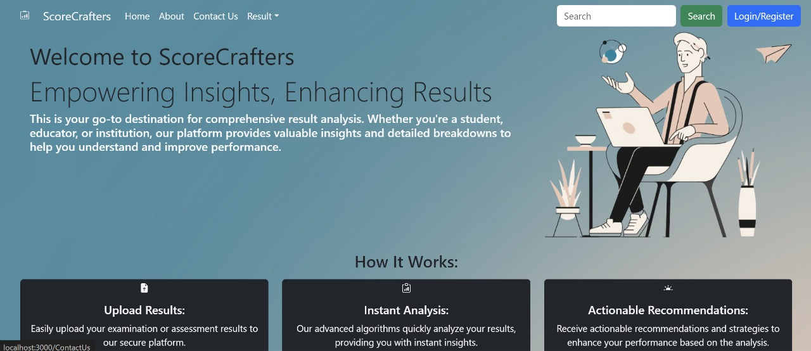

**Home Page Diagram**

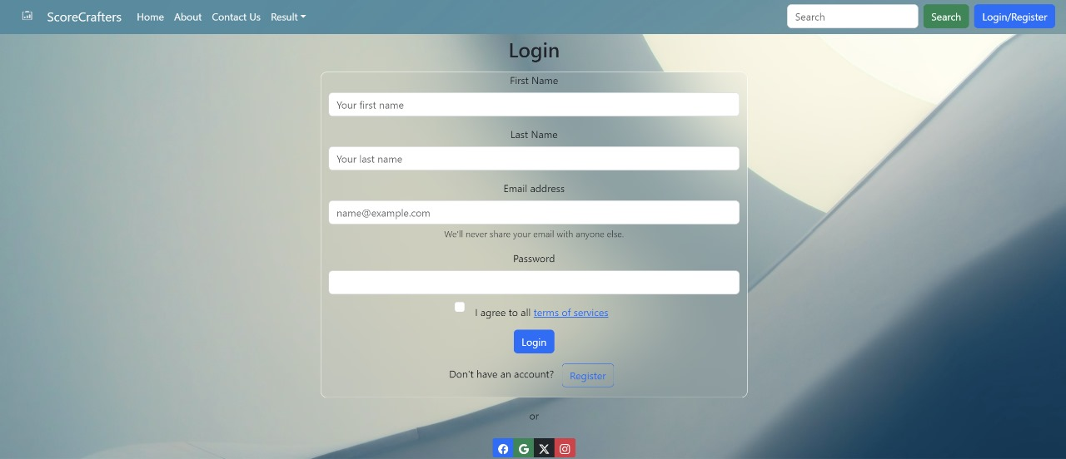

**Login Page**

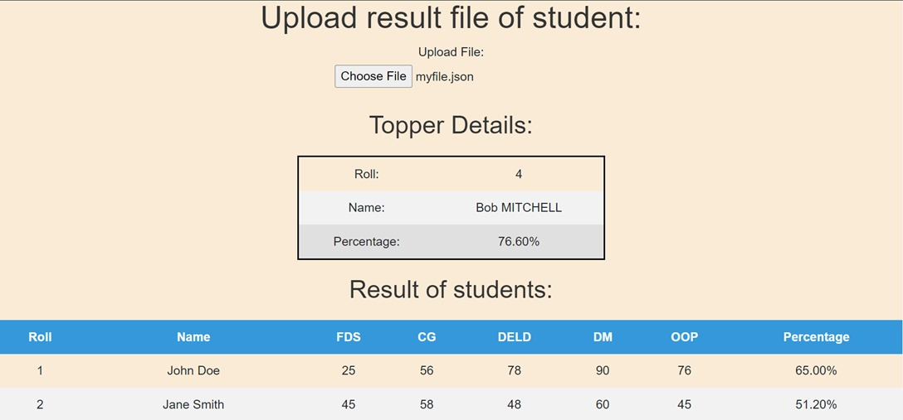

**Upload result**

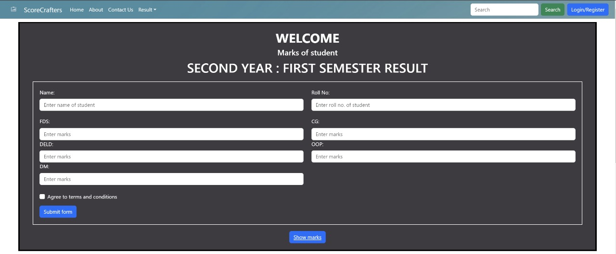

**Result Form**

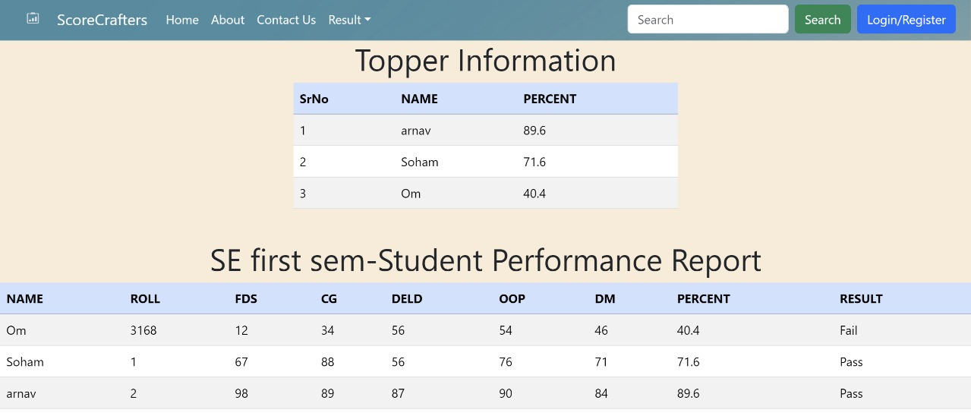

**Result Page**

**Future Enhancement**

The student result analysis website for college students can embrace exciting future enhancements to stay ahead of educational trends. Incorporating Artificial Intelligence (AI) and machine learning can make the system smarter, predicting academic trends and helping educators take proactive steps. Using blockchain technology can enhance the security of student records, ensuring trustworthiness and authenticity.

Future upgrades may also include more advanced data visualization tools for a clearer understanding of student performance. Predictive analytics could be used to forecast how well a student might do in the future, enabling personalized support. Recognizing the growing use of mobile devices, creating a user-friendly mobile app can offer on-the-go access to information and notifications.Looking ahead, the student result analysis website for college students can embrace exciting future enhancements to stay ahead of educational trends. Incorporating Artificial Intelligence (AI) and machine learning can make the system smarter, predicting academic trends and helping educators take proactive steps. Using blockchain technology can enhance the security of student records, ensuring trustworthiness and authenticity.

Future upgrades may also include more advanced data visualization tools for a clearer understanding of student performance. Predictive analytics could be used to forecast how well a student might do in the future, enabling personalized support. Recognizing the growing use of mobile devices, creating a user-friendly mobile app can offer on-the-go access to information and notifications.

**Advantages**

* User-friendly interface.
* Fast access to database.
* More storage capacity.
* Look and feel environment.
* RMS automates result computation and grading, reducing efforts and saving time for educators .
* RMS minimizes the likelihood of errors in result recording and computation, ensuring accurate and reliable data.

**Conclusion**

In conclusion, the student result analysis website for college students emerges as a valuable asset, streamlining and modernizing the way we understand and manage academic performance. The project resolves existing challenges by providing a user-friendly platform that automates result analysis, fosters collaboration, and ensures real-time updates. It marks a significant step towards efficient education management. Looking ahead, the integration of advanced technologies like Artificial Intelligence and blockchain promises to keep the platform relevant and secure. The website not only meets current needs but anticipates future trends, ensuring it remains a dynamic tool for educators, administrators, and students. In essence, it stands as a testament to the ongoing commitment to improving the higher education experience, creating a more accessible, collaborative, and future-ready educational environment for college students.

**Bibliograph**

<https://r.search.yahoo.com/_ylt=AwrPpHP9pJJluh0bKw67HAx.;_ylu=Y29sbwNzZzMEcG9zAzEEdnRpZAMEc2VjA3Ny/RV=2/RE=1704138110/RO=10/RU=https%3a%2f%2fgetbootstrap.com%2f/RK=2/RS=3isDwNN7D2Z_71kByjq9BilRXgE->

<https://r.search.yahoo.com/_ylt=AwrPpHNqpZJlx2gc0hi7HAx.;_ylu=Y29sbwNzZzMEcG9zAzEEdnRpZAMEc2VjA3Ny/RV=2/RE=1704138219/RO=10/RU=https%3a%2f%2freact-bootstrap.github.io%2f/RK=2/RS=3whX0WSSM8m8G9rSArPFDxwTcD8->