**Department of Information Technology**

**Academic Year: 2022-23 Name of Student:**

**Semester: VI Student ID:**

**Class / Branch / Div: TE- IT A/B Roll No.**

**Subject: MAD & PWA Lab Date of Submission:**

**Name of Instructor:**

**Experiment No.:4**

**Aim:** To Design an interactive Form using various form widgets.

**Prerequisites:** Android studio, flutter SDK **.**

**Problem Statement:** To develop a flutter Form for creating form using widgets of flutter.

**Software:** Android studio, flutter SDK **.**

**Code:**

import 'package:flutter/material.dart';

void main() {

runApp(MaterialApp(

home: MyForm(),

));

}

class MyForm extends StatefulWidget {

@override

State<StatefulWidget> createState() {

return MyFormState();

}

}

class MyFormState extends State<MyForm> {

var _myFormKey = GlobalKey<FormState>();

@override

Widget build(BuildContext context) {

return Scaffold(

appBar: AppBar(

title: Text("My Form"),

),

body: Container(

padding: EdgeInsets.symmetric(vertical: 25.0, horizontal: 25.0),

child: Form(

key: _myFormKey,

child: Column(

children: <Widget>[

Padding(

padding: EdgeInsets.all(10.0),

child: TextFormField(

validator: (msg) {

if (msg.isEmpty) {

return "Please enter name";

}

return null;

},

decoration: InputDecoration(labelText: "Name", hintText: "Enter Your Name", border: OutlineInputBorder(borderRadius: BorderRadius.circular(10.0))),

),

),

Padding(

padding: EdgeInsets.all(10.0),

child: TextFormField(

keyboardType: TextInputType.phone,

validator: (msg) {

if (msg.isEmpty) {

return "Please enter Mobile Number";

}

if (msg.length != 10) {

return "Please Enter Correct Digits";

}

return null;

},

decoration: InputDecoration(labelText: "Mobile", hintText: "Enter Your Mobile No.", border: OutlineInputBorder(borderRadius: BorderRadius.circular(10.0))),

),

),

Padding(

padding: EdgeInsets.all(10.0),

child: TextFormField(

validator: (msg) {

if (msg.isEmpty) {

return "Please enter Mobile Number";

}

if (msg.length != 6) {

return "Please Enter Correct Digits";

}

return null;

},

obscureText: true,

decoration: InputDecoration(labelText: "Password", hintText: "Enter Your Password.", border: OutlineInputBorder(borderRadius: BorderRadius.circular(10.0))),

),

),

],

)),

),

floatingActionButton: FloatingActionButton(

child: Icon(Icons.done),

onPressed: () {

_myFormKey.currentState.validate();

},

),

);

}

}

**Output:**

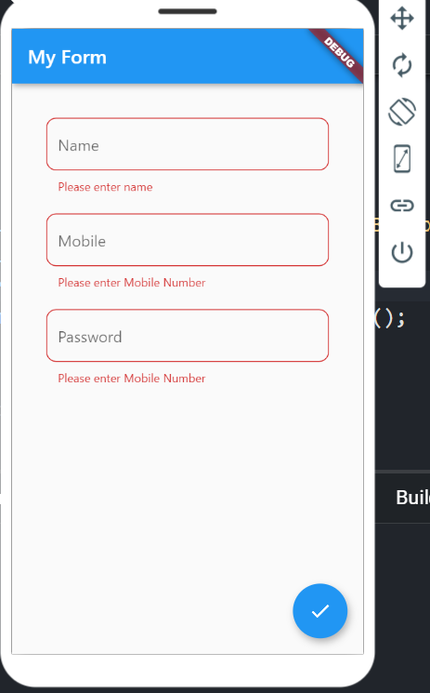 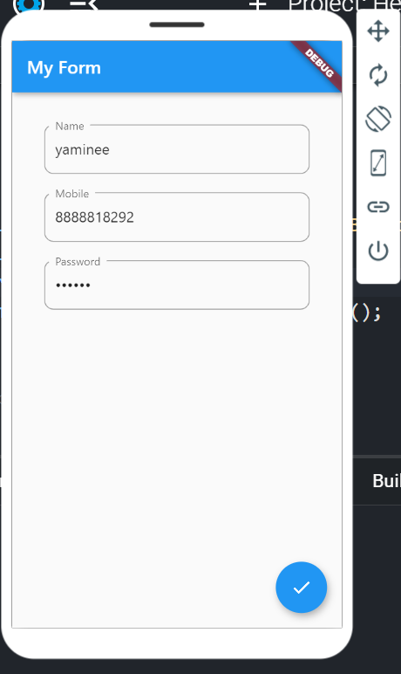

**Conclusion:** In this experiment we have designed an interactive form by using various form widgets.