**Department of Information Technology**

**Academic Year: 2022-23 Name of Student:**

**Semester: VI Student ID:**

**Class / Branch / Div: TE- IT A/B Roll No.**

**Subject: MAD & PWA Lab Date of Submission:**

**Name of Instructor:**

**Experiment No.:6**

**Aim:** Apply concepts of gestures in Flutter App.

**Prerequisites:** Android studio, flutter SDK**.**

**Problem Statement:** To develop a flutter UI using GestureDetector widget of flutter.

**Software:** Android studio, flutter SDK**.**

**Code:**

import 'package:flutter/material.dart';  
  
void main() => runApp(const MyApp());  
  
class MyApp extends StatelessWidget {  
 const MyApp({super.key});  
  
 static const String *_title* = 'Flutter Code Sample';  
  
 @override  
 Widget build(BuildContext context) {  
 return const MaterialApp(  
 title: *_title*,  
 home: MyStatefulWidget(),  
 );  
 }  
}  
  
class MyStatefulWidget extends StatefulWidget {  
 const MyStatefulWidget({super.key});  
  
 @override  
 State<MyStatefulWidget> createState() => _MyStatefulWidgetState();  
}  
  
class _MyStatefulWidgetState extends State<MyStatefulWidget> {  
 bool _lightIsOn = false;  
  
 @override  
 Widget build(BuildContext context) {  
 return Scaffold(  
 appBar: AppBar(title: Text('CHANGE STATE OF LIGHTS'),  
 ),  
 body: Container(  
 alignment: FractionalOffset.*center*,  
 child: Column(  
 mainAxisAlignment: MainAxisAlignment.center,  
 children: <Widget>[  
 Padding(  
 padding: const EdgeInsets.all(8.0),  
 child: Icon(  
 Icons.*lightbulb_outline*,  
 color: _lightIsOn ? Colors.*yellow*.shade600 : Colors.*black*,  
 size: 60,  
 ),  
 ),  
 GestureDetector(  
 onTap: () {  
 setState(() {  
 *// Toggle light when tapped.* _lightIsOn = !_lightIsOn;  
 });  
 },  
 child: Container(  
 color: Colors.*yellow*.shade600,  
 padding: const EdgeInsets.all(8),  
 *// Change button text when light changes state.* child: Text(_lightIsOn ? 'TURN LIGHT OFF':'TURN LIGHT ON'),  
 ),  
 ),  
 ],  
 ),  
 ),  
 );  
 }  
}

**Output:**

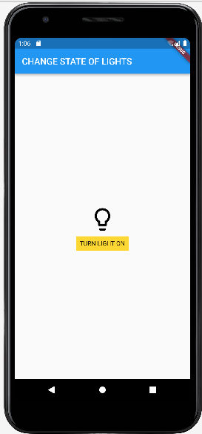

**Conclusion:** In this experiment, we have successfully designed a flutter application using GestureDetector.