**Department of Information Technology**

**Academic Year: 2022-23 Name of Student:**

**Semester: V Student ID:**

**Class / Branch/ Div: TE- IT B Roll No.**

**Subject: IP Lab Date of Submission:**

**Name of Instructor: YP/RS/SA**

**Experiment No:10**

**Aim:** Write a program to demonstrate React Router.

**Software Used:** Visual Studio Code or Sublime Editor

**Program:**

**Index.js**

import React from 'react';

import ReactDOM from 'react-dom';

import { BrowserRouter as Router, Route, Link, NavLink, Routes} from 'react-router-dom'

import './index.css';

import App from './App';

import About from './About'

import Contact from './Contact'

import Notfound from './Notfound'

const routing = (

<Router>

<div className='aa'>

<h1>React Router Example</h1>

<ul>

<li>

<NavLink to="/" exact activeStyle={

{color:'red'}

}>Home</NavLink>

</li>

<li>

<NavLink to="/About" exact activeStyle={

{color:'green'}

}>About</NavLink>

</li>

<li>

<NavLink to="/Contact" exact activeStyle={

{color:'magenta'}

}>Contact</NavLink>

</li>

</ul>

<Routes>

{/* <Route exact path="/" component={App} /> */}

<Route path="/" element={<App/>} exact />

{/* <Route path="/about" component={About} /> */}

<Route path="/About" element={<About />} />

{/* <Route path="/contact" component={Contact} /> */}

<Route path="/Contact" element={<Contact />} />

<Route component={Notfound} />

</Routes>

</div>

</Router>

)

ReactDOM.render(routing, document.getElementById('root'));

**App.js**

import React from 'react'

import './App.css'

class App extends React.Component {

render() {

return (

<div>

<h1 className='ccc'>Home</h1>

</div>

)

}

}

export default App

**output:**

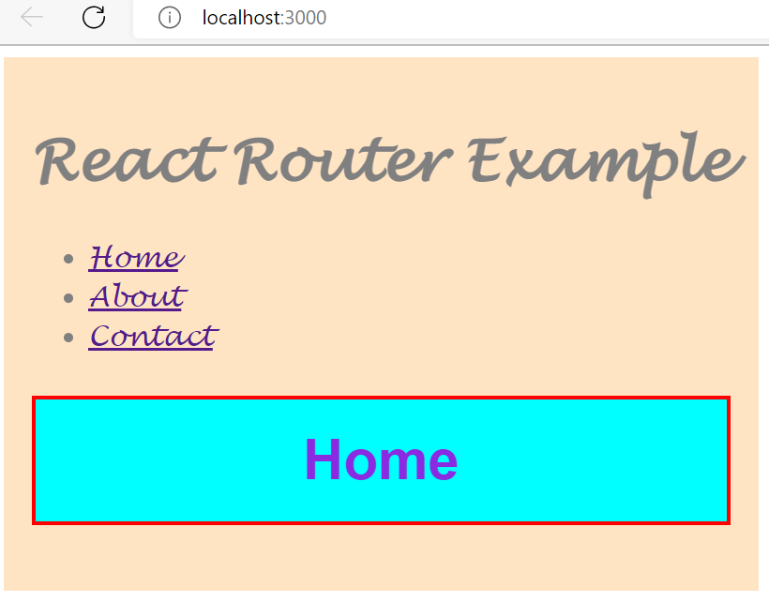

**About.js**

import React from 'react'

import './App.css'

class About extends React.Component {

render() {

return <h1 className='ccc'>This is About Page</h1>

}

}

export default About

**output:**

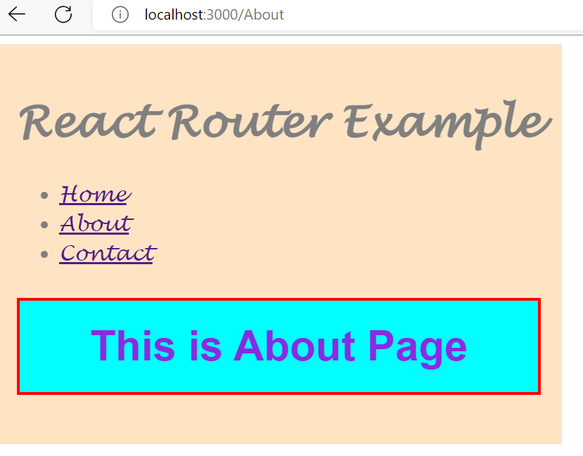

**Contact.js**

import React from 'react'

import './App.css'

class Contact extends React.Component {

render() {

return <h1 className='ccc'>welcome to Contact page!!!!!!!!</h1>

}

}

export default Contact

**output:**

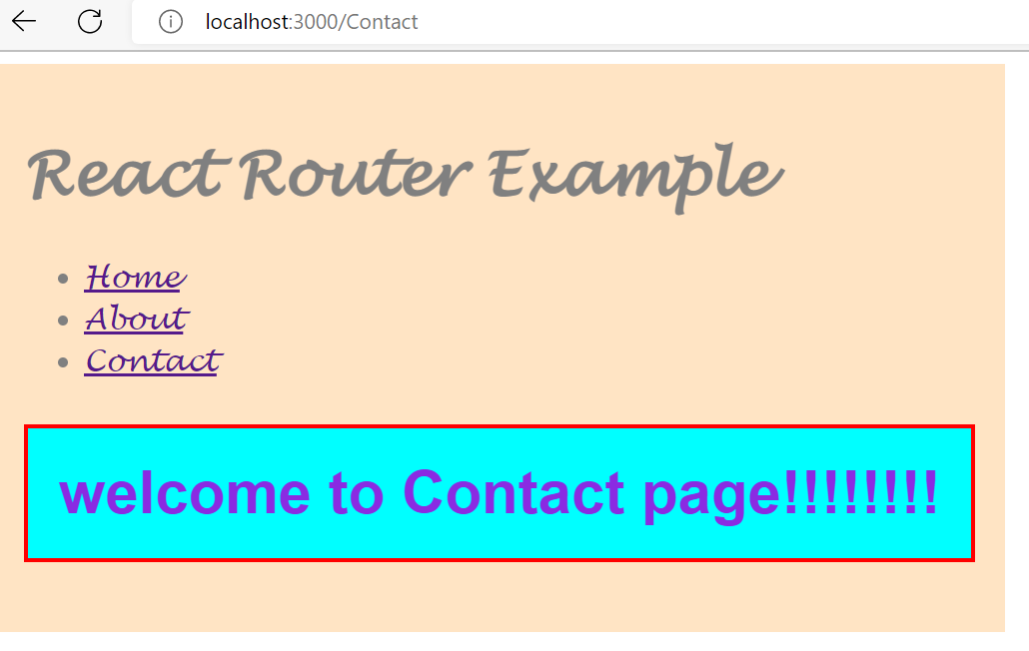

**Index.css**

.aa{

font-family: Lucida Handwriting;

font-size: 20px;

background-color: bisque;

padding: 20px;

display:inline-block;

color:grey;

}

**App.css**

.ccc{

background-color: aqua;

padding: 20px;

border: solid red 3px;

text-align: center;

font-family: Helvetica;

color: blueviolet;

}

**Conclusion:** Thus we have studied how to install react router & how navigate among different webpages using react router with the help of Browser Router, route & routes concept.