**Department of Information Technology**

**Academic Year: 2022-23 Name of Student:**

**Semester: V Student ID:**

**Class / Branch/ Div: TE- IT A/B Roll No.**

**Subject: IP Lab Date of Submission:**

**Name of Instructor: YP/RS/SA**

**Experiment No.:1**

**Aim:** Write a program to create a student portfolio webpage using HTML 5 elements.

**Software Used:** Visual Studio Code

**Theory:**

The portfolio is used to showcase your skills and projects. It can help you to get a job, internship etc.

**1 main.html**

<!DOCTYPE html>

<body bgcolor="orange">

<h1><b> SHITAL AGRAWAL</b></h1></h1>

<div style="font-size:40px;color:blue;font-family: Lucida Handwriting;">

<img class="profile_img" src="C:\Shital College\IP_LAB\rose.webp" alt="student dp" width="300" height="300" >

<center><p ><nav>

<a target="_blank" href="C:\Shital College\IP_LAB\STD_OP\Exp1\Basic.html">BASIC</a>|

<a target="_blank" href="C:\Shital College\IP_LAB\STD_OP\Sample Programs\Academic.html">Academic</a>|

<a target="_blank" href="C:\Shital College\IP_LAB\STD_OP\Sample Programs\other.html">Other</a>|

</nav>

</p></center></div>

</body>

</html>

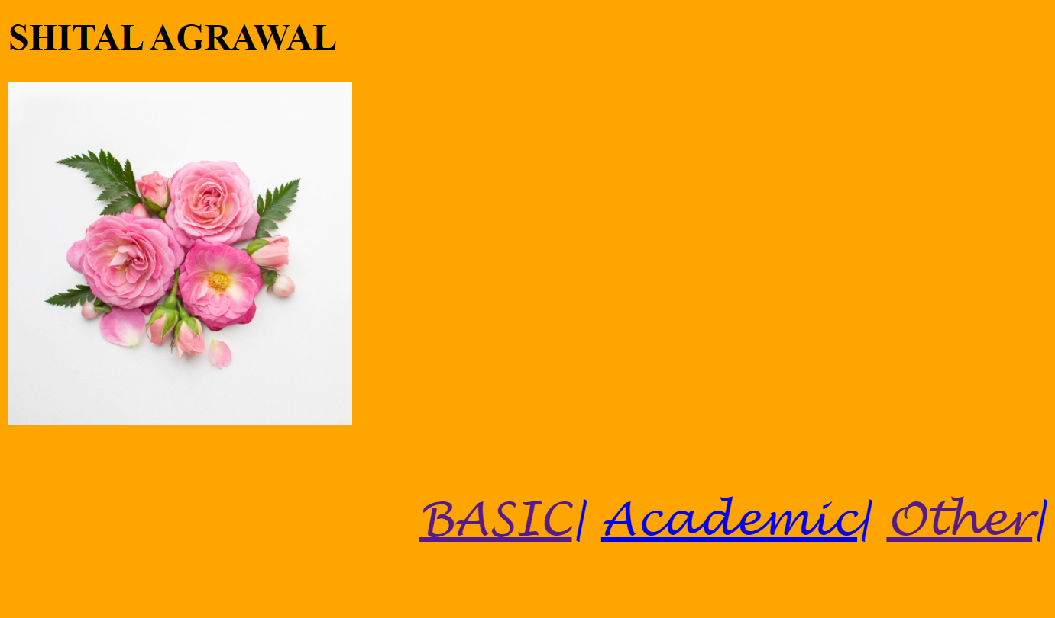

**2 Basic.html**

<!DOCTYPE html>

<html lang="en">

<head>

<title>Student Portfolio </title>

</head>

<body>

<header>

<h1> My Portfolio</h1>

</header>

<section>

<h2><u>Basic Information </u></h2>

</section>

<div>

<img class="profile_img" src="C:\Shital College\IP_LAB\rose.webp" alt="student dp" width="100" >

<p> Name:Shital Agrawal</p>

<p>Class:TE</p>

<p>Department:IT</p>

</div>

<p>MY HOBBIES</p>

<ul>

<li>Reading</li>

<li>Playing</li>

<li>Dancing</li>

</ul>

</div>

<div>

<p>

Email ID

<br>

<a href="https://mail.google.com/mail/u/0/#inbox">syagrawal2801@gmail.com</a>

</p>

<br>

<br>

<br>

<footer style="text-align: right">

<p> A.P.SHAH INSTITUTE OF TECHNOLOGY </p>

</footer>

</body>

</html>

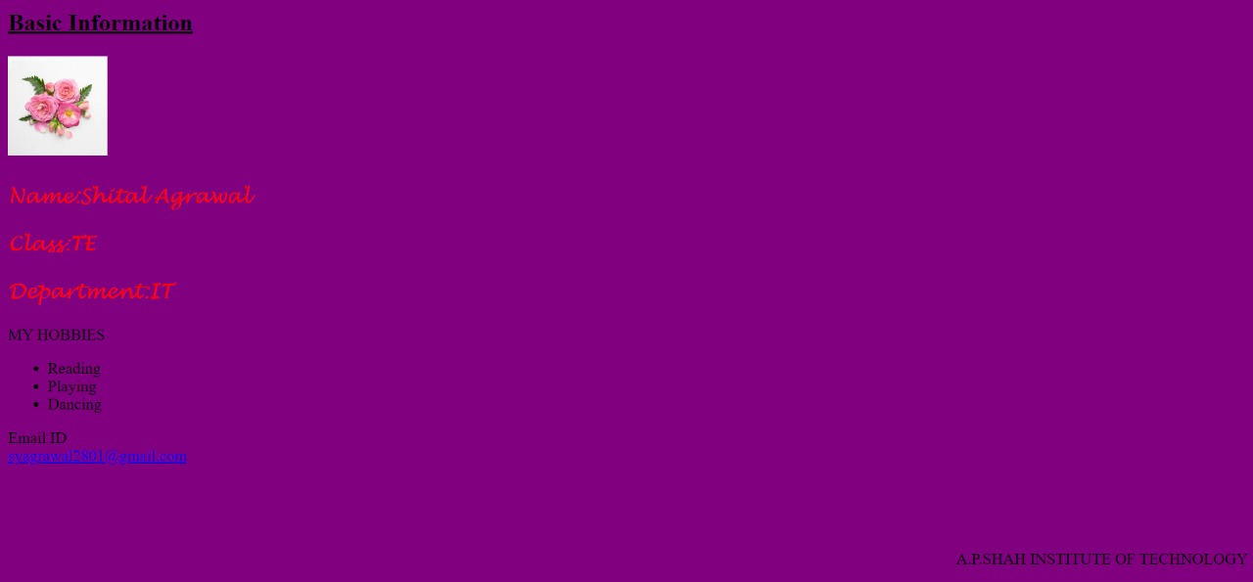

**3 Academic.html**

<!DOCTYPE html>

<html lang="en">

<head>

<meta charset="UTF-8">

<meta http-equiv="X-UA-Compatible" content="IE=edge">

<meta name="viewport" content="width=device-width, initial-scale=1.0">

<title>Academic Details</title>

</head>

<body bgcolor="yellow">

<div style="font-size:20px;color:black;font-family:serif; ">

<h1><u>Academic Achievements</u></h1>

</div>

<table border="5">

<br>

<br>

<br>

<br>

<tr>

<th>Education Level</th>

<th>MARKS</th>

</tr>

<tr>

<td>HSC</td>

<td>60%</td>

</tr>

<tr>

<td>SSC</td>

<td>70%</td>

</tr>

<tr>

<td>Diploma</td>

<td>63%</td>

</tr>

<tr>

<td>BE</td>

<td>72%</td>

</tr>

</table>

</body>

</html>

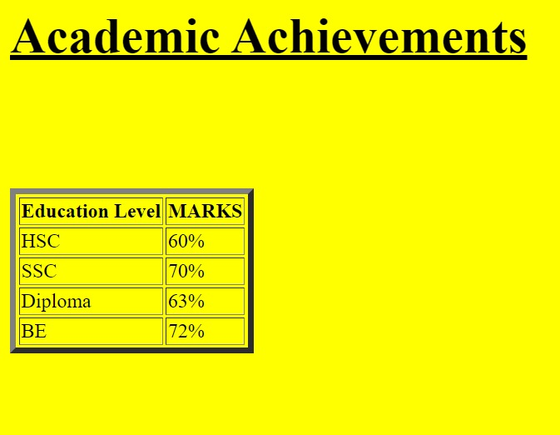

**4 other.html**

<!DOCTYPE html>

<html lang="en">

<head>

<meta charset="UTF-8">

<meta http-equiv="X-UA-Compatible" content="IE=edge">

<meta name="viewport" content="width=device-width, initial-scale=1.0">

<title>Other Info</title>

</head>

<body bgcolor="green">

<div style="font-size:20px;color:blackd;font-family: Lucida Handwriting;">

<h1><U>OTHER COURSES</U></h1>

<ul>

</div>

<li>PYTHON ESSENTIAL</li>

<li>LINUX ESSENTIAL</li>

<li>NETWORKING ESSENTIAL</li>

</ul>

</body>

</html>



**Conclusion:** Thus we have studied and implemented program to create a student portfolio using various HTML tags like div, img, table,list,footer etc.