**PHARMA MANAGEMENT SYSTEM**

Ashutosh Singh

Shivam Singh

Vishal Singh

**EXECUTIVE SUMMARY**

Pharma Management System project is a web application developed on Java technology, Spring framework and Hibernate. The web application provides the pharmacy shop a systematic tool and comprehensive solution to maintain record of all the medicine in pharmacy and vary them accordingly whenever necessary. It is based on the principle of CRUD – Create, Read, Update and Delete the records as per admin’s input to the web application. The Pharma Management System displays the records entered by administrator in form of a list. It provides the security of data since the first module is authentication. The data fed inside the web application can be accessed only after proper authentication using username and password of the administrator.

**PROBLEM STATEMENT**

To develop a Spring Hibernate ORM that runs on Apache Tomcat Server. The web application should be dynamic. The web application should be a Pharma Management System that takes user’s login information and then grants access only after correct authentication. The web application should be developed in such a manner that administrator should be able to perform CRUD application on the data of medicine in pharmacy. The data that is added in the front end on the server should be stored in the backend server in the database. For each new session the data (or any changes on existing data) of the previous session should be reflected in the front end.

**DESCRIPTION**

Pharma Management web application is divided into three major modules, viz. Login, Dashboard, Logout. All three modules provide different functions that can used by administrator.

Whenever an administrator opens the web application, admin is asked to enter the username and password provided by the developer. The Login Module of Pharma Management System takes the username and password input and checks it’s authentication. If the username and password supplied by the administrator matches with the one declared in the code, the authentication is successful and access to dashboard is granted.

Fig 1 : Block Diagram of College Management System

Once the administrator reaches the dashboard the CRUD operations can be performed using Add, View List and Edit options which gives the user the feature to add, update, read and delete the data as per requirement. The changes done by the user in the front end are updated in the backend using JDBC connectivity for MySQL database on the server.

**FINDINGS**

HTML is the most widely used technology to create websites. Although every web browser supports HTML, but it can only create static and plain pages. Hence HTML cannot be used for creating dynamic web application. The need for high rendering web application is increasing day-by-day. This requirement cannot be fulfilled by the existing traditional technologies like HTML. To overcome the issue, Java Technology was used to create a dynamic CRUD application. Java Technology gives the developer powerful and efficient web development tools like Java Servlet Page, Spring framework and Hibernate Database connection to develop dynamic web applications which can be used to eliminate human work that is involved in creating, updating and deleting records.

The project incorporated Spring framework which provides modularity while developing a web project unlike other existing technology where developers are required to code in a single module. Spring provides Model View Control (MVC) Architecture that’s support Enterprise application development. The biggest benefit of Spring over other technology is it’s versatility to get integrated with Hibernate and other Java frameworks resulting in a powerful platform on which a developer can code and develop front end, back end and establish the connectivity with database using driver files like JDBC. Spring is a modular framework and it comes with may modules such as Spring MVC, Spring ORM, Spring JDBC etc. which can be used as per application requirement in future. Spring is an emerging technology that will continue to dominate the web development field in future as well because of the edge it provides over others.

Due to diversity and complexity of web-based application it’s difficult to develop the applications in object-oriented manner. Hence we opt for MVC architecture.

**IMPLEMENTATION**

1. Software used:

|  |  |
| --- | --- |
| Operating system | Windows, MacOs, Linux |
| IDE | Eclipse 2019-12 on JDK 1.8 |
| Front end | Java Servlet Page (JSP), CSS |
| Backend | MySQL |
| Server | Apache Tomcat v 9.0 |
| Web Browser | Google Chrome / Internet Explorer / Mozilla Firefox |

1. Hardware used:

|  |  |
| --- | --- |
| RAM | Minimum 256MB required |
| Processor | P4, double core, i3 and other |
| Hard Disk | Minimum 40GB |

The coding was done in Eclipse IDE (Java EE module) in order to design and implement the project. Eclipse provides powerful functionalities to create dynamic web projects. The project was divided into three components – Views, Controllers and Database connection. The views were created using JSP (Java Servlet Page), HTML and CSS. Each page was created separately and then linked to each other using Controllers. These interfaces were designed to provide the ‘view’ in the front end.

The web application uses Java classes to turn the static JSP, HTML pages into dynamic web application. These classes are called Controllers. In these controllers sessions were stored by using POST method. These Java classes provided the method to design flow of process and data in our web application. For example, AuthController which was created for Login pages takes the data that user enters in front end, verifies the username and password and then fetches the data from backend MySQL database and then redirects the user to the dashboard. They are an integral component of MVC architecture on which the project has been designed.

The backend of Pharma Management System is based on MySQL database that runs on Xampp server. With the help of JDBC driver and Hibernate Database Connection method, the front end of web application is linked with the backend. This connection ensures that whatever changes the administrator makes in the front end is stored i.e. created, updated and deleted in the database. It’s because of the database connection the administrator can view the data that was stored in previous session whenever a new login session starts. The application is able to fetch the data of previous session as well as provide functionality to store the new data. JDBC and hibernate connection are powerful tools to access and link database with front end.

**DISCUSSION**

This project is aimed at developing an Online Pharma Management System that is of importance to pharmacy shops. The system is an Internet based application that can be accessed from anywhere. This system is being developed for pharmacy owner or worker to maintain and facilitate easy access to information of medicine. For administrator, they needed to be registered with the system after which they can access or modify data as per the permissions given to them.

When application is start there is login page for easy accessibility. user is required to provide the username and password. It’s the authentication interface that provides access to further pages only to recognized user. Hence data security is ensured.

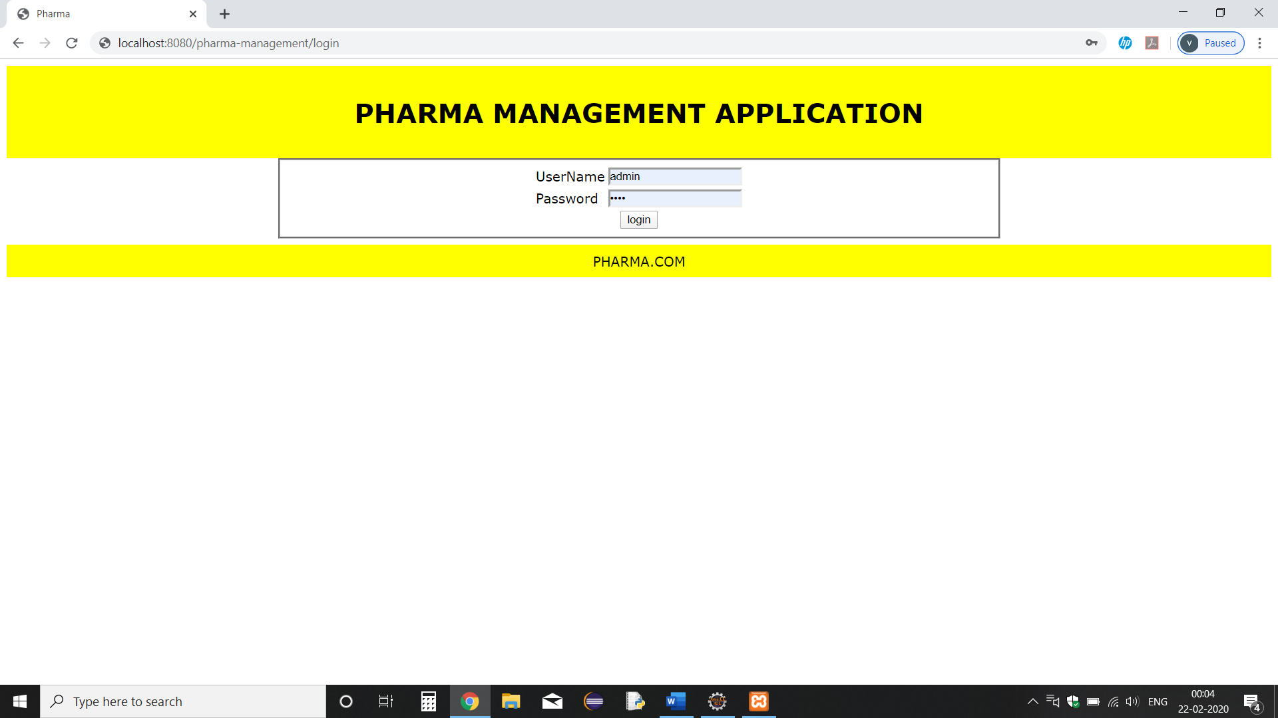

Fig. 2: Login Page

When the user provided username and password are found to be correct then the college management system grants the access to Dashboard of Pharmacy Employee. It’s the main frame of the web application. It contains method to perform CRUD operations on the database. It shows student list, provides method to add a new record, edit the existing record and delete it. The session can be terminated using Logout option.

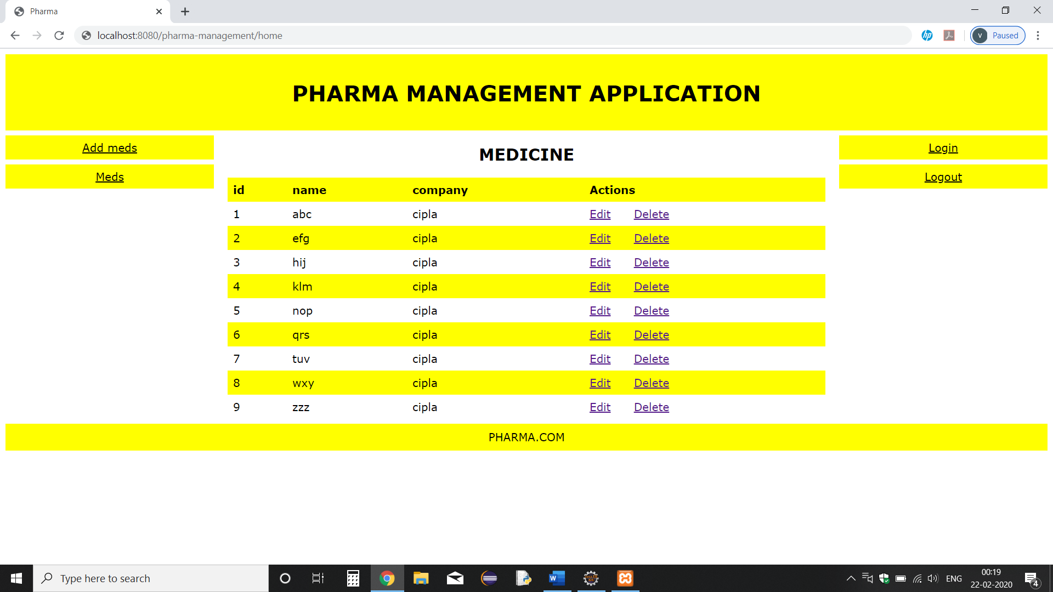

Fig. 4: Dashboard (home page)

The Java web application fetches the database and provides method to edit and create a new data. It’s the most important component of any CRUD application.

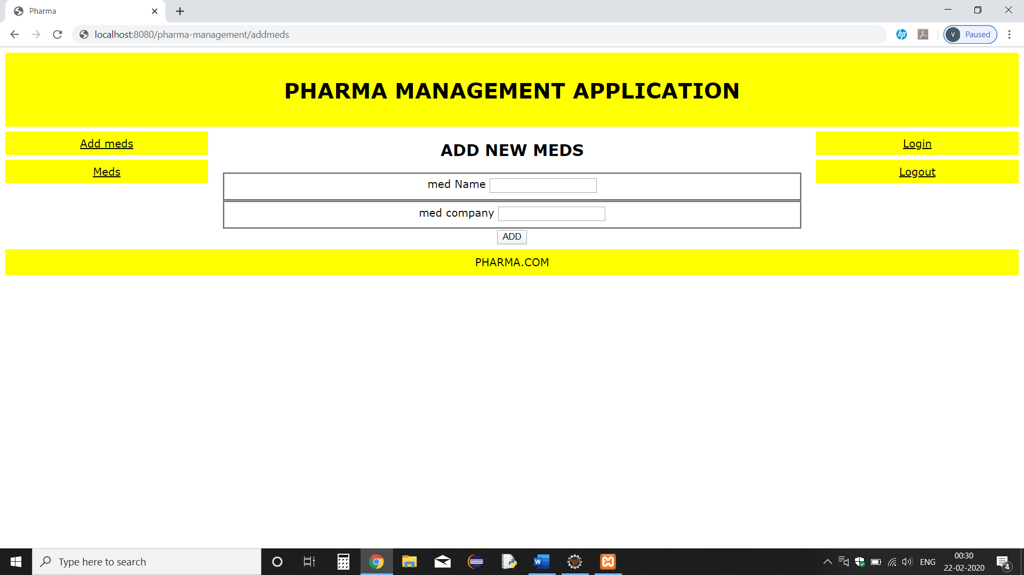

Fig. 5: Add Medicine Page

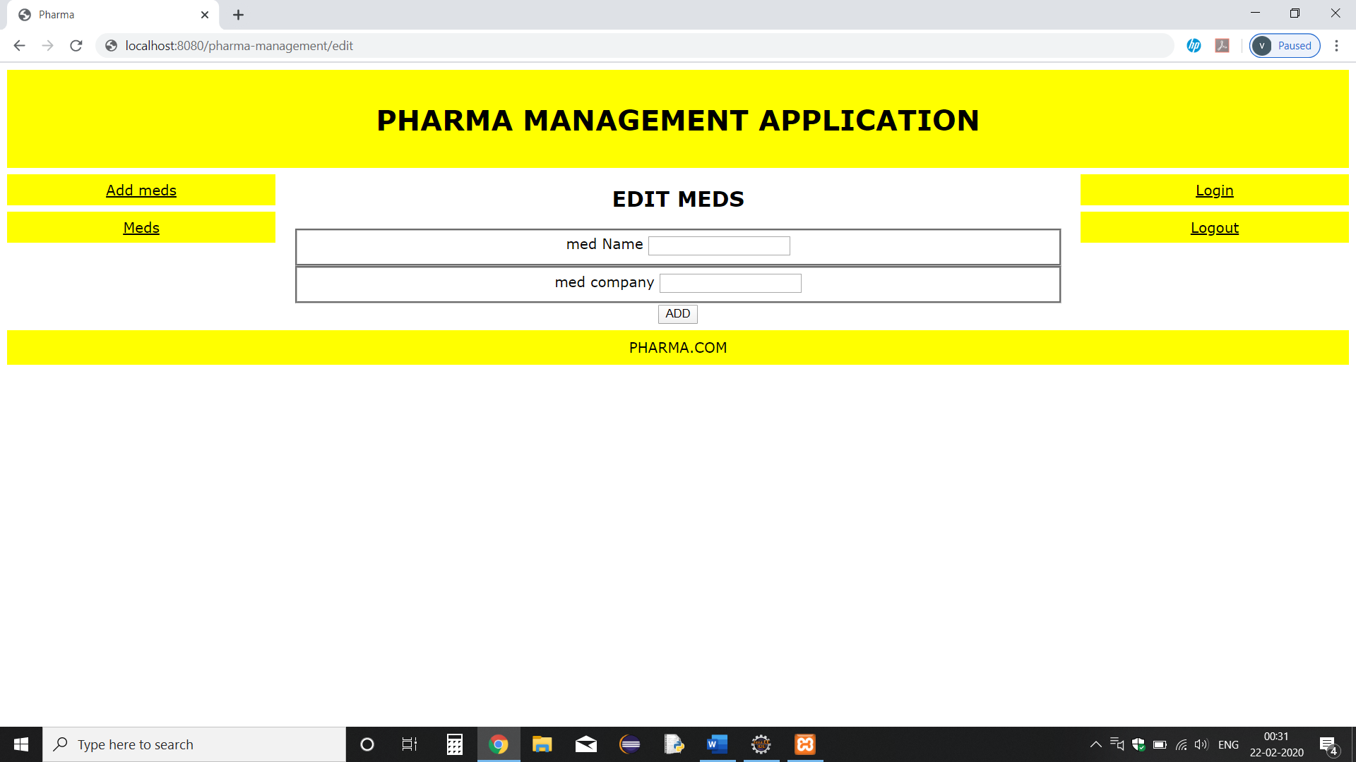

Fig. 6: Edit Medicine details.

**INPUT STUDY**

Nahar Wildan in his paper titled - Dynamic View Rendering wrote that rendering in HTML is one of the most common problems in web development world but it gets complicated and inefficient when web page to be developed is dynamic, especially when the data that rendered get bigger and more complex. Spring framework, a MVC schema of Java is one of the most powerful front-end frameworks that can deals with large data with fast dynamic rendering.

Khawas Chunnu & Shah Pritam explained the need and importance of an efficient database their paper titled Database in Android App Development, a study for International Journal of Computer Applications. They concluded that web application has become more and more reliant upon large amount of database.

**CONCLUSION**

This project was successfully implemented with all the features mentioned in system requirements specification. So this application serves the right purpose in achieving the desired requirements of pharmacy owner or worker. It will useful in managing the data of medicine in their pharmacy. The Pharma Management System was implemented on MVC architecture. The Model layer was based on MySQL that was connected using JDBC and Hibernate to the front end which contained Views designed using JSP and CSS. The Controller has servlets stored in it and used HTTP Session Request and POST method.

The dynamic web application was tested on Apache Tomcat server . The web application was able to authenticate the login information, grant access to dashboard and gave the administrator method to perform CRUD operation on the database.

**REFERENCES**

[1] Khawas Chunnu & Shah Pritam, “Database in Android App Development”, for International Journal of Computer Applications.

[2] Herbet Schildt, “Java The Complete Reference”, Eleventh Edition, New York, 2019.

[3] S. Marzic, I. Jugo and M. Radvon, “Developing ddynamic web applications: “Exam Scheduler”,” *2011 Proceedings of the 34th International Convention MIPRO*, Opatija, pp. 1127-1132

[4] Mari Abe, Takashi Nermoe, Masahiro Hori, “Model Driven Development of Dynamic Web Applications”, for International Journal of Computer Applications, 2002.

[5] D Guell, N Schewabe, “ Modelling Interactions and Navigation in Web Applications”, vol. 1921, pp. 115-127. Springer, Heidelberg (200).

[6] JavaTPoint, Spring Tutorial, https://www.javatpoint.com/spring.