Entity Framework

# What is Entity Framework?

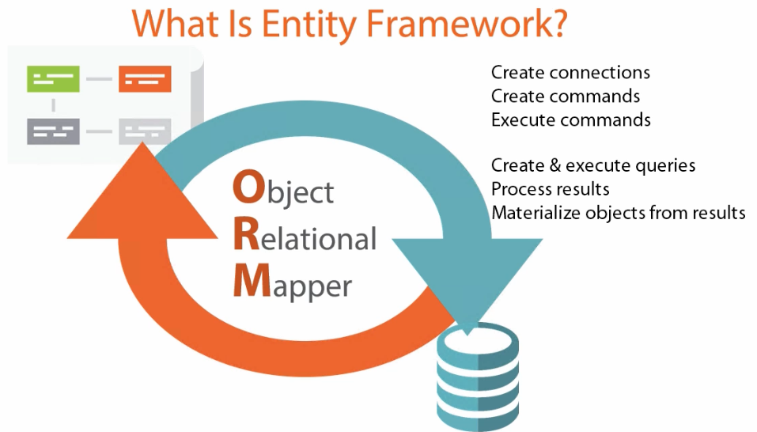

# EF vs ORMs

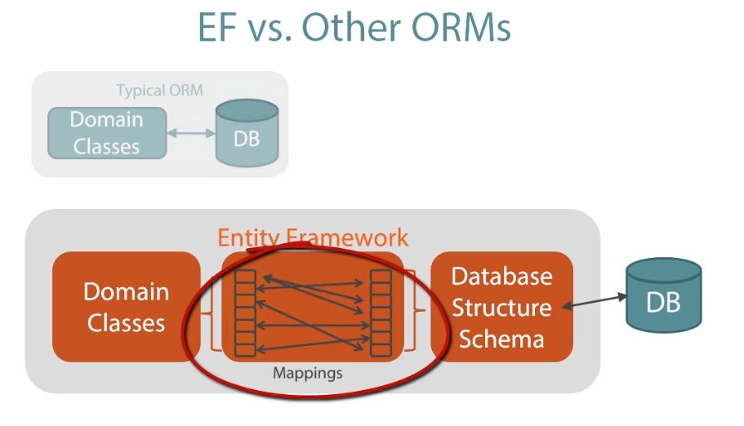

# Why Entity Framework?

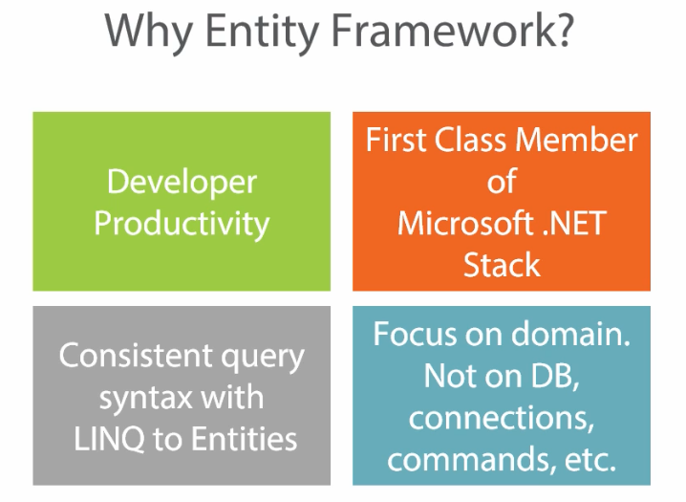

# Where to use Entity Framework 6?

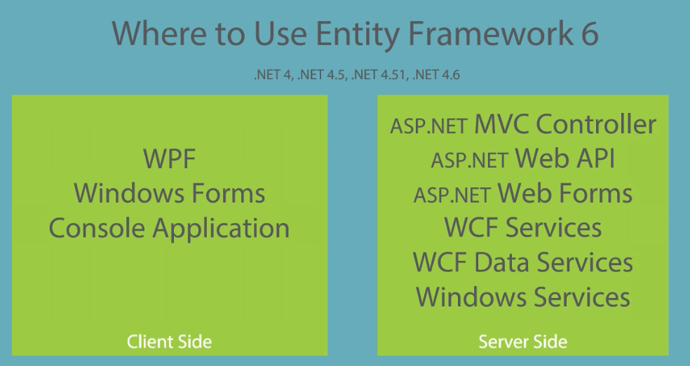

# How EF works

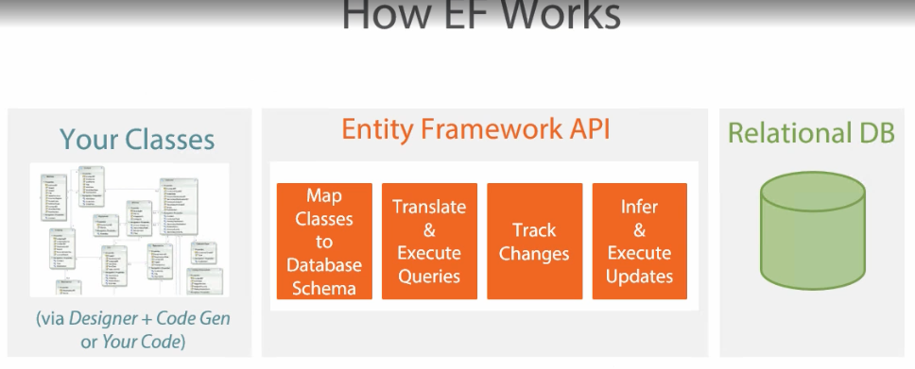

# Model Options

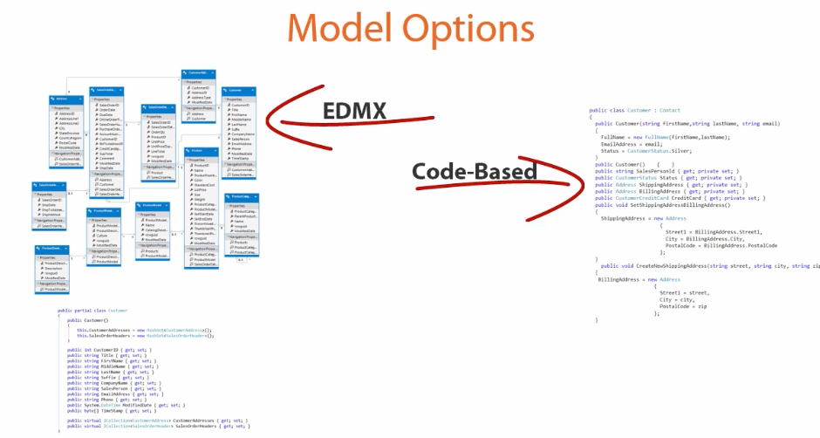

# The abilities

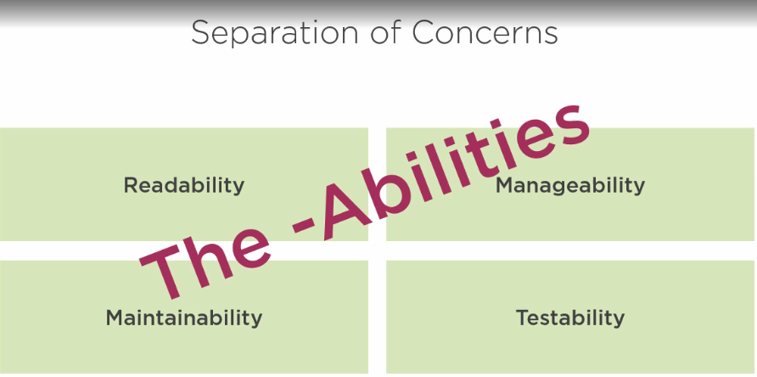

Repo patern <https://www.youtube.com/watch?v=rtXpYpZdOzM>