Folder Structure
Liferay-dxp-docker/
modules/
custom-module.jar
docker-compose.yml
Dockerfile
.env
. gitignore

docker-compose.yml
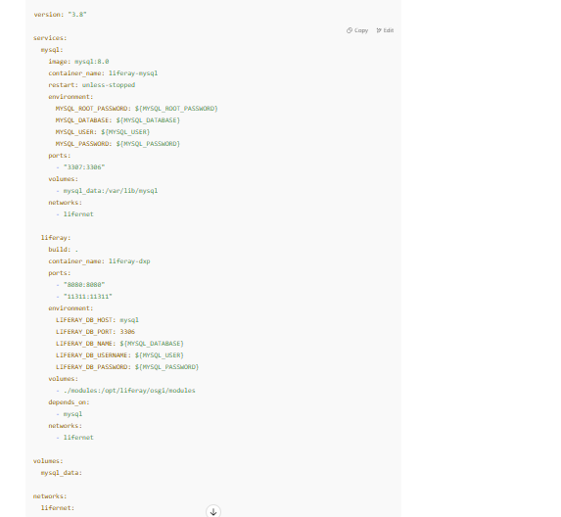
Dockerfile
FROM liferay/dxp:7.4.13-u70
# Copy your startup configs or patches if needed
# COPY configs /opt/liferay/configs
# Optional: auto copy built modules
COPY modules/*.jar /opt/liferay/osgi/modules/ ## You can auto-clone a Git repo of modules using an entrypoint script:
COPY entrypoint.sh /usr/local/bin/entrypoint.sh
RUN chmod +x /usr/local/bin/entrypoint.sh
ENTRYPOINT ["/usr/local/bin/entrypoint.sh"]

entrypoint.sh File
#!/bin/sh
# Clone repo and copy JARs
git clone https://github.com/yourname/liferay-modules.git /tmp/modules
cp /tmp/modules/build/libs/*.jar /opt/liferay/osgi/modules/
# Start Liferay
exec /opt/liferay/tomcat-9.0.82/bin/catalina.sh run

execute command:
docker-compose down -v
docker-compose up --build

