**Folder Structure**

Liferay-dxp-docker/

modules/

custom-module.jar

docker-compose.yml

Dockerfile

.env

. gitignore

**docker-compose.yml**

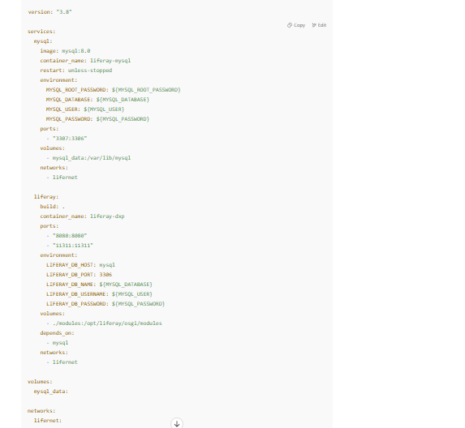

**Dockerfile**

FROM liferay/dxp:7.4.13-u70

# Copy your startup configs or patches if needed

# COPY configs /opt/liferay/configs

# Optional: auto copy built modules

COPY modules/*.jar /opt/liferay/osgi/modules/ **## You can auto-clone a Git repo of modules using an entrypoint script:**

COPY entrypoint.sh /usr/local/bin/entrypoint.sh

RUN chmod +x /usr/local/bin/entrypoint.sh

ENTRYPOINT ["/usr/local/bin/entrypoint.sh"]

**entrypoint.sh File**

#!/bin/sh

# Clone repo and copy JARs

git clone https://github.com/yourname/liferay-modules.git /tmp/modules

cp /tmp/modules/build/libs/*.jar /opt/liferay/osgi/modules/

# Start Liferay

exec /opt/liferay/tomcat-9.0.82/bin/catalina.sh run

execute command:

**docker-compose down -v**

**docker-compose up --build**