**What are Gradle build types, and how do they differ from flavors?**

* **Explanation**: Build types (e.g., debug and release) define how the app is built/packaged and include configurations like signing and minification. Flavors are used for creating different versions of an app (e.g., free vs. paid).

**How do you manage dependencies in Gradle?**

* **Explanation**: Discuss how to use implementation, api, compileOnly, and runtimeOnly configurations, as well as dependency constraints and resolution strategies.

**What are the differences between compile,compileOnly,compileClasspath and implementation?**

### **1. compile**

* **Usage:** This configuration is used to declare dependencies that are required at compile time and runtime.
* **Visibility:** Dependencies declared with compile are exposed to consumers of the project, meaning any project that depends on this project will also have access to these dependencies.
* **Deprecation:** The compile configuration has been deprecated in favor of implementation and api.

### **2. compileOnly**

* **Usage:** This configuration is for dependencies that are needed only at compile time but should not be included in the final build (e.g., annotations).
* **Visibility:** Dependencies declared as compileOnly are not visible to consumers; they are only used during compilation.
* **Example:** You might use compileOnly for libraries that are provided by the runtime environment, like servlet APIs in a web application.

### **3. implementation**

* **Usage: T**his is the recommended configuration for dependencies that are needed at both compile time and runtime.
* **Visibility:** Dependencies declared with implementation are not exposed to consumers, which helps reduce compile-time dependencies and keeps the API surface clean.
* **Benefit:** Improves build performance because Gradle does not recompile consumers when the implementation details change.

### **4. compileClasspath**

* **Usage:** This configuration is not commonly used directly by developers; it represents the classpath for compiling the project's source code.
* **Visibility:** It’s an internal configuration that includes all compile-time dependencies, including those that are declared with implementation and compileOnly.
* **Purpose:** Primarily used by Gradle to resolve classpath dependencies during the compile phase.

### **Summary**

* **compile:** Deprecated, exposes dependencies to consumers.
* **compileOnly:** Compile-time only, not included in the runtime.
* **implementation:** Compile and runtime, not exposed to consumers, improves performance.
* **compileClasspath:** Internal configuration for resolving classpath dependencies during compilation.

**Explain the concept of Gradle tasks and their lifecycle.**

* **Explanation**: Gradle tasks are units of work that Gradle executes.
* The Gradle build lifecycle consists of three main phases: **Initialization**, **Configuration**, and **Execution**.

**Initialization**: In this phase, Gradle determines which projects are going to be part of the build.Gradle identifies the project structure defined in the settings.gradle file.

**Configuration**: Evaluate build scripts and configure tasks.Gradle configures the project. It evaluates the build scripts (e.g., build.gradle) for each project.

**Execution**: Gradle creates a task graph, determining what tasks need to be executed based on their dependencies.The results of the tasks (e.g., compiled classes, generated files) are created during this phase.

**What is a Gradle wrapper, and why is it recommended?**

* **Explanation**: The Gradle wrapper (gradlew) allows you to run a Gradle build without requiring users to install Gradle. It ensures a specific version is used for builds, which enhances consistency across environments.

### **Key Features of Gradle Wrapper**

1. **Consistency**: By using the Gradle Wrapper, you ensure that everyone on the team uses the same version of Gradle, reducing compatibility issues.
2. **No Installation Required**: Users can build the project by simply running the wrapper scripts, without needing to install Gradle manually.
3. **Automatic Gradle Version Management**: If the specified version of Gradle is not installed, the Wrapper can automatically download it.

### **How to Set Up Gradle Wrapper**

To add the Gradle Wrapper to your project, run the following command in your project directory:

gradle wrapper : This will generate the necessary scripts and configuration files.

### **Using Gradle Wrapper**

Once the Wrapper is set up, you can use it to run Gradle commands like this:

./gradlew build # Unix/Linux/macOS

gradlew.bat build # Windows

**How can you customize the Gradle build process?**

* **Explanation**: Discuss ways to customize builds using build scripts, task configuration, and plugins. Mention build.gradle file modifications and the afterEvaluate block.

**What are Gradle plugins, and how do you create one?**

Gradle plugins are reusable pieces of code that extend Gradle’s capabilities, allowing you to encapsulate build logic, configurations, and tasks. Plugins can be created to simplify the build process, apply custom tasks, manage dependencies, or integrate with external tools & services.

### **Types of Gradle Plugins**

1. **Built-in Plugins**: Gradle comes with several built-in plugins for common tasks (e.g., Java, Groovy, Android).
2. **Third-Party Plugins**: Many community-contributed plugins are available through repositories like the Gradle Plugin Portal.
3. **Custom Plugins**: You can create your own plugins to encapsulate specific build logic tailored to your project.

**Creating a Gradle Plugin**

#### **Step 1: Set Up a New Project**

Create a new Gradle project for your plugin. You can use the command line:

**gradle init --type java-library**

#### **Step 2: Modify build.gradle**

In your build.gradle, you need to apply the java-gradle-plugin plugin and set the necessary properties:

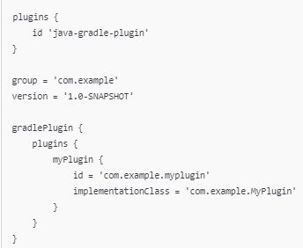

#### **Step 3: Create Your Plugin Class**

Create a new class that implements the Plugin interface. This class will contain the logic for your plugin.

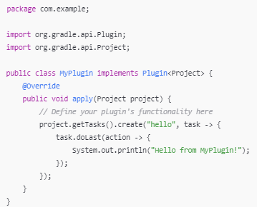

#### **Step 4: Build the Plugin**

You can build your plugin using the command “**./gradlew build**”:

This will create a JAR file for your plugin in the build/libs directory.

#### **Step 5: Publish Your Plugin (Optional)**

If you want to share your plugin, you can publish it to the Gradle Plugin Portal or your own

Maven repository. You can add the maven-publish plugin and configure it:

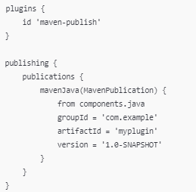

#### **Step 6: Use Your Plugin**

To use your newly created plugin in another project, include it in the build.gradle file:



**How do you handle multi-module projects in Gradle?**

* **Explanation**: Discuss project structure, how to define module dependencies, and how to configure a parent build.gradle file to manage shared configurations and dependencies.

**in gradle if there are same dependency with different version which will be used**

**1. Latest Version Wins:** By default, Gradle will select the latest version of the dependency declared in your project.

### **2. Force a Specific Version:** You can explicitly force a particular version of a dependency to be used across all modules by using the resolutionStrategy in your build.gradle file:

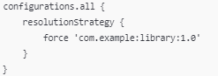

This will ensure that version 1.0 is used, regardless of other versions declared.

### **4. Using Strict Version Constraints**

If you want more control, you can declare strict version constraints using strictly:

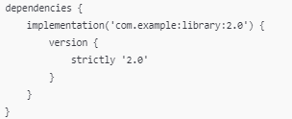

This setup will ensure that only version 2.0 is used, and any other version will be rejected.

**What is the purpose of settings.gradle?**

* **Explanation**: settings.gradle is used to define the structure of a multi-module project, including which modules are included in the build and their names.

**Explain the difference between project and subprojects in a multi-module setup.**

* **Explanation**: The project block applies configurations to the current project, while subprojects applies configurations to all subprojects in a multi-module setup.

**How can you optimize build performance in Gradle?**

* **Explanation**: Discuss techniques like configuring parallel builds, using the build cache, enabling incremental builds, and avoiding unnecessary dependencies.

**What are task inputs and outputs, and how do they affect build caching?**

* **Explanation**: Inputs are data that a task uses to perform its work, while outputs are the results it produces. Properly defining them helps Gradle determine when to skip task execution based on cached results.

**How do you manage versioning of dependencies in Gradle?**

* **Explanation**: Using resolution strategy, strict etc. Discuss using a versions.gradle file, dependency constraints, and how to manage transitive dependencies effectively.

**What is a Gradle property, and how can you use it?**

* **Explanation**: Properties allow you to define configuration parameters in your build.gradle file or pass them during the build process using command-line options.

**How can you execute Gradle tasks in parallel?**

### **1. Enable Parallel Execution**

* You can enable parallel execution in your gradle.properties file by adding: **org.gradle.parallel=true**

### **2. Command-Line Option**

You can also enable parallel execution directly from the command line when running a Gradle build:  **./gradlew build --parallel**

### **3. Dependencies and Task Execution**

Gradle automatically determines which tasks can be executed in parallel based on their dependencies. If tasks do not depend on one another, they can run simultaneously.

### **4. Use the --max-workers Option**

You can specify the maximum number of worker threads Gradle should use. This can help you control resource usage on your machine:

**./gradlew build --max-workers=4**

The default number of workers is based on the number of available CPU cores.

### **5. Configure Task-Specific Parallelism**

While Gradle’s parallel execution is managed automatically, you can also mark specific tasks as runnable in parallel by ensuring they do not have dependencies on each other. For instance, if you have two independent tasks:

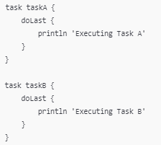

Running ./gradlew taskA taskB will allow both tasks to execute in parallel if parallel execution is enabled.