1.Creation of Amazon EC2 Instances (Linux and Windows) and Establishing Secure Connections Using SSH from Local Machine, PuTTY (.pem & .ppk), AWS CloudShell, and Remote Desktop Protocol (RDP)

🧾 PREREQUISITES
Make sure you have:
- ✅ EC2 Ubuntu instance running
- ✅ .ppk private key file
- ✅ PuTTY installed (Windows)-- https://putty.org/index.html (INSTALL FIRST ONE)

🔹 STEP 1: Check Security Group
Go to EC2 → Security Groups → Inbound rules
Ensure this rule exists:
Type: SSH
Port: 22
Source: My IP
❌ If SSH is blocked → connection will fail
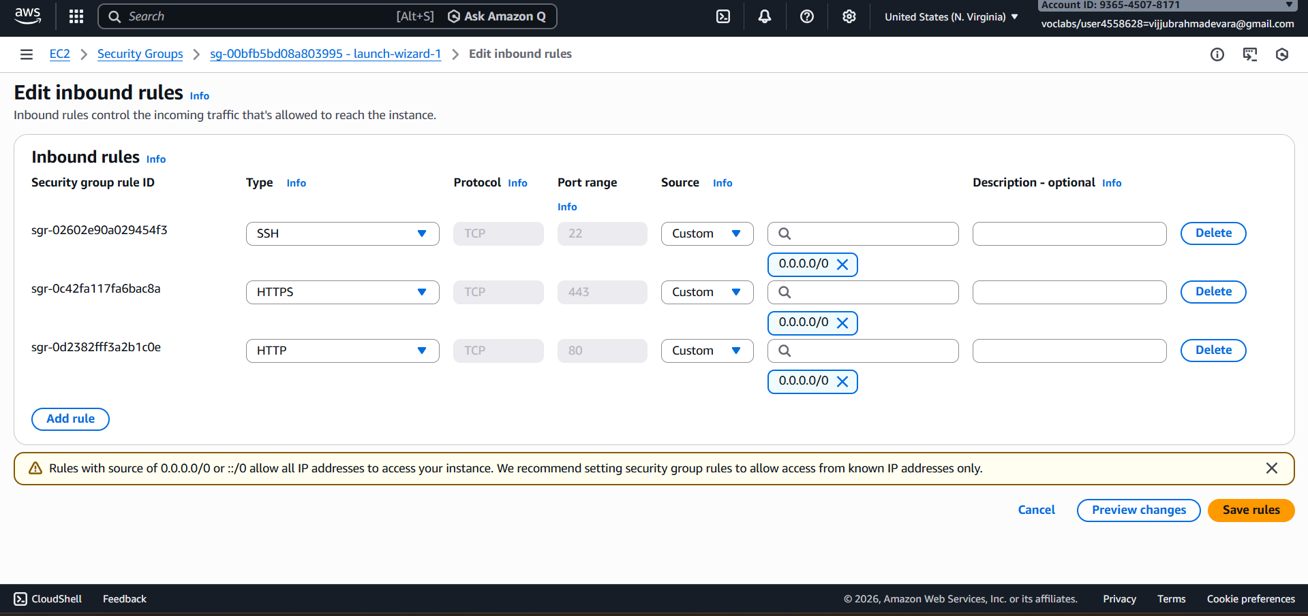

🔹 STEP 2: Open PuTTY
- Launch PuTTY
- In Session screen:
Host Name (or IP address): EC2—CONNECT—COPY (DNS NAME)
ubuntu@<PUBLIC-IP>
Example:
ubuntu@3.110.xxx.xxx
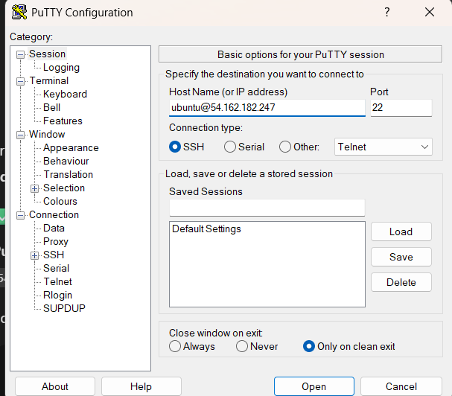

🔹 STEP 3: Attach the .ppk Key
In PuTTY left menu, go to:
Connection → SSH → Auth → Credentials
- Click Browse
- Select your .ppk file
- Click Open
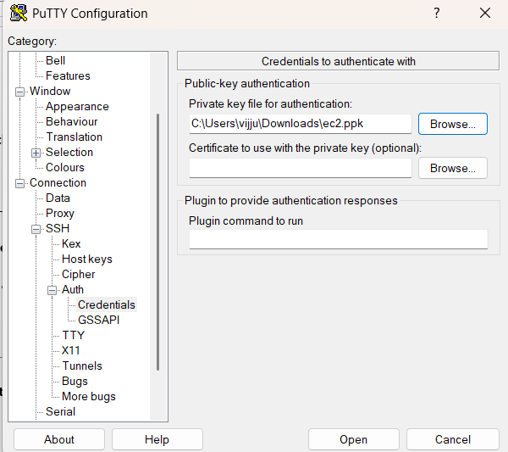

🔹 STEP 4: Connect to EC2
Click Open
- First time → click Yes (security alert)
- PuTTY will log in automatically as:
ubuntu
🎉 You are now connected to your Ubuntu EC2 instance

🧪 VERIFY CONNECTION
Run:
whoami
Output should be:
Ubuntu
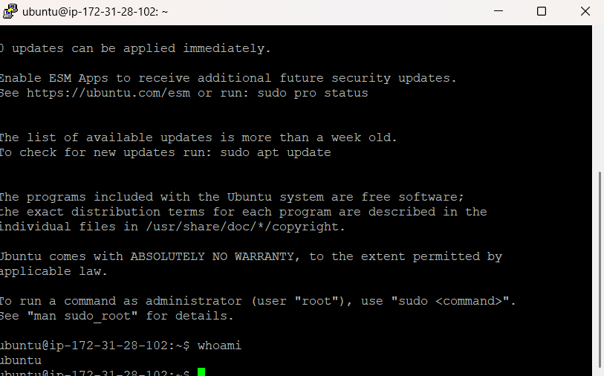

Connect EC2 Ubuntu Instance Using PuTTY (Windows) ---USING PEM KEYPAIR

PREREQUISITES
You must have:
- ✅ EC2 Ubuntu instance running
- ✅ Public IPv4 address (or Elastic IP)
- ✅ Key pair (.pem file) used while launching EC2
- ✅ PuTTY & PuTTYgen installed
👉 Download PuTTY:
https://www.putty.org
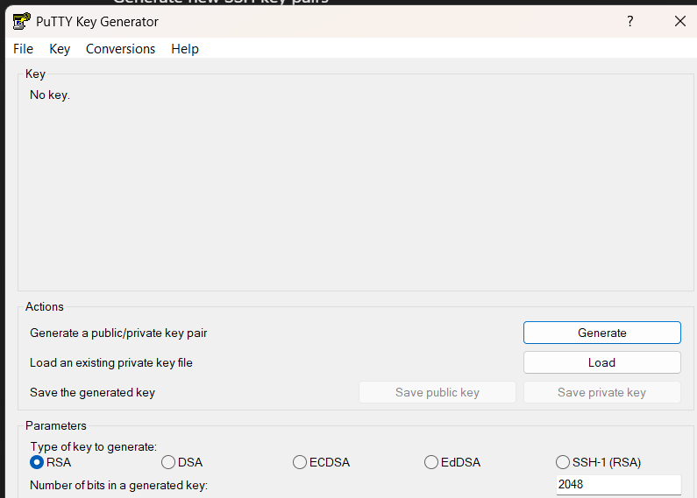

🔹 STEP 1: Convert .pem to .ppk using PuTTYgen
PuTTY cannot use .pem directly.
Steps:
- Open PuTTYgen
- Click Load
- Select your .pem file
(change file type to All Files)
- Click Open
- Click Save private key
- Save as keyname.ppk
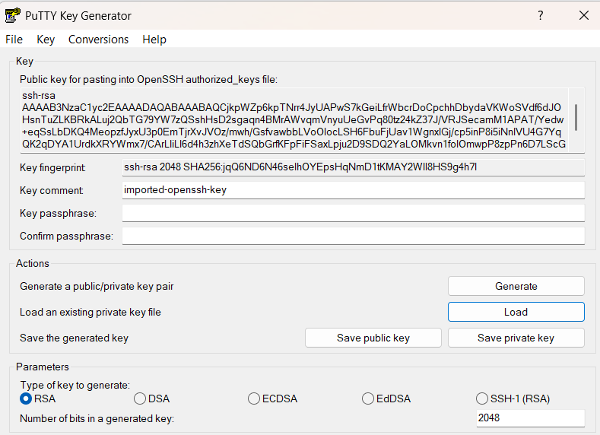
✔ Conversion done

🔹 STEP 2: Get EC2 Public IP
Go to:
AWS Console → EC2 → Instances---CONNECT –COPY DNS NAME

🔹 STEP 3: Configure PuTTY
1️⃣ Open PuTTY
Session:
- Host Name (or IP address): dns name

2️⃣ Load Private Key
Go to:
Connection → SSH → Auth → Credentials
- Click Browse
- Select your .ppk file
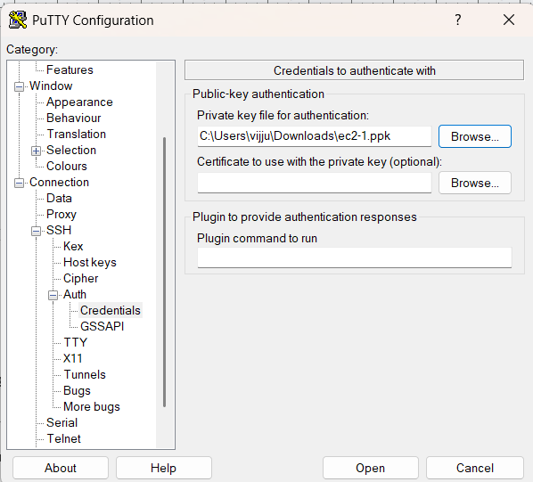

🔹 STEP 4: Connect
Click Open
- First time → click Yes (security alert)
- Login happens automatically as:
ubuntu
🎉 You are now connected to Ubuntu EC2

🧪 VERIFY CONNECTION
Run:
whoami
Output:
Ubuntu
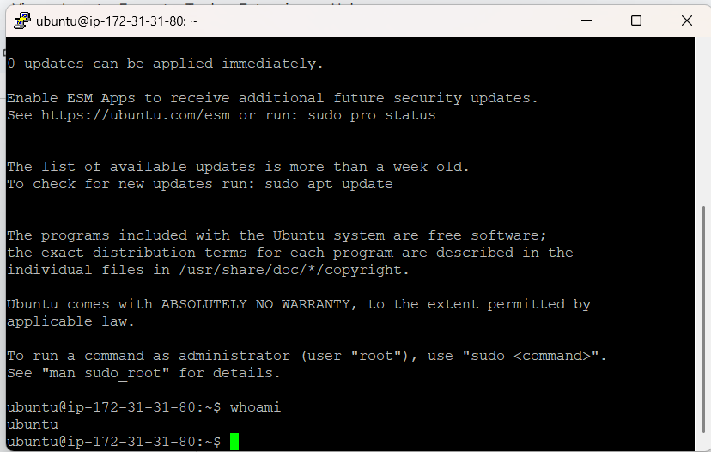

):

Connecting to EC2 Using AWS CloudShell
- Create the EC2 instance using a key pair (.pem).
- Log in to AWS Console and click on the CloudShell icon (terminal icon on the top-right).
- Once CloudShell opens, go to AWS Services → EC2.
- Select your EC2 instance and click Connect.
- Choose the SSH client tab.
- Copy the ssh -i command shown there.
- Paste the command in CloudShell and try to run it.
❌ It will fail with an error like:
“key pair is not available / no such file or directory”
(because the key file is not yet in CloudShell).
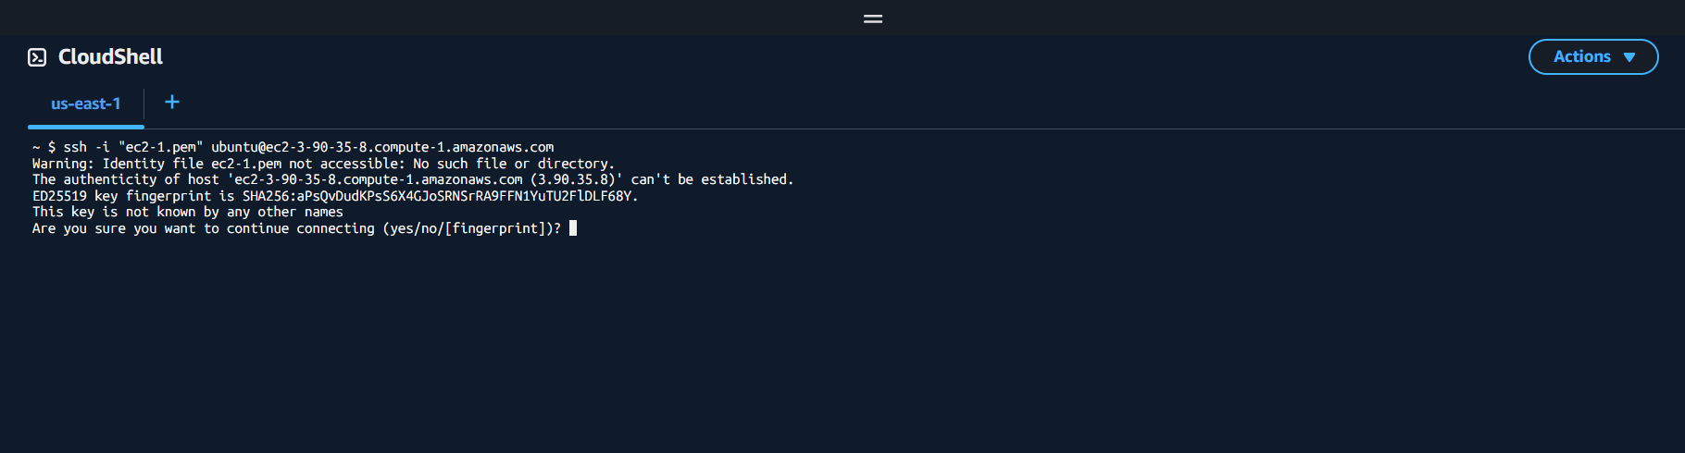
- Now, in CloudShell, click on the “+” (Actions) icon on the right side.
- Select Upload file and upload the key pair (.pem) from your local machine.
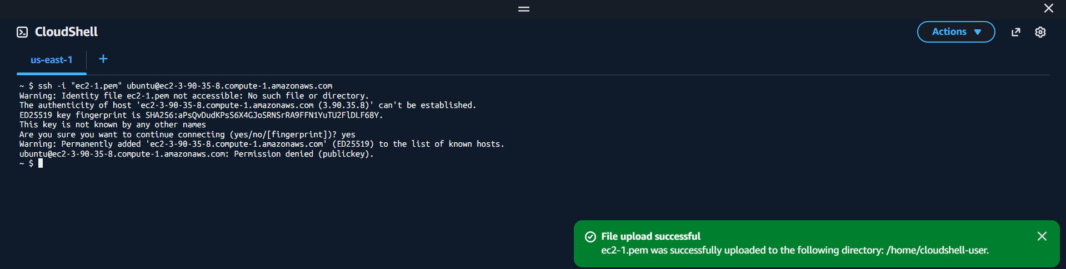
- After upload, copy the ssh -i command again from EC2 → Connect → SSH client.
Chmod 400 keyname.pem
- Paste and execute the command in CloudShell.
- ✅ You are now successfully connected to the EC2 instance.
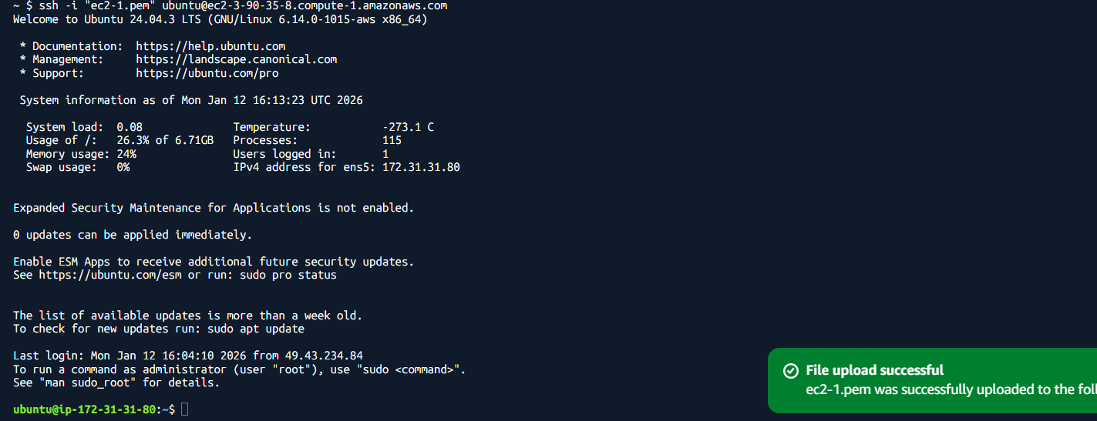

Step-by-Step: Create Windows EC2 Instance and Connect via RDP
Step 1: Launch a Windows EC2 Instance
- Log in to your AWS Management Console.
- Navigate to EC2 → Instances → Launch Instances.
- Select an Amazon Machine Image (AMI):
  - Choose a Windows Server AMI (e.g., Windows Server 2019 or 2022).
- Choose an Instance Type (e.g., t2.micro for free tier or as per your requirement).
- Configure Instance Details as needed.
- Add Storage if required (default is usually sufficient).
- Configure Security Group:
  - Ensure RDP port 3389 is allowed.
  - Source can be My IP (for security) or a wider range if needed.
- Select or create a new Key Pair:
  - Download the .pem file (keep it safe; it’s needed to decrypt the password).
- Click Launch Instance.
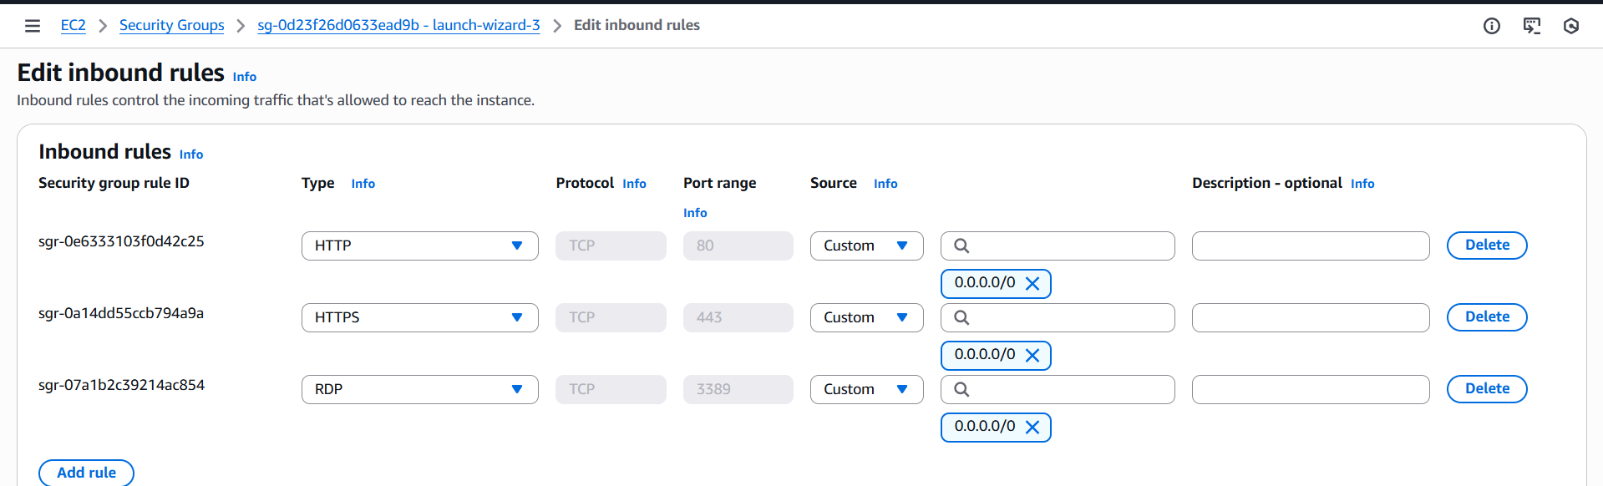

Step 2: Get the Public DNS / IP
- After the instance is running, go to EC2 → Instances.
- Select your instance and note the Public DNS (IPv4) or Public IP.

Step 3: Retrieve the Windows Administrator Password
- Select your instance → Click Connect → RDP Client.
- Click Get Password.
- Upload your Key Pair (.pem) file.
- Click Decrypt Password.
- Copy the Administrator password shown.
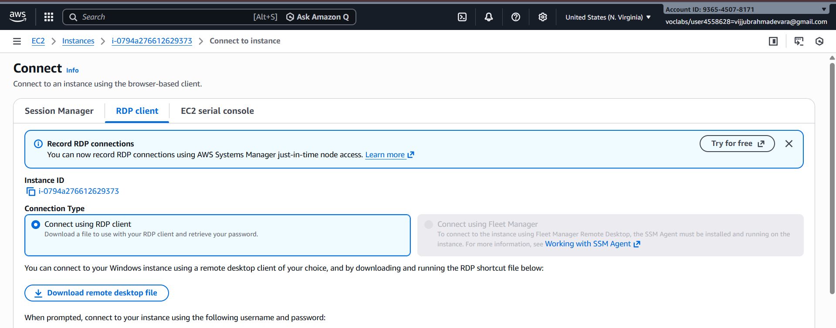
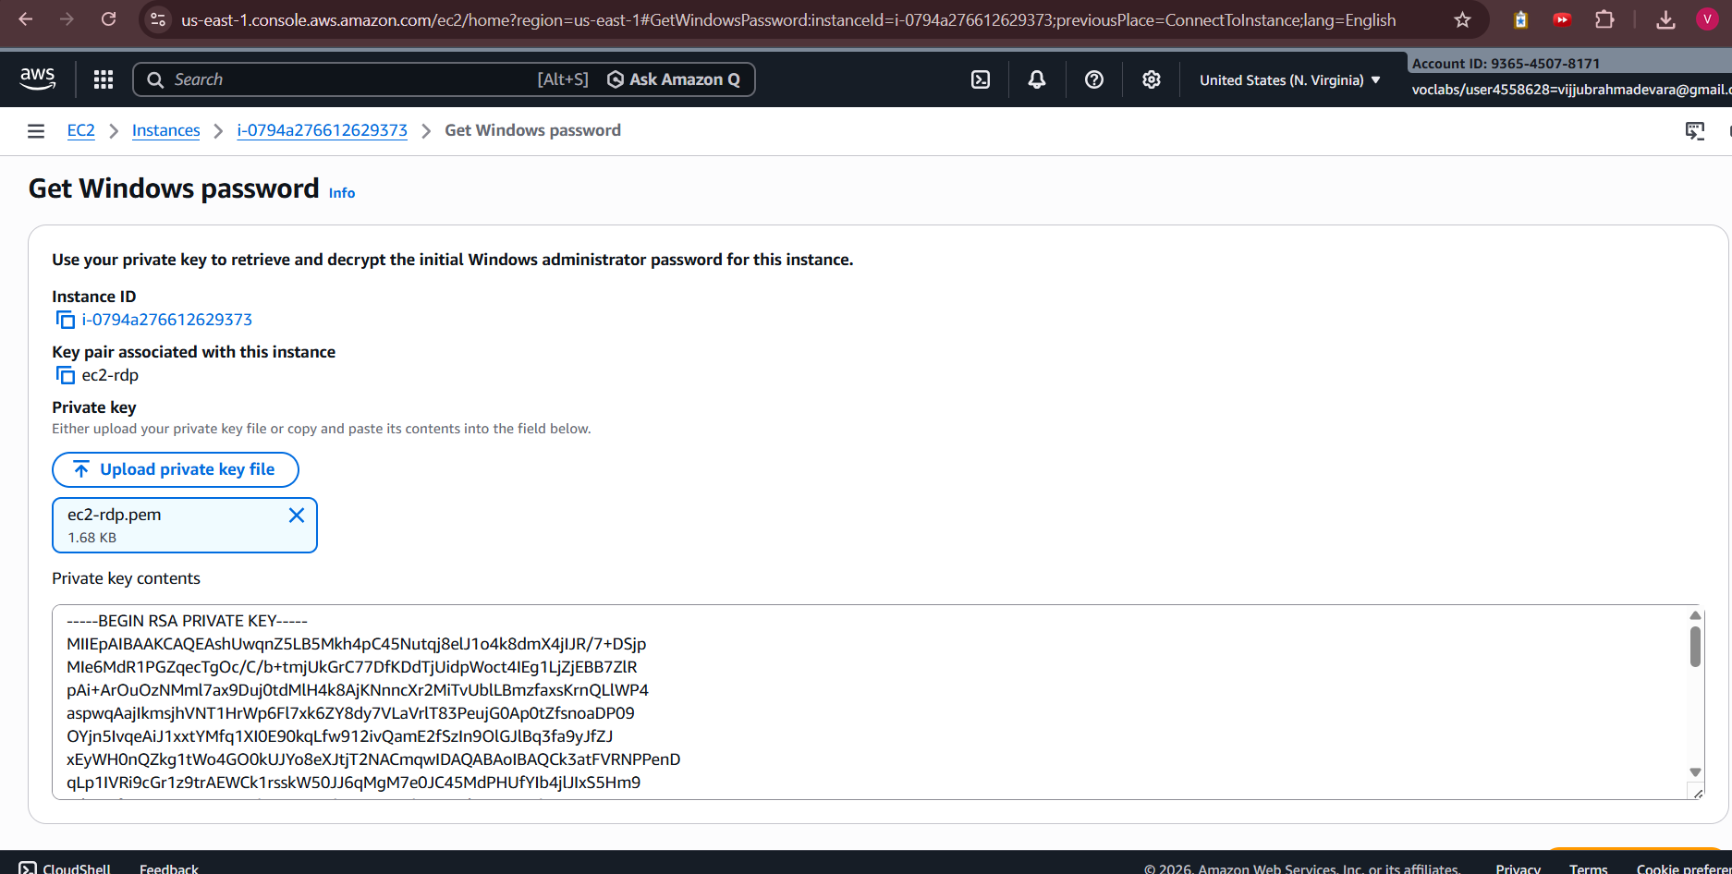

Step 4: Connect via RDP
- On your local Windows machine, open Remote Desktop Connection (mstsc).
- In the Computer field, enter the Public DNS or IP address of the EC2 instance.
- Click Connect.
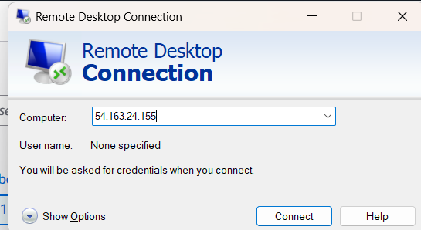
- In the login prompt:
  - Username: Administrator
  - Password: Paste the decrypted password from Step 3.
- Click OK.

Step 5: You’re connected
- Your Windows EC2 instance desktop should appear.
- You can now use it as a normal Windows machine.
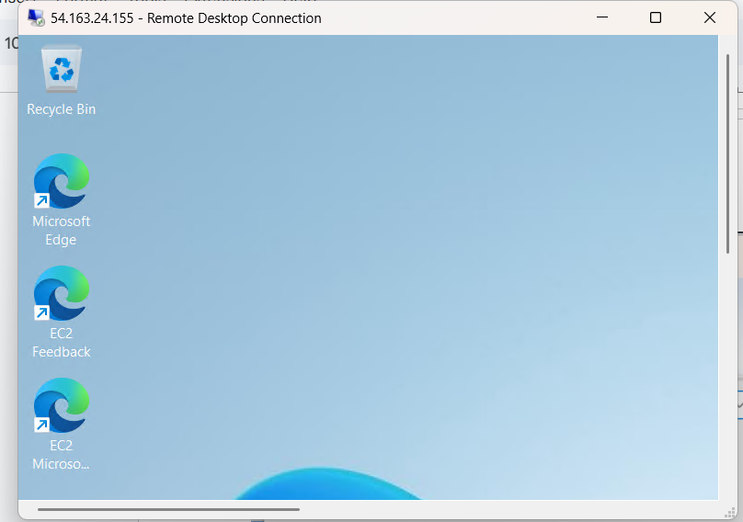

What is an AWS EC2 Instance?
An AWS EC2 instance is a virtual server in the cloud used to run applications.
It provides configurable computing resources such as CPU, memory, storage, and networking.
Users can launch, stop, resize, and terminate instances as needed and pay only for usage.

Key Components of EC2
The main components of EC2 include AMI, instance type, key pair, and security group.
AMI defines the operating system, while instance type decides CPU and RAM.
Key pairs enable secure login and security groups control network access.

How EC2 Works
EC2 works by launching a virtual machine on AWS data centers using a selected AMI.
AWS allocates hardware resources based on the chosen instance type.
Users connect to the instance using SSH or RDP to run applications.

Uses of EC2
EC2 is used for hosting websites and web applications.
It is widely used for development, testing, and academic projects.
EC2 also supports data processing, backend servers, and enterprise applications.

Advantages of EC2
EC2 is highly scalable and flexible according to user needs.
It is cost-effective because users pay only for what they use.
EC2 provides high security, reliability, and integration with other AWS services.

Examples of EC2
A student can use EC2 to practice Linux or deploy a project.
A company can host its website or backend services on EC2.
An e-commerce site can scale EC2 instances during high traffic periods.

