Elastic File Storage
Amazon Elastic File System (EFS) is a scalable and fully managed file storage service provided by Amazon Web Services (AWS). It allows you to create and configure file systems that can be accessed concurrently from multiple EC2 instances, providing a highly available and scalable storage solution for your applications and workloads.
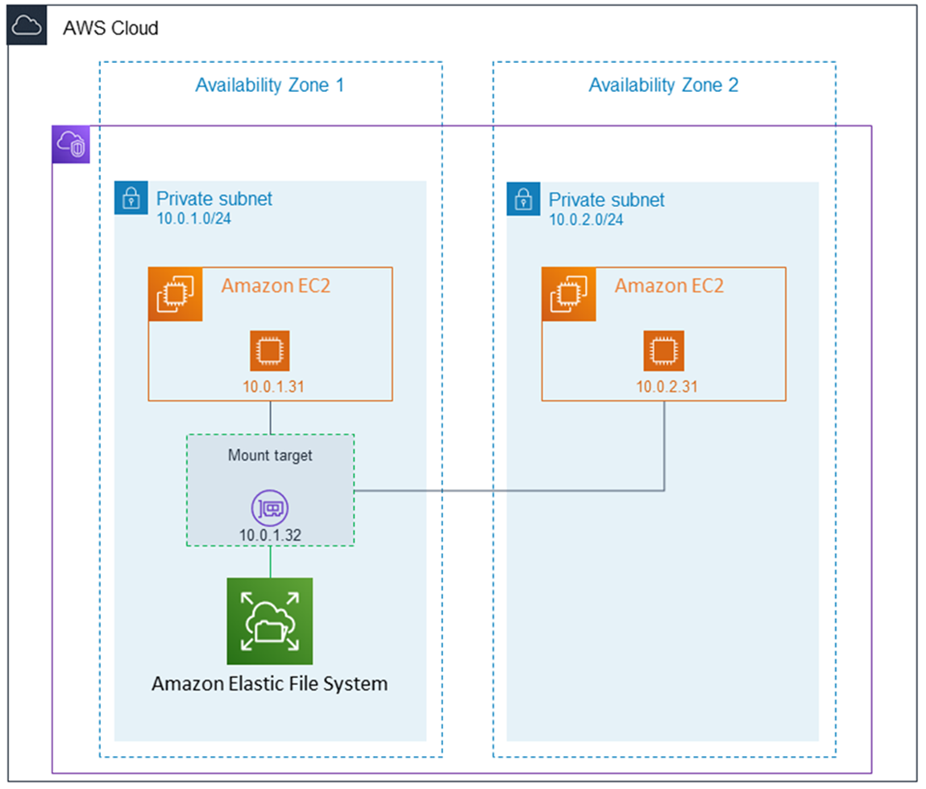
Amazon EFS supports for only Amazon Linux instance:
Step 1: Launching EC2 Instances
1. Sign in to AWS Management Console.
2. Go to the EC2 dashboard.
3. Click on "Launch Instance".
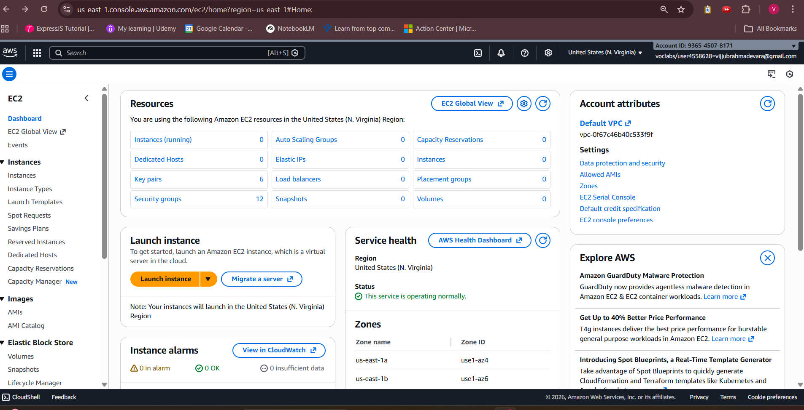
4. Configure instance details:
- Instance Name: EFS-1
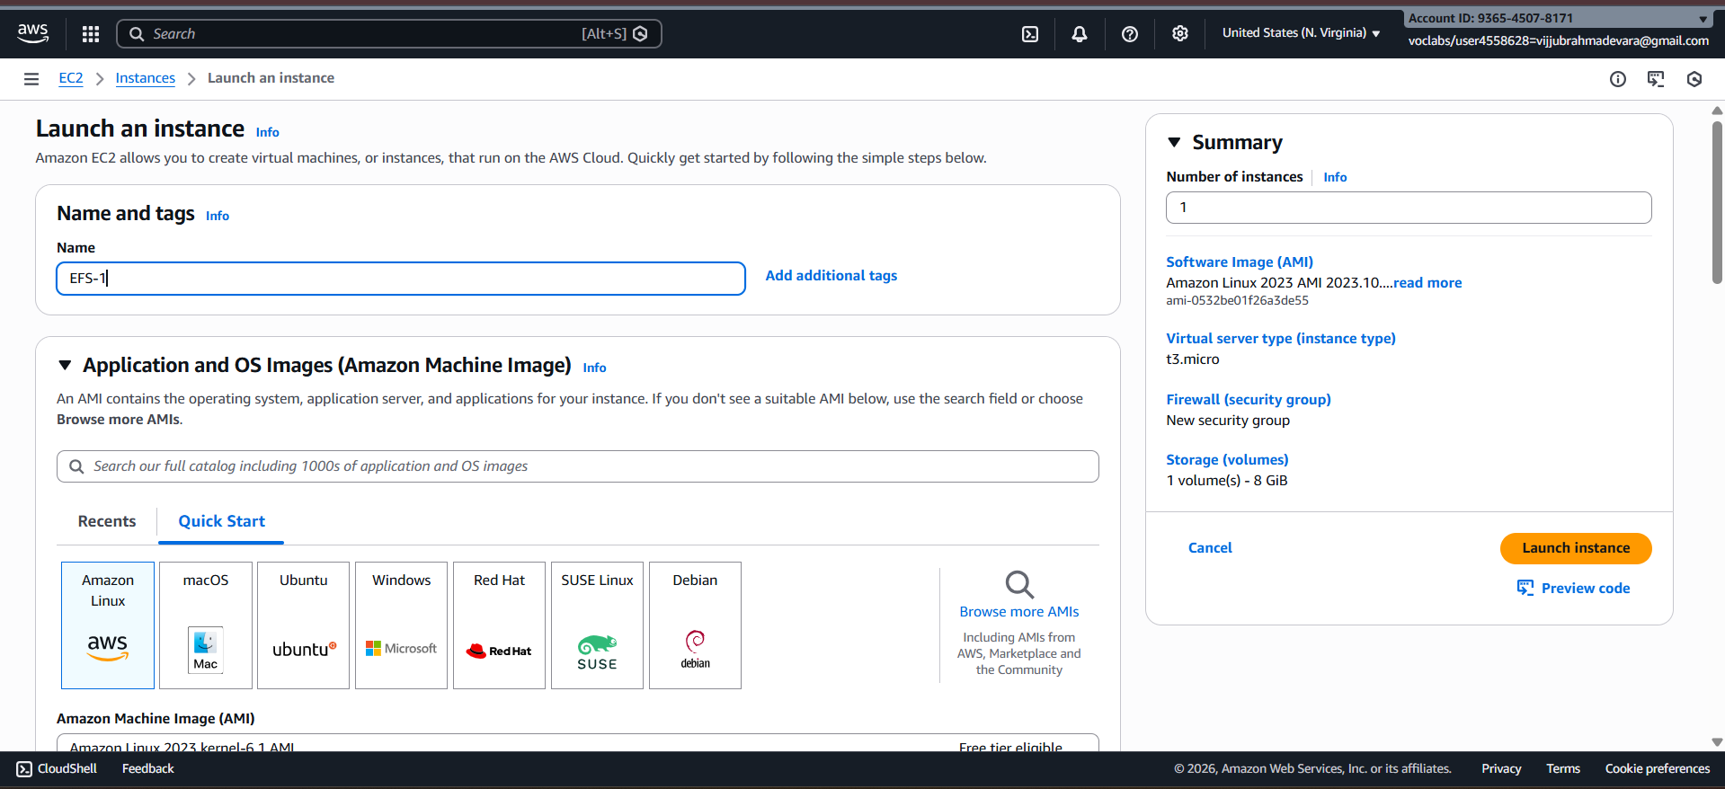
5. Choose an Amazon Machine Image (AMI) for Linux.
6. Select instance type: t2.micro.
- Key Pair: EFS
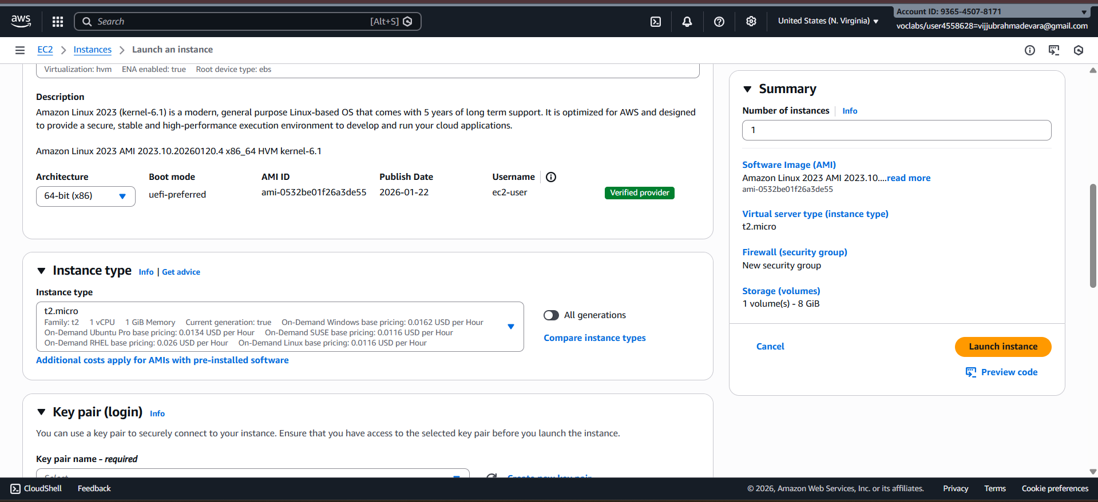
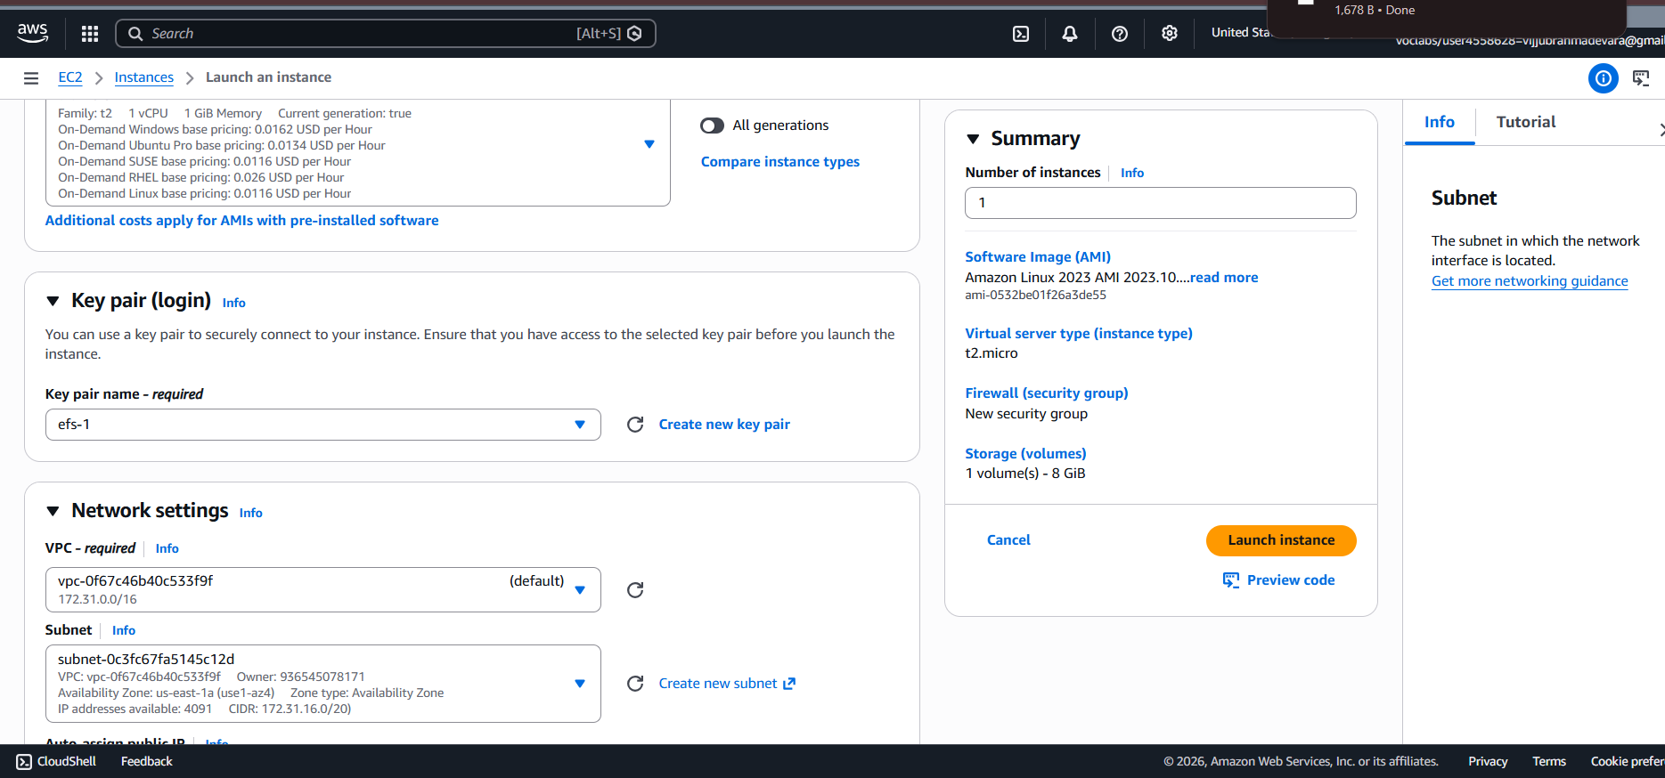
- Network: Choose Subnet-1a
- Security Group: Create a new security group (SG) and add NFS and allow from anywhere.
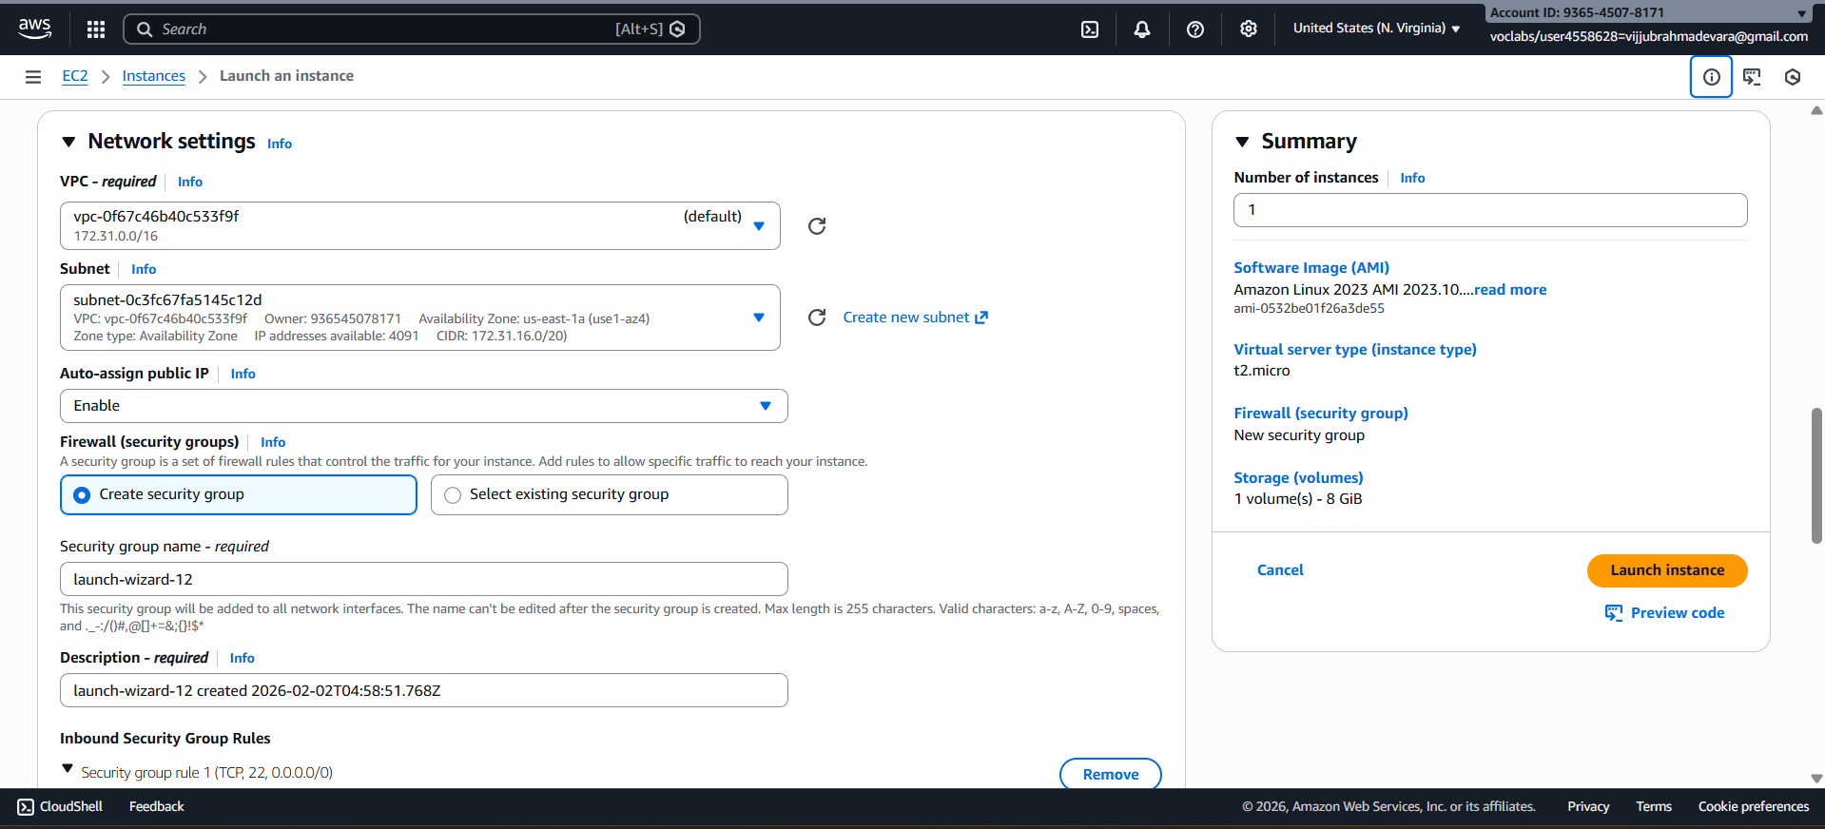
7. Launch the instance.
8. Repeat the above steps to launch another instance named EFS-2 in Subnet-1b with the same configuration.
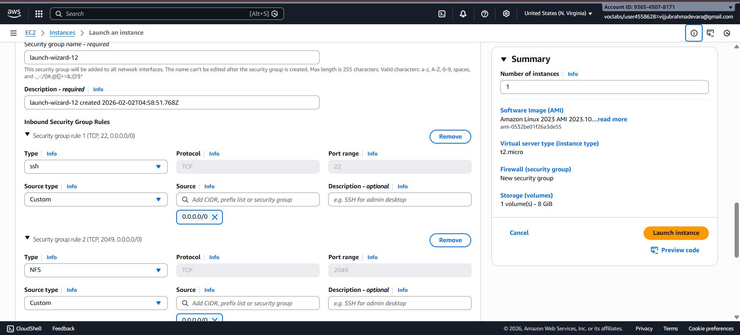
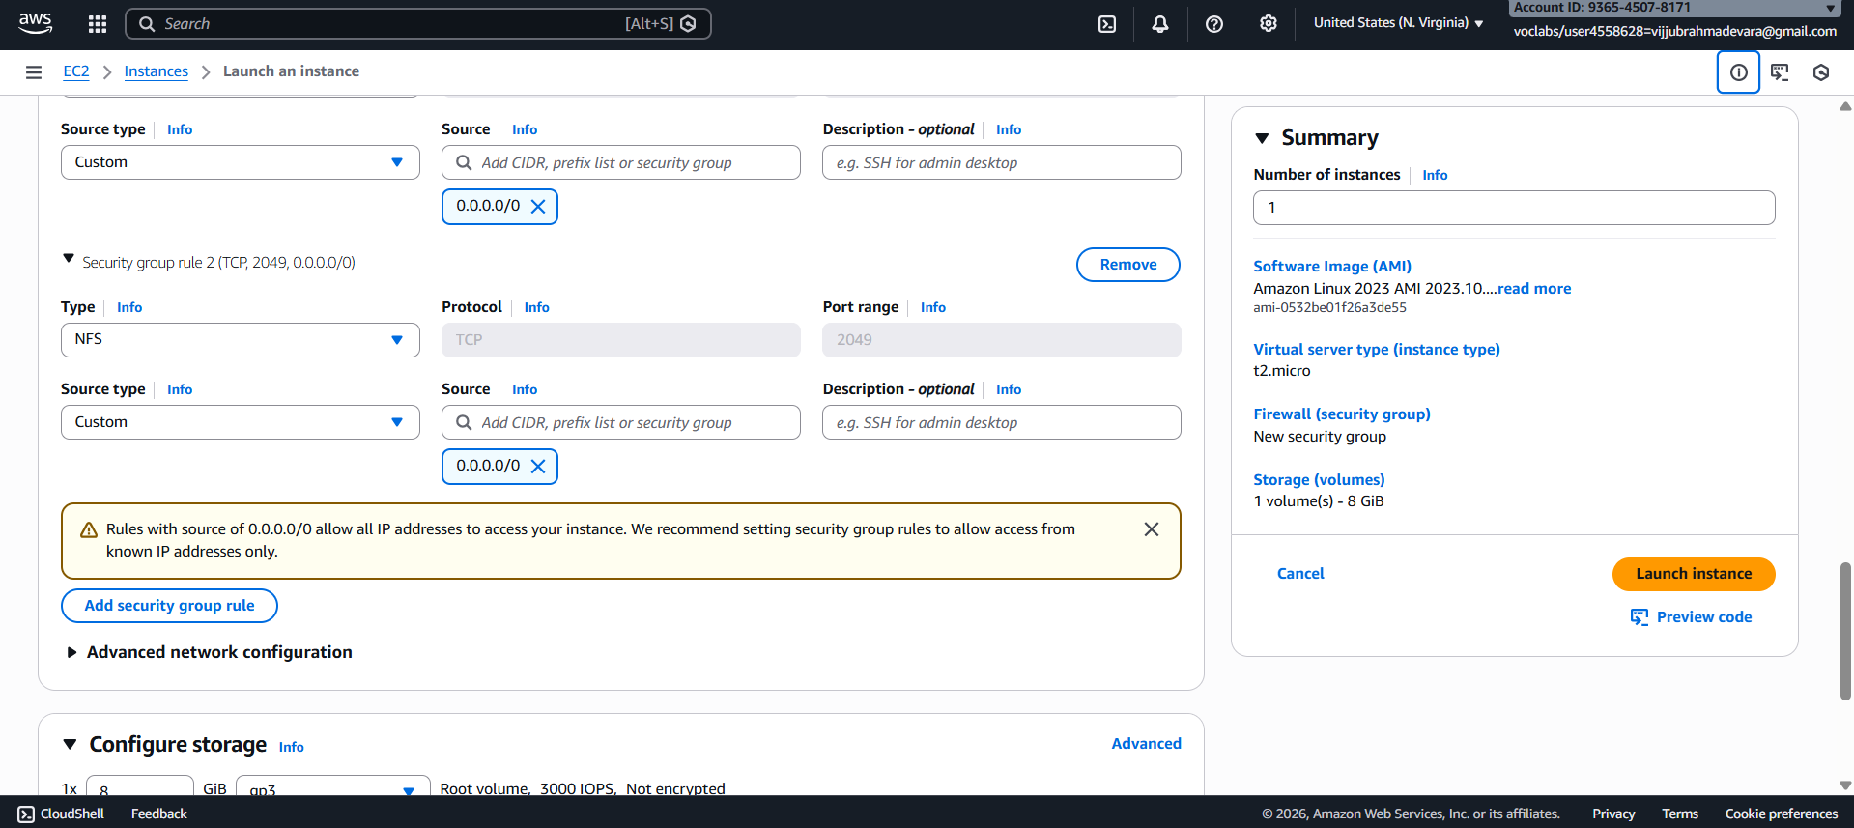
Step 2: Creating an EFS File System
1. Go to the EFS service in the AWS Management Console.
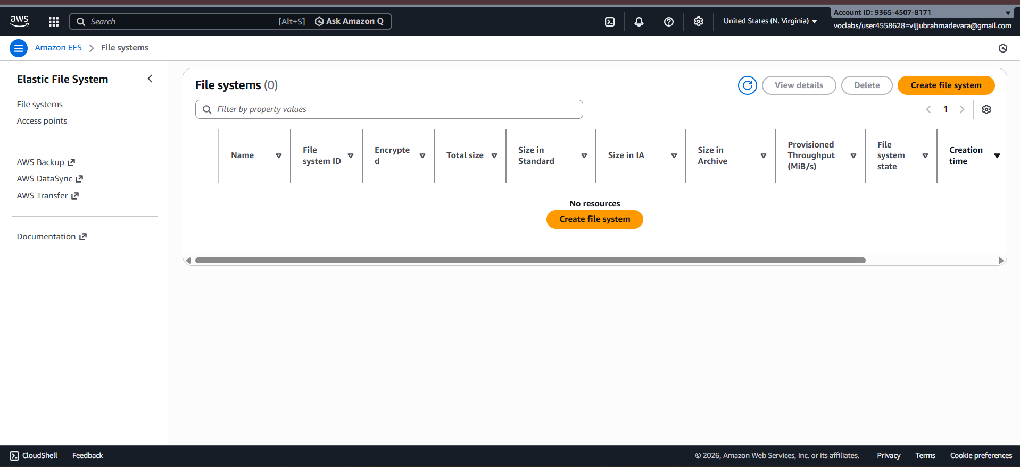
2. Click on "Create file system".
3. Specify details:
- Name: Optional
- VPC: Default
- Enable region button.
Click on "Next".
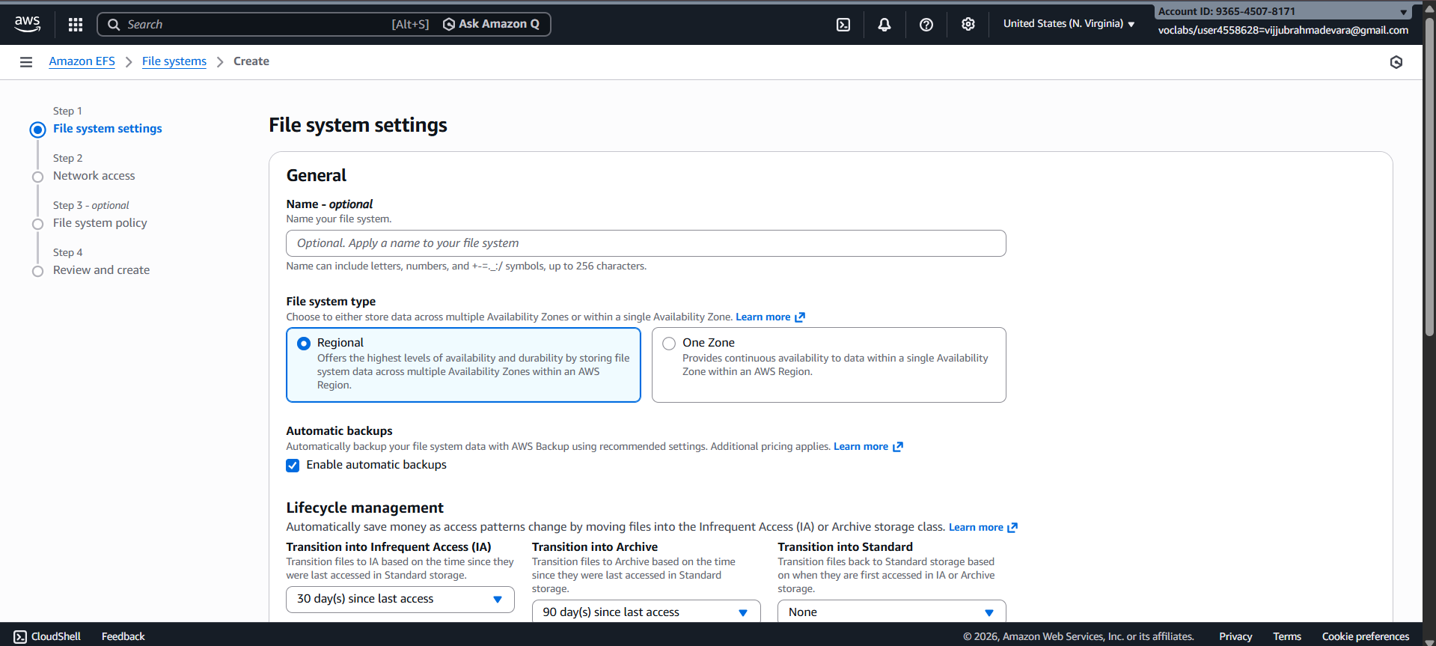
4. In the Network settings:
- Delete all security groups.
- Select the newly created security group (NFS).---which is created while creating instance
Click on "Next" and review the configuration.
Click on "Create file system".
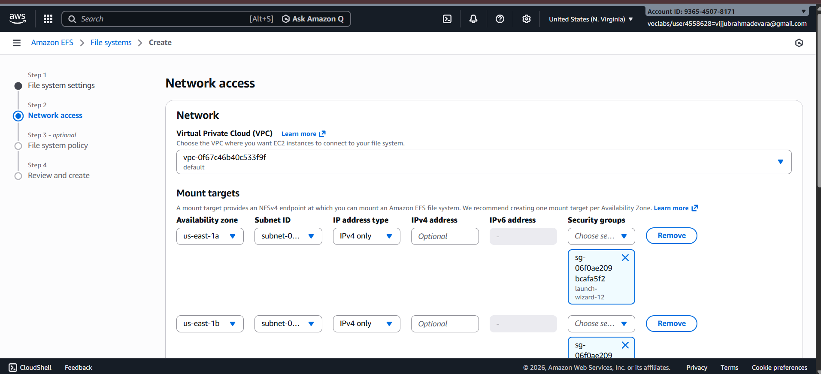
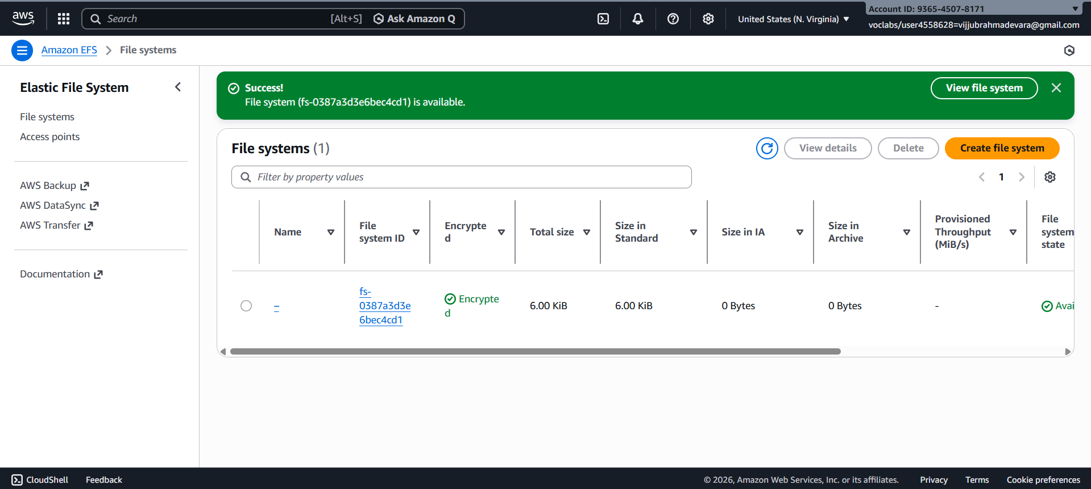

Step 3: Accessing the two EC2 instances named EFS-1 & EFS -2 in two different PowerShell sessions and performing the specified tasks:
Accessing EFS-1 Instances in Two Different PowerShell Sessions:
1. Open Two PowerShell Sessions:
- Open two separate PowerShell windows or tabs on your local machine.
For each Instance:
2. SSH into the Instance:
- Use the SSH command to connect to the EFS-1 instance
ssh -i [path-to-your-keypair.pem] ec2-user@[instance-public-ip]
3. Switch to Root User:
- Gain root access by executing the following command:
sudo su
4. Create a Directory:
- Make a directory named "efs" using the following command:
mkdir efs
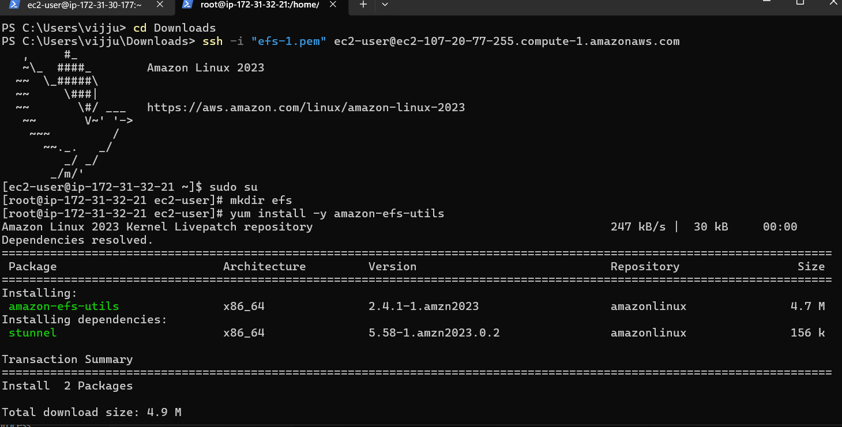
5. Install Amazon EFS Utilities:
- Use yum package manager to install the Amazon EFS utilities:
yum install -y amazon-efs-utils
6. List Files:
- Execute the following command to list files in the current directory:
Ls
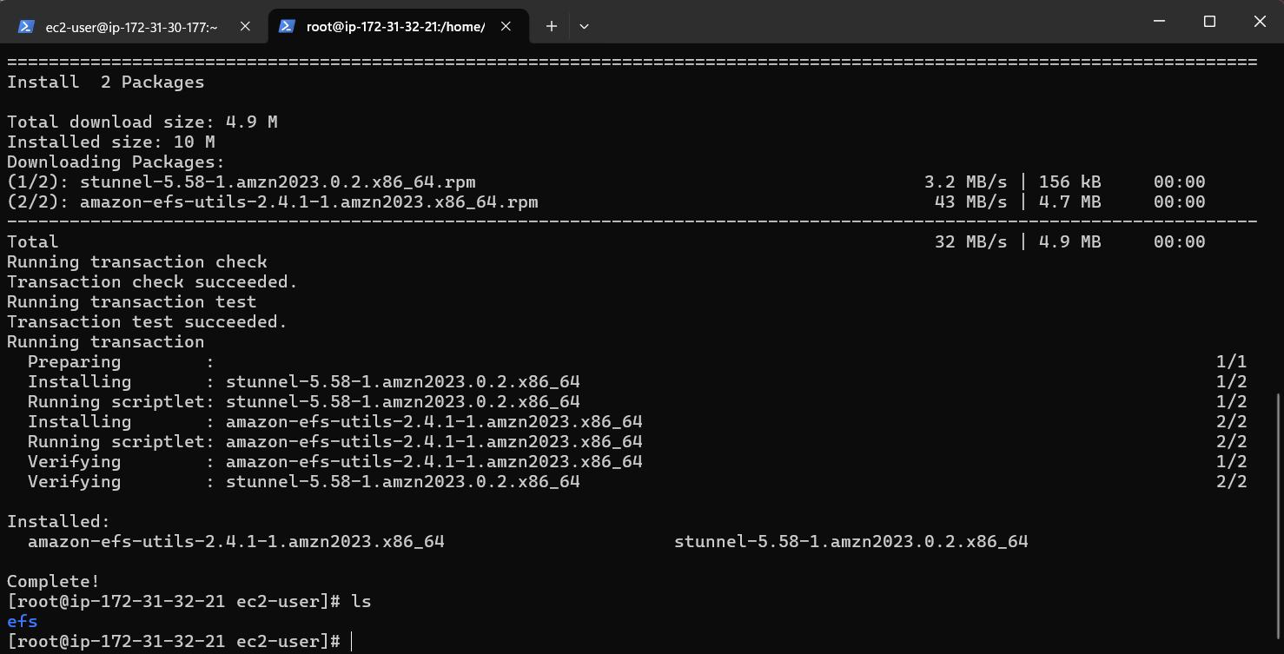
7. Verify Installation (Optional):
- Optionally, you can verify the installation of the Amazon EFS utilities by checking the version:
efs-utils --version
Repeat Steps 2-7 for ------------------------- EFS-2 Instance.
By following these steps, you'll have accessed each EFS-1 instance in separate PowerShell sessions, switched to the root user, created a directory named "efs," installed the Amazon EFS utilities, and listed files in the directory. This setup allows you to configure and manage each instance individually as needed.
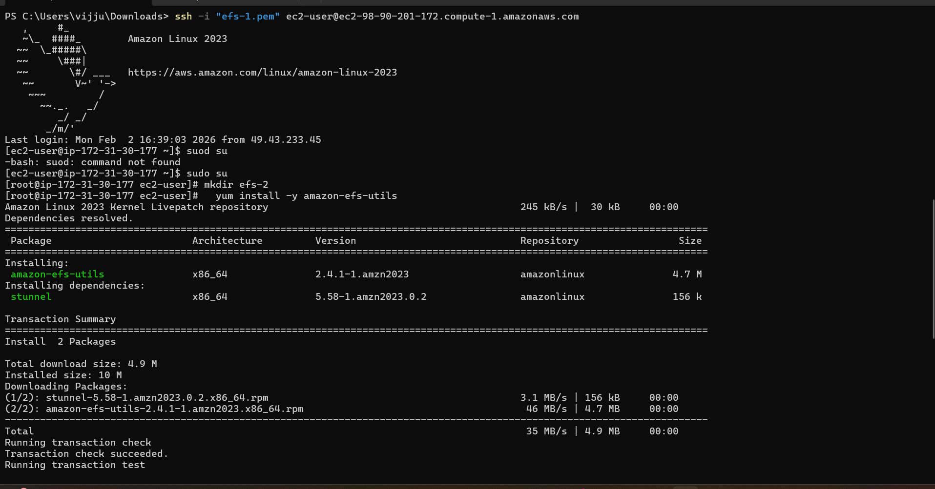
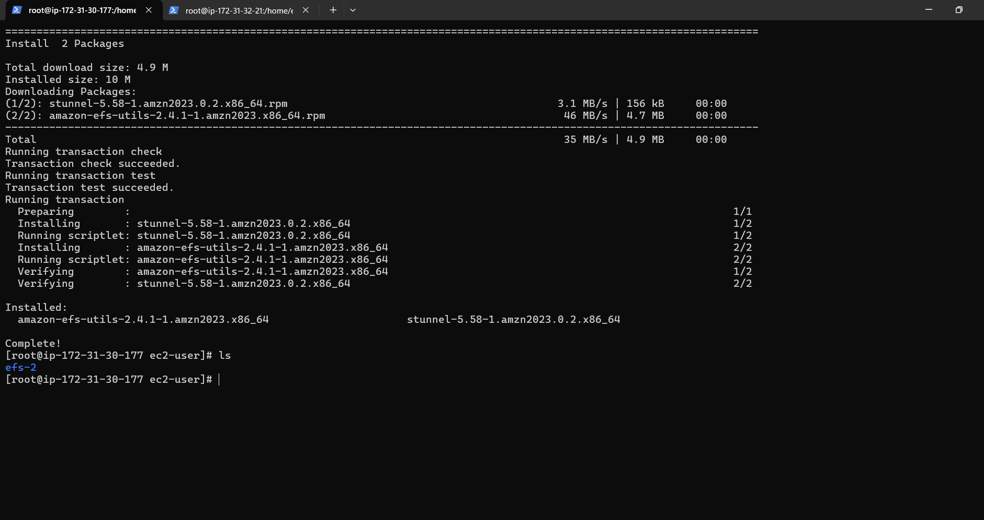
Step 4: Attaching EFS to EC2 Instances
1. Go to the EFS service in the AWS Management Console.
2. Click on the target EFS file system.
3. Click on the "Attach" button.
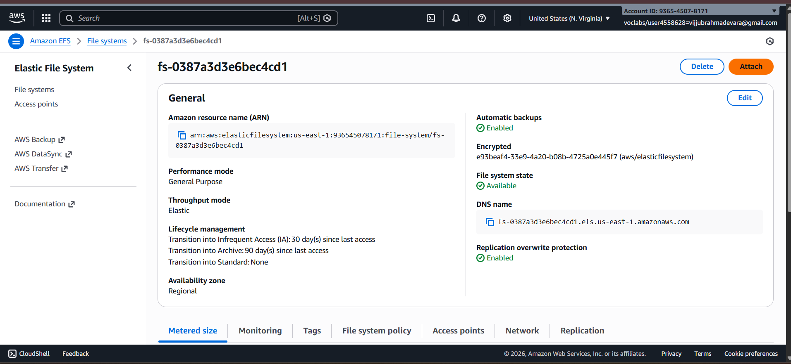
4. Choose "Mount via DNS" option.
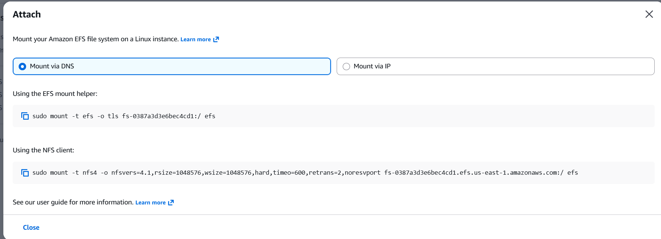
5. Copy the displayed command. ,on both ec2 instances(powershell)
6. Paste and execute the copied command in the terminal to mount the EFS file system onto the instance.
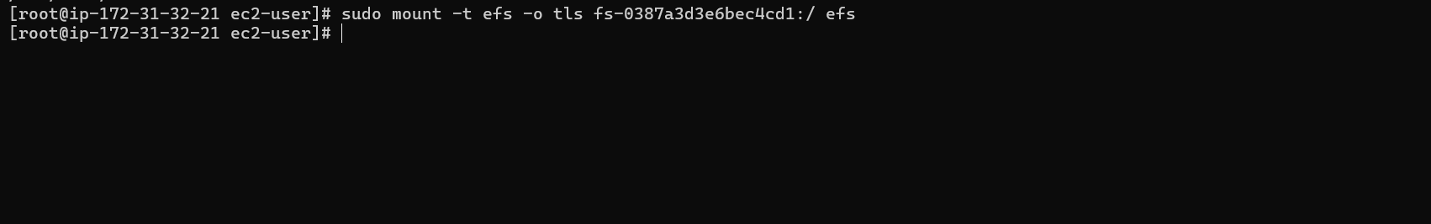
Step 5: Verify and Test EFS
1. Change the directory to EFS on both instances.
2. Create a file on one instance.
3. Verify that the file automatically synchronizes and appears on the other instance.
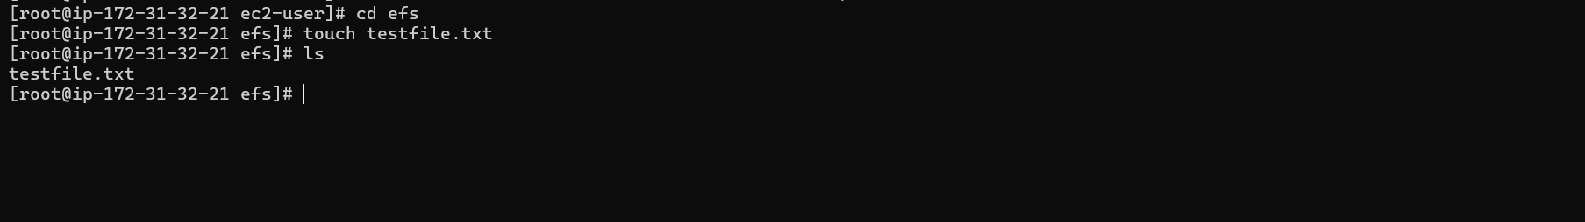
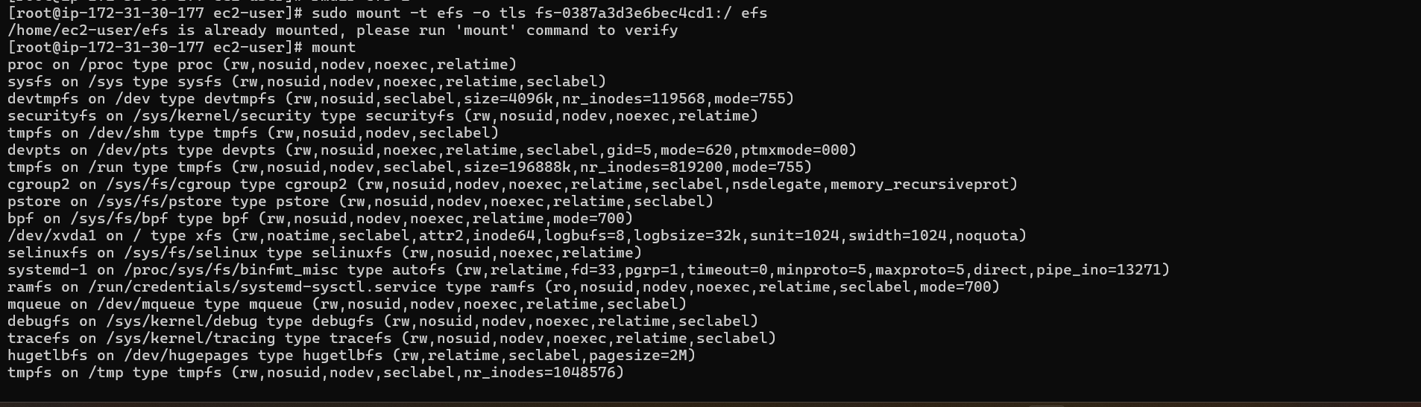
By above steps, we can successfully create EC2 instances, configured them, created an EFS file system, and attached it to the instances in the same availability zone in the Mumbai region. Now, the instances can seamlessly access and share files stored in the EFS file system.

VIVA
1. Multiple EC2 instances across different Availability Zones must read and write the same files at the same time. Which AWS storage service fits this requirement and why?
Amazon Elastic File System (EFS) is the correct service because it is a regional, shared file system that allows multiple EC2 instances across Availability Zones to simultaneously read and write data using the NFS protocol.
2. An application running on EC2 in three different AZs needs a shared file system with low operational overhead. How would EFS support this setup?
EFS automatically creates mount targets in each Availability Zone and manages scaling, replication, and availability, allowing EC2 instances in all AZs to access the same data without manual administration.
3. You mounted an EFS file system on one EC2 instance. Can another EC2 instance modify the same file simultaneously? What happens in such a scenario?
Yes, EFS supports concurrent access from multiple EC2 instances. File locking and consistency are handled by the NFS protocol to prevent data corruption.
4. Your team tried to attach an EFS file system to an EC2 instance, but the mount command timed out. What networking components would you check first?
You should verify that EFS mount targets exist in the instance’s Availability Zone and ensure the security group allows inbound NFS traffic on port 2049.
5. An EC2 instance in a private subnet is unable to mount EFS. What configuration might be missing at the subnet or VPC level?
The private subnet may lack proper routing to the EFS mount target or the security group may not allow NFS traffic within the VPC.
6. You created an EFS file system but forgot to create mount targets in all AZs. How will this affect EC2 instances in those AZs?
EC2 instances in Availability Zones without mount targets will be unable to mount the EFS file system, causing mount failures or timeouts.
7. Why does EFS require mount targets in each Availability Zone, and what happens if one AZ goes down?
Mount targets provide local network endpoints for EC2 instances in each AZ. If one AZ fails, instances in other AZs continue accessing EFS normally.
8. Two applications in different subnets need access to the same EFS file system. How should the EFS networking and security groups be configured?
Both subnets must be in the same VPC, and the EFS mount targets and EC2 instances should share a security group that allows NFS traffic on port 2049.
9. Your security team wants only specific EC2 instances to access EFS. How can security groups be used to enforce this?
The EFS security group can restrict inbound NFS access to only the security groups attached to authorized EC2 instances.
10. While mounting EFS, the command specifies -t nfs4. Why does EFS use NFS, and what advantage does it provide?
EFS uses the NFS protocol because it supports shared, concurrent file access and POSIX file permissions across multiple EC2 instances.
11. An organization wants to migrate from EBS to EFS because multiple EC2 instances need concurrent access to data. What limitation of EBS is driving this decision?
EBS volumes can be attached to only one EC2 instance at a time, whereas EFS supports simultaneous access from multiple instances.
12. An application team complains about increased latency when accessing EFS from EC2. What factors related to networking or AZ placement should be considered?
Latency can increase if EC2 instances access EFS across Availability Zones or if network congestion and security group misconfigurations exist.
13. Can an EFS file system be accessed from EC2 instances in different VPCs? If yes, what networking setup is required?
Yes, EFS can be accessed across VPCs using VPC peering or AWS Transit Gateway, along with proper routing and security group rules.

