**Network Performance Evaluation of M2M With Self Organising Cluster Head to Sink Mapping**

**A mid-semester Major report**

***Submitted by:***

**Vishal Pandey 15/ICS/076**

**Shweta Rani 15/ICS/051**

**Shivani 15/ICS/043**

***Supervised by:***

**Ms. Deepshikha Lodhi**



**SCHOOL OF INFORMATION AND COMMUNICATION TECHNOLOGY**

**GAUTAM BUDDHA UNIVERSITY, GAUTAM BUDDHA NAGAR,**

**GREATER NOIDA**

**UTTAR PRADESH-201308**

**CERTIFICATE**

This is to certify that the project titled “**Network Performance Evaluation of M2M With Self Organising Cluster Head to Sink Mapping**” is the bonafide work carried out by **Shivani Singh (15/ICS/046)**, **Shweta Rani (15/ICS/051)** and **Vishal Pandey (15/ICS/076)**, students of B.Tech + M.Tech (Dual Degree) (AIR) of Gautam Buddha University, Gautam Buddha Nagar, Greater NOIDA, Uttar Pradesh (India) during the academic year 2018-19 in partial fulfillment of the requirements for the award of the degree of Master of Technology (Artificial Intelligence and Robotics) and that the project has not formed the basis for the award previously of any other degree, diploma, fellowship or any other similar title.

**Place: GBU Greater Noida Signature of Supervisor**

**Date: 28 March 2019 (Dr. Vidushi Sharma)**

**ABSTRACT**

Machine to machine communication is defined as direct communication between devices using any communication channel that can be wired or wireless. M2M supports an energy-efficient routing protocol to transmit data from cluster member (nodes) to a sink node along cluster heads in Wireless Sensor Network(WSN). Due to heavy M2M traffic network congestion can occur which is checked using load balancing solutions so that network performance can be maintained. Here we have used a Multilevel Clustering Multiple Sinks(MLCMS) with IPV6 protocol over Low Wireless Personal Area Networks(6LoWPAN) and an intensified network performance is accomplished through non-linear based optimization. Self-Organising Cluster Head to Sink Algorithm (SOCHSA) is proposed, with the help of Discrete Particle Swarm Optimisation(DPSO) and Genetic Algorithm (GA) as Evolutionary Algorithms(EAs) to solve the network optimization problem. Here SOCHSA is tested on the basis of two criteria problems with two and three sinks. While performing with 2 sinks the average residual energy was less than as compared to three sinks were used ie about 2%. So Genetic Algorithm is used to solve the network optimisation problem.

**ACKNOWLEDGMENTS**

I take this opportunity to express a deep sense of gratitude towards my guide **Dr. Vidushi Sharma**, for providing excellent guidance, encouragement and inspiration throughout the project work. Without her invaluable guidance, this work would never have been a successful one. I would also like to thank all my classmates for their valuable suggestions and helpful discussions.

**Shivani Singh (15/ICS/046)**

**Shweta Rani (15/ICS/051)**

**Vishal Pandey (15/ICS/076)**

**TABLE OF CONTENT**

Certificate 1

Abstract 2

Acknowledgement 3

1. Introduction 5
2. Problem Idea 6
3. Previous Work 7
4. System Architecture 8
   1. Transmission Range Formulas
   2. Cluster Head Selection
   3. Residual Energy :- Remaining Energy / Initial Energy
5. Work Done Till Now 11
   1. Platforms Used
   2. Library Description
6. Work To Be Done 11
7. List of Figures 12
8. List of Abbreviations 17
9. List of Tables 18
10. References 19
11. **INTRODUCTION**

Iot has the ability to transfer data over a network without requiring human-to-human or human-to-computer interaction. Iot consist of millions of devices for that transmitting and receiving. M2M is considered as the core of Iot. Machine to machine is used for direct communication between devices using any communication channel that can be wired or wireless.

Key features of M2M include:

1. Low mobility
2. Packet switching
3. Time controlled data transmission
4. Monitoring events of interest
5. Low power consumption

In WSN, multiple sinks at correct locations can sharply decrease the energy use and the message transfer delay in communication. Moreover, a multiple-sink WSN has much less tendency for sink node isolation .But if there is only a single sink then heavy traffic load and packet loss can take place . The nodes present in the network should be near to the sink so that less power consumption can take place. If network load situations occurs then it can have a bad impact on network performance as a result effective load balancing algorithm is used over here.Through load balancing algorithm the load can fairly and evenly distributed among resources available. The algorithms where the nodes are arranged in clusters in the network for data transmission are termed as cluster-based methods.

The aim of the project is to improve network performance by integrating an efficient routing protocol (MLCMS) and a load balancing strategy to introduce new transmission techniques while maintaining a more balanced system.

MLCMS is responsible for transmission of multiple sinks and is used for selection of cluster head which could be beneficial for network enhancement. The load balancer obtains optimum CH-Sink reconfiguration via an algorithm called SOCHSA. Once the load on any sink reaches an alarming threshold, the load balancer triggers SOCHSA algorithm. SOCHSA algorithm hosts two evolutionary algorithms i.e. GA and DPSO to solve the load balancing optimisation problem. A sharing node with unlimited energy is also deployed in this model so the it can enable every CH with the ability of flexible transmission to any sink based on the CH-Sink configuration.

**2. PROBLEM IDEA**

The aim of the project is to improve network performance by integrating an efficient routing protocol (MLCMS) and a load balancing strategy to introduce new transmission techniques while maintaining a more balanced system. SOCHSA algorithm is used to obtain optimum CH-Sink reconfiguration.

**3. PREVIOUS WORK**

To enhance the performance of WSN clustering techniques have been widely researched. The energy balanced unequal clustering protocol (EBUC) is a centralized clustering protocol, with which the creators aimed to surmount the hot-spot problem through creation of unequal cluster by deploying centralised PSO algorithm at the base station (BS). The clusters are created so that those close to the BS have fewer nodes, which thus increases cluster numbers in its proximity.

Regarding cluster-cluster communication, a greedy algorithm is deployed to choose a relay node according to its distance from the BS and residual energy. A centralised clustering protocol, which involves energy-aware clustering for WSNs implementing a PSO algorithm (PSO-C) at the BS.

The available node energy and the distances between the CHs are considered in this protocol. An objective function that is aimed at minimising the maximum average Euclidean distance of the nodes to their linked CHs, as well as the ratio of the aggregated starting energy of the nodes to the total energy of those CHs that are candidates, is defined. Also, the protocol warrants those nodes with enough energy can be chosen to be CHs. LEACH and LEACH-C about the network lifetime and the throughput are both outperformed by PSO-C.

Moreover, has demonstrated that regarding convergence time, network lifetime and data delivery, this algorithm also surpasses GA and K-means-based clustering protocols regarding performance. An earlier protocol based on GA aimed at selecting CHs so as to minimise the total network distance can be found in. The objective function is the minimisation of the aggregate distance between the cluster members and their allocated CHs along with the distance of the latter to the BS. As with PSO-C, it too warrants nodes having sufficient energy can be chosen as CHs.

**4. SYSTEM ARCHITECTURE**

Consider a network in which a sensing field is logically divided into N sections depending on the number sinks to be used. If there are two sinks the sensing field is divided into four sections, if there are 3 sinks the sensing field is divided into six sections. Each section consist of 3 levels. Each CH consist of a sink and nodes around it.

The sensing field size is assumed to be NxN.

For the demonstration in this project we have used 2 sink.

The proposed network model contains the following elements.

1. **Nodes**

There are no. of nodes distributed randomly in the sensing field. The nodes present in the sensing field can be selected as a normal node or it can act as cluster.

1. **Centralized Server**

Server is responsible for collecting the network information like network topology, the number of CHs, Sink-CH configuration and number of active nodes so that it can identify optimum Sink-CH configuration to increase the network performance. The server also hosts intelligent algorithm to identify optimum CH-Sink configuration, which buzzes when the load on the sinks reaches above a threshold.

1. **Sharing sensor node**

The sharing sensor nodes are used to transmit data between the sections of the sensing field to avoid crossing of the transmission range boundaries(T.R).

1. **Transmission ranges of the sensing field**

Each section is divided into three levels . At each level, there is a maximum T.R, which is the diagonal length of the level. Nodes that are beyond this are unable to connect with the CHs, whereas those within the range transmit their parameters to the CH for new CH election or to the centralised node of each level initially.. Moreover, the T.Rs between a CH and the closest sharing node is considered equal to that of CHs and CH in the sensing field.

# **4.a Transmission Range Formulas**

Hch-node = √(a)² + (b)² --- (1)

Hch-ch = √(a)²+(2*b)² ---(2)

Hch-sink = √(0.5*a)²+(3*b)² ---(3)

**4.b Cluster Head Selection**

MLCMS routing protocol consist of two phases that are set up phase and steady state phase. The CH selection phase is present in setup phase ,CH consist of cluster nodes around it. Initially send a Hello message is send to all the nodes at the same level. Only those nodes that comes within transmission range can receive the message and hence, send information regarding residual energy.In this phase, the node with the highest weight is elected as the CH.

The weight of the node is calculated by equation (4), which takes the residual energy, the number of neighbours and the distance to the sink . Thus, we can generate more balanced clusters by calculating the maximum W(n) are then selected as the CHs of this level.

After the CHs are selected they send the invite message to all nodes nearby within the transmission range.After that these nodes send their data to the cluster head. Ihe CH’s energy is checked regularly, and if it is less than 25% of its residual energy, it should be changed. The new CHs for each level will be selected by the old CH, sending a request to all related nodes’ about their residual energy, the number of neighbours and their (x,y) position so as to measure their distance from their sink.

The one that has maximum, W(n), will be awarded the role of new CH for that level.

**4.c Residual Energy :- Remaining Energy / Initial Energy**

W(n) = ω1 E(n) + ω2N(n) - w3D(n)

W(n) = weight of node (n)

w1, w2, w3, are effect factors

0 <= w1, w2, w3 <=1

w1 + w2 + w3 = 1

E(n) = Rn(t)/Ein

E(n) = Residual energy of node n

Rn(t) = Remaining energy of node at time (t)

Ein = Initial energy of node

N(n) = number of neighbours of node (n)

D(n) = the distance b/w node n to the sink

ωi = (1/F) ∑n=iF (1/n)

w1 = 1/3(1/1 + 1/2 + 1/3) = 0.6

w2 = 1/3(1/2 + 1/3) = 0.2

w3 = 1/3(1/3) = 0.1

**5. WORK DONE TILL NOW**

Using python libraries *numpy*, *math*, *plotly*, *pandas* the sensing field visualization is generated as the phenotype for the genetic algorithm also, partial genotype modeling is generated. The result is present in the list of the figure, (Fig. 5).

Flowchart for the algorithms proposed is generated they are also present in the list of figures (Fig. 1 , Fig. 2 , Fig. 3 , Fig. 4).

**Platforms Used**

For the coding and visualization of the network Python Jupyter Notebook is used.

Jupyter Notebook is web based python runtime execution feasible for the documentation and presentation.

**Library Description**

* **Numpy :-** Numpy is the library for the numerical manipulation in the python. Generally used for the scientific calculation work.
* **Math :-** Math is a library in the python comes built in used to perform various mathematical operations.
* **Pandas :-** Pandas is the library in used for the import the datasheet files in the memory of the program and model it in the data-structures of the python (Objects, arrays, list, dictionary, tuples)
* **Plotly :-** Plotly is a library for the various data visualization technique in the python Jupyter Notebook.

**6. WORK TO BE DONE**

Using the genotype modeled above the algorithm as described in the flow-diagram is to be implemented. And a pipeline is to be generated for the active find cluster head to sink mapping.

**7. LIST OF FIGURES**

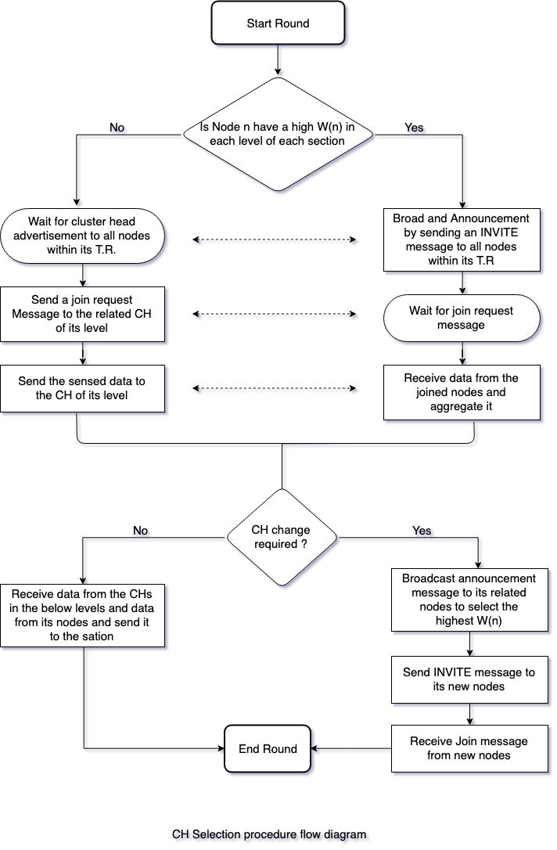

Fig. 1 CH Selection procedure flow diagram

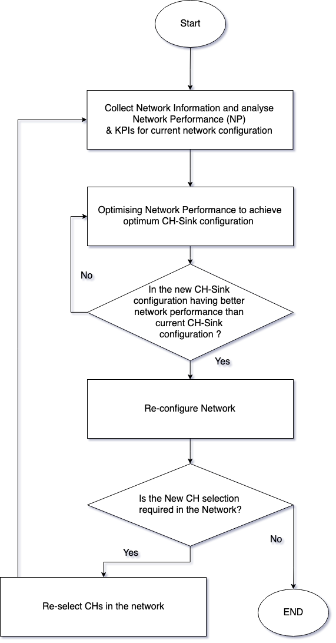

Fig. 2 SOCHA Algorithm

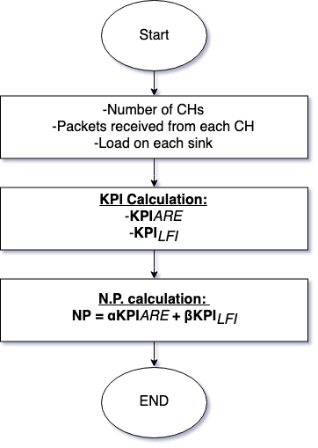

Fig. 3 Fitness Calculation

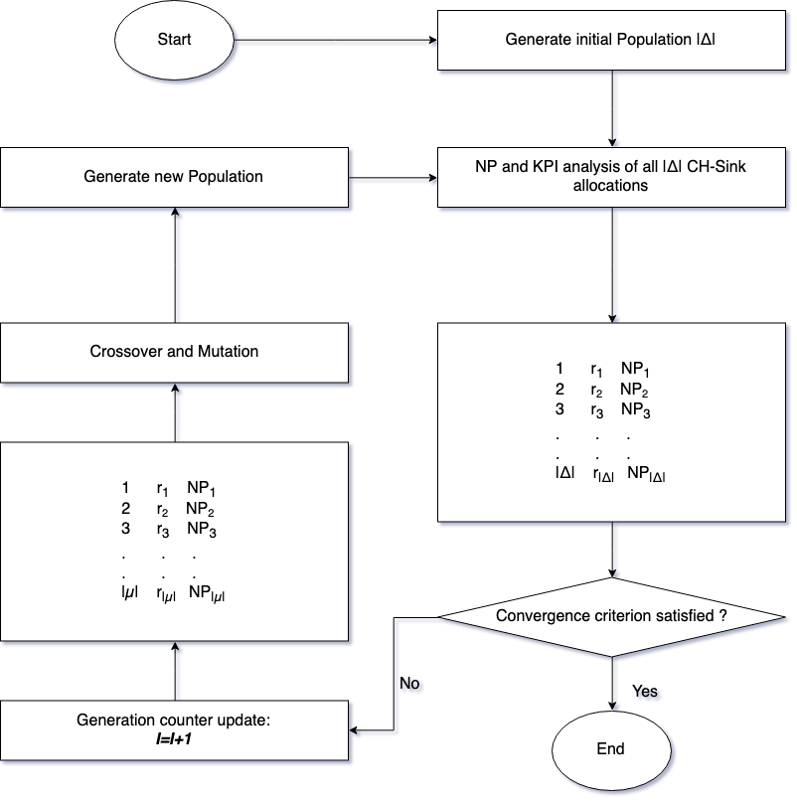

Fig. 4 Genetic Algorithm

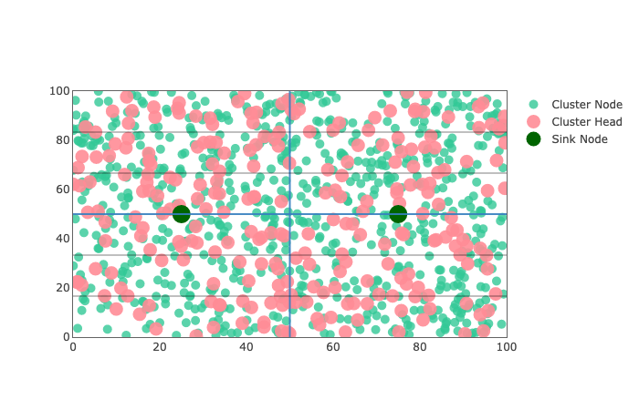

Fig. 5 Visualisation of the network

**8. LIST OF ABBREVIATION**

1. CH - Cluster Head
2. TR - Transmission Range
3. MLCMS - Multilevel Clustering Multiple Sink
4. 6LoWPAN - IPv6 protocol over Low Wireless Personal Area Network
5. KPIs - Key Performance Indicator

**9. LIST OF TABLES**

|  |  |
| --- | --- |
| **Parameter Name** | **Value** |
| Number of sensor nodes(n) | 1000 |
| Base station location for two sinks | (25,50), (75, 50) |
| Base station locations for three sinks | (50, 100), (100, 100), (150, 100) |
| Length of the packet(L) | 4,000 bits |
| Initial energy of the sensor nodes (Eini) | 0.5J |
| Energy consumption in the circuit (Eelec) | 50nJ/bit |
| εfs | 10pJ/bit/m2 |
| εmp | 0.0013pJ/bit/m4 |
| Network Size for two sink | 100m X 100m |
| Network Size for three sink | 200m X 200m |
| Data aggregation energy (EDA) | 5nJ/bit/signal |

Table 1.

**10. REFERENCES**

1. <https://ieeexplore.ieee.org/document/7938616>
2. <https://vishal-pandey.github.io/major/>
3. <https://github.com/vishal-pandey/major>
4. [https://plot.ly](https://plot.ly/)
5. <http://www.numpy.org/>
6. <http://vishal-pandey.github.io/genetic-algorithm>
7. <https://vishal-pandey.github.io/ga-travelling-salesman-problem>