**AMAZONE S3 GLACIER**

**NAME :- LAKSHIKA VIJAYVARGIYA**

**ROLL NO :- 15**

**Introduction:**

Amazon S3 Glacier is a low-cost cloud storage service provided by Amazon Web Services (AWS), specifically designed for long-term data archiving and backup. It offers secure, durable, and scalable storage for data that is infrequently accessed and for which retrieval times of minutes to hours are acceptable. Glacier is part of the Amazon S3 family and is ideal for regulatory archives, digital preservation, and disaster recovery.

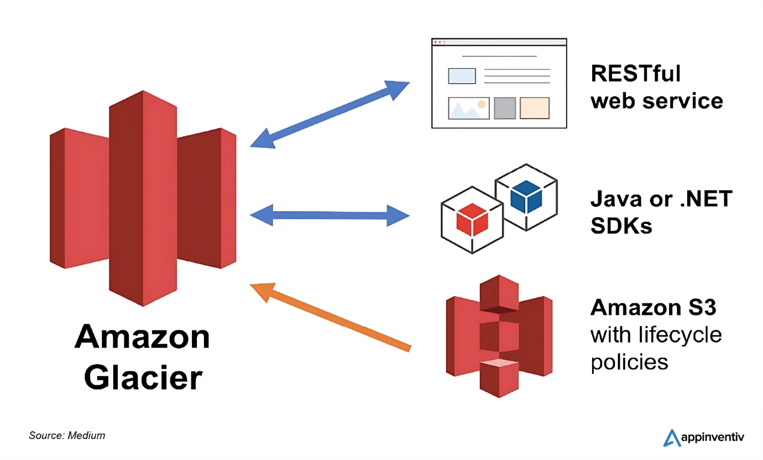

**Key Features:**

* **Low-Cost Storage:** Optimized for data archiving with pricing much lower than standard S3 storage classes.
* **High Durability:** Designed for 99.999999999% (11 9's) durability by automatically storing data across multiple facilities.
* **Retrieval Options:** Supports three retrieval speeds – Expedited (1–5 minutes), Standard (3–5 hours), and Bulk (5–12 hours).
* **Vault Lock:** Allows users to lock policies using compliance controls to meet regulatory requirements.
* **Data Encryption:** Data is automatically encrypted at rest using 256-bit AES and can be encrypted during transit.
* **Access Control:** Supports IAM policies, S3 bucket policies, and audit logging with AWS CloudTrail.
* **Scalable:** Automatically scales storage to match your data growth without manual intervention.
* **Integration:** Integrates easily with AWS services like AWS Backup, Amazon S3, AWS Lambda, and Amazon Macie.

**Benefits:**

* **Cost Savings:** Ideal for storing large volumes of archival data at a fraction of the cost of active storage.
* **Compliance Ready:** Meets regulatory and compliance requirements with features like Vault Lock and detailed logging.
* **Security:** Built-in encryption and access control ensure secure storage of sensitive data.
* **Flexible Retrieval:** Choose retrieval options based on urgency and cost.
* **Durability & Reliability:** Automatically replicates data across multiple AWS availability zones.
* **No Administrative Overhead:** Fully managed by AWS, requiring no on-premises infrastructure.
* **Long-Term Archiving:** Designed for long-term storage with features to automate data lifecycle management.

**Use Cases:**

* Archiving financial and healthcare records for compliance.
* Storing media assets that are infrequently accessed.
* Backup storage for disaster recovery plans.
* Digital preservation for academic institutions, museums, and libraries.
* Archival storage of logs and machine-generated data.

**Comparison with Other Services:**

* **Amazon S3 Standard/Intelligent-Tiering:** Glacier is cheaper but slower for retrieval, best used for long-term data.
* **Google Cloud Archive:** Comparable in purpose, but AWS Glacier often has more flexible retrieval options.
* **Azure Archive Storage:** Similar in cost structure; Glacier has more integration with broader AWS ecosystem.

**Conclusion:** Amazon S3 Glacier is an ideal solution for organizations needing secure, durable, and affordable storage for archival data. With flexible retrieval options, strong integration across AWS services, and robust compliance features, Glacier provides a reliable and cost-effective way to manage long-term data storage.