**AZURE FILE**

**NAME :- LAKSHIKA VIJAYVARGIYA**

**ROLL NO :- 15**

**Introduction:**

Azure Files is a secure, fully managed cloud-based file sharing service offered by Microsoft Azure. It allows you to create shared folders in the cloud that can be accessed via standard protocols like SMB and NFS from anywhere in the world, just like a network drive on your PC. It supports Windows, Linux, and macOS platforms and requires no physical infrastructure.

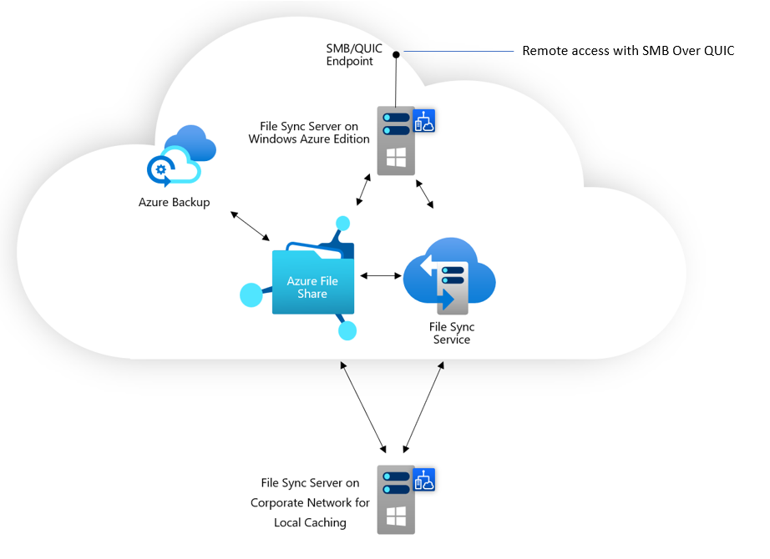

**Key Features:**

* **Cloud-based File Sharing:** Access files globally using SMB/NFS protocols.
* **Fully Managed:** No need to manage physical file servers or hardware.
* **Cross-platform Access:** Works seamlessly with Windows, Linux, and macOS.
* **Azure File Sync:** Sync your on-premises file server with Azure Files for hybrid access.
* **Snapshots:** Create point-in-time backups of your file share for recovery.
* **Integration:** Supports Azure Active Directory authentication and private networking.

**Redundancy & Availability:** Offers options like LRS (Locally Redundant), ZRS (Zone-Benefits:

* Redundant), and GRS (Geo-Redundant) storage for data protection.
* **Remote Accessibility:** Users can securely access files from any location.
* **No On-Premises Server Required:** Reduces the need for local infrastructure.
* **Cost-effective:** Pay only for the storage and features you use.
* **Secure:** Includes encryption in transit and at rest, with access control via Azure AD.
* **Backup & Restore:** Use snapshots to quickly recover lost or corrupted data.
* **Easy Integration:** Easily integrates with Azure VMs and cloud-based applications.
* **Scalability:** Supports dynamic scaling to match your storage needs.